# User Manual

Objective: TDPS OA Ledger Report generation

## Step to generate report

* 1. Start Teamcenter
  2. Login to Teamcenter with correct user id and password

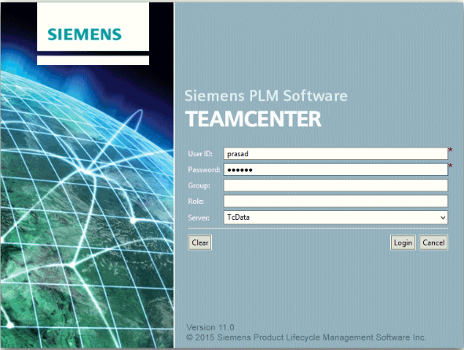

* 1. Click on Report menu

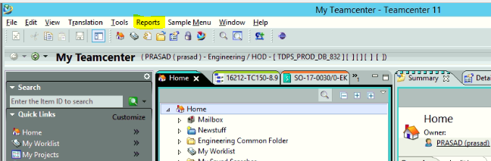

* 1. Click on OA Ledger sub menu

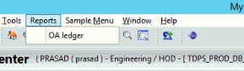

* 1. Search criteria UI will open

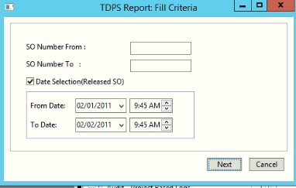

* 1. Input should be matched with below criteria(Scope of search criteria)

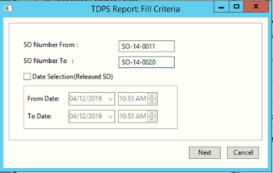

* + 1. Search criteria should have "From" and "To' within range values
    2. "From" should always be less than or equal to "To"
    3. Only "TO' is not the valid input
    4. When date field is used, the ‘From' and ‘To' SO range should be within the date range
    5. When date field is used SO ‘From Date’ should be less than equal to SO ‘To Date’ date
    6. Upper case of "SO / so", both are acceptable
    7. SO From : SO-xx* and SO To: SO-xx* this is not valid for correct output

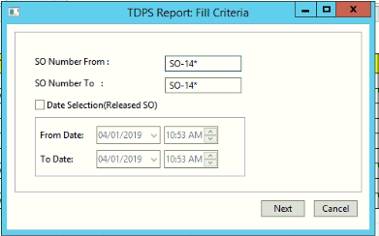 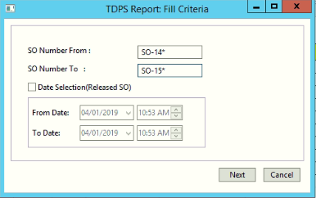

* + 1. For more input criteria information please follow **TDPS_InputsForSearchCriteria.xlsx** document
  1. Click on next button
  2. TDPS Column management : Property display UI will open
     1. All available properties are displayed in Left table column
     2. Default selected properties are displayed in Right table column
     3. Properties can traverse from right to left and left o right
     4. Right table properties can be up down which sequence you want to show in report
     5. Table columns can be sort

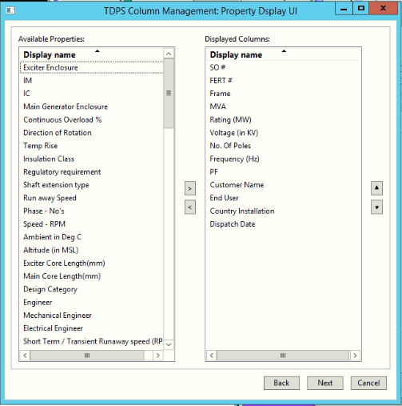

* 1. Click on next button
  2. TDPS report UI will be open with all searched data
  3. Loading time is displayed below table on UI.

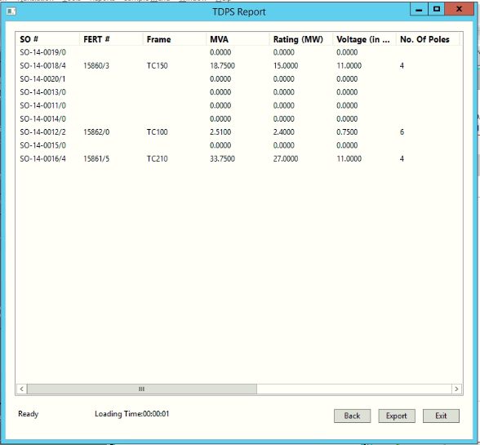

* 1. Report Button will enable when data is available and only for below user
     1. User group should be “**Engineering**”
     2. User Role should be “**Approver**” or “**HOD**”
  2. User can should click on ‘Export’ Button



* 1. Message will display once report will print

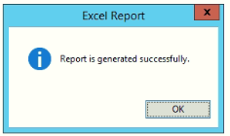

* 1. Click on ‘ok’ button excel report will generate

