**1. INTRODUCTION**

**1.1 Project Description**

The authorized employees of bookstore portals upload all details about each book product components in to the server such as book id, book name, author name, version details, and rate and tax details also. The customers who want to access this resource should be registered and get login credential. In registration process the customer type such as single customer or retailer is mandatory. The concern fixes the rate and tax for the products based on the customer type.

This information is retrieved and used for billing module. In a billing section, the sold product details, no of items sold, rate of the product, concession amount based on the customer type and total bill amount details are stored to a server and an invoice also generated. The authorized administrator views the customer details, product stock information and also able to view the report of the products. In this report the frequently sold company products are highlighted and which customers buy many products are also highlighted. Based on this report the admin balances the stock, maintain customer relationship such as give offer, rate reduction for a valuable customer.

**1.2 Company Profile**

TechCiti is a huge far reaching data innovation administrations and arrangements stage that carefully changes business tasks, improves client commitment and enlarges operational proficiency for its clients everywhere throughout the world. TechCiti offers a coordinated arrangement of items, arrangements and administrations. It serves in excess of 1500 clients extending from Fortune 500 organizations to developing new companies. TSC gets quality form its solid initiative group concentrated on moving a domain of pioneering society leaked in conveying outstanding incentive to the clients.

Through an all-around characterized advancement, backing and quality structure, TechCiti counsels’ organizations on their innovation guide and actualizes, underpins and keeps up business-basic applications and the basic foundation.

### Our Vision

Our aim is to empower individuals and associations understand their latent capacity rehashing their commitment in characterizing the more drawn out term utilizing - innovation.

### Our Mission

Our central goal is to understand the main situation as a recognized and outright start to finish data innovation framework and specialist organization.

**2. LITERATURE SURVEY**

**2.1 Existing System**

In an existing system a shop owner maintain all the details in manually As we all know the manual process it will be difficult to handle the multiple data files. It has so many problems in some cases

1. Within short duration we can’t retrieve the files

2. Some files will lost

3. Data is not secure

**2.1 Proposed System**

The main objective of the proposed system is to computerize all the manual work-related shopping product inventory and keep track of all purchased product information and keep records of all the transaction made in the sun power system. Making it easy to view and update stock details and sales details. To store the information of the customer and to make it easy to update the information of the customer. Advantages

1.Within short duration we can retrieve the file

2.Data is safe secure

3.Only authenticate users can access

4.Manage all the book details based on categories

## **2.2** FEASIBILTY STUDY

Feasibility is nothing but determining or finding the project is doing well or not.

The steps involves in this process is called feasibility study. In other words it is the method of processing the functional requirements of user and uses of the resources and managing of those resources with the time. This study is used to understand and analyse whether the created system is working feasible or not.

Once the requirement specification is done then development will be moved to next level that is design. In design phase lots of solutions will be presented. But the best solution among all the solutions will be chosen, this is the biggest responsibility of the developer for the further development.

### Technical Feasibility

As name indicates it consider software equipment and tells about the technical feasibility like whether the system fulfilling the user needs by giving desire and expected outputs, whether the system running in all the environments. And it gives response time of the system and the speed of the process. Here developer have to make sure the programming languages that he chosen is to be understand to a common or normal person. Here it is very important that, whatever decision the developer takes, he make sure that it should be flexible, that means front and backend should be flexible and it should work and support in all the environment.

### Economic Feasibility

Economic feasibility is the most commonly used method or technique for analysing or estimate the effectiveness of a proposed system. Further it is also known as fare/profit analysis. The approach is to calculate the profit and the savings and proposed system will be compare with the fare. The decision of design and implementation of the system is taken and made if there is any chance of being selected. There will be a continuous

attempt that boost the accuracy in every step or level of system life cycle.

### Operational Feasibility

As name indicates operational is nothing it is related to the action or performance or behaviour of the system. Here some points will be taken under consideration and those are given below.

* + - 1. What kind of changes will be introduce with the system.
      2. What kind of professionalism and new talent is required.
      3. Whether the existing staff persons have these talent or not.
      4. If they don’t have, then are they going to be trained.

once the system is designed and completed then it will be taken for use. The once who wants to use the system should have at least some knowledge about how to use it. The user should be trained at least basic level.

**2.2 Tools and Technologies Used**

**HTML**

**2.3.1 HTML**

Html is the Hyper Text Markup Language it is used for creation of websites or webpages.For creation of website/webpages we are using Cascading Style Sheet(CSS) it is used to create styles for your webpages like font,color,animation and Javascript it is used for validation purpose.

Web browser get Html file from a web server and we can see the website page in any type of browsers. HTML describes the structure of a web page and it is the tag based language.

.

**2.3.2 CSS**

CSS is used for while creating webpage adding style in that in a simple and easiest way. CSS explanation"Cascading Style Sheet". **C**ascading **S**tyle **S**heets, referred to as CSS, it is simple style based language to make website attractive.

**4 Python**

pythonis a programming language which is widely useful,adaptable and mainstream.it’s incredible as a first language since it is compact and easy to peruse,and it is additionally d decent language to have in any developer’s stack as it very well may be utilized for everything from advancement to programming improvement and logical applications

* Instinct mode is obliged better testing and to keep up a real testing acknowledgment.
* It is contionuously natural to the extent working.
* It is object masterminded in nature.

### Django

Django is an open source and web framework present in python which is developed and maintain by DSF(Django Software Foundation). Now a days django widely in used because of its more built in functionalities. There are some famous and well-known companies and apps are using django for the development of their websites and those companies and apps are Google, Instagram,Discus, Spottily, You Tube, Pinterest, .It is used in web development in python. It support templates and static files that means you can easily render the HTML pages by putting all the HTML files in the directory called ‘templates’ and similarly you can place all the files related to styles like CSS and JS will be placed inside the directory called ‘static’. In this project django is used for the front end development. Further django provide more features as compared to other frameworks and those features are given below.

* + - 1. Built in locallhostserver
      2. Built in administrationfacility
      3. Highsecurity
      4. Rapiddevelopment
      5. Outstandingdocumentation

### Bootstrap4

Bootstrap is an open source framework used to develop the responsive web applications or responsive designs. Responsive means application should be runs on smaller screens like mobile phones and tablets. Every element of the HTML document get stacked when the page get smaller or minimized. By default bootstrap takes 12 columns of width with equal separation of the columns that means every column having same size. But you can alter the default values and you can make layouts,designaccording to your requirements using <span> tag.

Bootstrap provide grid system for all kind of devices such as extra small, small, medium, large, extra-large which can help to run the app on every devices. Further it provide some stylish buttons, forms, tables and so on. Bootstrap 4 is the newest version with some additional features compare to previous versions. In this project bootstrap 4 is used for the front development along with the django framework

**2.3.3 SQLITE:**

**SQLITE** is self-container it supports the operating system or any external library, and it is requires the minimal support. In our project, SQLite is used to connect the database. SQLite code is a public domain, it is freely use for any purpose like commercial or private purpose.

Each column in SQLite is assigned the SQLite3 database. SQLite consists of following data types Integers, Text, Numeric, Boolean, BLOB (Binary Large Objective collection of Binary data), Real, Varchar. SQLite use in any environment especially in the embedded devices like Android phones, iPhones, media players, game consoles etc.

**2.4 Hardware and Software Requirements**

**2.4.1 Hardware Requirements:**

* System Processor : Pentium IV 2.4 GHz.
* System Hard Disk : 150 GB.
* System Ram : 4 GB or greater (Recommended)
* System Processor Speed: 3.20 GHz or Higher

**2.4.2 Software Requirements:**

* Operating system : - Windows 10.
* IDE : Spyder
* Coding Language : Python
* Data Base : MYSQL

**3. SOFTWARE REQUIREMENTS SPECIFICATION**

Software Requirement Specification (SRS) is a completely preserve and saved catalogue which is maintained by the developer. It gives detailed clarity about the software system, which is developed with its functional requirements and also non-functional requirements. It may also contain some use cases, which tells about the customer interactions.

**3.1 Users**

User can search any books by using name of book, name of author and publication. User have the option of searching any available book or specifying in checkbox list which books to search.They can pay the bill of books by cash on delivery**.**

**3.2 Functional Requirements**

Functional requirements of the system tells about the functional part of the system and it contains computation, practical details, manipulation and operations on data and some more unique functionalities of the system. It actually tells about the system what supposed do. Here we can see how and what the kind of outputs and results are generating and what kind of services it providing to the end users.

The functional requirements of the system tells about the cost of the system and it also tells about reliability of the system that means the services provided by the system is fulfilling the user needs or not and the output which is getting from the system is expected output or not will be studied.

It also gives the complete functionality of the subsystems of a system and a document of high level statements will be maintained in which all the above points will be completely and clearly explained in detail. The document may include some key points or functional requirements such as safety and security, quality, manufacturability, usability, performance, reliability and environmental friendliness and so on

**3.3NON- FUNCTONAL REQUIREMEMTS:**

Non functional requirements of the system is nothing but it describe the standard which is used to conclude the operations of the system. In other words non functional requirements of the system is defined as the constraints, rules, guidelines and the procedure applied on the functional requirements is called non functional requirements. It tells about how a system is should be present, that means it gives the plan about the architecture of the system. It is also called as “quality attributes” and it is divided into two types, first one is execution and another one is evolution.

The first type of non functional requirements that is execution contains security and safety, usability which can be seen at the run time. Whereas the second type contains scalability, extensibility, maintenance and testing. Which are merged in the fixed structure of the system. in this project, if you want to figure out some non functional requirements yes you can do that and those are connecting to internet, initiating the localhost server, creating virtual environment for the project and so on.

**4. SYSTEM DESIGN**

**4.1 System Perspective:**

Programming process improvement frequently needs solid connects to extend the executives and control exercises, which are worried about recognizing the need of procedure change and activating improvement activities. Task the executives, then again, regularly comes up short at choosing suitable programming designing strategies and innovation that help to guarantee venture achievement.

It proposes a model that guides venture directors

* To set up a task with the goal that it can achieve its particular objectives.
* To identify restorative changes once an undertaking is danger of fizzling its objectives.

In a System Perspective one ought to be cautious about thinking about the framework with regards to nature and not as a confined element. Along these lines one ought to incorporate the associations between the framework and the earth. This can be stated as the first step of identifying the solution from the start of the problem

**4.2 Data Flow Diagram**

Data flow diagram explains the entire project flow. The authorized employees of bookstore portals upload all details about each book product components in to the server such as book id, book name, author name, version details, and rate and tax details also. The customers who want to access this resource should be registered and get login credential.

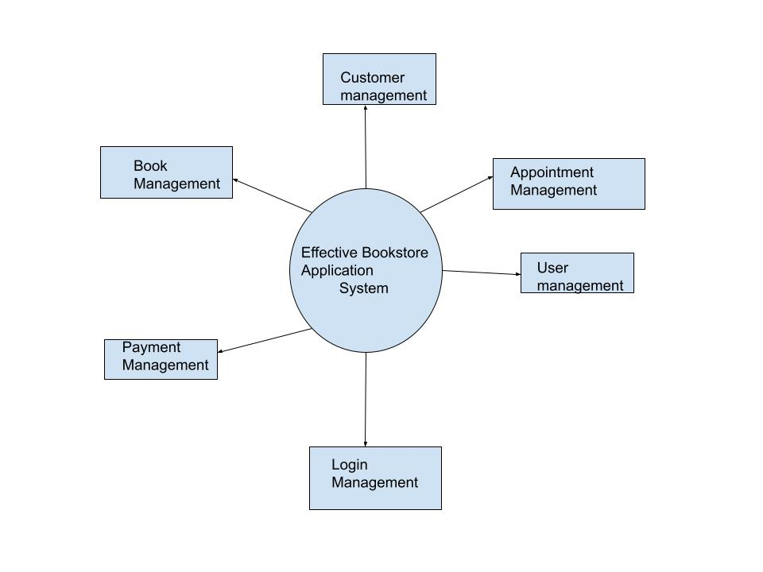

Figure 4.2: Shows the DFD diagram, it is describing the modules are how to work

and flow of the data in the project.

In this diagram the store admin maintains all accessories information such as product name, company detail, specification information and price of the product for single customer and retailers. The administrator able to view the report on which company products are sales frequently and which retailers purchase many items. Based on this report the admin fixes the offer rate for the regular customer. The authorized customers also able to view new product details and offer details also in their account. The store consists of varied shopping categories include different collection of features. Users may browse for various categories of product. Then they'll select desired products to their handcart. The shopping cart is updated accordingly.

**5. DETAILED DESIGN**

**5.1Use Case Diagram**

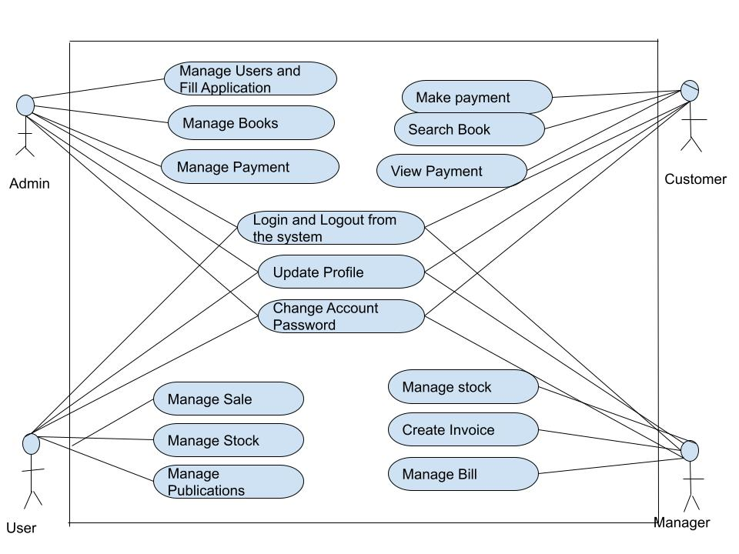

Figure 5.1: shows the Use Case diagram in this diagram used four actors.

.

**5.2 Sequence Diagram**

A sequence diagram in Unified Modelling Language (UML) is a kind of interaction diagram that shows how processes operate with one another and in what order. We can also call event diagrams or time transaction diagrams.

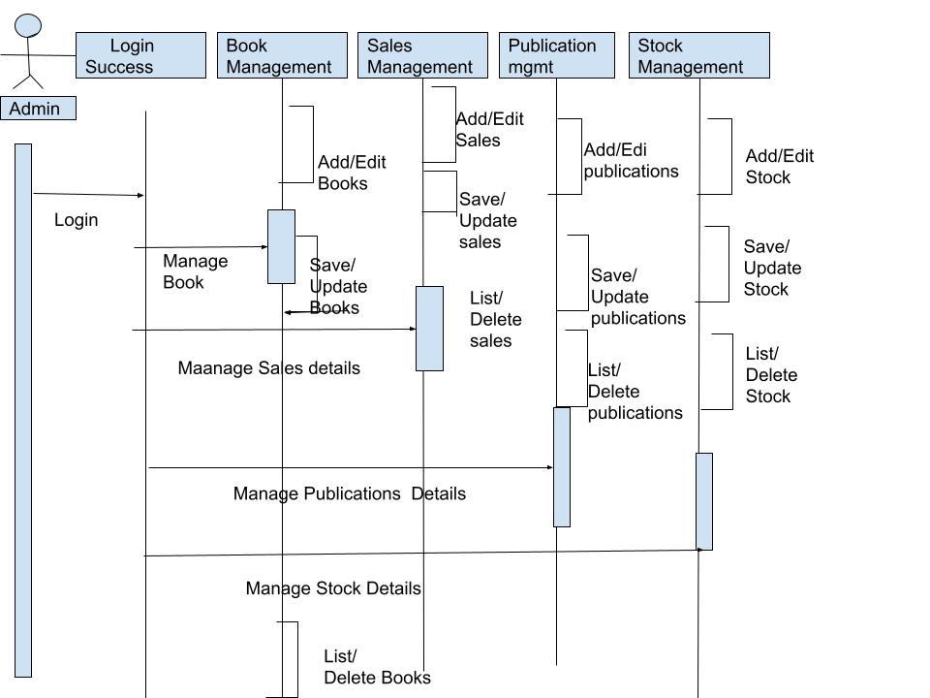

Figure 5.2: shows the Sequence diagram, it is also called interaction diagram. This

diagram shows interaction flow between modules.

The store admin maintains all accessories information such as product name, company detail, specification information and price of the product for single customer and retailers. The administrator able to view the report on which company products are sales frequently and which retailers purchase many items. Based on this report the admin fixes the offer rate for the regular customer. The authorized customers also able to view new product details and offer details also in their account. The store consists of varied shopping categories include different collection of features. Users may browse for various categories of product. Then they'll select desired products to their handcart.

**5.3 Activity Diagram**

Activity diagrams are graphical representations of workflows of stepwise activities and actions with support for choice, iteration and concurrency. It manages the control of flows according to all the entities types of users.

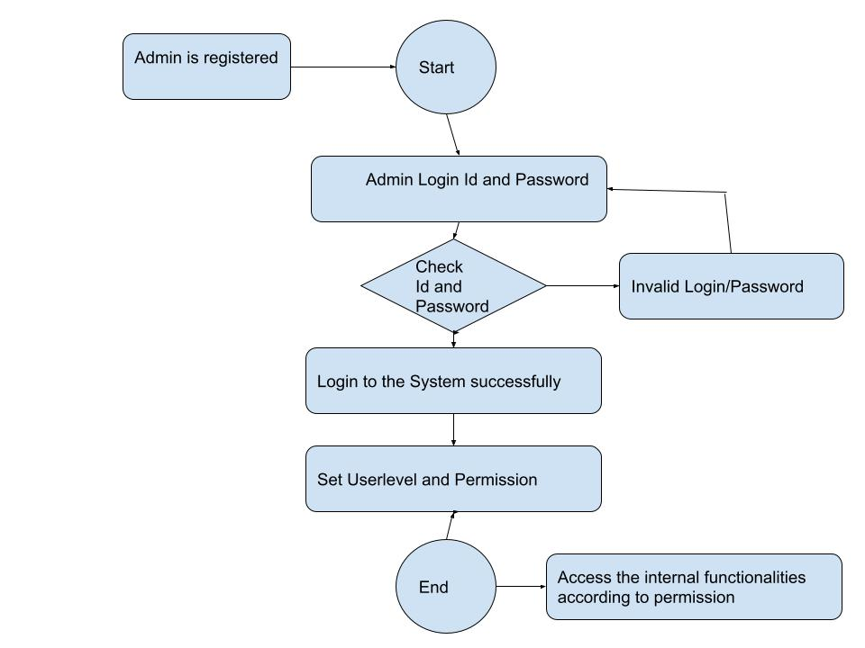

Figure 5.3: shows the Activity Diagram, it is showing the overall flow of control

of the modules in this project.

This project “Online Bookstore Application Portal “is form a proper network among the bookstore, customer and retailers. The store admin maintains all accessories information such as product name, company detail, specification information and price of the product for single customer and retailers. The administrator able to view the report on which company products are sales frequently and which retailers purchase many items. Based on this report the admin fixes the offer rate for the regular customer.

**5.4 Database Design**

Database tables are stored all the information regarding their tables. Here I have used four data tables as shown below

**5.4.1 Authorized User table**

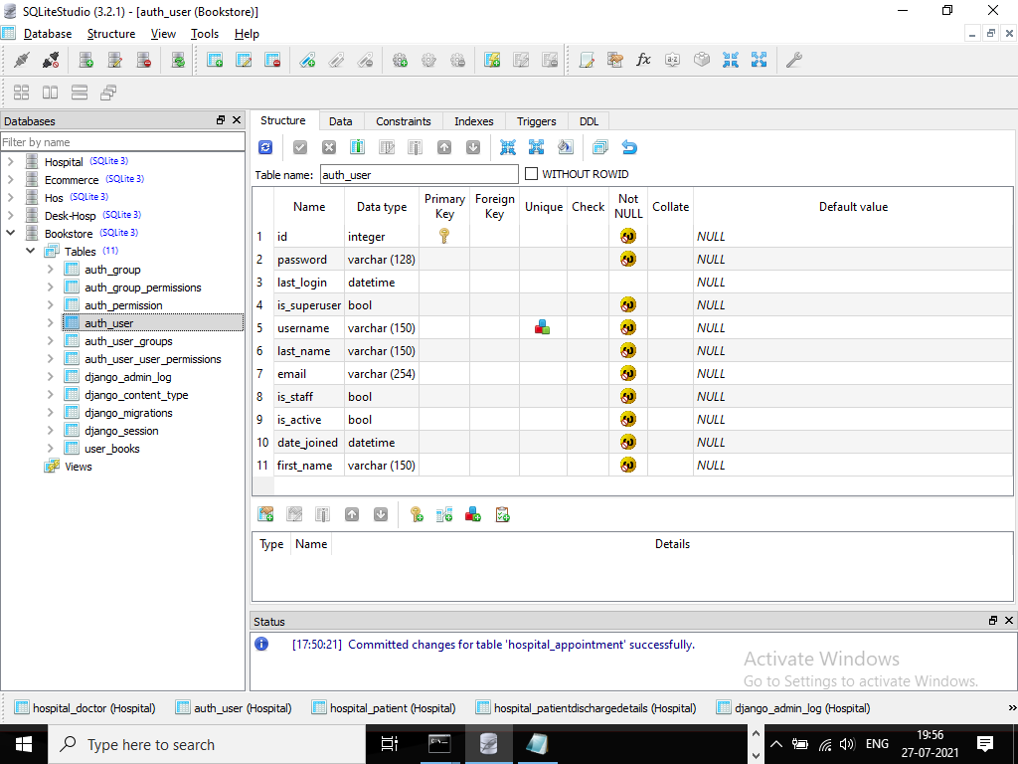

Figure 5.4.1 this shows the user login details

**5.4.2 User manage table**

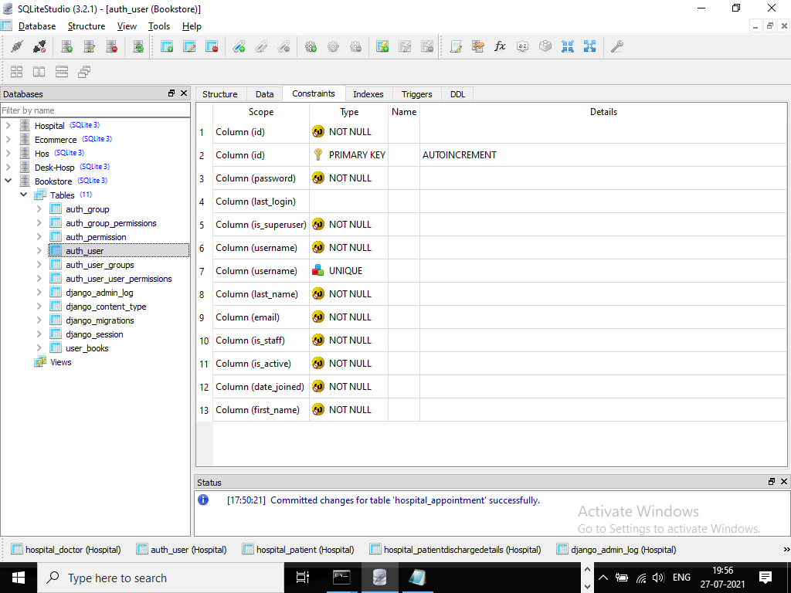

Figure 5.4.2 this shows the user manage table

**5.4.3 User Books details table**

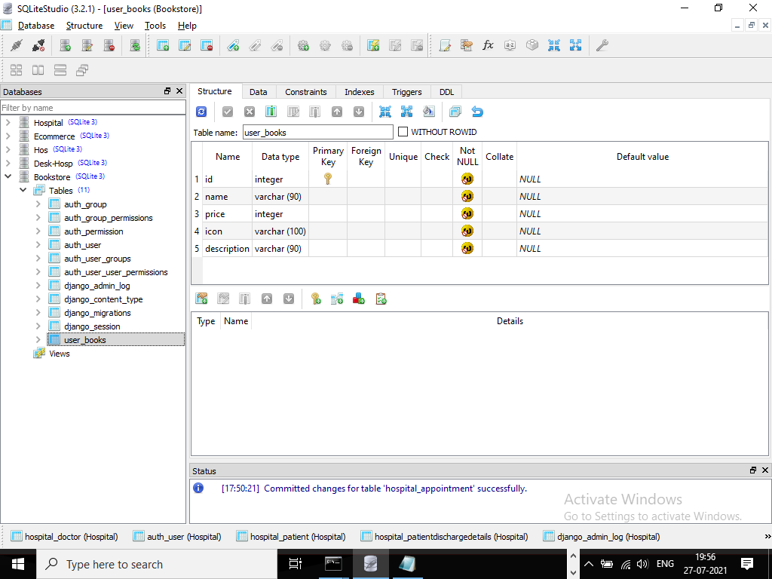

Figure 5.4.3 It shows the User books details

**5.4.4 Information about the books table**

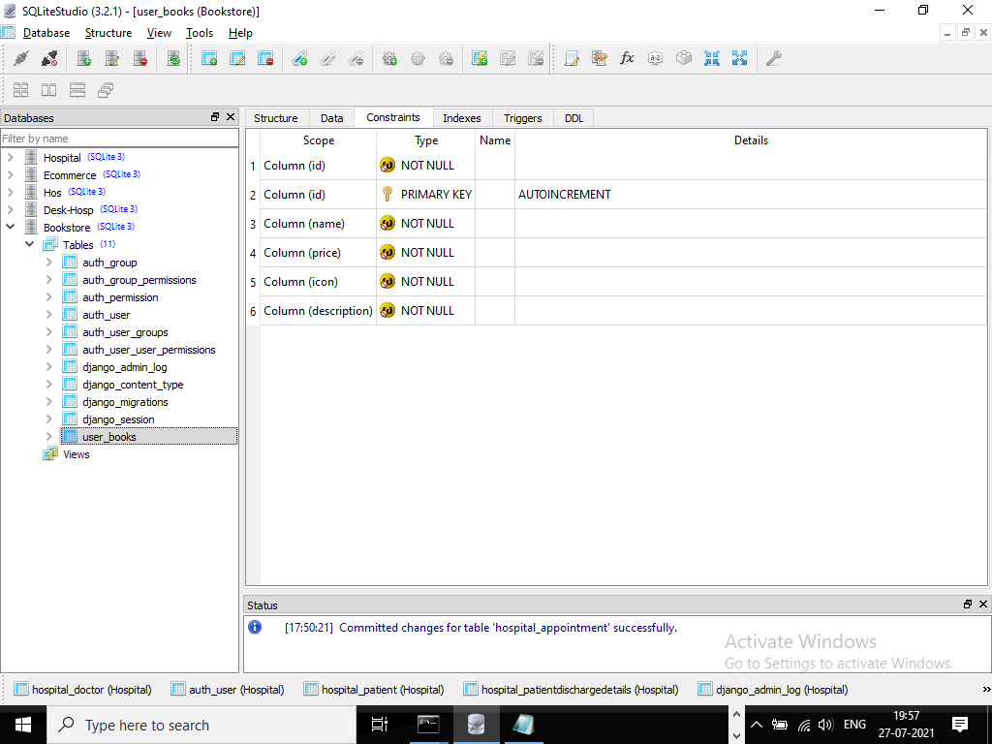

Figure 5.4.4 It shows the information’s about the books

**5.4 E-R Diagram**

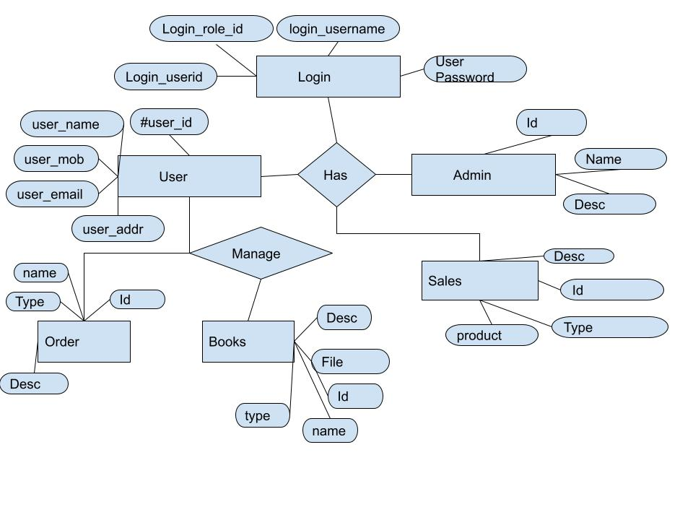

Figure 5.5.6: shows an Entity-Relationships model and it is describing the interrelationships

between entities.

**6. IMPLEMENTATION**

This coding implementation shows the store admin maintain all accessories information such as product name, company detail, specification information and price of the product for single customer and retailers. The administrator able to view the report on which company products are sales frequently and which retailers purchase many items. Based on this report the admin fixes the offer rate for the regular customer. The authorized customers also able to view new product details and offer details also in their account. The store consists of varied shopping categories include different collection of features. Users may browse for various categories of product.

**6.1 Coding Screen Shots**

**6.1.1 Code for creating views**

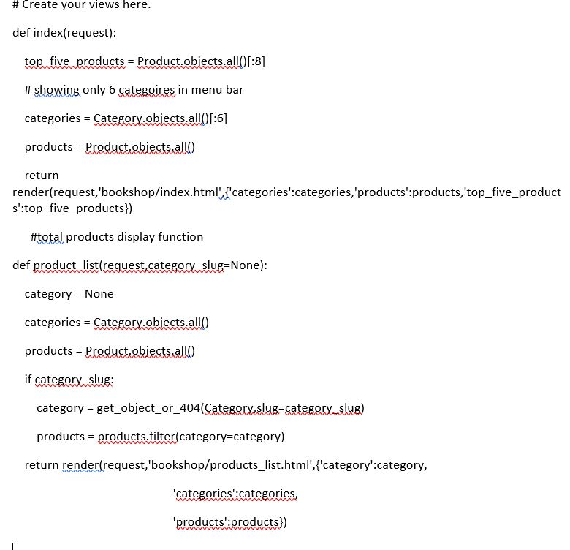

Figure 6.1.1 Code for creating user views

**6.1.2 Code for product details**

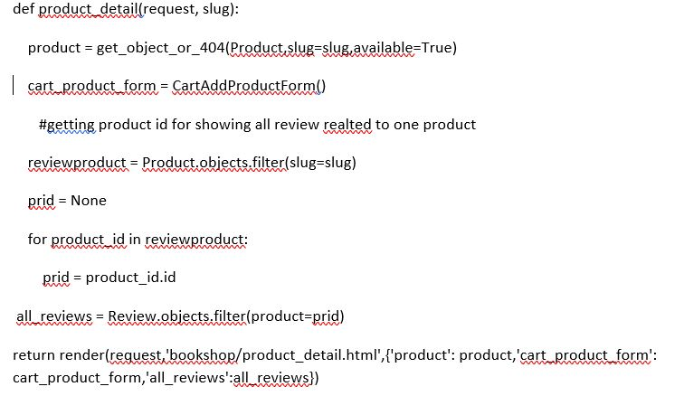

**6.1.3 Code for all categories**

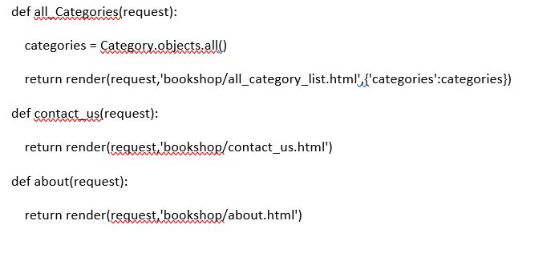

**6.1.4 Code for search Details**

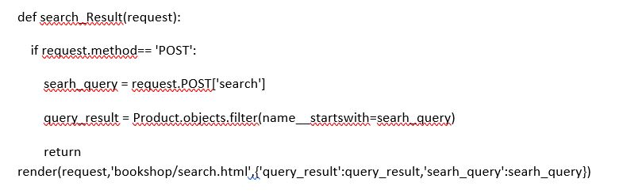

**6.1.5 Code for Comment Review**

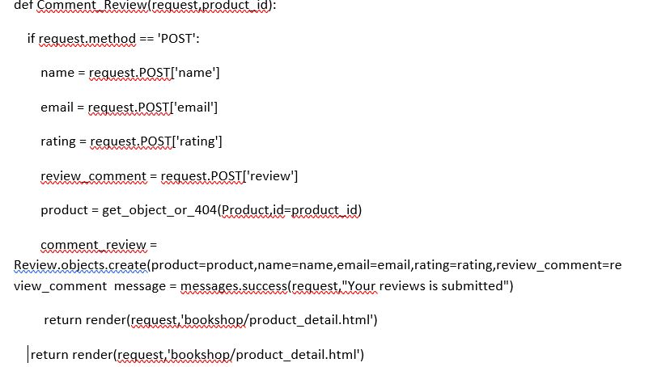

**6.1.6 Code for user orders**

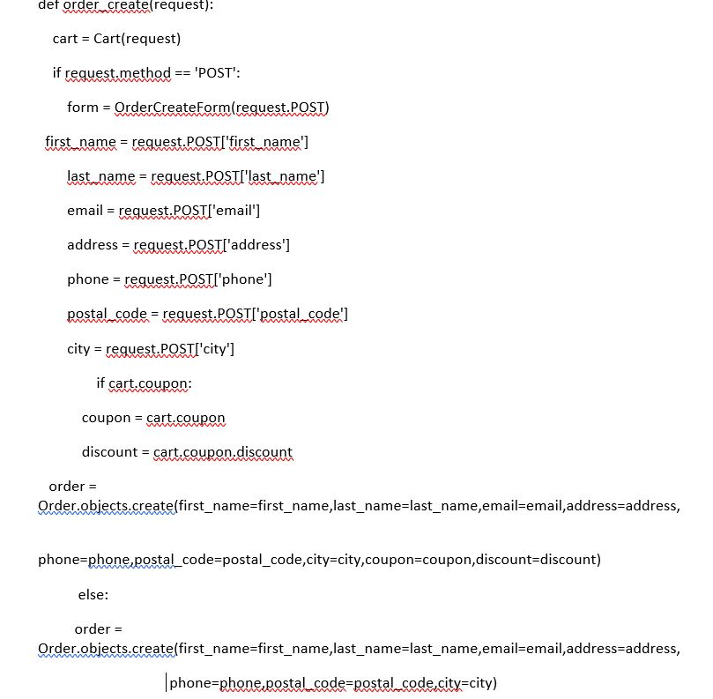

**6.1.7 Code for payment details**

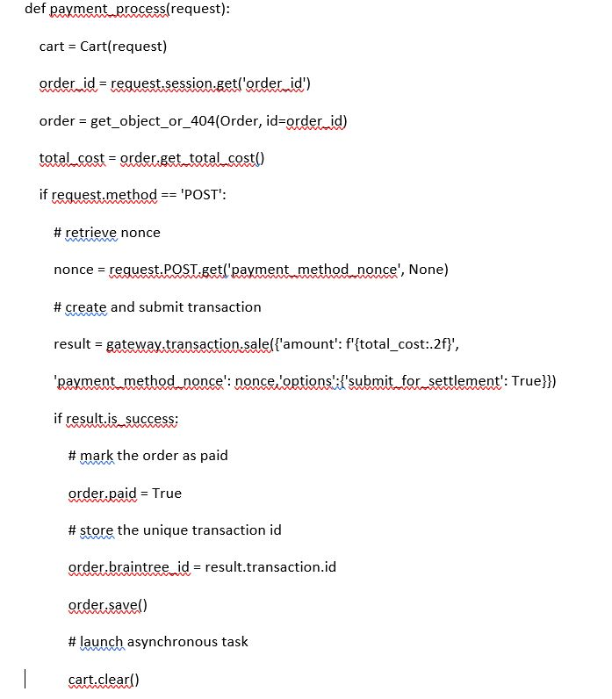

**6.2 Screen Shots**

**6.2.1 Home page**



Figure 6.2.1 Home page

**6.2.2 Registration page**

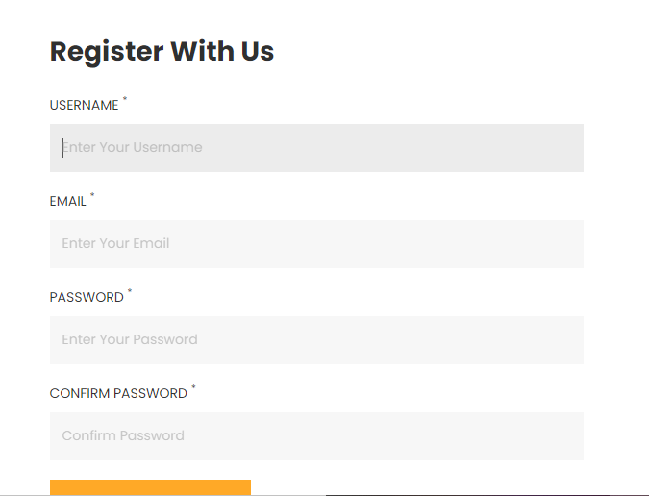

Figure 6.2.2 Registration page

**6.2.3 User Login page**

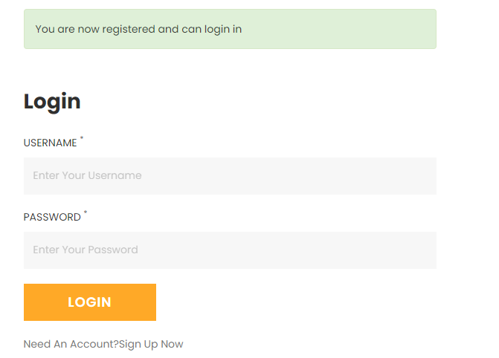

Figure 6.2.3 User Login page

**6.2.4 Admin login page**

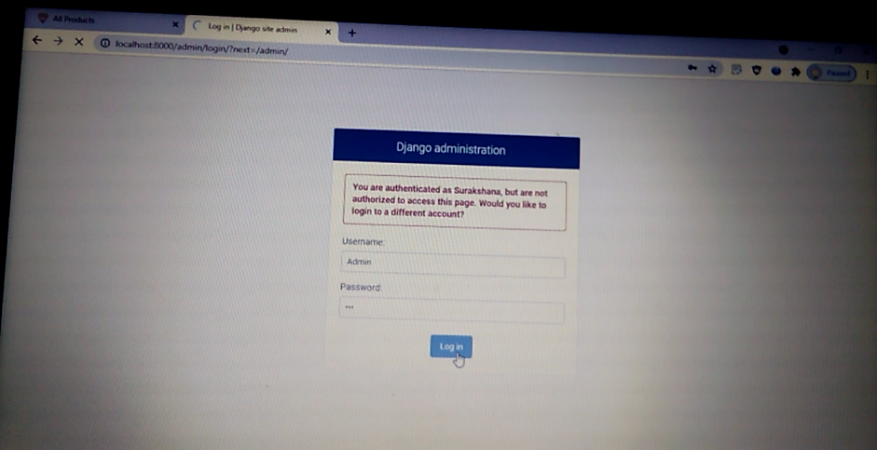

Figure 6.2.4 Admin login page

**6.2.5 Administration page**

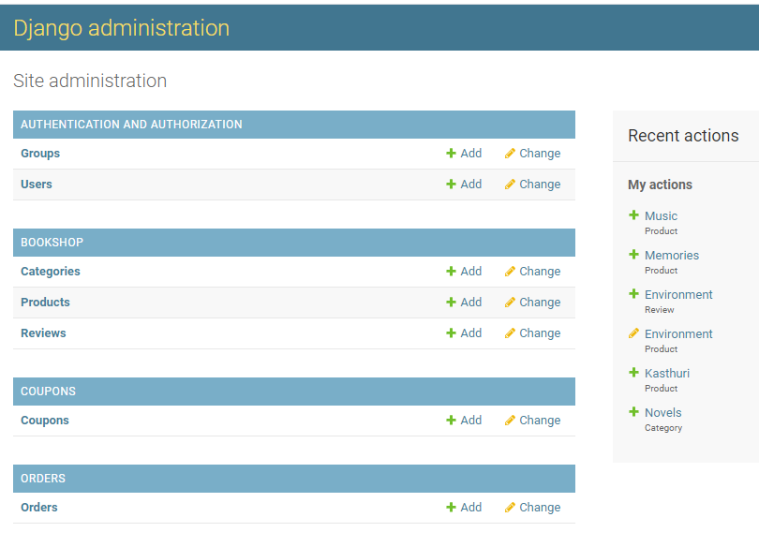

Figure 6.2.5 Administration Page

**6.2.6 Select categories to change**

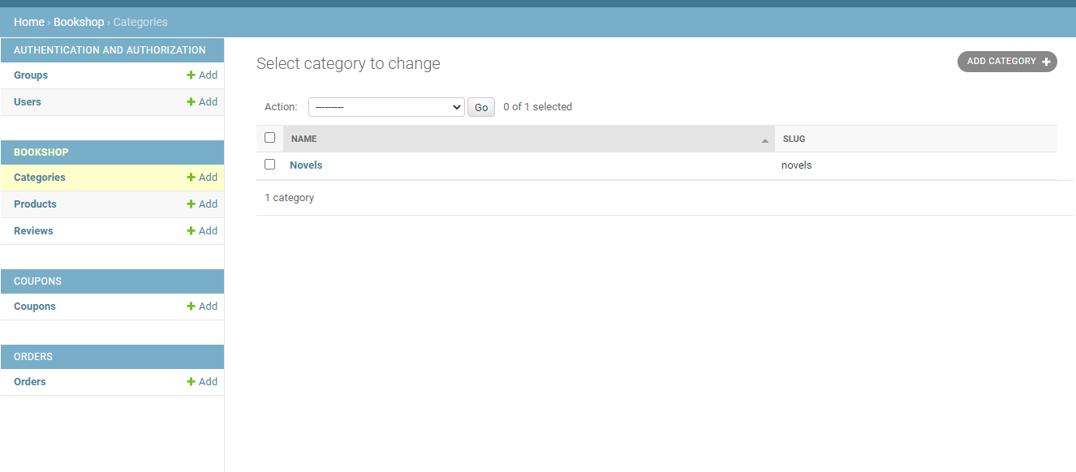

Figure 6.2.6 admin can change the categories

**6.2.7 Select product to change**

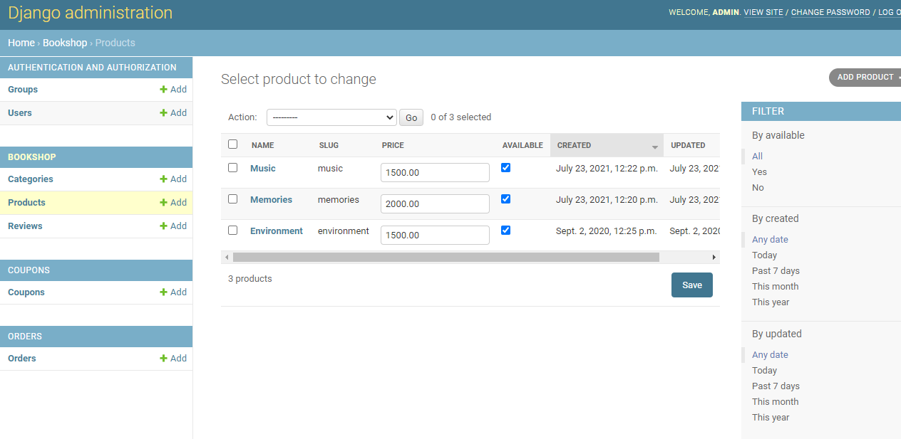

Figure 6.2.7 Select product to change

**6.2.8 Admin can add the product**

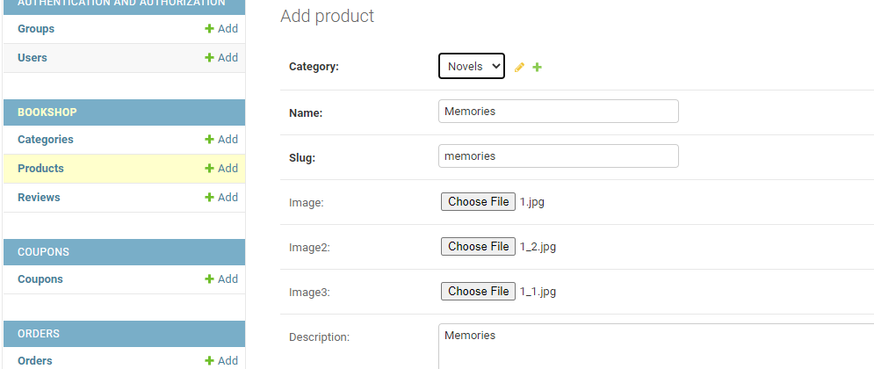

Figure 6.2.8 Admin can add the products

**6.2.9 Select user to change**

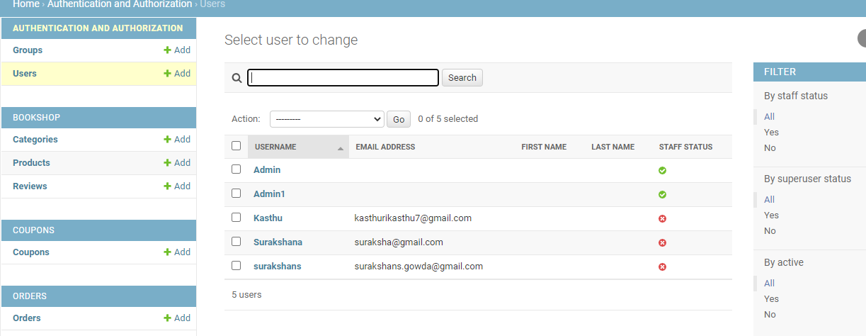

Figure 6.2.9 Select user to change

**6.2.10 Select order to change**

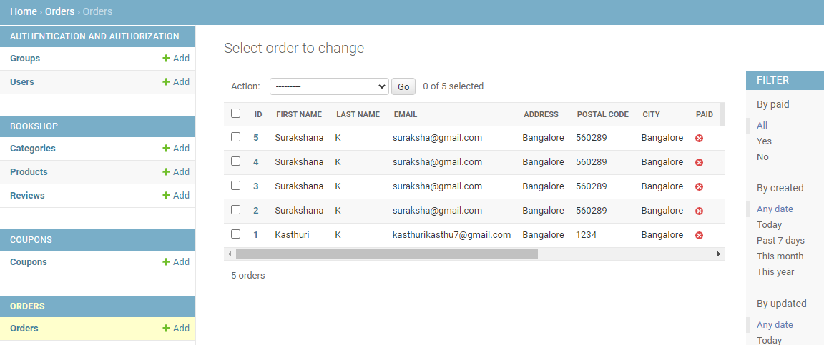

Figure 6.2.10 Authorized user can change the order

**6.2.11 User billing details**

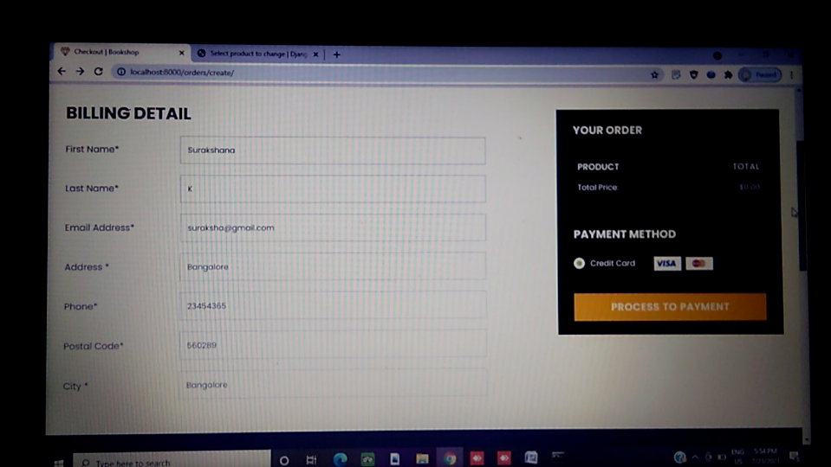

Figure 6.2.11 User billing information’s.

**6.2.12 User cart**

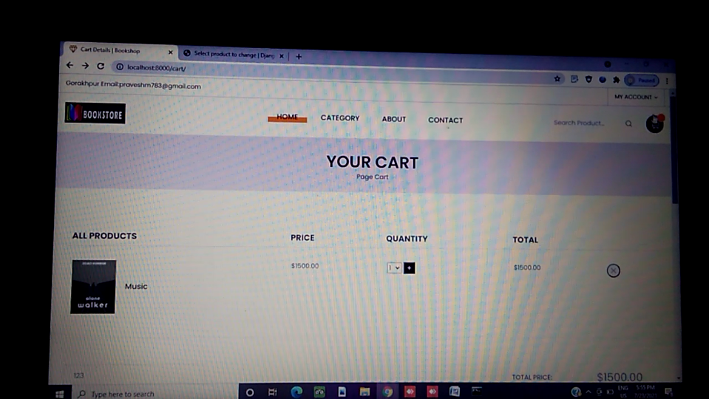

Figure 6.2.12 for user cart

**7. SOFTWARE TESTING**

Software testing is a process of identifying errors and faults. These errors will lead to inefficient results. When system is not capable to fulfilling the functional specifications then the failure occurs. Test cases with different scenarios are used to perform testing. Test data will include complete range of inputs, valid and invalid inputs and exceptional cases. The obtained results validated across the expected results.

**1. Unit Testing**: Unit Testing is used to verify the small piece of code or small part of the program. Initially functionalities of small modules are verified. If the specified requirements are fulfilled, then testing will be proceeding further. Otherwise, the failed test results will be reported to development team for the code correction. This process repeats until the functionality of each module is accurate. As each unit is tested separately, fixing errors would be easy. Hence, it is called as unit testing.

**2. Integration Testing**

This testing is performed once all the individual units are tested. The unit tested modules are integrated together and checked for the functionalities. It mainly focuses on the interoperability of each unit when they are combined. Here admin, user and vendor modules are integrated together and overall system functionality is verified.

**3. Graphical User Interface** (**GUI) Testing**

GUI testing is used to check the front-end design of the project is user-friendly. Here tester checks proper page alignment, size, styles, fonts. Users would get feel comfortable if interfaces are designed using proper style, icons and buttons.

**8. CONCLUSION**

Nowadays most of the people shows interest in advanced technology in that one of the platform is mobile ecommerce. Ecommerce websites will be very useful for all the customers who willing to purchase and sell the products within shorten time period. By using this ecommerce platform most of the customers are happy using this method because without moving any place they can able to purchase all the thing based on their requirement needs

From this project we have data entry module, supplier and admin all the modules are perform different categories. For example, in data entry module we can enter the data what are the stocks are available or not from this module we can monitor all the stocks it is useful to manage the users also. And admin modules need to check the user interest, supplier and data entry module to monitor and based on that admin module can launch different products. Supplier sells the product from user and manage the purchasing bill. From this project it is useful to maintain all the accessories based on user interest and they can achieve the success rate.

**9. FUTURE ENHANCEMENT**

In future there may be able to provide bar code support and make rebates on system configurations and group of shopping categories components. Export data filters such as employee, payments, companies, sold items, components etc into excel file format and later there may be easy to change the data and print that file.

In this project the database can be quickly back up in future and there is debts/demands of customer management and customize the bills that you want to print and also create estimates and later it can be converted into bills. There is also a report to make comparisons between the months. Sell computer System by instalments. And will provide pay-roll administrations for our employees. Also, server database is protected from unauthorized modifications.

**Appendix A**

**BIBLIOGRAPHY**

**References:**

* **www.python.org**
* **www.coursera.org**
* **en.wikipedia.org**
* **http://www.tutorialspoint.com /python/index.htm**
* "Python Build bot". Python Developer’s Guide. Python Software Foundation. Retrieved 24 September 2011
* "What's New in Python 3.9". Python. Retrieved 28 November 2019
* "Built-in Types". Retrieved 3 October 2019.

**Appendix B**

**USER MANUAL**

Step 1 – Open Anaconda application and lunch the PyCharm community.

Step 2 – Open Anaconda prompt and install the pycryptodomepython library packages.

Step 3 – Run the python run server command on the anaconda prompt, then this command -------------provide the localhost address of the project.

Step 4 – Copy the localhost address and paste on chrome search bar.

Step 5 – Run the project localhost address and shows the home page of project.

Step 6 – Login the user through username and password.

Step 7 – User make a banking transaction through the user digital cards.

Step 8 – Logout from the website.