

Figure

Foundation Certificate for Higher Education

Module: DOC 333 Introduction to Programming Principles

Module Leader: Mr. Sudarshan Welihinda

Assignment Type: Individual

Submission Date: 2023.12.11

Student ID: 20231264

Student Name: Ranuga Disansa Belpa Gamage

Student Email: [ranuga.20231264@iit.ac.lk](mailto:ranuga.20231264@iit.ac.lk)

Acknowledgement

I want to express my appreciation to those who have helped complete this report.

I have been able to complete this report because of the Academic advisor Mr. Sudarshan Welihinda for their invaluable support, mentorship, and feedback and the faculty members of Doc 333 (Introduction to Programming Principles).

Additionally, I would like to thank my family members for their unwilling encouragement and help throughout the report.

Thank you.

Table of Contents

Introduction 5

The Problem 5

The Solution 5

Algorithm 6

PesudoCode 6

Verification Functions 11

date_vertification() 11

project_code_vertification() 13

check_if_int() 13

Explanation 14

Add a new project to existing projects. 14

Removing a Completed project from existing projects 14

Adding new workers to the available worker's group 15

Updating Details to an ongoing project 15

Project Statistics 16

Exiting the Program 16

Assumptions 17

Python Code 18

Test Cases 22

Add a New Project 22

Test 1 22

Test 2 22

Test 3 23

Test 4 23

Test 5 24

Test 6 25

Remove a Project 26

Assuming the project below has been added 26

Test 1 26

Test 2 27

Test 3 27

Add new Workers 28

Test 1 28

Test 2 28

Test 3 29

Test 4 29

Update Project Details 30

Assuming the project below has been added 30

Test 1 30

Test 2 31

Test 3 31

Test 4 32

Test 5 33

Test 6 33

Test 7 34

Test 8 35

Project Statistics 36

Assuming the project below has been added from Choice 3 36

Assuming the project below has been added from Choice 1 36

Test 1 36

Test 2 37

Exit 38

Test 1 38

List of Figures

Figure 1 0

Figure 2 11

Figure 3 12

Figure 4 13

Figure 5 13

Figure 6 14

Figure 7 14

Figure 8 15

Figure 9 15

Figure 10 16

Figure 11 18

Figure 12 18

Figure 13 19

Figure 14 19

Figure 15 20

Figure 16 21

Figure 17 21

Figure 18 21

Figure 19 22

Figure 20 22

Figure 21 23

Figure 22 24

Figure 23 25

Figure 24 26

Figure 25 27

Figure 26 27

Figure 27 28

Figure 28 28

Figure 29 29

Figure 30 29

Figure 31 30

Figure 32 30

Figure 33 31

Figure 34 32

Figure 35 32

Figure 36 33

Figure 37 34

Figure 38 35

Figure 39 35

Figure 40 37

Figure 41 37

Figure 42 38

# Introduction

## The Problem

The company “XYZ” a company that undertakes large housing construction projects needs an information system to maintain details of the projects they undertake. This system should keep details of all ongoing projects, the details and the number of workers available to assign to a new project. Before undertaking a project, the company makes sure they have enough workers if not the company doesn’t undertake the project. Once the project is finished it is taken out of the ongoing projects and assigned to completed projects and the workers are released when the project is completed.

## The Solution

The solution that is created is for the problem to maintain the details of projects the construction company named “XYZ” undertakes. The solution is an information system built using Python programming language.

# Algorithm

The solution which is implemented by Python Programming language is stated below in the form of algorithm steps and with an explanation of how each aspect of the program functions.

## PesudoCode

1. Start
2. # importing packages

* IMPORT datetime

1. # initialization of variables

* SET company_name TO “XYZ Company.”
* SET workers TO 0
* SET choice TO 0
* SET all_projects TO []
* SET completed_projects TO []
* SET execute TO True
* SET project_names TO []
* SET possible_inputs TO [“ongoing”, “completed”, “on hold”]
* SET statistics_list TO [0] * len(possible_inputs)
* SET redirect_choice TO False
* SET redirect_to TO None

1. define function menu(redirect,to,company_name,msg):

* SET main_menu TO company_name + ”””

Main Menu

1. Add a new project to existing projects.
2. Remove a completed project from existing projects
3. Add new workers to available workers group
4. Update details on ongoing projects
5. Project Statistics
6. Exit

“””

* OUTPUT “Redirecting…” if redirect is True else main_menu
* RETURN to if redirect is True else INPUT user choice

1. define function remove_completed_projects(code_of_project,every_project,workers_tot,stats_list,complete_projects,possible_stats):

* TRY
* SET index_of_project TO project_names.index(code_of_project)
* SET date_time TO datetime.datetime.now()
* SET actual_end_date TO date_time.strftime(“%m/%d/%Y”)
* SET code_of_project,clients_name,start_date,expected_end_date,number_of_workers,_,index TO every_project[index_of_project]
* SET completed_project_details TO [code_of_project,clients_name,start_date,expected_end_date,number_of_workers,actual_end_date]
* SET workers_tot TO workers_tot + num_of_workers
* SET stats_list[index] TO stats_list[index] - 1
* SET stats_list[possible_stats.index(“completed”)] TO stats_list[possible_stats.index(“completed”)] + 1
* APPEND completed_project_details TO completed_projects
* DELETE every_project[index_of_project]
* DELETE project_names[index_of_project]
* RETURN (True, “Successful removed completed projects.”,workers_tot,status_list,completed_projects,every_project,project_names)
* EXCEPT Exception as e
* RETURN (False,e,workers_tot,status_list,completed_projects,every_project,project_names)

1. define function create_project(status_list,index,code_of_project,clients_name,start_date,expected_end_date,number_of_workers,project_status,workers_tot,every_project,stats_list,possible_stats)

* TRY
* SET status_list[index] TO status_list[index] + 1
* SET project_date TO [code_of_project,clients_name,start_date,expected_end_date,number_of_workers,project_status,index]
* IF project_status EQUALS “ongoing” and number_of_workers > workers_tot
* RETURN (False,”There is not enough workers”, workers_tot)
* IF project_status EQUALS “ongoing”
* SET workers_tot TO workers_tot – number_of_workers
* APPEND code_of_project TO project_names
* APPEND project_data to all_projects
* RETURN (True, “Successfully created a new project”, workers_tot)
* EXCEPT Exception as e
* RETURN (False, e, workers_tot)

1. define function update_project_details(status_list,index,previous_index,code_of_project,clients_name,start_date,expected_end_date,number_of_workers,project_status,current_workers,workers_tot,previous_project_status)

* TRY
* IF project_status EQUALS “ongoing”
* IF number_of_workers > workers_tot + (current_workers if previous_project_stautus EQUALS “ongoing” else 0)
* RETURN (False, “Workers chosen are too much”, workers_tot)
* IF project_status EQUALS “ongoing”
* SET workers_tot TO workers_tot – number_of_workers
* IF previous_project_status EQUALS “ongoing”
* SET workers_tot TO workers_tot + current_workers
* SET status_list[index] TO status_list[index] + 1
* SET status_list[previous_index] TO status_list[previous_index] – 1
* SET project_data TO [code_of_project,clients_name,start_date,expected_end_date,number_of_workers,project_status,index]
* SET index TO project_names.index(code_of_project)
* SET all_projects[index] TO project_data
* RETURN (True, “Project details updated successfully”, workers_tot)
* EXCEPT Exception as e:
* RETURN (False,e,workers_tot)

1. define function date_vertification(msg)

* SET date TO INPUT(msg)
* SET splitted_date TO date.split(date[2] if len(date) > 3 else “ “)
* IF len(splitted_date) != 3
* OUTPUT “Enter a valid format of the date…!”
* SET month TO splitted_date[0]
* SET date TO splitted_date[1]
* IF month > 12
* OUTPUT “Enter a valid month! “
* RETURN date_vertification(msg)
* IF date > 31
* OUTPUT “Enter a valid date !”
* RETURN date_vertification(msg)
* RETURN date

1. define function project_status_vertification(msg,update_status)

* SET project_state TO INPUT(msg).replace(“ “,””).lower()
* IF project_state NOT IN possible_inputs:
* OUTPUT “The entered project status is incorrect”
* IF update_status IS True
* SET statistics_list[possible_inputs.index(project_state)] TO statistics_list[possible_inputs.index(project_state)] + 1
* RETURN (project_state,statistics_list,possible_inputs.index(project_state))

1. define function project_code_vertification(msg,project_codes)

* SET project_code TO INPUT(msg)
* IF project_code IN project_codes
* OUTPUT “Project code already exists”
* RETURN project_code_vertification(msg,project_codes)
* RETURN project_code

1. define function check_if_int(msg)

* TRY
* RETURN int(INPUT(msg)
* EXCEPT
* OUTPUT “The msg entered was not an integer”
* RETURN check_if_int(msg)

1. while execute

* SET choice TO menu(redirect_choice,redirect_to)
* SET redirect_choice TO False
* SET redirect_to TO None
* IF choice EQUALS “1”
* OUTPUT company_name + “Add a new project”
* SET code_of_project TO project_code_vertification(“Project Code : “, project_names)
* IF code_of_project EQUALS “0”
* CONTINUE
* SET clients_name TO INPUT(“Clients Name : “)
* SET start_date TO date_vertification(“Start Date (MM/DD/YYYY) : ”)
* SET expected_end_date TO date_vertification(“Expected end date (MM/DD/YYYY)”)
* SET number_of_workers TO check_if_int(“Numbers of Workers : “)
* SET project_status, status_list, index TO project_status_vertification()
* SET save to INPUT(“Do you want to save the project (Yes/No)”)
* IF save.upper() EQUALS “YES”
* SET execution_status, response_msg, workers TO create_project(status_list,index,code_of_project,clients_name,start_date,expected_end_date,number_of_workers,project_status,workers,all_projects,statistics_list,possible-Inputs)
* OUTPUT response_msg + execution_status
* ELSE:
* OUTPUT “The project was *not* saved !”
* ELSEIF choice EQUALS “2”
* OUTPUT company_name + “Remove completed project”
* SET code_of_project TO INPUT(“Project Code : “)
* IF code_of_project NOT IN project_names
* OUTPUT “The project does not exist”
* CONTINUE
* SET save TO INPUT(“Do you want to save the project (Yes/No) ? “)
* IF save.upper() EQUALS “YES”
* SET Execution_status,response_msg,workers,status_list,completed_projects,every_project, project_names TO remove_completed_projects(code_of_project,all_projects,workers,statistics_list,completed_projects,possible_inputs)
* OUTPUT response_msg + execution_status
* ELSE
* OUTPUT “The project was not removed”
* ELSEIF choice EQUALS “3”
* OUTPUT company_name + “Add new workers”
* SET new_no_of_workers TO check_if_int(“Number Workers to Add : “)
* IF new_no_of_workers < 0
* OUTPUT “Workers must be more than 0”
* IF save.upper() EQUALS “YES”
* SET workers TO workers + new_no_of_workers
* ELSE
* OUTPUT “Workers were not added”
* ELSEIF choice EQUALS “4”
* OUTPUT company_name + “Update Project Details”
* SET code_of_project TO INPUT(“Project Code : “)
* IF code_of_project NOT IN project_names
* OUTPUT “There isn’t a project with the mentioned project code…!”
* IF code_of_project.replace(“ “,””) EQUALS “0”
* CONTINUE
* SET clients_name TO INPUT(“Clients Name : “)
* SET start_date TO date_vertification(“Start Date (MM/DD/YYYY) : “)
* SET expected_end_date TO date_vertification(“Excepected End Date (MM/DD/YYYY) : “)
* SET number_of_workers TO check_if_int(“Numbers of Workers : “)
* SET project_status,status_list,index TO project_status_vertification()
* SET save TO INPUT(“Do you want to update the project details (Yes/No)”)
* IF save.upper() EQUALS “YES”
* SET current_workers,previous_project_status,previous_index TO all_projects[project_names.index(code_of_project)][4:]
* SET execution_status,response_msg,workers TO update_project_details(status_list,index,previous_index,code_of_project,client_name,start_date,expected_end_date,number_of_workers,project_status,current_workers,workers,previous_project_status)
* OUTPUT response_msg + execution_status
* ELSE
* OUTPUT “The project was not updated”
* ELSEIF choice EQUALS “5”
* OUTPUT company_name + “Project Statistics”
* FOR idx, item IN enumerate(possible_inputs)
* OUTPUT “Number of “ + item + “projects : “ + statistics_list[idx]
* OUTPUT “Number of Available Workers: “ + workers
* SET add_project TO INPUT(“Do you want to add the project”)
* IF add_project.upper() EQUALS “YES”
* SET redirect_choice, redirect_to TO True, “1”
* ELSEIF choice EQUALS “6”
* SET execute TO False
* ELSE
* OUTPUT “Please enter a valid choice!”

## Verification Functions

### date_vertification()

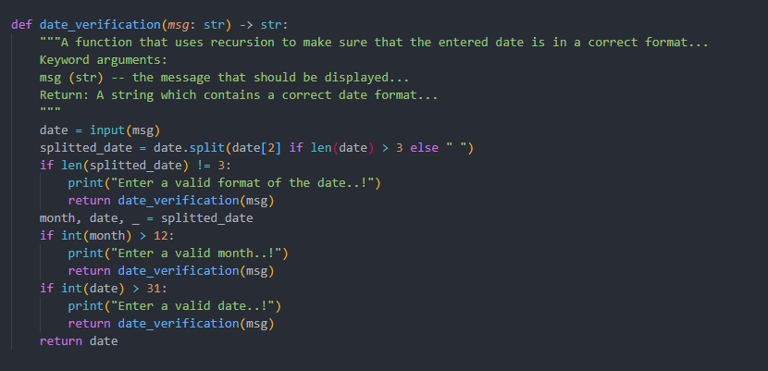

Figure

`date_vertification()` is a function that uses recursion to make sure the entered date is in the correct format. It has 1 argument which is `msg` which is the message that is displayed to the user. A string containing the correct date format is returned. The function works by first asking the user for a date, and then the data is split by the second character (3’rd letter), for example, “12**/**21/2008” The second element which is “/” will be used to split and it is taken in consideration that the string may be smaller than 3 letters so if it is then an empty string will be used. Then the length of the spliced list is checked and if it is not 3 then the `date_vertification()` function calls itself (recursion). Then after that, the month and date are extracted from the list. Finally, the month and date are checked if they are higher than 12 and higher than 31 respectively, and if all the arguments are passed then the date is returned.

project_status_vertification()

Figure

The `project_status_vertification()` function checks whether the project status that is entered is allowed and if not it uses recursion to make sure that the user enters the allowed status. It has 2 arguments which is `msg` which is the message that should be displayed to the user and `update_status` which is a Boolean argument that if True the statistics_list is updated with the status that was entered. First, the user has displayed a message which they need to respond to then the “ “ (blank spaces) are replaced with “and the entire message is lowered, then it is checked if the project_state entered is not in the possible_inputs list, if it is not then the function is calling itself (recursion) and if the project_state is in the possible_input the `statistics_list` is updated and then the following is returned : (project_state, statistics_list, possible_inputs.index(project_state)) => (The project state, the statistics list that is used for the choice `5`, the index of the project state in the list possible_inputs), an example would be: [“ongoing”,[2,1,5],1]

### project_code_vertification()

Figure

`project_code_vertification()` is a function which uses recursion to make sure the project_code entered does not exist already. The parameters are `msg` which is the message that should be displayed to the user and `project_codes` which is the list of project_codes where the function checks if the entered project code exists or not, and finally if the project code does not exist it is returned.

### check_if_int()

Figure

`check_if_int()` function uses recursion with having 1 parameter `msg` which is what is displayed to the user then the message is displayed and the function tries to return the message by trying to convert the inputted data into an integer and if an error is caused then a message saying “The msg entered was not an integer” is displayed and then the function calls itself (recursion).

## Main Functions

## Explanation

### Add a new project to existing projects.

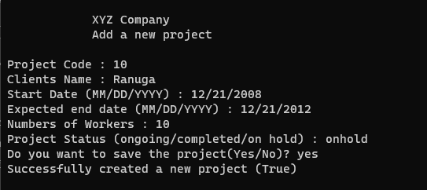

Figure

When the user enters the choice `1` the program asks the user for the Project Code which is directed through a function `project_code_vertification()` which makes sure that the project code is unique, for the start date and expected end date, function `date_vertification()` is used which makes sure the date entered is in the correct format of MM/DD/YYYY. When asking the user for the project status it is passed through a function `project_status_vertification()` which checks whether the status entered was either “ongoing”, “completed” or “on hold”.

### Removing a Completed project from existing projects

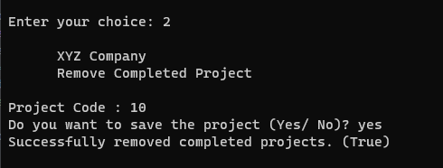

Figure

When the user enters the choice `2` the program asks for the project code which needs to be removed, and it makes sure that the project code exists in the list `project_names`.

### Adding new workers to the available worker's group

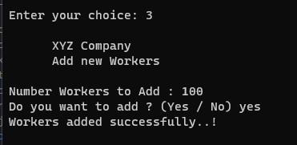

Figure

When the user chooses the choice `3` the user is asked for the number of workers that they want to add and the function `check_if_it()` is used to make sure the user enters an integer value.

### Updating Details to an ongoing project

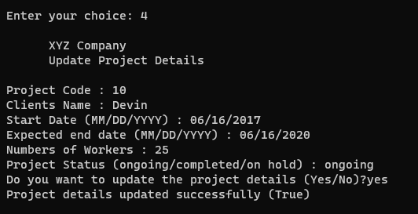

Figure

When the user chooses the choice `4` the user is asked for the project code and other details such as Clients Name, Start Date, Expected end Date, Number of workers, and Project Status which uses functions such as `date_vertification()`, `check_if_int()` and `project_status_vertification()`, and this updates the data in the main list `all_projects`

### Project Statistics

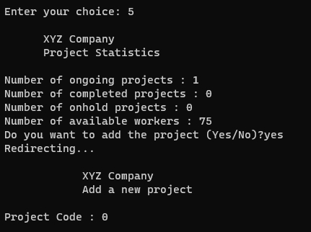

Figure

When the user chooses the choice `5` it displays the project statistics such as ongoing, completed, hold projects and the available workers. It also allows the user to be redirected to the 1st choice.

### Exiting the Program

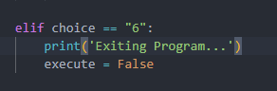



When the user chooses the choice `6` then the program exits by changing the variable `execute` which is the condition that is given to the while loop in turn looping until `execute` is False.

# Assumptions

The listed below are assumptions that were made about the solution, are as listed below.

1. Unique Project Code

It was assumed that the project code must be unique throughout all other projects with either ongoing or on-hold status.

1. When removing a project, the current date should be stored.

It was assumed that the date on which the user removes a project needs to be stored as stated in the “DOC 333 CW Specification”, due to that reason the package “datetime” was imported to get the date on which the project is removed.

1. Only workers are assigned to ongoing projects.

It was assumed that only ongoing projects need to be assigned workers, the other statuses do not get assigned workers when they are created, but if they are updated to ongoing then workers are assigned to those projects.

1. The date format was assumed to be (MM/DD/YYYY)

It was assumed that the Date format that should be used is MM/DD/YYYY

1. There were 0 workers initially.

It is assumed that there are no workers initially when the program starts so it is required for the user to add workers before adding an `ongoing` project.

# Python Code

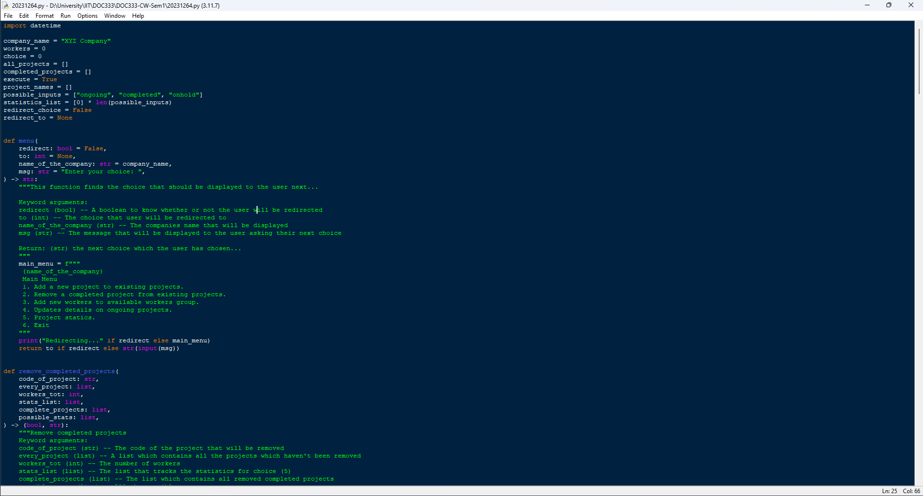

Figure 11

Figure 12

Figure 13

Figure 14

Figure 18

# Test Cases

## Add a New Project

### Test 1

The following test cases are for the 1st choice (“Add a new project to existing projects.”)

|  |  |  |  |  |
| --- | --- | --- | --- | --- |
| Field | Input Entered | Expected Outcome | Actual Outcome | Results |
| Project Code | “0” | Exit and Go to the Main Menu | Exit and Go to the Main Menu | Pass |

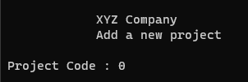

Figure

### Test 2

The following test cases are for the 1st choice (“Add a new project to existing projects.”)

|  |  |  |  |  |
| --- | --- | --- | --- | --- |
| Field | Input Entered | Expected Outcome | Actual Outcome | Results |
| Project Code | “10” | Continue | Continue | Pass |
| Clients Name | “Ranuga” | Continue | Continue | Pass |
| Start Date | “2” | Error Raised, asking the user to enter the date again… | Error Raised, asking the user to enter the date again… | Pass |

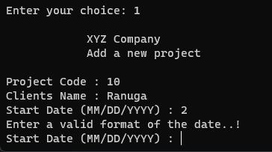

Figure

### Test 3

The following test cases are for the 1st choice (“Add a new project to existing projects.”)

|  |  |  |  |  |
| --- | --- | --- | --- | --- |
| Field | Input Entered | Expected Outcome | Actual Outcome | Results |
| Project Code | “10” | Continue | Continue | Pass |
| Clients Name | “Ranuga” | Continue | Continue | Pass |
| Start Date | “12/12/2000” | Continue | Continue | Pass |
| Expected End Date | “01/01/2001” | Continue | Continue | Pass |
| Number of Workers | “!@” | “The msg entered was not an integer” | “The msg entered was not an integer” | Pass |

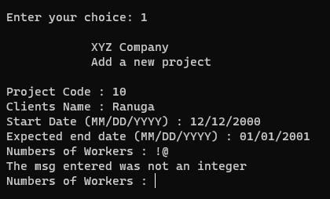

Figure

### Test 4

The following test cases are for the 1st choice (“Add a new project to existing projects.”)

|  |  |  |  |  |
| --- | --- | --- | --- | --- |
| Field | Input Entered | Expected Outcome | Actual Outcome | Results |
| Project Code | “10” | Continue | Continue | Pass |
| Clients Name | “Ranuga” | Continue | Continue | Pass |
| Start Date | “12/12/2000” | Continue | Continue | Pass |
| Expected End Date | “01/01/2001” | Continue | Continue | Pass |
| Number of Workers | 10 | Continue | Continue | Pass |
| Project Status | “ongone” | “The entered project status is incorrect...” | “The entered project status is incorrect...” | Pass |

Figure

### Test 5

The following test cases are for the 1st choice (“Add a new project to existing projects.”)

|  |  |  |  |  |
| --- | --- | --- | --- | --- |
| Field | Input Entered | Expected Outcome | Actual Outcome | Results |
| Project Code | “10” | Continue | Continue | Pass |
| Clients Name | “Ranuga” | Continue | Continue | Pass |
| Start Date | “12/12/2000” | Continue | Continue | Pass |
| Expected End Date | “01/01/2001” | Continue | Continue | Pass |
| Number of Workers | 10 | Continue | Continue | Pass |
| Project Status | “on hold” | Continue | Continue | Pass |
| Save | “No” | “The project was *not* saved ..!” | “The project was *not* saved ..!” | Pass |

Figure

### Test 6

The following test cases are for the 1st choice (“Add a new project to existing projects.”)

|  |  |  |  |  |
| --- | --- | --- | --- | --- |
| Field | Input Entered | Expected Outcome | Actual Outcome | Results |
| Project Code | “10” | Continue | Continue | Pass |
| Clients Name | “Ranuga” | Continue | Continue | Pass |
| Start Date | “12/12/2000” | Continue | Continue | Pass |
| Expected End Date | “01/01/2001” | Continue | Continue | Pass |
| Number of Workers | 10 | Continue | Continue | Pass |
| Project Status | “on hold” | Continue | Continue | Pass |
| Save | “Yes” | “Successfully created a new project (True)” | “Successfully created a new project (True)” | Pass |

Figure

## Remove a Project

### Assuming the project below has been added

|  |  |  |  |  |
| --- | --- | --- | --- | --- |
| Field | Input Entered | Expected Outcome | Actual Outcome | Results |
| Project Code | “10” | Continue | Continue | Pass |
| Clients Name | “Ranuga” | Continue | Continue | Pass |
| Start Date | “12/12/2000” | Continue | Continue | Pass |
| Expected End Date | “01/01/2001” | Continue | Continue | Pass |
| Number of Workers | 10 | Continue | Continue | Pass |
| Project Status | “on hold” | Continue | Continue | Pass |
| Save | “Yes” | “Successfully created a new project (True)” | “Successfully created a new project (True)” | Pass |

### Test 1

The following test cases are for the 2nd choice (“Remove Completed Project”)

|  |  |  |  |  |
| --- | --- | --- | --- | --- |
| Field | Input Entered | Expected Outcome | Actual Outcome | Results |
| Project Code | “90” | “The project does not exist..!” | “The project does not exist..!” | Pass |

Figure

### Test 2

The following test cases are for the 2nd choice (“Remove Completed Project”)

|  |  |  |  |  |
| --- | --- | --- | --- | --- |
| Field | Input Entered | Expected Outcome | Actual Outcome | Results |
| Project Code | “10” | Continue | Continue | Pass |
| Save | “No” | “The project was not removed…!” | “The v was not removed…!” | Pass |

Figure

### Test 3

The following test cases are for the 2nd choice (“Remove Completed Project”)

|  |  |  |  |  |
| --- | --- | --- | --- | --- |
| Field | Input Entered | Expected Outcome | Actual Outcome | Results |
| Project Code | “10” | Continue | Continue | Pass |
| Save | “Yes” | “Successfully removed completed projects.” | “Successfully removed completed projects.” | Pass |

Figure

## Add new Workers

### Test 1

The following test cases are for the 3rd choice (“Add new Workers”)

|  |  |  |  |  |
| --- | --- | --- | --- | --- |
| Field | Input Entered | Expected Outcome | Actual Outcome | Results |
| Number of Workers | -10 | “Workers must be more than 0..!” | “Workers must be more than 0..!” | Pass |

Figure

### Test 2

The following test cases are for the 3rd choice (“Add new Workers”)

|  |  |  |  |  |
| --- | --- | --- | --- | --- |
| Field | Input Entered | Expected Outcome | Actual Outcome | Results |
| Number of Workers | “test” | “The msg entered was not an integer” | “The msg entered was not an integer” | Pass |

Figure

### Test 3

The following test cases are for the 3rd choice (“Add new Workers”)

|  |  |  |  |  |
| --- | --- | --- | --- | --- |
| Field | Input Entered | Expected Outcome | Actual Outcome | Results |
| Number of Workers | 10 | Continue | Continue | Pass |
| Save | No | ” Workers were not added...!” | ” Workers were not added...!” | Pass |

Figure

### Test 4

The following test cases are for the 3rd choice (“Add new Workers”)

|  |  |  |  |  |
| --- | --- | --- | --- | --- |
| Field | Input Entered | Expected Outcome | Actual Outcome | Results |
| Number of Workers | 10 | Continue | Continue | Pass |
| Save | Yes | “Workers added successfully...!” | “Workers added successfully...!” | Pass |

Figure

## Update Project Details

### Assuming the project below has been added

|  |  |  |  |  |
| --- | --- | --- | --- | --- |
| Field | Input Entered | Expected Outcome | Actual Outcome | Results |
| Project Code | “10” | Continue | Continue | Pass |
| Clients Name | “Ranuga” | Continue | Continue | Pass |
| Start Date | “12/12/2000” | Continue | Continue | Pass |
| Expected End Date | “01/01/2001” | Continue | Continue | Pass |
| Number of Workers | 10 | Continue | Continue | Pass |
| Project Status | “on hold” | Continue | Continue | Pass |
| Save | “Yes” | “Successfully created a new project (True)” | “Successfully created a new project (True)” | Pass |

### Test 1

The following test cases are for the 4th choice (“Update Project Details”)

|  |  |  |  |  |
| --- | --- | --- | --- | --- |
| Field | Input Entered | Expected Outcome | Actual Outcome | Results |
| Project Code | 0 | Exit and Go to the Main Menu | Exit and Go to the Main Menu | Pass |

Figure

### Test 2

The following test cases are for the 4th choice (“Update Project Details”)

|  |  |  |  |  |
| --- | --- | --- | --- | --- |
| Field | Input Entered | Expected Outcome | Actual Outcome | Results |
| Project Code | “10” | Continue | Continue | Pass |
| Clients Name | “Devin” | Continue | Continue | Pass |
| Start Date | “0000” | “Enter a valid format of the date…!” | “Enter a valid format of the date…!” | Pass |

Figure

### Test 3

The following test cases are for the 4th choice (“Update Project Details”)

|  |  |  |  |  |
| --- | --- | --- | --- | --- |
| Field | Input Entered | Expected Outcome | Actual Outcome | Results |
| Project Code | “10” | Continue | Continue | Pass |
| Clients Name | “Devin” | Continue | Continue | Pass |
| Start Date | “01/01/2020” | Continue | Continue | Pass |
| Expected End Date | “007” | “Enter a valid format of the date…!” | “Enter a valid format of the date…!” | Pass |

Figure

### Test 4

The following test cases are for the 4th choice (“Update Project Details”)

|  |  |  |  |  |
| --- | --- | --- | --- | --- |
| Field | Input Entered | Expected Outcome | Actual Outcome | Results |
| Project Code | “10” | Continue | Continue | Pass |
| Clients Name | “Devin” | Continue | Continue | Pass |
| Start Date | “01/01/2020” | Continue | Continue | Pass |
| Expected End Date | “12/12/2022” | Continue | Continue | Pass |
| Number of Workers | “test” | “The msg entered was not an integer” | “The msg entered was not an integer” | Pass |

Figure

### Test 5

The following test cases are for the 4th choice (“Update Project Details”)

|  |  |  |  |  |
| --- | --- | --- | --- | --- |
| Field | Input Entered | Expected Outcome | Actual Outcome | Results |
| Project Code | “10” | Continue | Continue | Pass |
| Clients Name | “Devin” | Continue | Continue | Pass |
| Start Date | “01/01/2020” | Continue | Continue | Pass |
| Expected End Date | “12/12/2022” | Continue | Continue | Pass |
| Number of Workers | 25 | Continue | Continue | Pass |
| Project Status | “on done” | “The entered project status is incorrect…” | “The entered project status is incorrect…” | Pass |

Figure

### Test 6

The following test cases are for the 4th choice (“Update Project Details”)

|  |  |  |  |  |
| --- | --- | --- | --- | --- |
| Field | Input Entered | Expected Outcome | Actual Outcome | Results |
| Project Code | “10” | Continue | Continue | Pass |
| Clients Name | “Devin” | Continue | Continue | Pass |
| Start Date | “01/01/2020” | Continue | Continue | Pass |
| Expected End Date | “12/12/2022” | Continue | Continue | Pass |
| Number of Workers | 25 | Continue | Continue | Pass |
| Project Status | “on hold” | Continue | Continue | Pass |
| Save | “no” | “The project was not updated” | “The project was not updated” | Pass |

Figure

### Test 7

The following test cases are for the 4th choice (“Update Project Details”)

|  |  |  |  |  |
| --- | --- | --- | --- | --- |
| Field | Input Entered | Expected Outcome | Actual Outcome | Results |
| Project Code | “10” | Continue | Continue | Pass |
| Clients Name | “Devin” | Continue | Continue | Pass |
| Start Date | “01/01/2020” | Continue | Continue | Pass |
| Expected End Date | “12/12/2022” | Continue | Continue | Pass |
| Number of Workers | 25 | Continue | Continue | Pass |
| Project Status | “on hold” | Continue | Continue | Pass |
| Save | “yes” | “Project details updated successfully (True)” | “Project details updated successfully (True)” | Pass |

Figure

### Test 8

The following test cases are for the 4th choice (“Update Project Details”)

|  |  |  |  |  |
| --- | --- | --- | --- | --- |
| Field | Input Entered | Expected Outcome | Actual Outcome | Results |
| Project Code | “58” | “There isn’t a project with the mentioned project code…!” | “There isn’t a project with the mentioned project code…!” | Pass |

Figure

## Project Statistics

### Assuming the project below has been added from Choice 3

|  |  |  |  |  |
| --- | --- | --- | --- | --- |
| Field | Input Entered | Expected Outcome | Actual Outcome | Results |
| Number of Workers | 100 | Continue | Continue | Pass |
| Save | “Yes” | “Workers added successfully” | “Workers added successfully” | Pass |

### Assuming the project below has been added from Choice 1

|  |  |  |  |  |
| --- | --- | --- | --- | --- |
| Field | Input Entered | Expected Outcome | Actual Outcome | Results |
| Project Code | “10” | Continue | Continue | Pass |
| Clients Name | “Ranuga” | Continue | Continue | Pass |
| Start Date | “12/12/2000” | Continue | Continue | Pass |
| Expected End Date | “01/01/2001” | Continue | Continue | Pass |
| Number of Workers | 10 | Continue | Continue | Pass |
| Project Status | “on going” | Continue | Continue | Pass |
| Save | “Yes” | “Successfully created a new project (True)” | “Successfully created a new project (True)” | Pass |

### Test 1

The following test cases are for the 5th choice (“Project Statistics”)

|  |  |  |  |  |
| --- | --- | --- | --- | --- |
| Field | Input Entered | Expected Outcome | Actual Outcome | Results |
| Add Project | “No” | Exit and Go to the Main Menu | Exit and Go to the Main Menu | Pass |

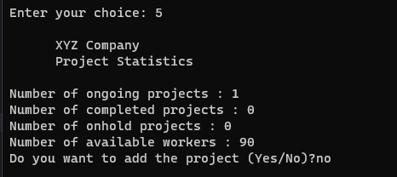

Figure

### Test 2

The following test cases are for the 5th choice (“Project Statistics”)

|  |  |  |  |  |
| --- | --- | --- | --- | --- |
| Field | Input Entered | Expected Outcome | Actual Outcome | Results |
| Add Project | “Yes” | Redirect to Choice 1 | Redirect to Choice 1 | Pass |

Figure

## Exit

### Test 1

The following test cases are for the 6th choice (“Exit”)

|  |  |  |  |  |
| --- | --- | --- | --- | --- |
| Field | Input Entered | Expected Outcome | Actual Outcome | Results |
| Choice | 6 | “Exiting Program…” | “Exiting Program…” | Pass |

Figure