

**CSCE 4613/5613: Introduction to Artificial Intelligence**

# Homework Assignment #3

**Submission Deadline**: 11:59PM, 10/22/2023

* This homework contains 3 questions. You are given a pdf file **AI_Homework3.pdf** (this one) containing the submission instructions and the questions from 1 to 3.
* **What to submit:**
  + **A single pdf file** contains your solution and your name.
  + Put all the to-be-submitted files into a folder with the name format as:

{*LASTNAME*}_{*FIRSTNAME*}_homework3

* You can discuss with your classmates, but **do not copy** each other work.

## Problem 1: Constraints Satisfaction Problem [40 pts]

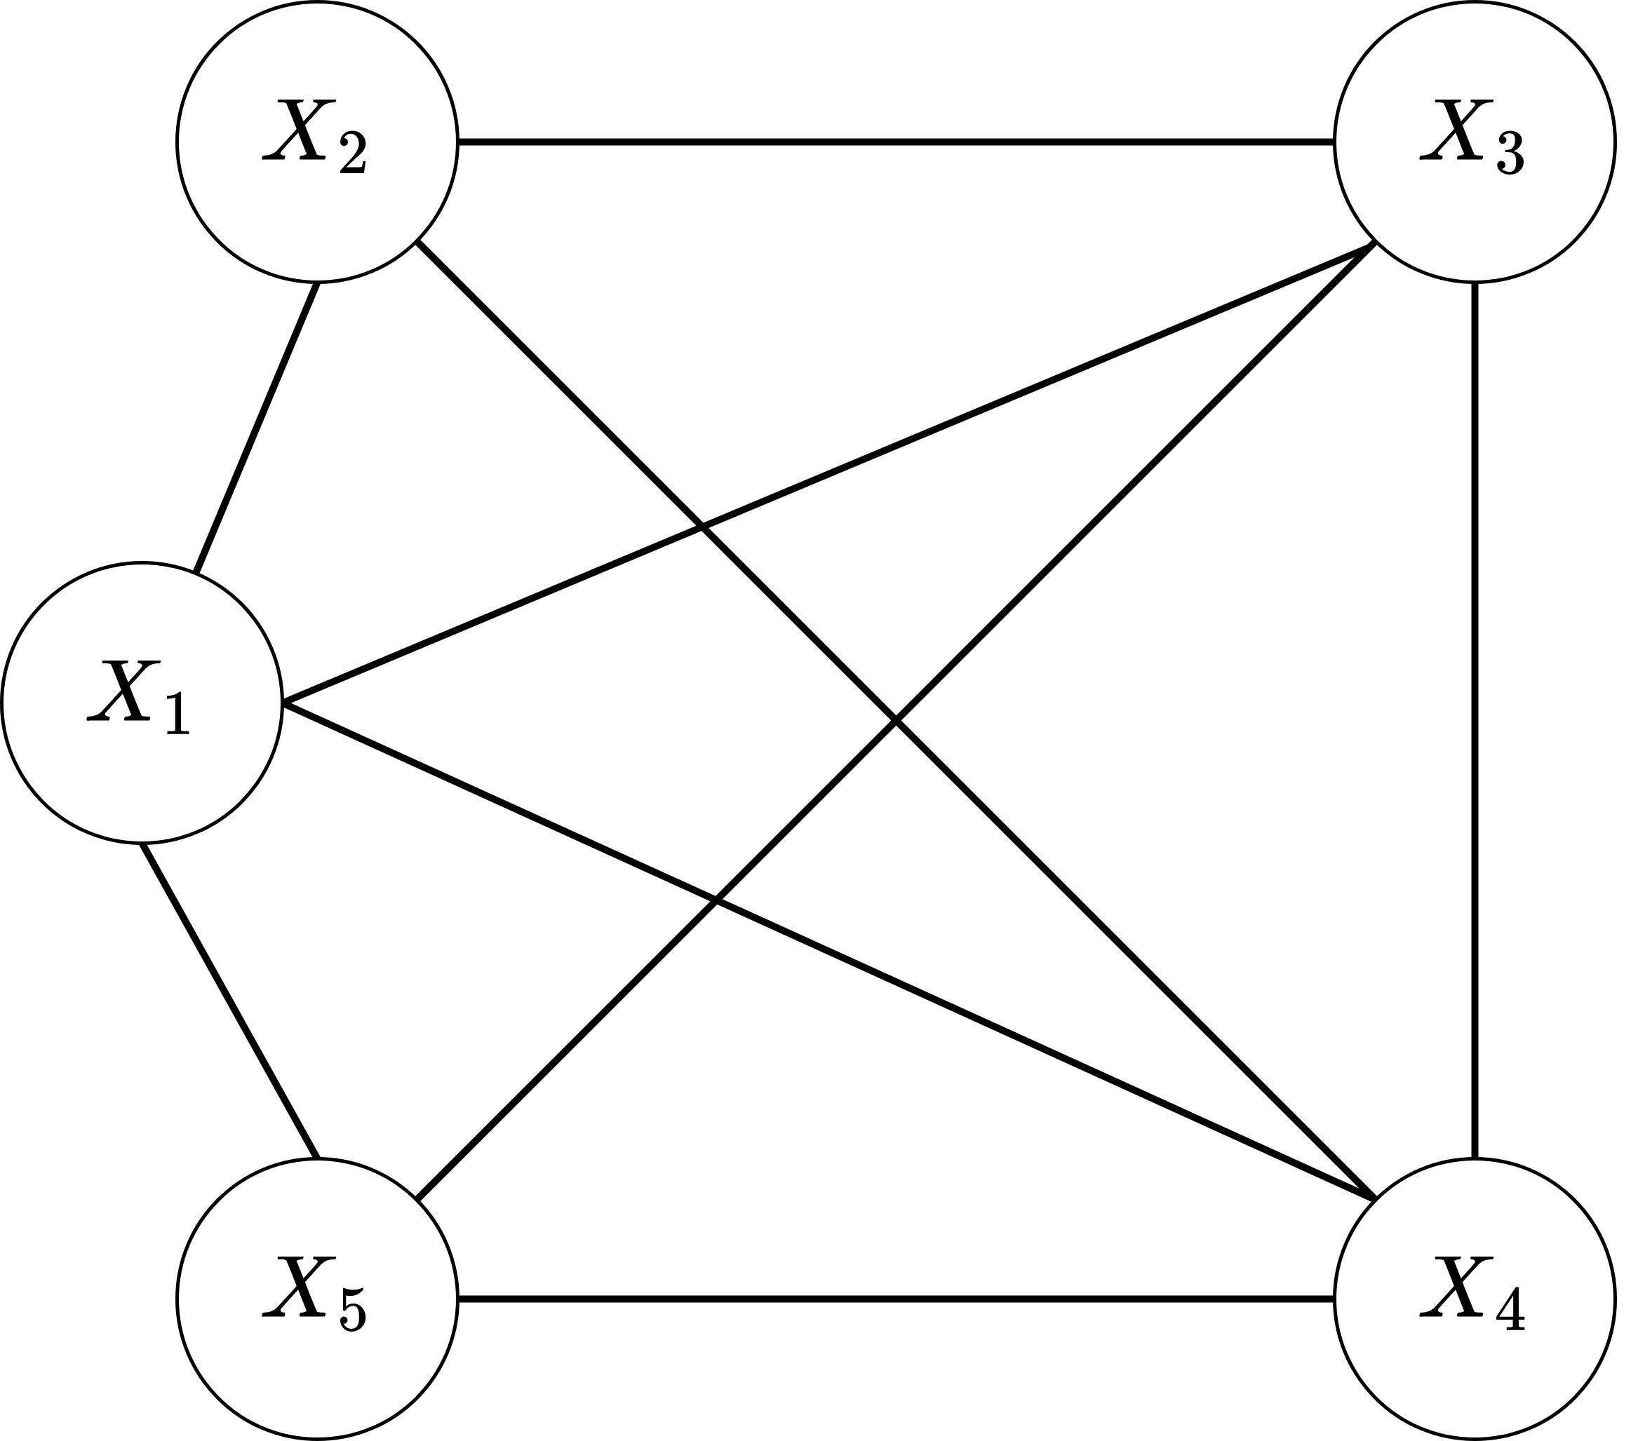

Figure 1: Constraint graph

We are given a constraint graph as can be seen in Figure 1. There are 5 variables {*Xi* : *i* ∈ [1*,*2*,*3*,*4*,*5]}.

Denote *D*(*Xi*) to be the domain of variable *Xi*.

*D*(*X*1) = [1*,*2*,*3*,*4*,*5]

*D*(*X*2) = [1*,*2*,*3*,*5]

*D*(*X*3) = [1*,*2*,*4*,*5]

*D*(*X*4) = [1*,*3*,*4*,*5]

*D*(*X*5) = [1*,*3*,*4*,*5]

Any 2 variables that are connected by an arc in the constraint graph cannot share the same value. For example, if *X*2 = 3, then *X*1*,X*3*,X*4 cannot take value 3. Denote *assign* to be the assign operation. If we are given the assignment as *assign*(*X*1 = 3*,X*5 = 4), that means *X*1 is assigned value 3 first, then *X*5 is assigned value 4, and other variables are not assigned yet.

**Questions:**

1. What are the neighbors of *X*4 on the constraint graph?
   1. The neighbors of X4 are X1,X2,X3,and X5
2. Assume we are doing backtracking with *assign*(*X*1 = 1*,X*2 = 2). If the next chosen variable is *X*4, what are the possible values *X*4 that could be assigned?
   1. Possible values are 3,4,5
3. Assume we are doing backtracking with forward checking and *assign*(*X*1 = 1*,X*2 = 2), what are the reduced domains of all the variables?
   1. Reduced Domains
      1. X3 = 4,5
      2. X4 = 3,4,5
      3. X5 = 3,4,5
4. Assume we are given the reduced domain *D*(*X*3) = [2]*,D*(*X*5) = [1], the assignment is provided as *assign*(*X*3 = 2*,X*5 = 1) as they are the only values these variables could take. If we apply the arc consistency on all arcs, what are the reduced domains of the other variables?
   1. Reduced Domains
      1. X1 = 3,4,5
      2. X2 = 1,3,5
      3. X4 = 3,4,5
5. Assume we are doing backtracking and the latest assignment is *assign*(*X*1 = 1*,X*2 = 2*,X*4 = 4*,X*5 = 5), the next chosen variable is of course *X*3, what should we do next (go back/backtrack or stop)? Why?
   1. We should backtrack. There is no valid value left for X3 with the current assignments. Therefore the current assignment cannot lead to a solution, so we must backtrack and revise previous assignments.

## Problem 2: MinMax and Alpha-Beta Pruning [20 pts]

1. (10pts) Fill in each blank trapezoid with the proper minimax search value. Process the tree from left to

right.

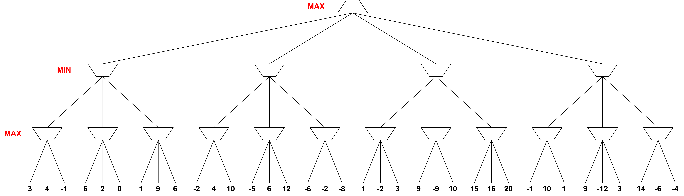

1. (10pts) Fill in each blank trapezoid and cross out the branches pruned by minimax + alpha-beta pruning.

Process the tree from left to right. What are values of *α* and *β*?



## Question 3: Pacman Finds All Food [40 pts]

In Assignment 2, we implemented searching algorithms that led Pacman to his food. In this assignment, we will lead Pacman to collect all his food. This assignment requires you to complete Assignment 2 because this will build upon that work.

|  |  |
| --- | --- |
| **Filename** | **Purpose** |
| search.py | You will implement your algorithm in this file. |
| searchAgents.py | This file will be used to call your implemented algorithms. |
| pacman.py | This file is the main program that runs the Pacman game. |
| util.py | This file consists of useful data structures. |
| game.py | This file defines how the Pacman is played. It describes supporting  types such as AgentState, Agent, Direction, and Grid. |
| graphicsDisplay.py graphicsUtils.py textDisplay.py ghostDisplay.py keyboardAgents.py layout.py | These files are used to render the Pacman game. You can ignore  these files. |

*Acknowledgement: The base code is borrowed from the Introduction to AI course of the University of California, Berkeley.*

## Format of Search Problem Class

|  |
| --- |
| # search.py class SearchProblem:  def getStartState(self): util.raiseNotDefined()  def isGoalState(self, state): util.raiseNotDefined()  def getSuccessors(self, state): util.raiseNotDefined()  def getCostOfActions(self, actions):  util.raiseNotDefined() |

The SearchProblem class is an abstract class that provides four important instance methods:

* getStartState(self): returns the start state.
* isGoalState(self, state): returns true if the state is a destination.
* getSuccessors(self, state): return all successors of the given state. This function will a list of successors where each element is a tuple of next state, action, and cost.
* getCostOfActions(self, actions): returns the total cost when Pacman executes actions.

Since this is an abstract class, you are NOT allowed to modify or implement this class. In addition, you are free to define the “state” concept. It can be a position, or even any additional information that you think it’s needed. You should read the PositionSearchProblem class in the searchAgent.py script to understand the example of a search problem and how to define four instance methods.

## Finding All Corners [20 pts]

Now, you have already had searching algorithms implemented in the second assignment. In this section, you will implement a search problem, specifically, CornersProblem in the searchAgent.py script.

|  |
| --- |
| class CornersProblem(search.SearchProblem):  def __init__(self, startingGameState):  self.walls = startingGameState.getWalls()  self.startingPosition = startingGameState.getPacmanPosition() top, right = self.walls.height-2, self.walls.width-2 self.corners = ((1,1), (1,top), (right, 1), (right, top)) for corner in self.corners:  if not startingGameState.hasFood(*corner):  print 'Warning:␣no␣food␣in␣corner␣' + str(corner)  self._expanded = 0  "***␣YOUR␣CODE␣HERE␣***" def getStartState(self): "***␣YOUR␣CODE␣HERE␣***" util.raiseNotDefined()  def isGoalState(self, state): "***␣YOUR␣CODE␣HERE␣***" util.raiseNotDefined()  def getSuccessors(self, state): "***␣YOUR␣CODE␣HERE␣***" util.raiseNotDefined()  self._expanded += 1 # DO NOT CHANGE return successors  def getCostOfActions(self, actions):  "***␣YOUR␣CODE␣HERE␣***" util.raiseNotDefined() |

The init(self, startingGameState) will initialize the information for the game, i.e., walls, a starting position, and four corners that contain food. You are free to define any additional information. The goal state is a state so that food at four corners has already been collected by Pacman. Now, your task is implementing four instance methods mentioned in Section 1. You can test your implementation by the command as follows.

python pacman.py -l tinyCorners -p SearchAgent -a fn=bfs,prob=CornersProblem python pacman.py -l mediumCorners -p SearchAgent -a fn=bfs,prob=CornersProblem

## Corners Heuristic [15 points]

In the corners problem, the A* searching algorithm will illustrate its performance when we choose the correct heuristic. In this section, you will implement a cornersHeuristic function in the searchAgent.py script that returns the estimated cost from the current state to the final states.

|  |
| --- |
| def cornersHeuristic(state, problem):  """  state: Your current search state problem: The CornersProblem instance for this layout.  This function should always return a number that is a lower bound on the shortest path from the state to a goal of the problem;  """  corners = problem.corners # These are the corner coordinates  walls = problem.walls # These are the walls of the maze, as a Grid (game.py  "***␣YOUR␣CODE␣HERE␣***"  return 0 # Default to trivial solution |

The grade of this section will be calculated based on how your optimal heuristic is. In particular, we will consider the number of nodes expanded:

More than 2000 nodes: 0%

From 1501 to 2000 nodes: 50%

At most 1500 nodes: 100%

You can test your heuristic by the command as follows.

python pacman.py -l mediumCorners -p SearchAgent -a \ fn=aStarSearch,prob=CornersProblem,heuristic=cornersHeuristic

Note: It may take a few seconds (or a few mins) to run the algorithm, please be patient when you don’t see your Pacman.

## Eating All Food [5 points])

You have already led Pacman to collect his food in four corners. Now, we will do a similar problem but a harder version. In this section, we will let Pacman collect all his food in the maze. The food may be located everywhere in the maze. For this problem, we will use FoodSearchProblem already implemented in

|  |  |
| --- | --- |
| **Number of Nodes Expanded** | **Grade** |
| More than 17000 nodes | 25% |
| From 12001 to 17000 nodes | 50% |
| At most 12000 nodes | 100% |
| At most 7000 nodes | +10% (Bonus grade) |

the searchAgent.py script. We will find a list of actions that leads Pacman to collect all his food. Your task is to implement a foodHeuristic function that returns a lower bound on the actual shortest path cost to the final state.

|  |
| --- |
| def foodHeuristic(state, problem):  position, foodGrid = state "***␣YOUR␣CODE␣HERE␣***" return 0 |

This function receives two arguments state and problem. State is a tuple including Pacman position and food grid (Grid data structure is in game.py). Problem is a FoodSearchProblem instance. Interestingly, if your solution in the previous section (your cornersHeuristic function) is an optimal and general solution. You can reuse corner heuristic for this food heuristic. Therefore, you try to implement your cornersHeuristic function as optimal as possible. The grade of this section will be calculated based on the number of nodes expanded.

You can test your heuristic by the command as follows.

|  |
| --- |
| python pacman.py -l trickySearch -p SearchAgent \  -a fn=astar,prob=FoodSearchProblem,heuristic=foodHeuristic |

Note: It may take a few seconds (or a few mins) to run the algorithm, please be patient when you don’t see your Pacman.