CSCE 47503 Computer Networks – Wireshark Introduction

Name: Blake Williams

ID: 010974718

20 points

4 questions (some of them are required screenshots)

# Instructions

* Type your work, print it to a single PDF, and upload it to Blackboard before the due date and time. It is strongly suggested that you use the given document.
* Show all of your work. Correct answers alone may not carry full credit without proper justification and details of steps.
* -2 points if you do not insert your name and ID at the top of the document.
* -5 points if it is not typed or legible. For this homework, you may scan it with something like the CamScanner app, but just make sure it is a legible PDF.
* -5 points if it is not a PDF file.
* -5 points if it is not a single PDF file. Submit one PDF file. Do not submit zip files containing one or more files.
* -5 points if you present the worked problems out of order. In other words, please show the problems in the order assigned, 1, 2, 3, …

**What to hand in**

The goal of this first lab was primarily to introduce you to Wireshark. The following questions will demonstrate that you’ve been able to get Wireshark up and running and have explored some of its capabilities. Answer the following questions based on your Wireshark experimentation:

1. (5 pts.) List five protocols appearing in the protocol column in the unfiltered packet-listing window in step 7 above. **Please attach a screenshot to your report**.

TCP, MDNS, ARP,DNS, and IGMPv2

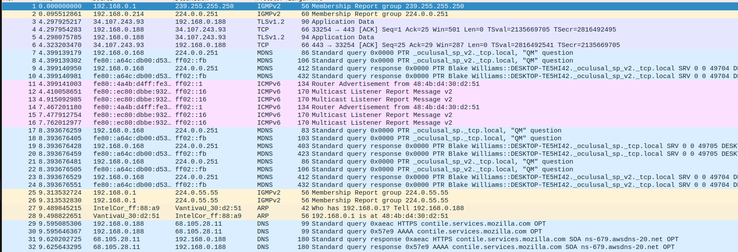

1. (5 pts.) How long did it take from when the HTTP GET message was sent until the HTTP OK reply was received? (By default, the Time column value in the packet-listing window is the amount of time, in seconds, since Wireshark tracing began. To display the Time field in time-of-day format, select the Wireshark *View* pull-down menu, select Time *Display Format*, then choose *Time-of-day*.) **Please attach a screenshot to your report**.

 According to the image it took 0.068 seconds for the HTTP OK was received.

1. (5 pts.) What is the Internet address of the ***gaia.cs.umass.edu***? What is the Internet address of your computer? **Please attach a screenshot to your report.**

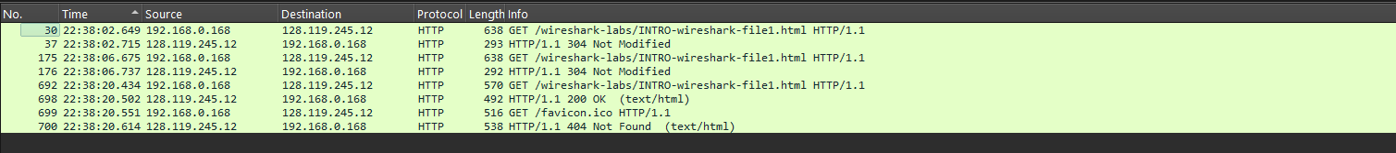 According to the screenshot the address of gaia.cs.unmass.edu was 128.119.245.12 while my computers address is 192.168.0.168

1. (5 pts.) Print the two HTTP messages (GET and OK) in question 2 above. To do so, select *Print* from the Wireshark *File* command menu, select the “*Selected Packet Only”* and *“Print as displayed”* radial buttons, and then click OK.

