Computer Networks Homework

Network Layer

Name: Max Thursby

ID: 010967047

35 points

**Instructions**

* Type your work, print it to a **single** PDF, and upload it to Blackboard before the due date and time. It is strongly suggested that you use the given document.
* Show all of your work. Correct answers alone may not carry full credit without proper justification and details of steps.
* -2 points if you do not insert your name and ID at the top of the document.
* -5 points if it is not typed.
* -5 points if it is not a PDF file.
* -5 points if it is not a single PDF file. Submit one PDF file. Do not submit zip files containing one or more files.
* -5 points if you present the worked problems out of order. In other words, please present the problems in the order assigned, 1, 2, 3, …

1. Consider the IP address 10.2.3.147 with network mask 255.255.255.240.
   * + - mask – 11111111.11111111.11111111.11110000
   1. (3 pts.) What is the subnet number?

- 00001010.00000010.00000011.10010000 : 10.2.3.144

* 1. (3 pts.) What is the directed broadcast address of the network?

- 00001010.00000010.00000011.10011111 : 10.2.3.159

1. An output port of a router maintains two queues of different classes, namely A and B. The queues have unlimited buffer space. Suppose seven packets arrive at this port, and their <packet identifier, time of arrival (second), class> are as follows:

<1, 0, A>, <2, 1, A>, <3, 1, B>, <4, 2, A>, <5, 2, B>, <6, 4, B>, <7, 5, A>

Suppose transmitting each packet to the next hop router takes one second.

1. (3 pts.) When the scheduling algorithm is FIFO, give the order of the seven packets being scheduled for transmission (for conciseness, only use the packet identifiers 1, 2, …, 7).

- 1, 2, 3, 4, 5, 6, 7

1. (3 pts.) Suppose the scheduling algorithm is Priority Scheduling, and A has higher priority than B. Give the order of packets being scheduled for transmission (for conciseness, only use the packet identifiers 1, 2, …, 7).

- 1, 2, 4, 3, 5, 7, 6

1. (3 pts.) Suppose Weighted Fair Queuing is the scheduling algorithm. A gets 2/3 of the service time, B has 1/3 of the service time, and the scheduling starts from queue A.

1, 2, 3, 4, 5, 7, 6

1. Suppose the host 10.0.0.2 sends a request packet to the external server 100.100.100.100 at service port 443; the host uses 2000 as its local port, and the router uses port 6000 as the WAN side port for this packet.

1. (2 pt.) Write the NAT Translation Table entry for this host.

|  |  |
| --- | --- |
| WAN side addr <IP, Port> | LAN side addr <IP, Port> |
| <138.76.29.7, 6000> | <10.0.0.2, 2000> |

1. (2 pts.) What is the <source IP, source port, destination IP, destination port> of the request transmitted from the host 10.0.0.2 to the router? And from the router to the external network?

- <10.0.0.2, 2000, 100.100.100.100, 443>

- <138.76.29.7, 6000, 100.100.100.100, 443>

1. (2 pts.) What is the <source IP, source port, destination IP, destination port> of the response transmitted from the external network to the router? And from the router to the host 10.0.0.2?

- <100.100.100.100, 443, 138.76.29.7, 6000>

- <100.100.100.100, 443, 10.0.0.2, 2000>

1. (a) (8 pts.) Show how the **link-state** algorithm builds the routing table for router A in AS 38 in the following network. (Hint: refer to the lecture slides of chapter 5)

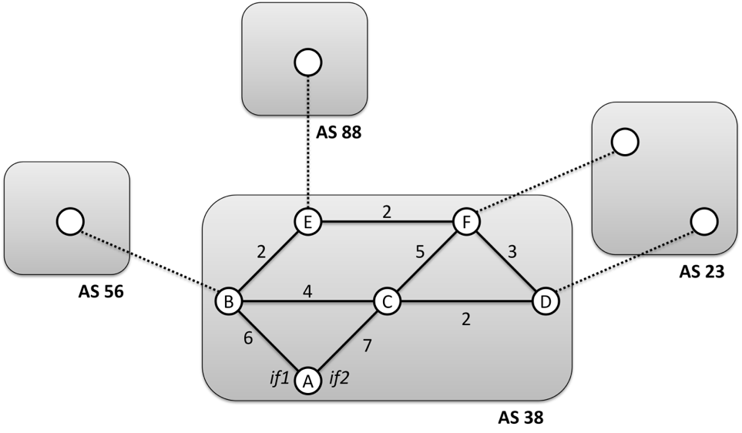

Notation:

* D(v): the current value of the cost of the path from source to destination v
* p(v): predecessor node along the path from source to v
* N': a set of nodes whose least cost path is definitively known

|  |  |  |  |  |  |  |
| --- | --- | --- | --- | --- | --- | --- |
| **Step** | **N'** | **D(b), p(b)** | **D(c), p(c)** | **D(d), p(d)** | **D(e), p(e)** | **D(f), p(f)** |
| 0 | a | 6,a | 7,a | ∞ | ∞ | ∞ |
| 1 | ab | x | 7,a | ∞ | 8,b | ∞ |
| 2 | abc |  | x | 9,c | 8,b | 12,c |
| 3 | abce |  |  | 9,c | x | 10,e |
| 4 | abced |  |  | x |  | 10,e |
| 5 | abcedf |  |  |  |  | x |

1. (6 pts.) Suppose that the gateway routers of AS 38 receive the following BGP advertisements from their BGP peers:

|  |  |
| --- | --- |
| **Network** | **AS Path** |

|  |  |
| --- | --- |
| **AS 56** | |
| 1.2.3.0/24 | 56 83 99 |
| 1.3.8.0/23 | 56 75 |
| 1.4.8.5/24 | 56 97 |

|  |  |
| --- | --- |
| **AS 88** | |
| 2.3.0.0/16 | 88 107 56 23 |
| 1.4.8.4/24 | 88 62 103 |

|  |  |
| --- | --- |
| **AS 23** | |
| 1.2.3.0/24 | 23 99 |
| 7.12.0.0/16 | 23 99 117 |

Show the routing table formed due to these advertisements in router A. Assume no routes are rejected due to local policy rules. Represent the routing table in this form:

|  |  |
| --- | --- |
| **Network** | **Interface** |
| 1.2.3.0/24 | if1 |
| 1.3.8.0/23 | if1 |
| 1.4.8.5/24 | if1 |
| 1.4.8.4/24 | if1 |
| 7.12.0.0/16 | if2 |
| 2.3.0.0/16 | if1 |