Balanced binary search trees – Sowmya Rajkumar 3/21/2025
- Binary search tree - sorted binary tree
- For unbalanced binary search trees worst case insertion/deletion/search time is O(N)

AVL tree – balanced binary search tree

- Balance = Height(left subtree) – Height (right subtree)
- Find balance and height for programming recursively starting from leaf node to root node.
- Important formula
  - Height(null node or no nodes) = -1, H(0) = -1
  - Height (1 node) = 0, H(1) = 0
  - Height of any subtree or node = maximum [H(left subtree), H(right subtree)] + 1

- If balance = 1 or balance =0 TREE IS BALANCED.
- If balance is negative, tree is right heavy or called right leaning tree
- If balance is positive, tree is left heavy or called left leaning tree
- Notation – mnemonic - for single rotations the rotation is named after how the tree leans
  - RR – single left rotation
  - LR – single left rotation followed by a single right rotation
  - LL – single right rotation
  - RL - single right rotation followed by a single left rotation

- If balance > 1 i.e unbalanced left leaning , type line, tree needs a single right or LL rotation (confusing I know)
- If balance >1 i.e unbalanced left leaning, type triangle or zig zag, tree needs LR rotation
- If balance < -1 i.e unbalanced right leaning, type line, tree needs a single left or RR rotation
- If balance < -1 i.e unbalanced right leaning, type triangle or zig zag, tree needs RL rotation
- AVL trees min-max height
minimum height² is easy, fill each level of the tree with nodes until you run out of nodes, height is the minimum.
To find the maximum, do the same as for the minimum, but then go back one step (remove the last placed node) and see if adding that node to the opposite sub-tree (from where it just was) violates the AVL tree property. If it does, your max height is just your min height. Otherwise this new height (which should be min height+1) is your max height.
Formula as an FYI - Given n nodes³:
Minimum: ceil(log₂(n+1))
Maximum: floor(1.44*log₂(n+2)-.328)

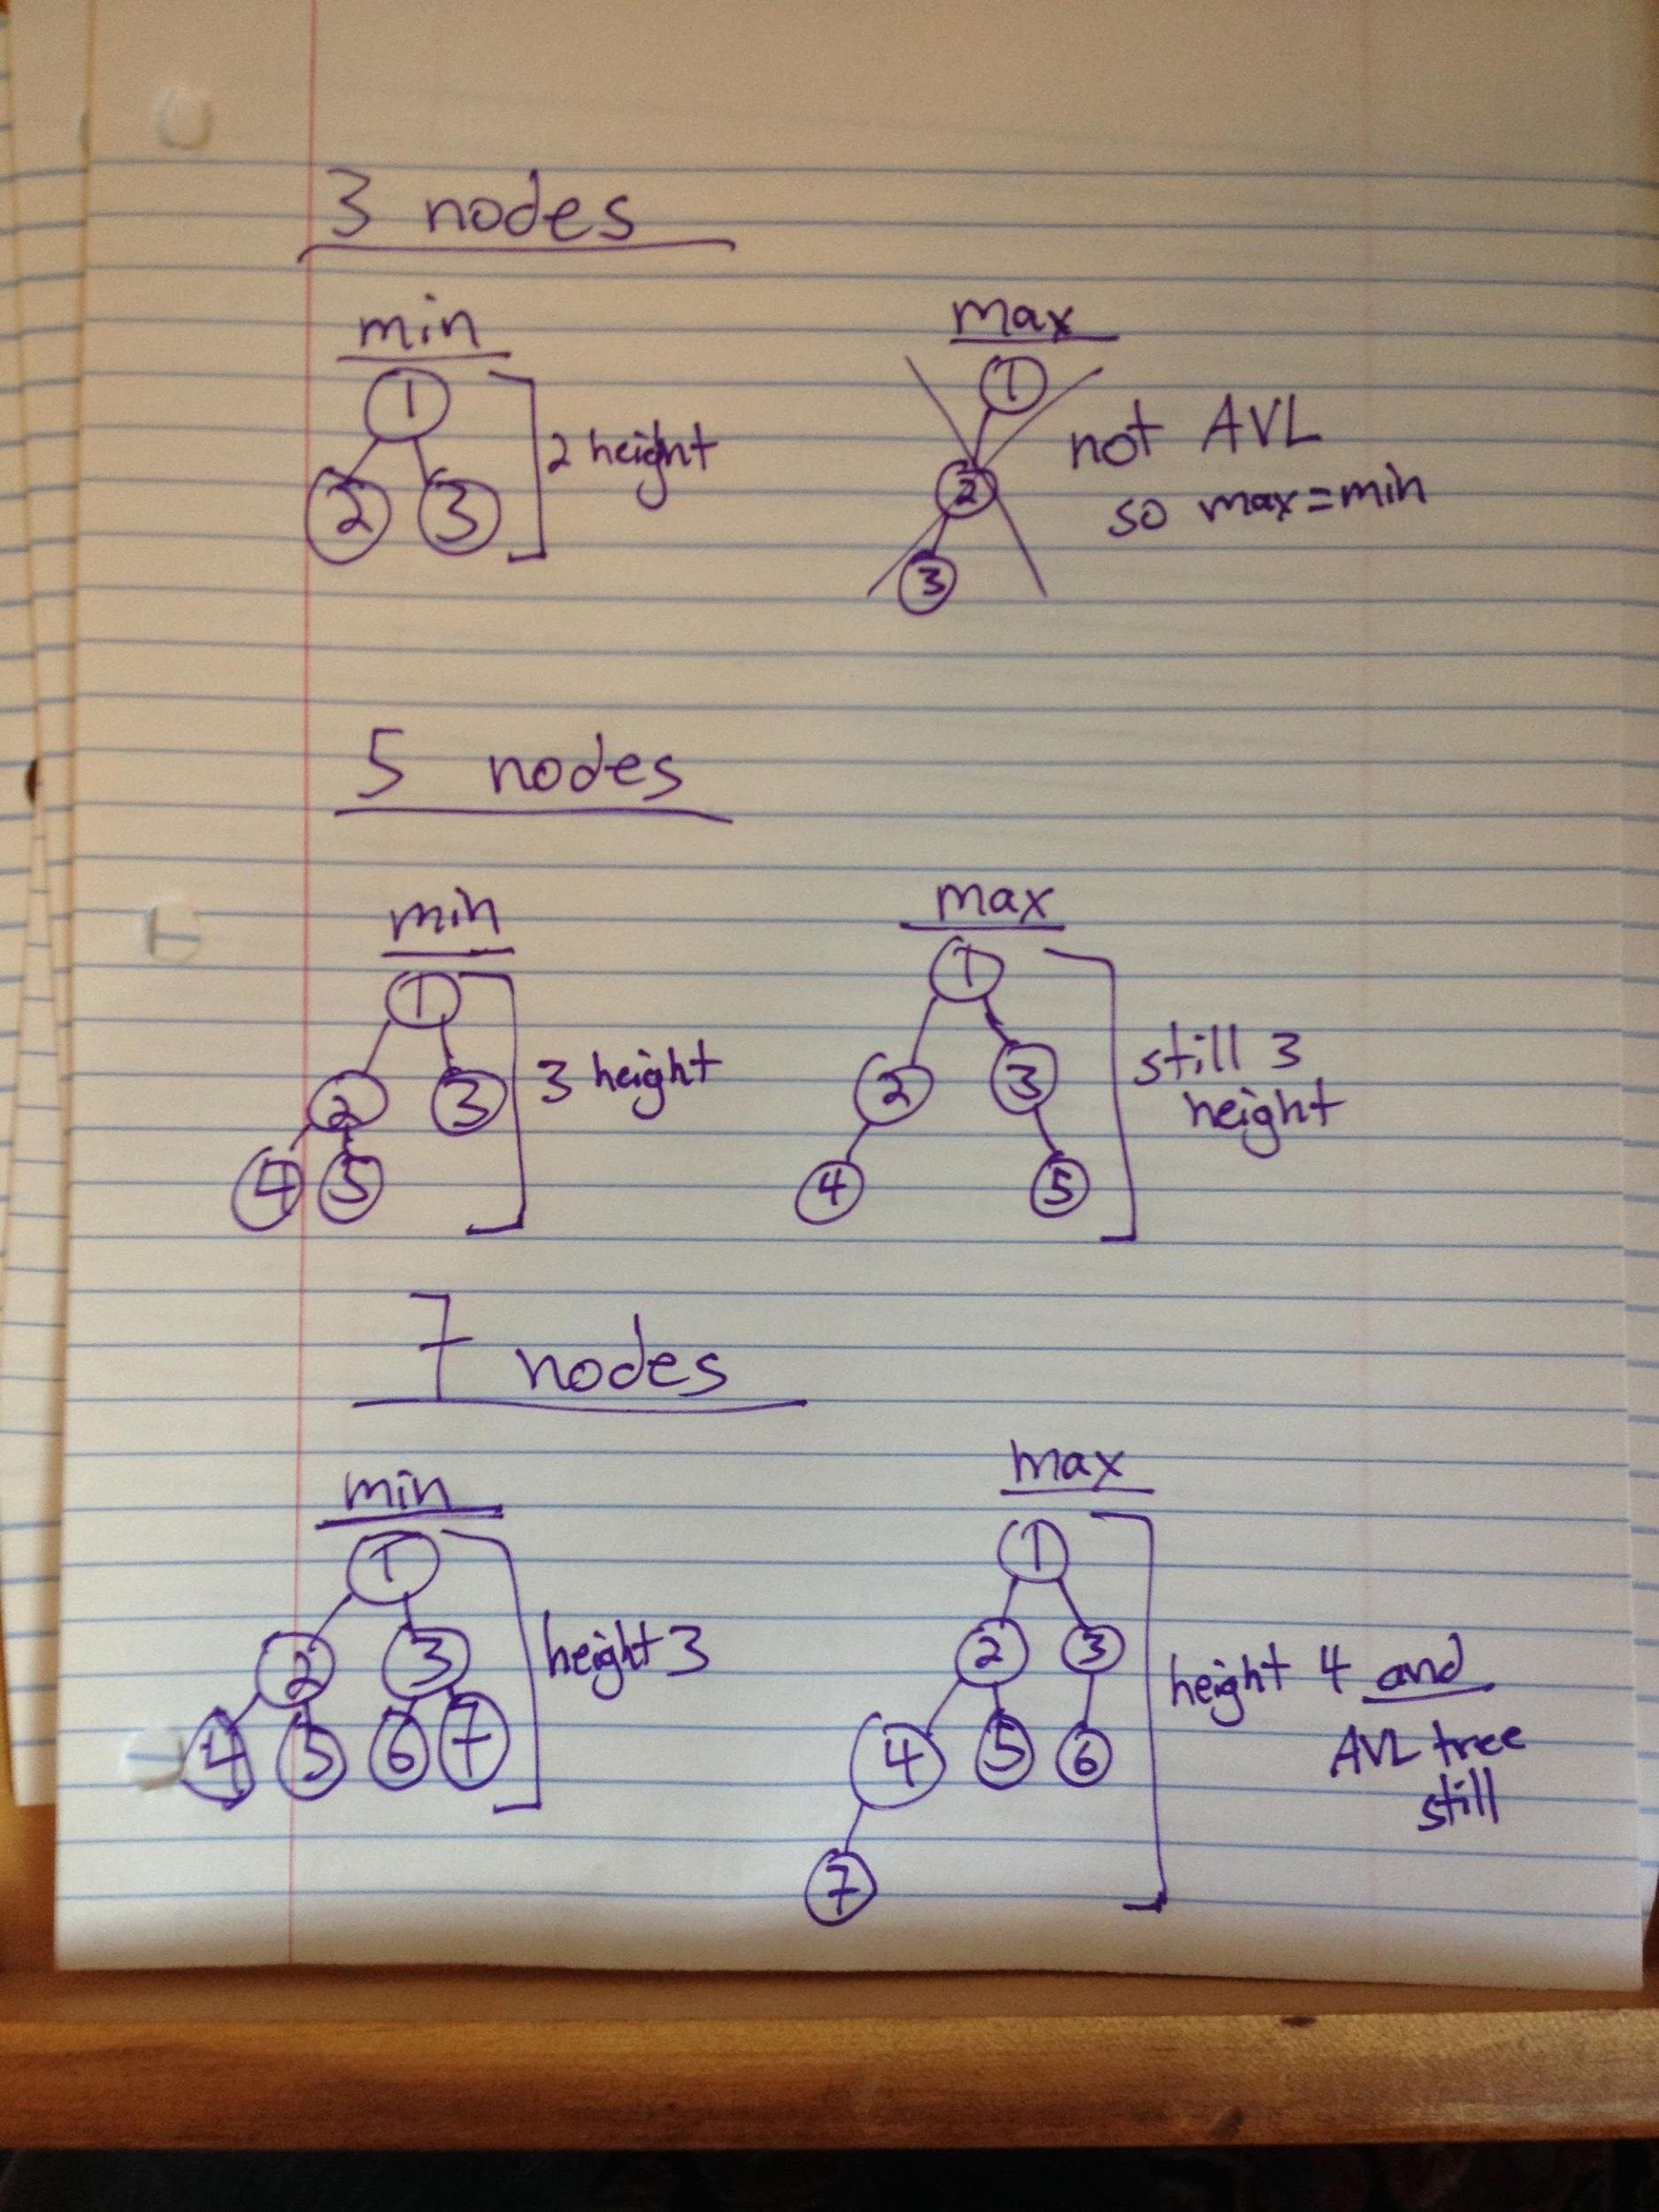

  - Height = min height, when balance = 0 is log₂(n)
  - Height = max height, when balance = 1 or -1, log₂(n)+1

- Cons - AVL trees require many rotations to keep them balanced or for O(log N) for insertion, deletion and search.

Balanced AVL tree

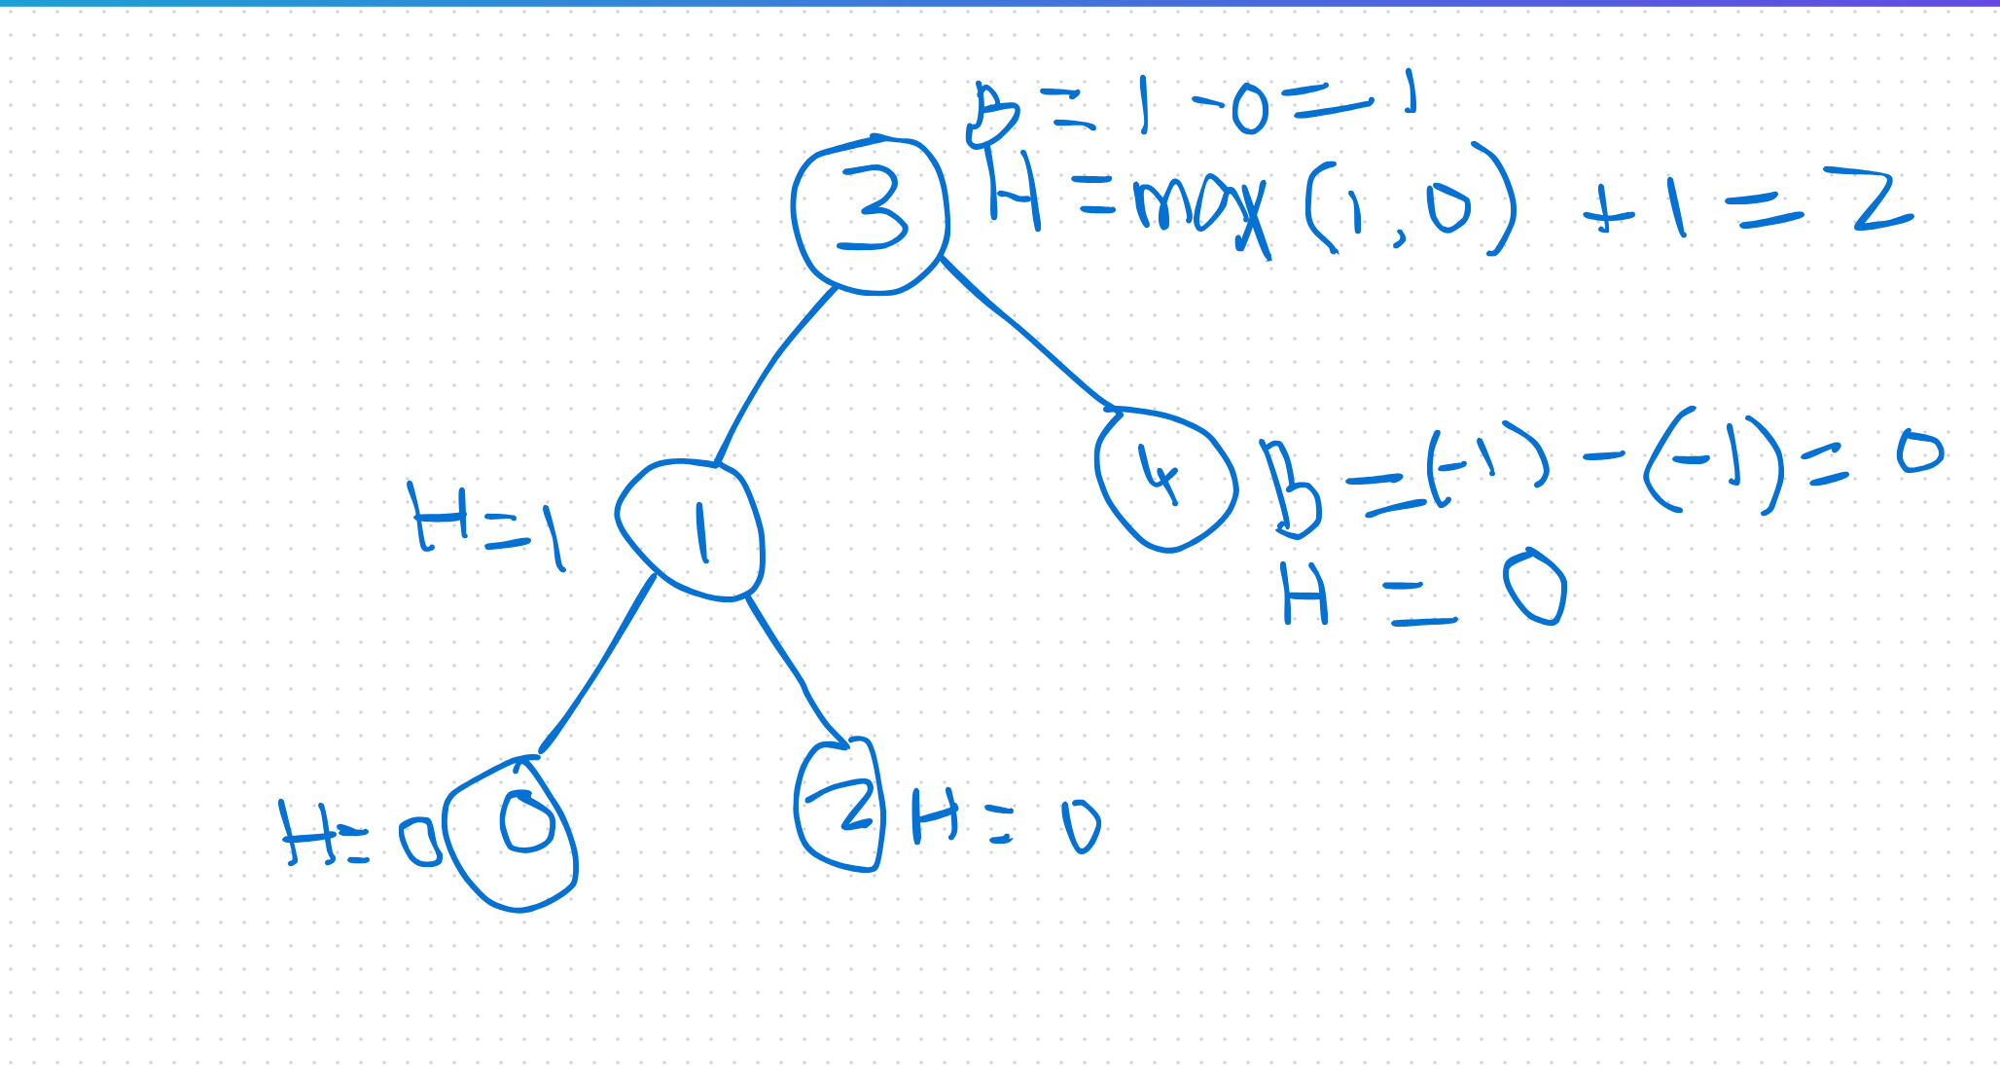

Right rotation example - simple
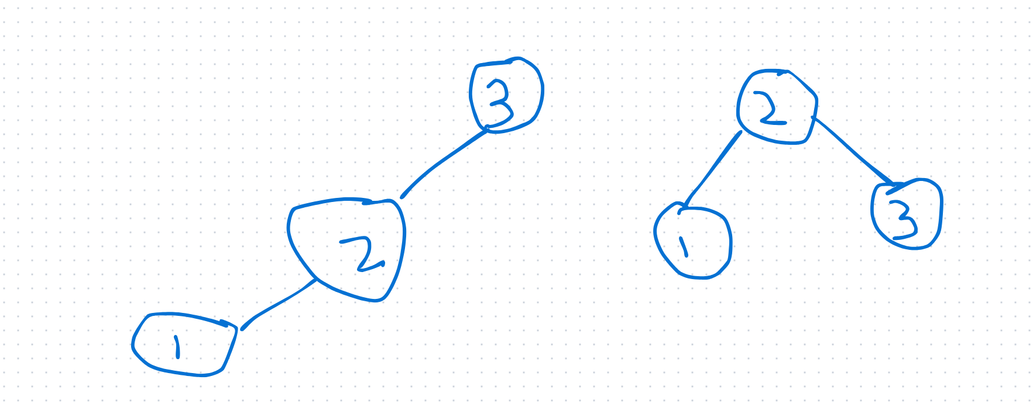

1 is always a child of 2, left most and right most parent-child relationship stays the same

Right rotation when the node has a right side branch
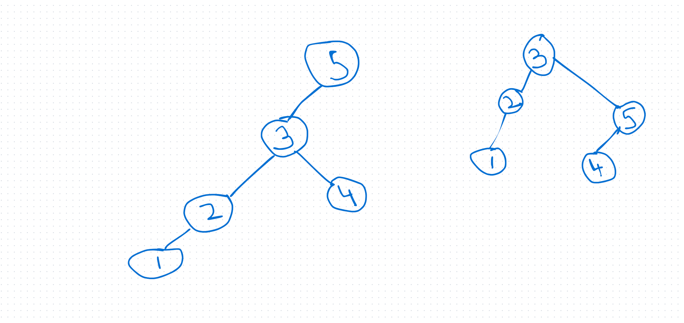
1 is always a child 2, and 2 always a child of 3.

Left right rotation for a left leaning tree
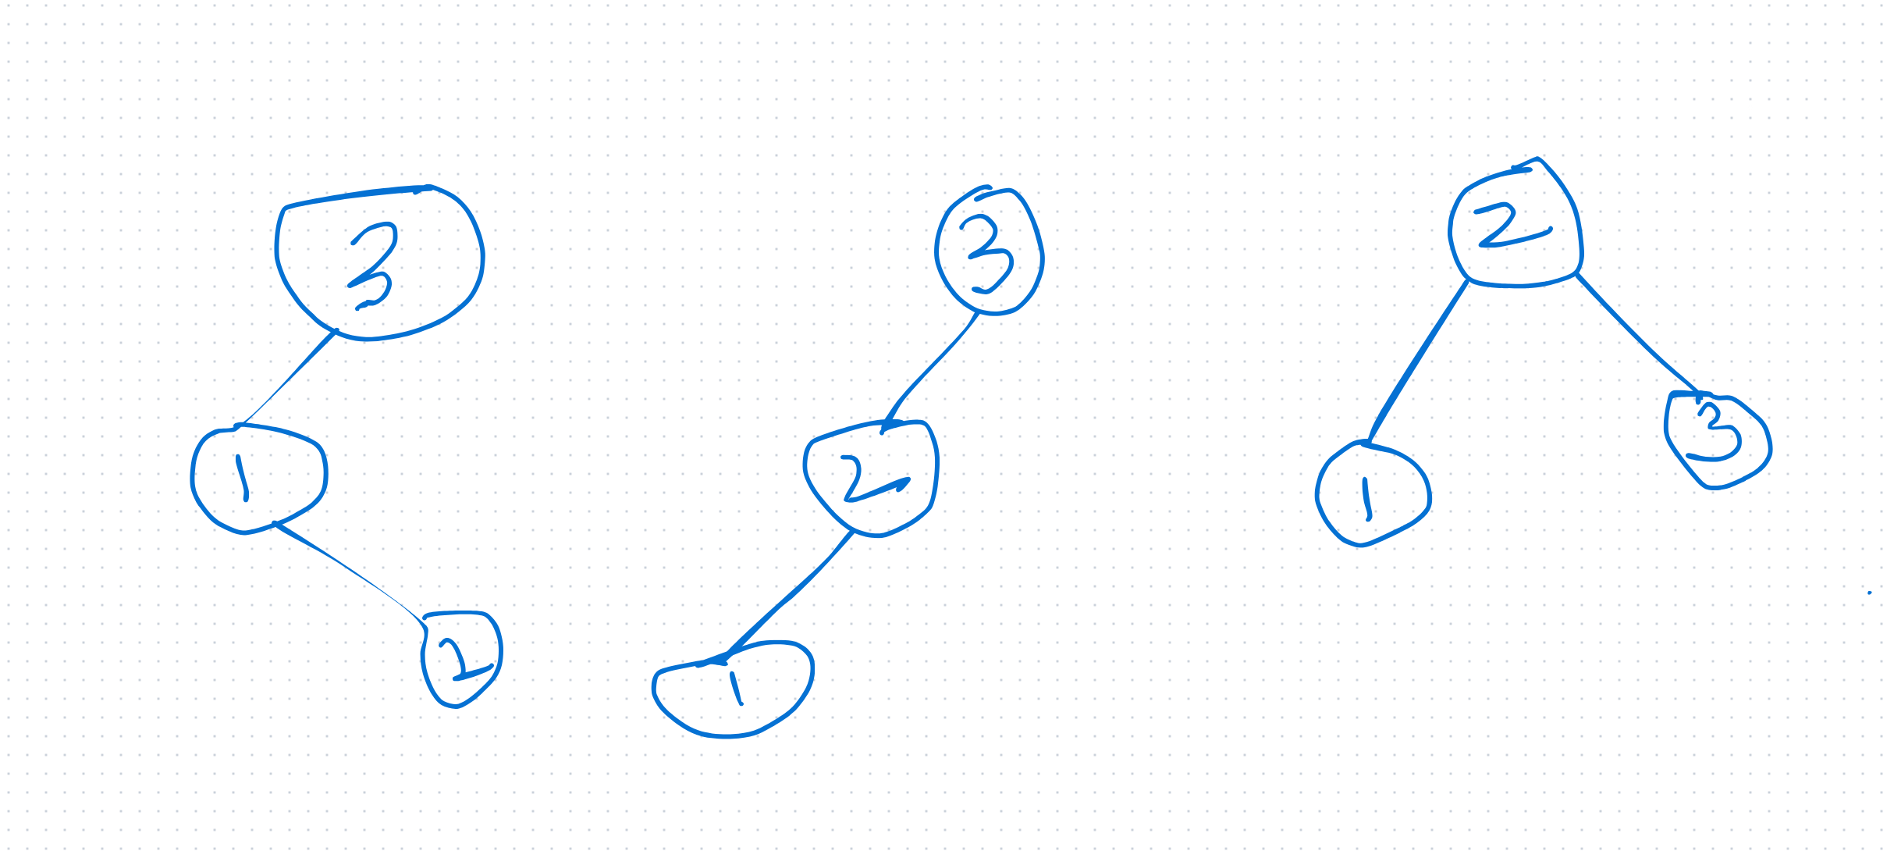

Right leaning or right heavy requiring left rotation called RR
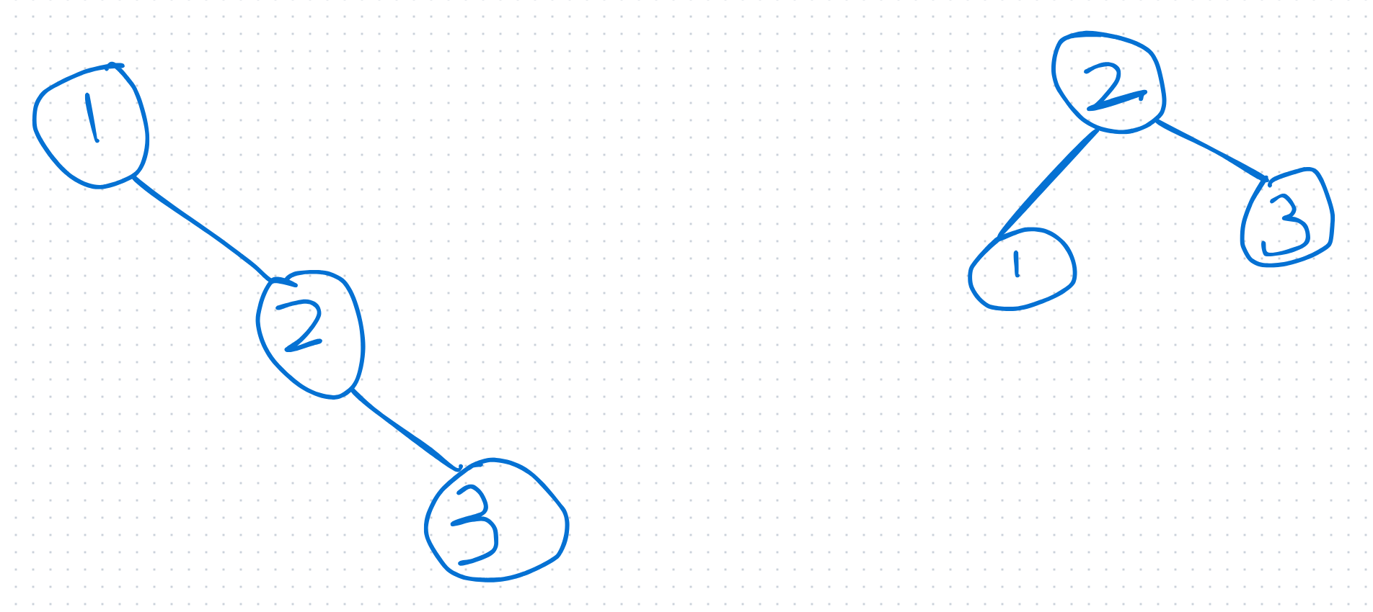

Right left Rotation

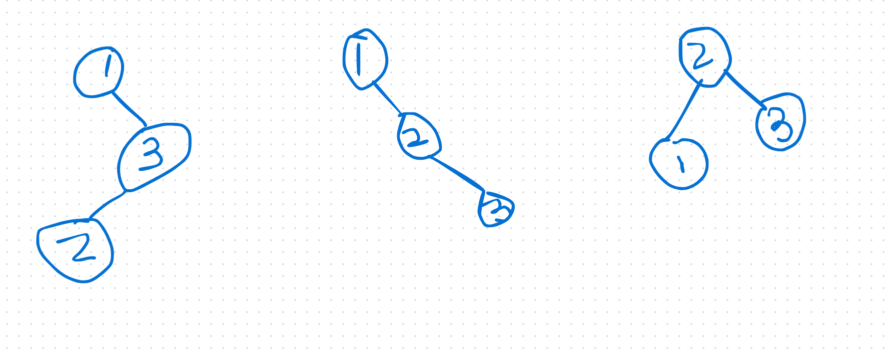

To delete a node from an AVL tree
- Go the node with the key value
- If the node is a leaf node, simply delete and check balance of the tree
- If the node has left child only which is a leaf, delete the node, move the left child to the deleted node’s place
- If the node has right child only which is a leaf, delete the node, move the right child to the deleted node’s place
- If the node has both a left and right subtree find the inorder successor which is the smallest value that is greater than the node’s value and delete the node and move the successor there.
Remove 60 below
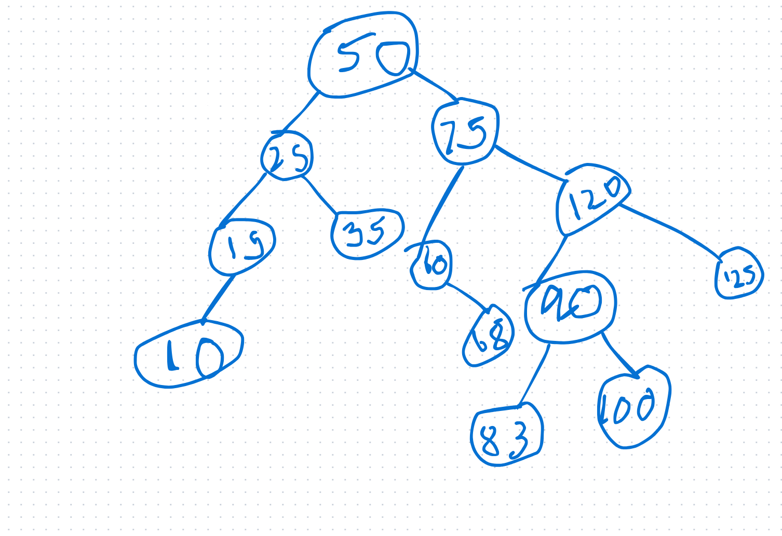

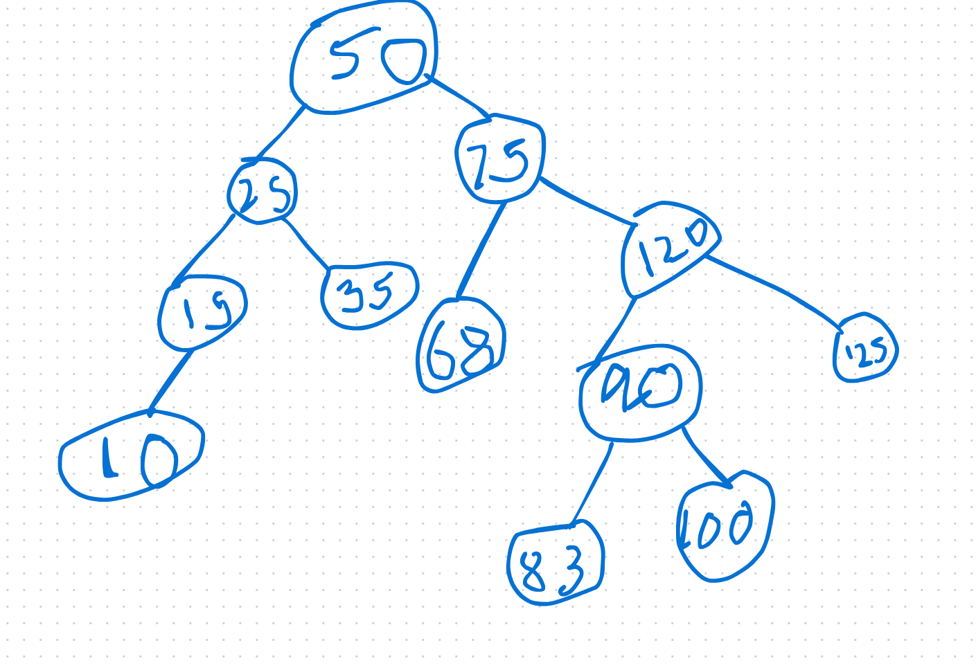

Remove 120
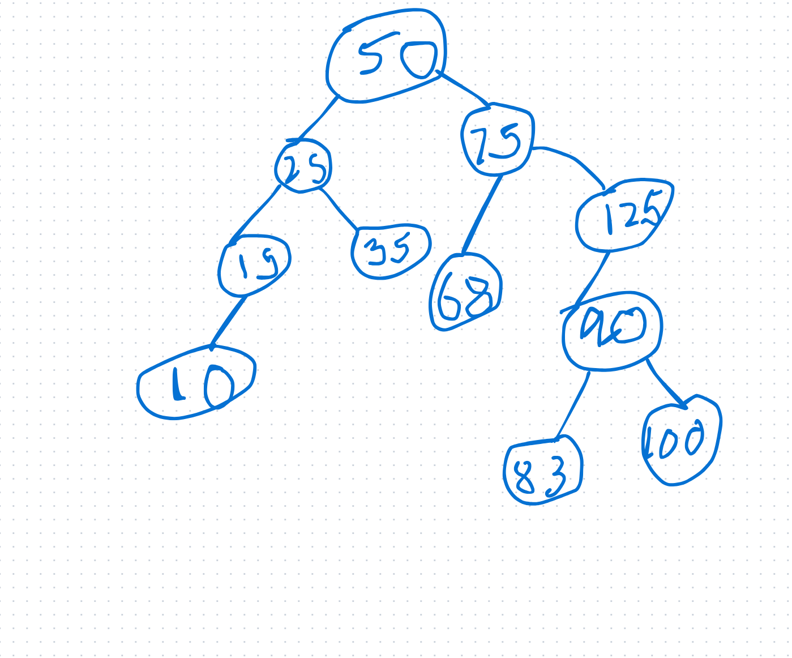

Red-black trees are balanced trees
- Pros – Require fewer rotations than AVL trees, sometimes require only re-coloring of nodes.
- A node is either red or black
- The root and leaves are black.
- Leaves are NIL nodes
- When a node has no children, it has two NIL leaves.
- A red node will always have black children
- All paths from a node to its nil descendants contain the same number of black nodes.
- Black height of a red-black tree – number of black nodes from the root to any NIL node excluding the root node.
- Maximum height of any RB tree 2*log(n+1)
- Memory – just one storage bit to keep track of color, so memory storage is O(n)
- Because of RB constraints
  - Shortest path has all black nodes
  - Longest path has alternating black and red nodes
  - Longest path is no more than twice the shortest path.
- Insert 3,1,5,7,6, 8, 9, 10
  - Root should be black
  - Always insert new nodes in red

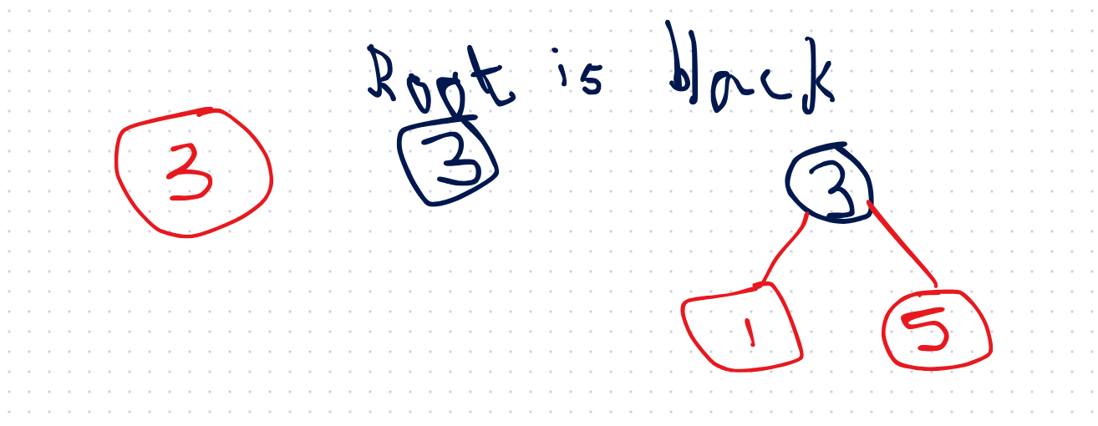
- This is not an RB tree because a red node has a red child.
- To fix the error look at the aunt/uncle of the new node. Parent of 7 is 5, grandparent is 3, aunt/uncle is 1, aunt is red
- When the aunt is red, to fix an issue re-color the node’s parent, grand-parent and uncle.
- But the root can never be red, so re-color the root, make it black.

Example 1
-------------
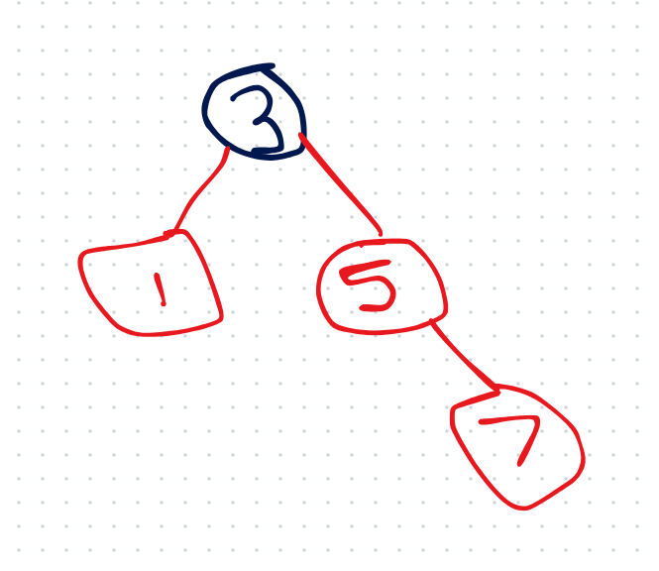

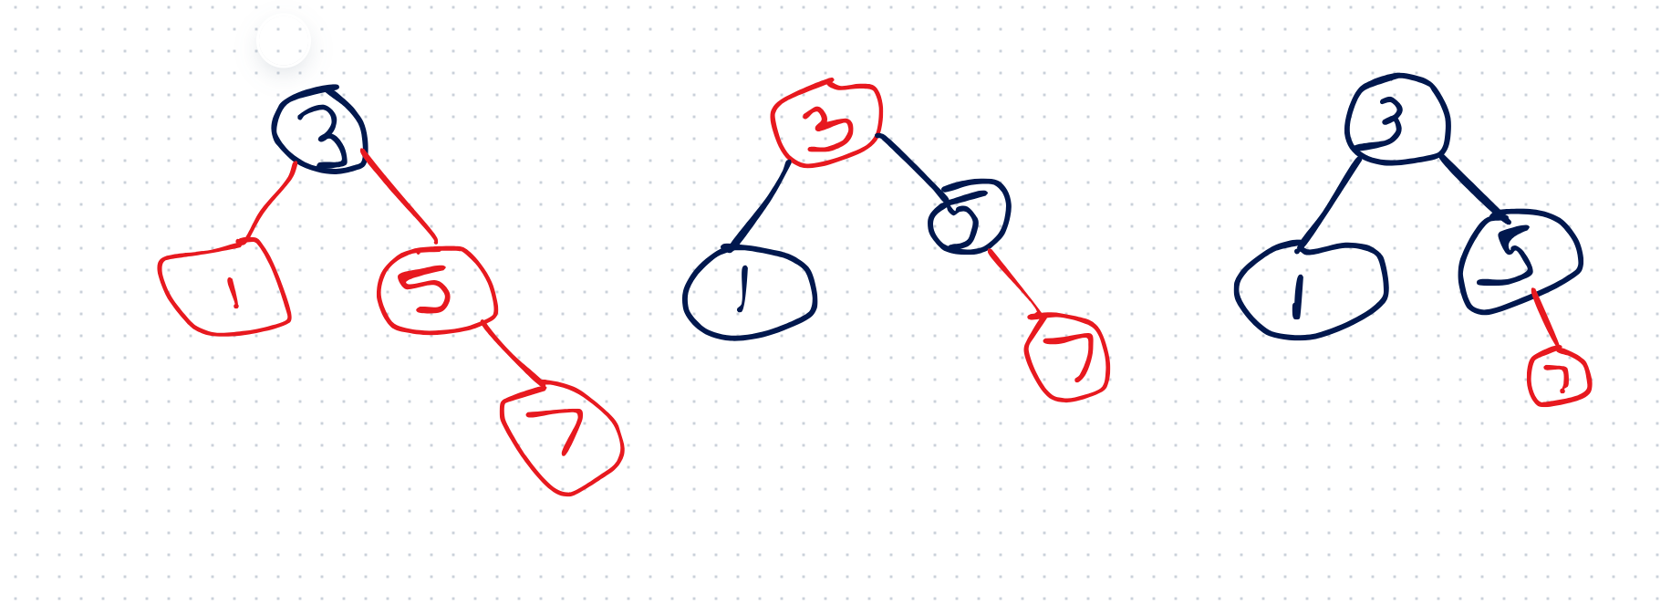

Example 2
-------------
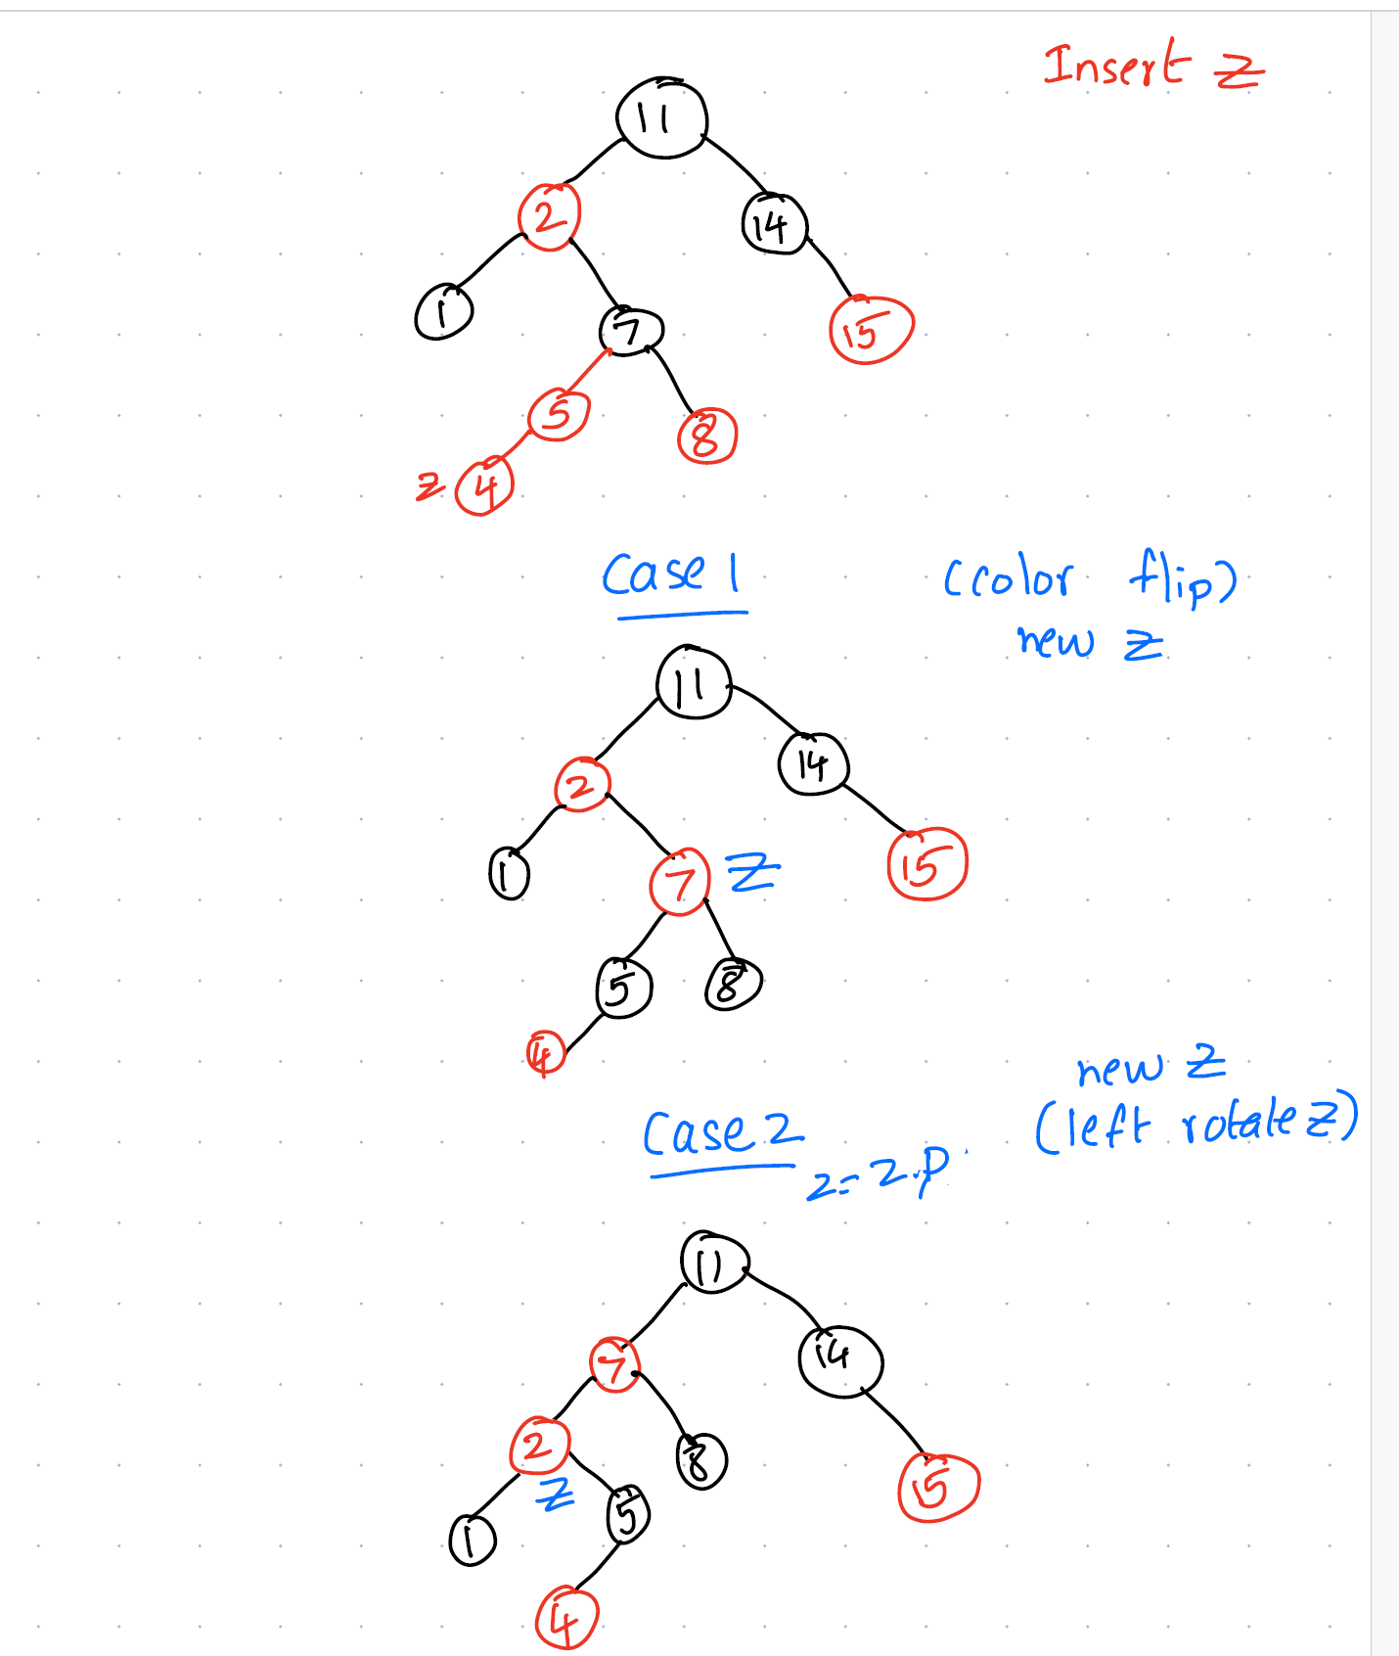

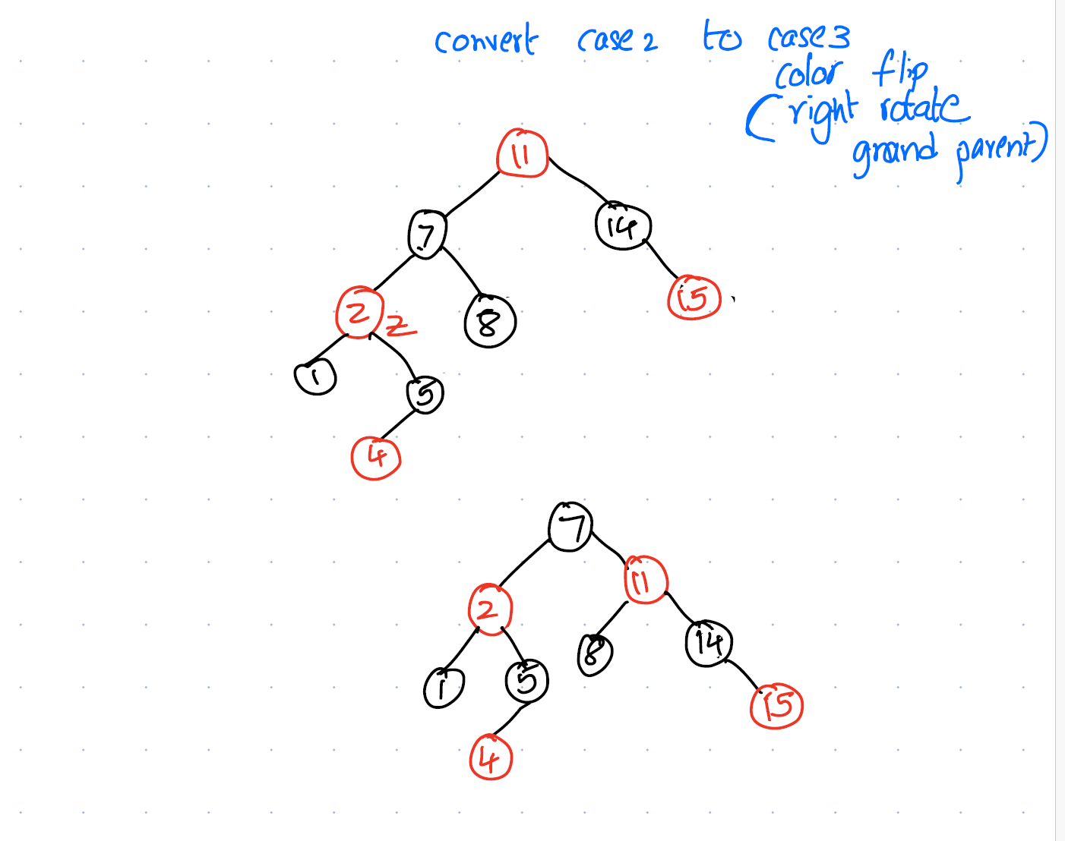

Pseudo code for RB tree insert
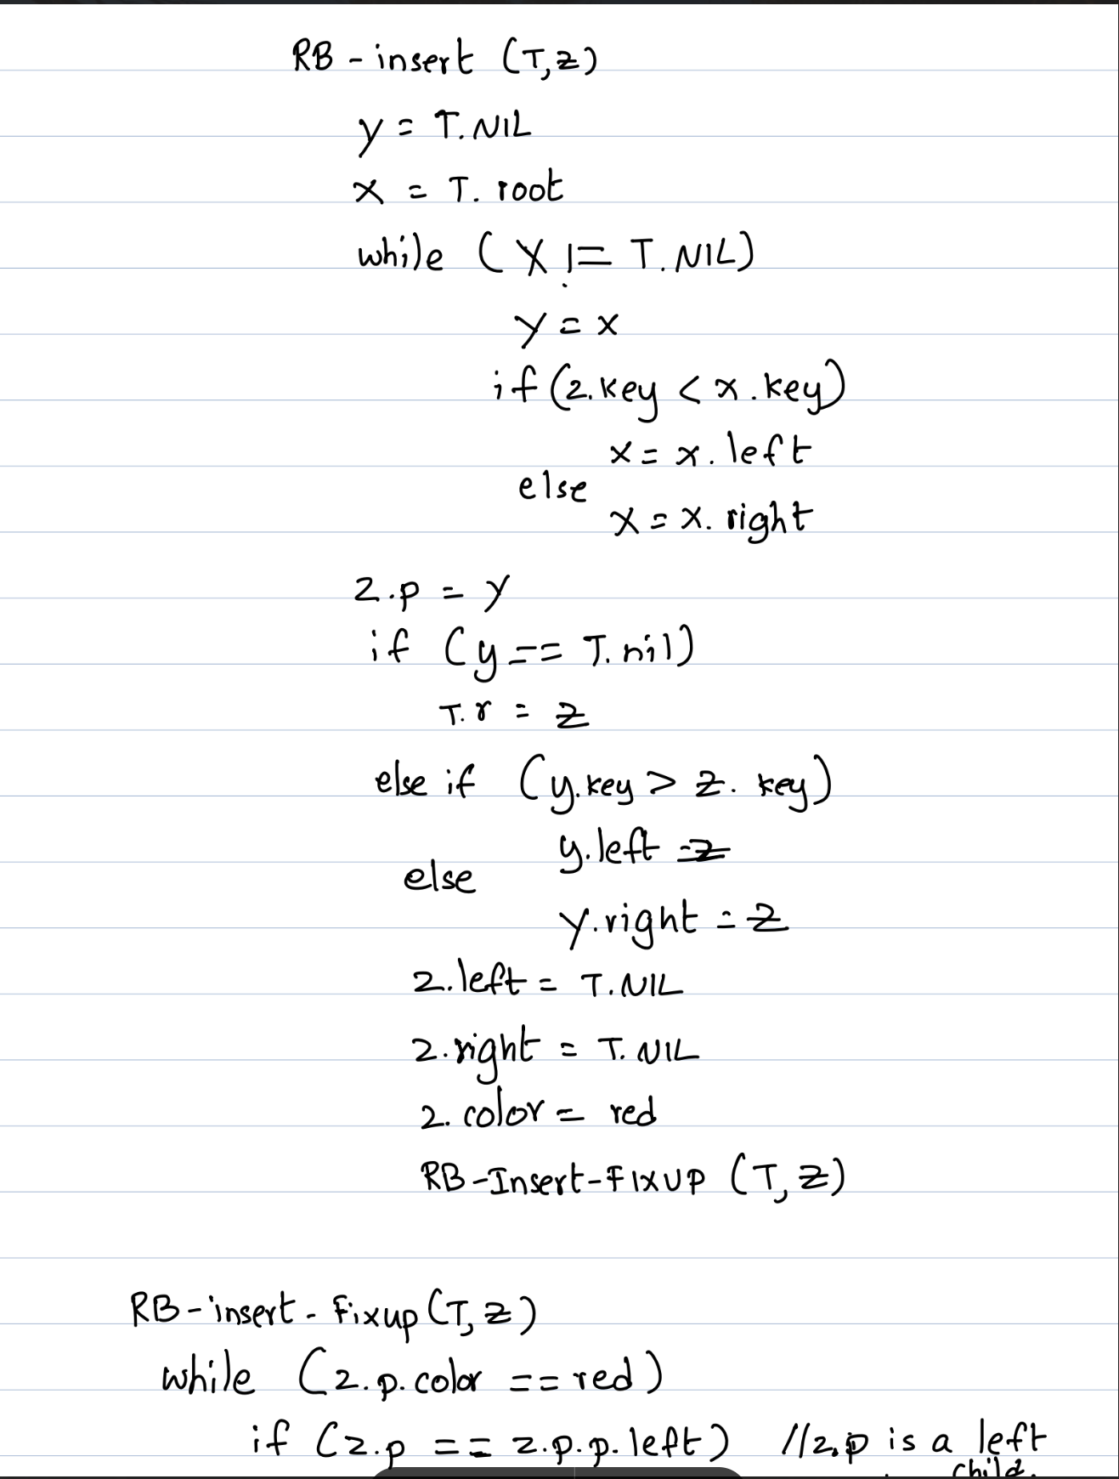
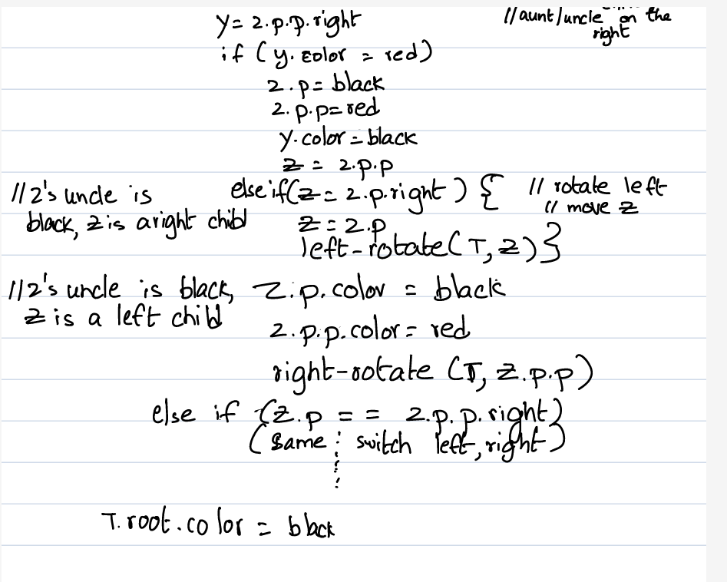
Example 3
Z = 1, Z.P.P = Z.P, so use above algo
Uncle is on the right, Z.P.P.right or NIL leaf uncle is black
Z.P.LEFT = Z (Z is a left child)
Flip color of parent and grand parent and right-rotate Z’s grand parent
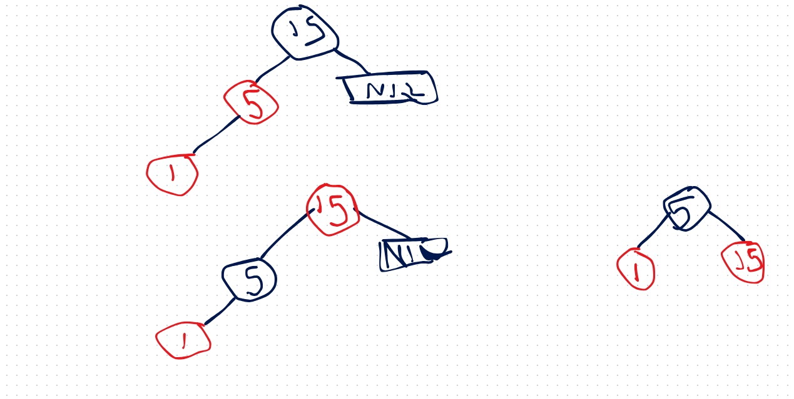

Example 4

- Z = 10, Z.P.P.LEFT = Z.P
- Look at the right for the uncle, because Z is on the grand parent’s left branch
- Uncle 13 is red, since uncle is red flip colors of parent, grand parent and uncle
- Grandparent is the new Z.
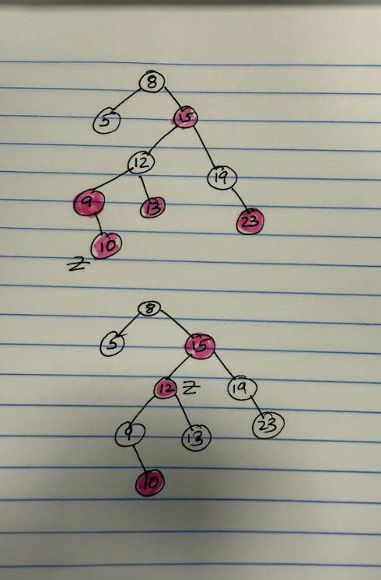

- The new Z is 12 - Z.P.P.P.Right = Z.P
- Z is on the right branch of the grandparent, switch left and right in the original algo
- Z’s uncle 5 is black, so check Z is the right branch or left branch of its parent
- Since Z.P.Left = Z , Z is a left child so Z = Z.P and right rotate Z.P
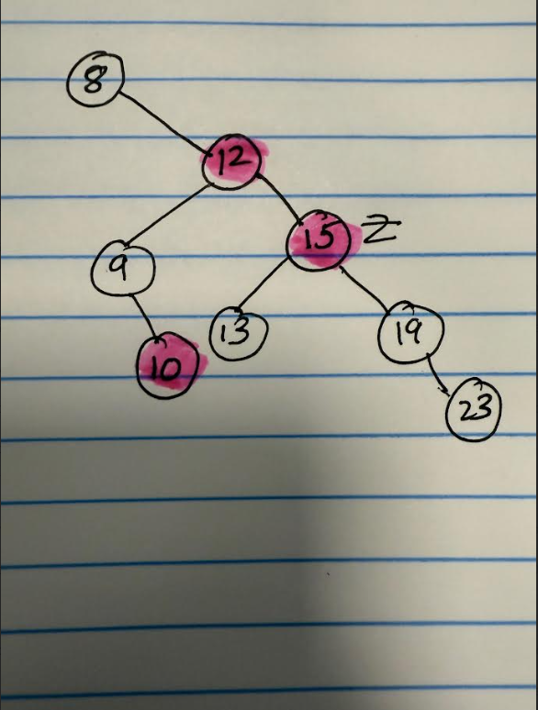
- Change color of parent and grandparent and left rotate
Pseudo code for left rotate for both AVL and red black trees
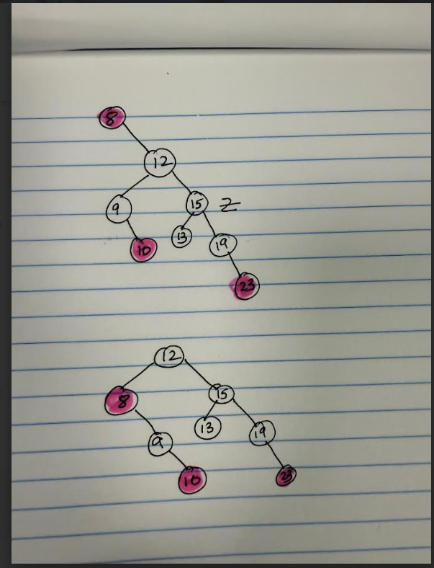

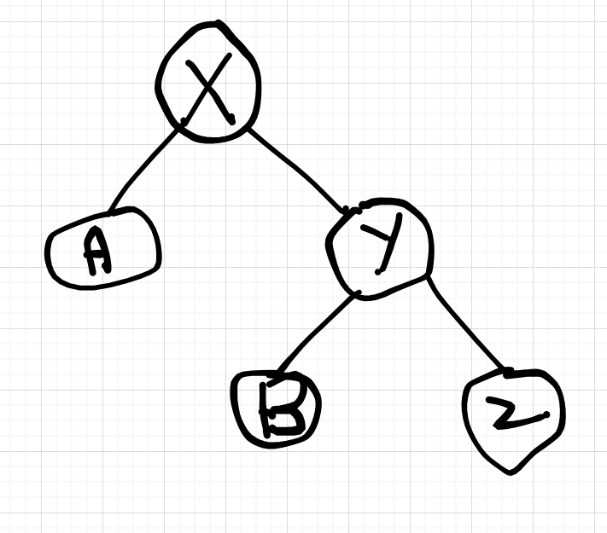

Left-Rotate (T, x)
Y = X.right
X.right = Y.left //x.right =B
X.parent= Y
If (Y.left != NIL) {
Y.left.parent = X //B.parent = X
}
Y.left = X
Y.parent = X.parent
If (X.parent == NIL)
T.root = Y
else if X.parent.right == X
X.parent.right = Y
else
X.parent.left = Y
X.parent = Y

Right-rotate (T, X)
Y = X.left
X.left = Y.right
X.parent = Y
If (Y.right != NIL)
Y.right.parent = X //B.parent = x
Y.parent = X.parent
If (X.parent == NIL)
T.root = Y
else if X.parent.right == X
X.parent.right = Y
else
X.parent.left = Y
X.parent = Y

2-3 trees are balanced trees
Isomorphism – A type of transformation that tells us that two objects have the same structure.
- Pros – require no rotations
- Cons – harder to implement because 2-3 nodes, intricate insertion, deletion

- Nodes with two children are called 2-nodes, they have one data value and two children

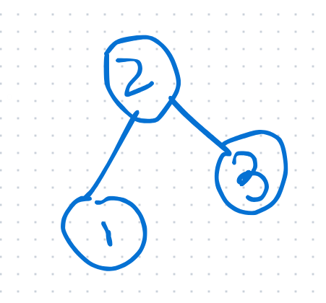
- Nodes with three children are called 3-nodes, they have two data values and three children,
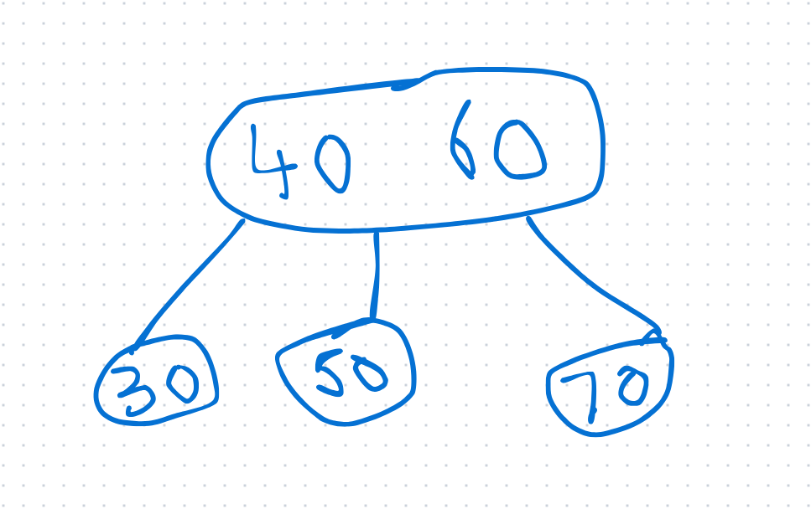
- A node can be a leaf node, a 2-node or a 3-node.
- Data in the tree is sorted, and a 3-node’s data is also sorted.
- All leaves are at the same level and insertion is always done at the leaf level
- Example insert 5, 6, 7, 4, 3, 2, 1,8, 9, 10
- When 5, 6 are in one node – it is in sorted order
- Only a maximum of 2 data values are allowed in a node, so add 7 to 5,6 in a sorted order and take the middle node up and make it a parent
- 3 is added to the 4, 5 node, which makes it more than 2 data points so sort and move the middle number up.

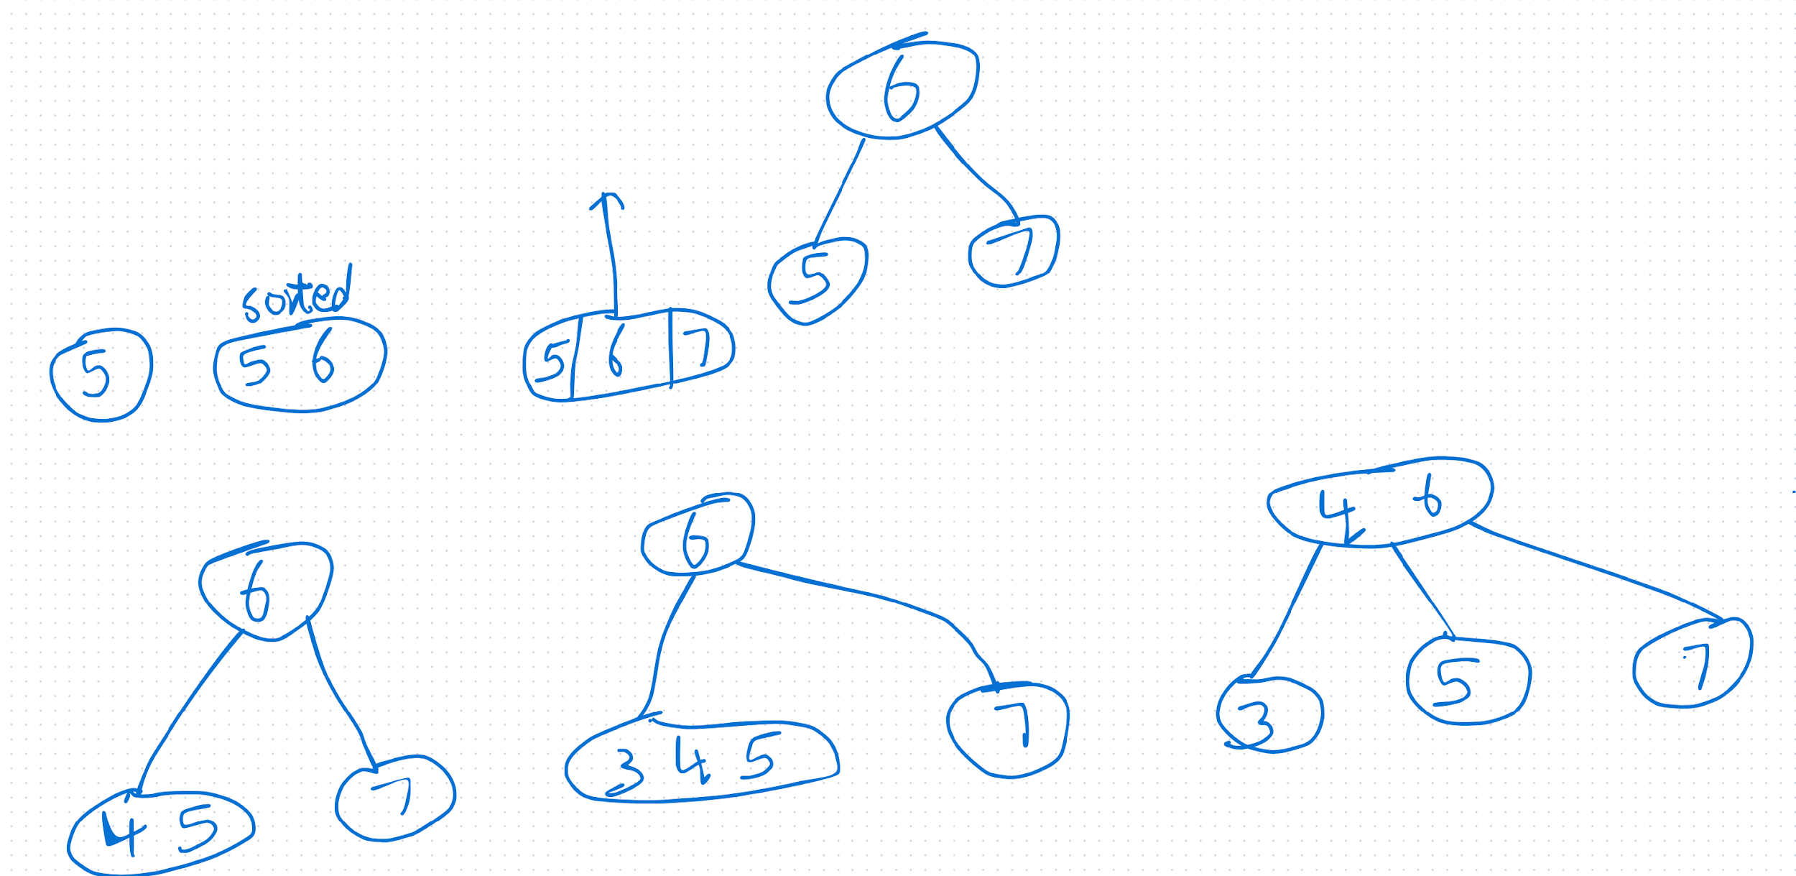

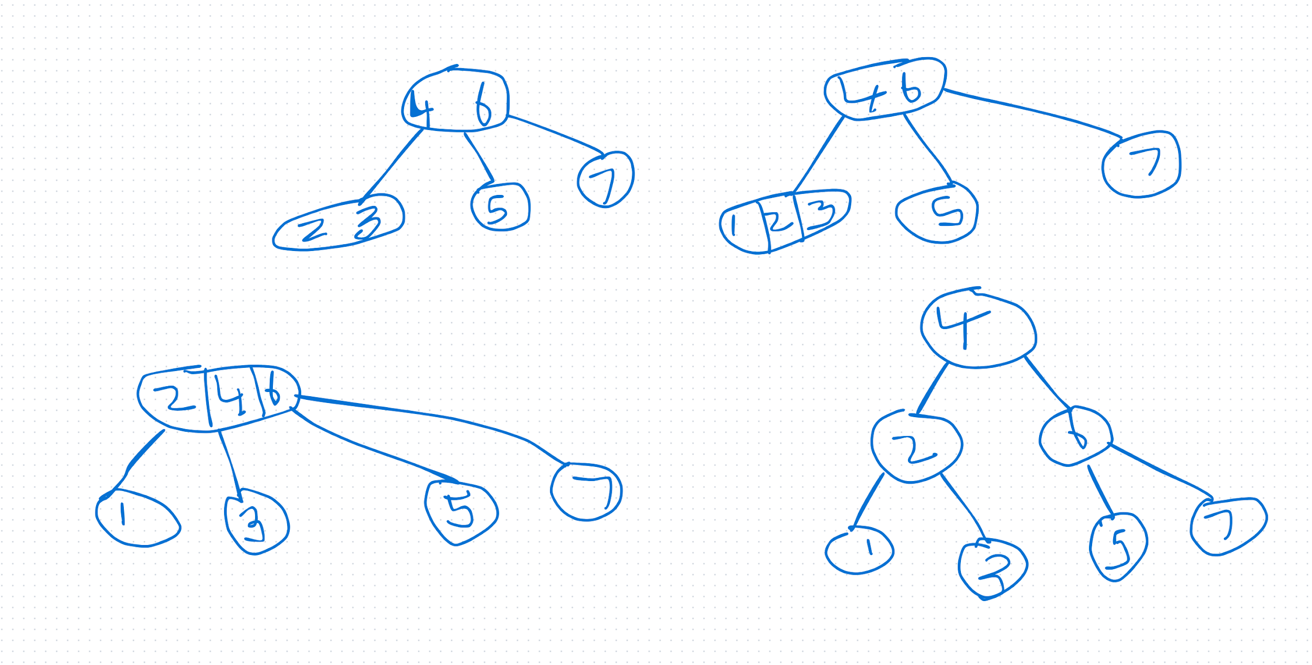
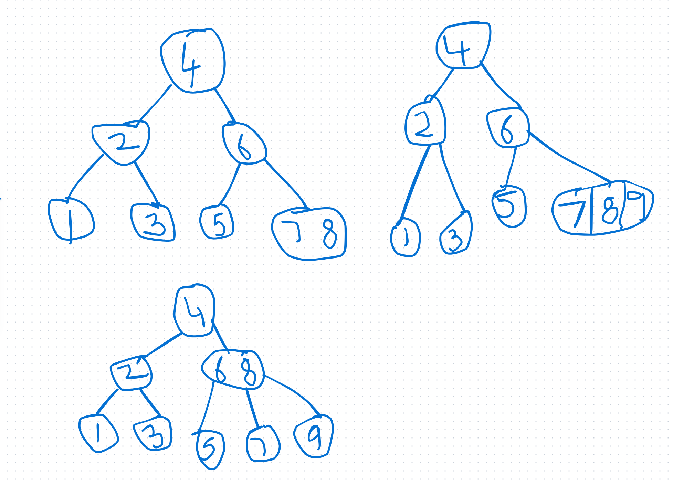

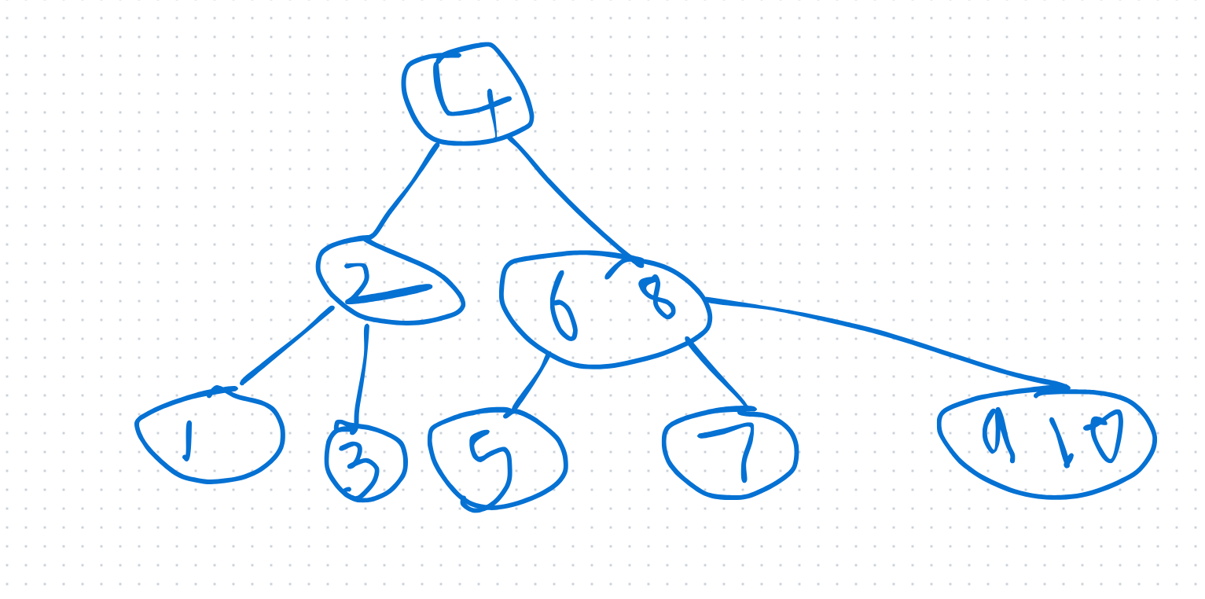

2-3 and LLRB trees
  - Red black are like 2-3 trees but easier to implement in code.
  - Two types of links, red links and black links
  - LLRB because red links are always added to the left.
  - Red links represent a node with 2 data values and 3 children
  - No node has two red links connected to it.
  - Red links lean left.
  - Every path from root to leaves has the same number of black links (perfect black balance).

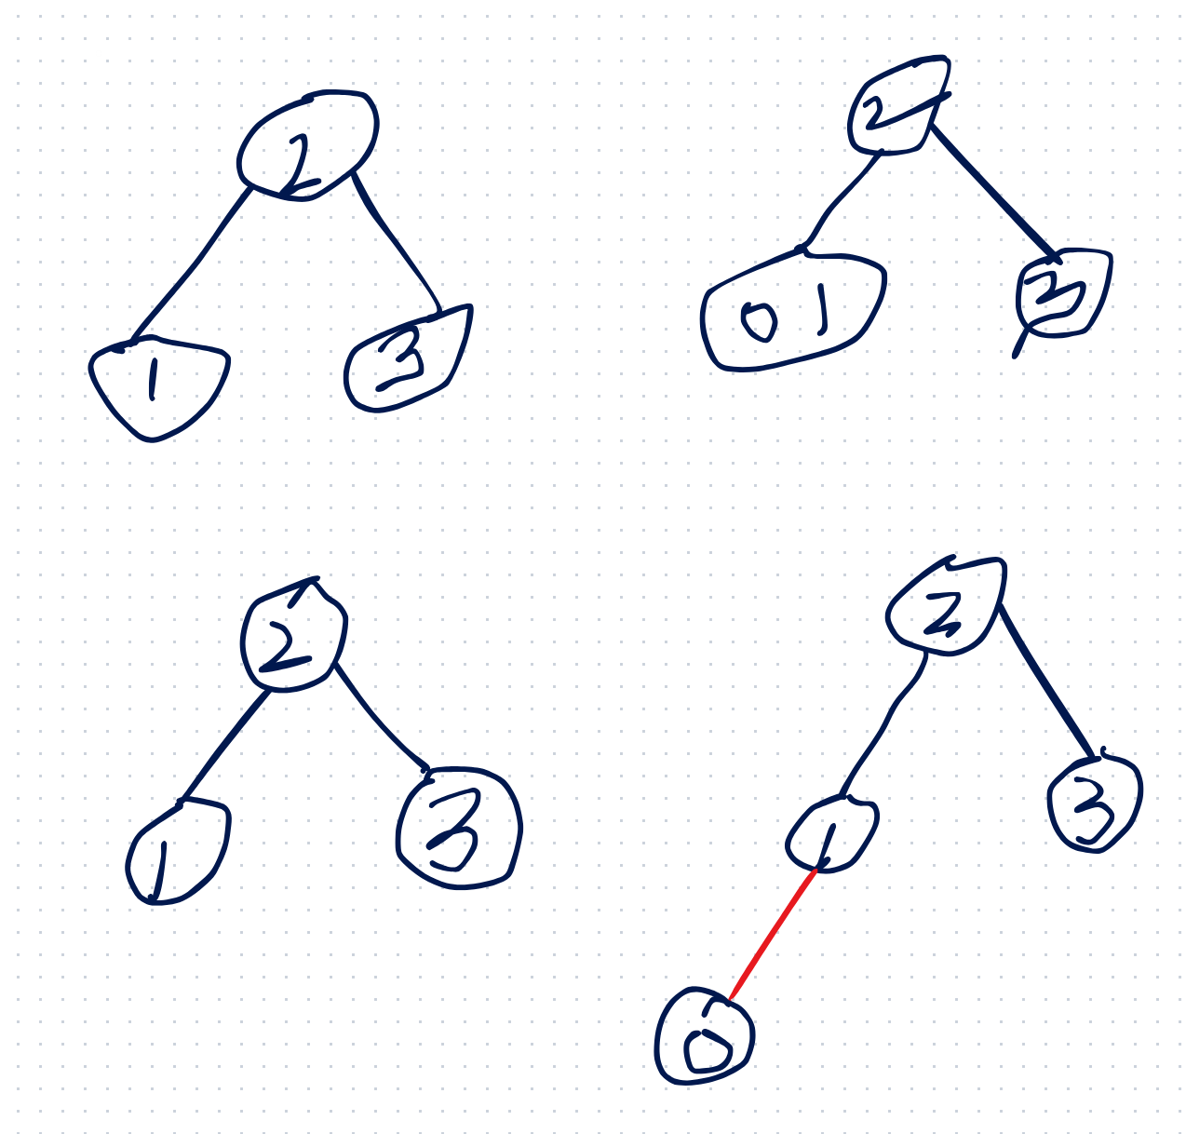
Always chose the greater value node as the parent so that the tree is left leaning

Insert 18, 12, 13 to 2-3 tree, solution shown below
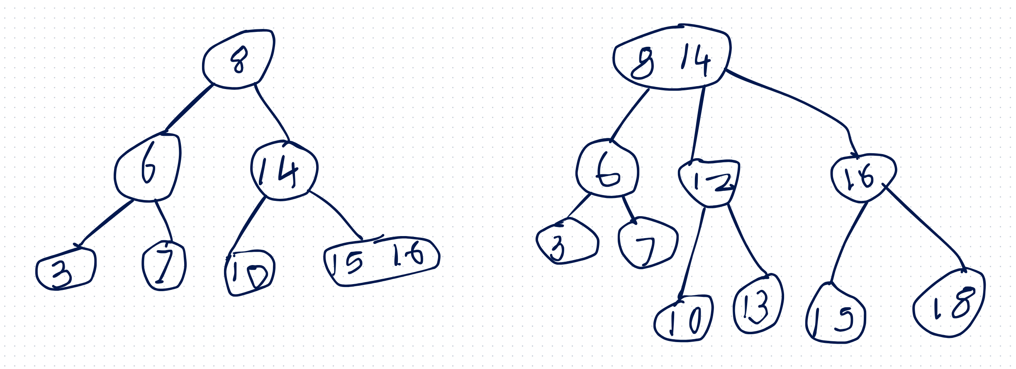

Converting a 2-3 tree to an LLRB
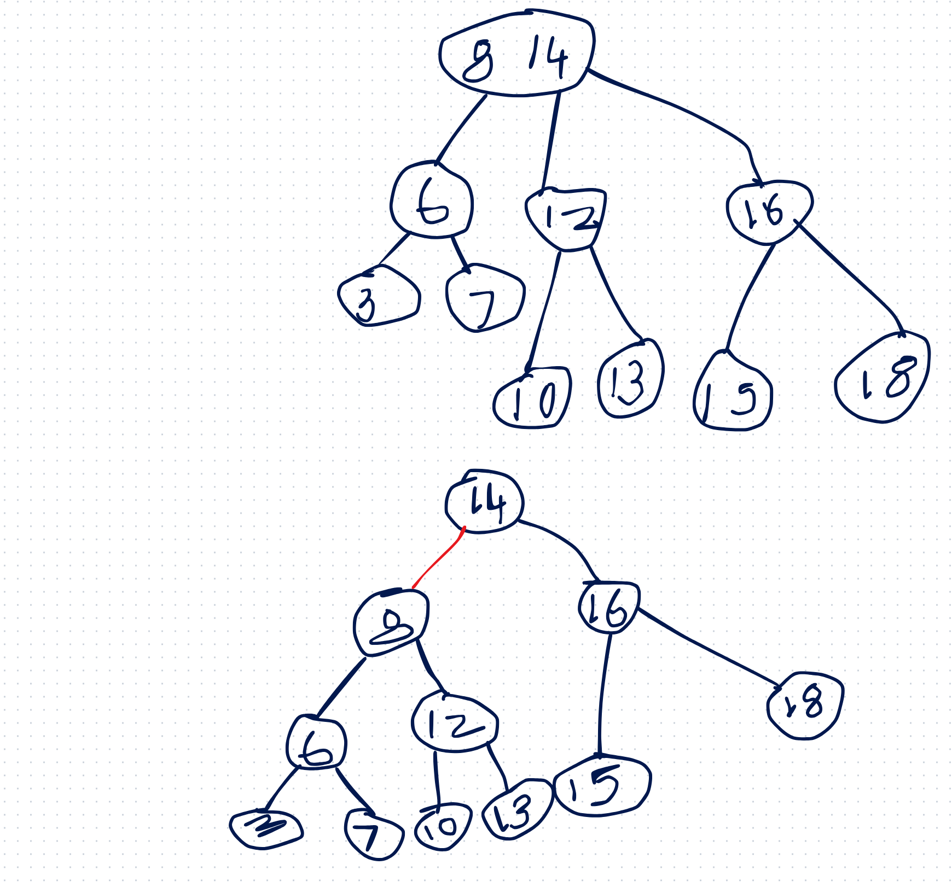
    - Larger value node becomes the parent
    - The subtree rooted at 12 cannot connect to 14, because it already has two subtrees
    - For an LLRB the number of black links from the root to any leaf is always the same, don’t count the red links

What to do if LLRB property is not satisfied

- Add 4 to the LLRB below, and it results in an unbalanced tree, so rotate THE RED LINK to the left

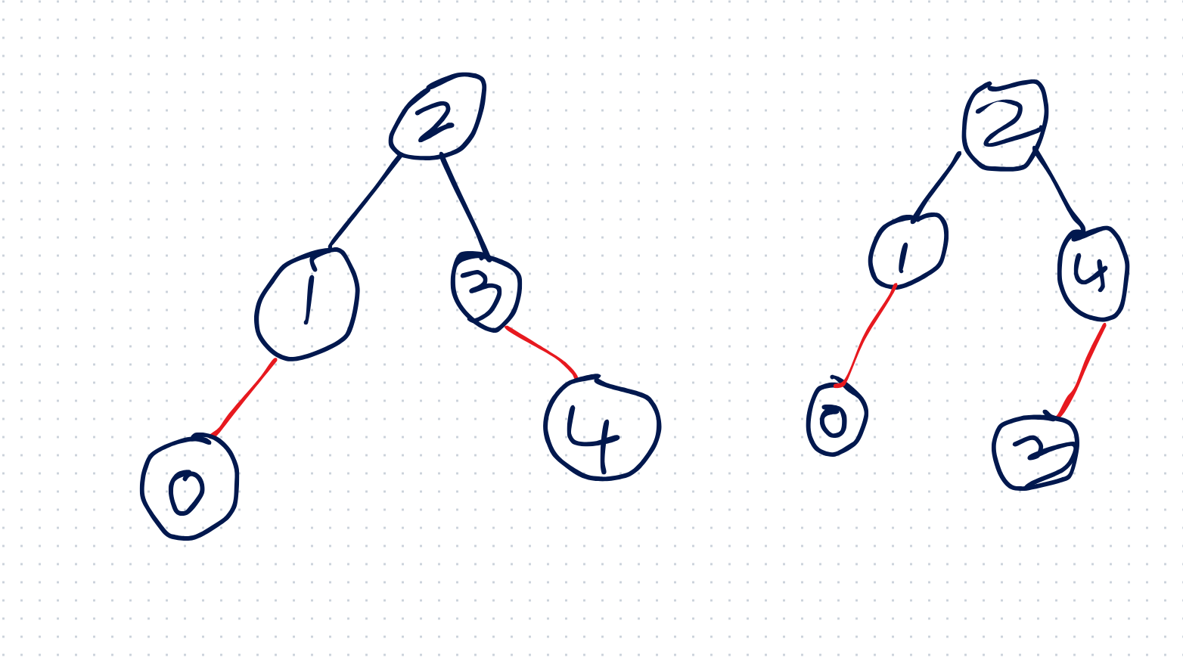
- Rotate red link to the right
- Pushing nodes up one level, 2 is pushed up to 4, hence create a red link , between 4 and 2.
