# Artificial Intelligence COMP 5600/ COMP 6600/ COMP 6600 - D01

Instructor: Dr. Shubhra (“Santu”) Karmaker

TA 1: Souvika Sarkar

TA 2: Sanjoy Kundu

Department of Computer Science and Software Engineering

Auburn University Spring, 2024

February 9, 2024

**Assignment #3**

**Probabilistic Graphical Models**

## Submission Instructions

This assignment is due on **February 20, 2024, at 11:59 pm**. Please submit your solutions via Canvas ([https://auburn.instructure.com/)](https://auburn.instructure.com/). You should submit your assignment as a PDF file. Please do not include blurry scanned/photographed equations, as they are difficult for us to grade.

## Late Submission Policy

The late submission policy for assignments will be as follows unless otherwise specified:

1. 75% credit within 0-48 hours after the submission deadline.
2. 50% credit within 48-96 hours after the submission deadline.
3. 0% credit 96 hours after the submission deadline.

## Bayesian Network and Distributions

1. **[10 points] Problem 1:** For the Bayesian Network shown in Figure 1, write the joint probability expressed as a product of the individual conditional probabilities.

P(A)P(C)P(B|A,C)P(E|A)P(B|A)P(D|E,C,B,)(P|FD)

*A*

B

C

E

D

F

Figure 1: Bayesian Network 1 (Problem Number 1)

1. **[10 points] Problem 2:** Draw the Bayes Network associated with the following joint distribution: *P*(*A*)*P*(*B*|*A*)*P*(*C*)*P*(*D*|*A,B,C*)*P*(*F*)*P*(*E*|*D,F*).

A B F

C D E

1. **[80 points] Problem 3:** We are going to take the perspective of an instructor who wants to determine whether a student has understood the material based on the exam score. Figure 2 gives a Bayesian network for this. As you can see, whether the student scores high on the exam is influenced both by whether (s)he is a good test taker and whether (s)he understood the material. Both of those, in turn, are influenced by whether (s)he is intelligent. Finally, whether a student understands the material is also influenced by whether (s)he is a hard worker.

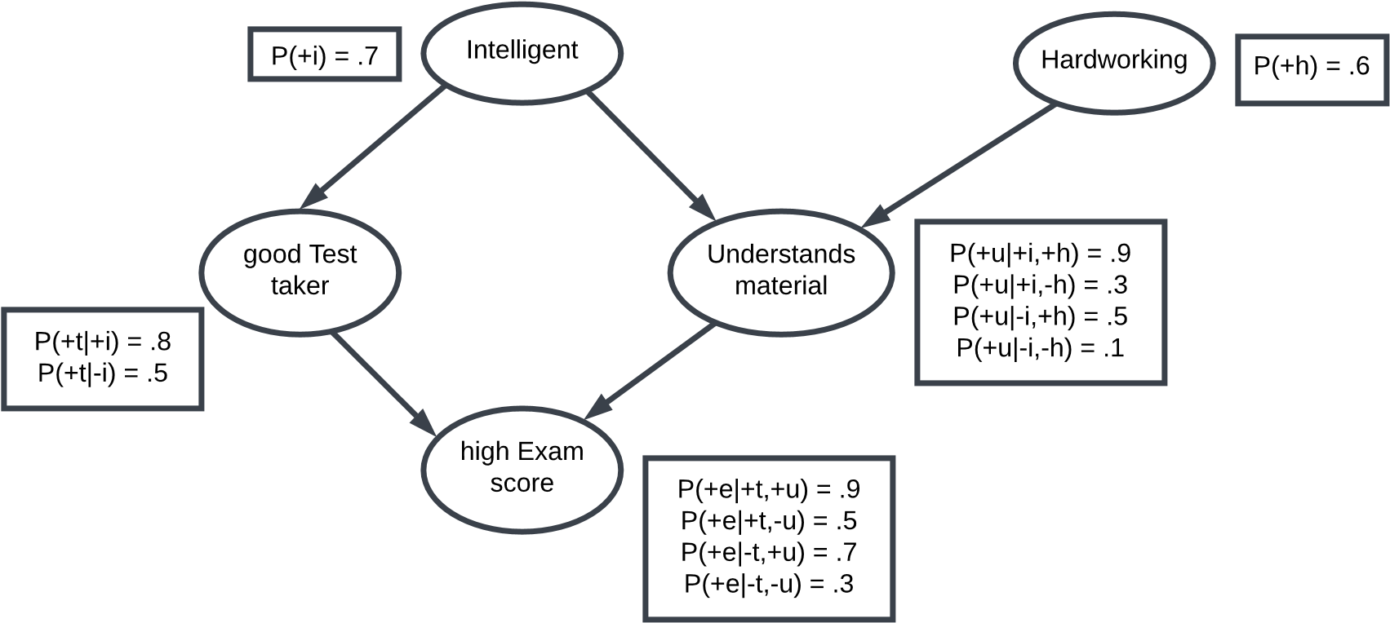

Figure 2: Bayesian Network for Student Understanding of Instruction Materials

**[50 points] Part 1:** Using variable elimination (by hand!) [refer to this Youtube video <https://youtu.be/FDNB0A61PGE?si=1Pon7xXTyyaYvtbT> for a tutorial on variable elimination], compute the probability that a student who did well on the test actually understood the material, that is, compute *P*(+*u*| + *e*).

Hint: You need to compute two functions *f*1(+*u*| + *e*) ∝ *P*(+*u*| + *e*) and *f*2(−*u*| + *e*) ∝ *P*(−*u*| + *e*), and then normalize *f*1(+*u*| + *e*) and *f*2(−*u*| + *e*) to derive the final values for *P*(+*u*|+*e*) and *P*(−*u*|+*e*), respectively. While computing *f*1(+*u*|+*e*) and *f*2(−*u*|+*e*), you will need to marginalize over other (unobserved) variables, i.e., I, H, T. Additional Reading materials on Bayesian Network have been posted on the file section on Canvas.

**[30 points] Part 2:** For the Bayesian network in Figure 2, label the following statements about conditional independence as True or False. For this question, you should consider only the structure (e.g., Cascade, Common Parent, V-structure. etc.) of the Bayesian network, not the specific probabilities. Explain each of your answers with justification.

1. **[3 points]** T and U are independent.

True there is not active path between T and U meaning that they are marginally independent.

1. **[3 points]** T and U are conditionally independent given I, E, and H.

False there is an active path between T and U through H meaning that they are conditionally independent given H

1. **[3 points]** T and U are conditionally independent given I and H.

True there is no active path between T and U when I and H are observed meaning that they are conditionally independent given I and H.

1. **[3 points]** E and H are conditionally independent given U.

False there is an active path between E and H through U meaning that they are not conditionally independent given U.

1. **[3 points]** E and H are conditionally independent given U, I, and T.

True there is no active path between E and H when T, I and U are observed meaning that they are conditionally independent given T I and U.

1. **[3 points]** I and H are conditionally independent given E.

False. There is an active path between I and H through E, meaning that they are not conditionally independent given E.

1. **[3 points]** I and H are conditionally independent given T.

False. There is an active path between I and H through T, meaning that they are not conditionally independent given T.

1. **[3 points]** T and H are independent.

True. There is no active path between T and H, meaning that they are marginally independent.

1. **[3 points]** T and H are conditionally independent given E.

False. There is an active path between T and H through E, meaning that they are not conditionally independent given E.

1. **[3 points]** T and H are conditionally independent given E and U.

True. There is no active path between T and H when E and U are observed, meaning that they are conditionally independent given E and U.

T and U are marginally independent.  
T and U are not conditionally independent given H.  
T and U are conditionally independent given I and H.  
E and H are not conditionally independent given U.  
E and H are conditionally independent given T, I, and U.  
I and H are not conditionally independent given E.  
I and H are not conditionally independent given T.  
T and H are marginally independent.

T and H are not conditionally independent given E.  
T and H are conditionally independent given E and U.