MEAN

Create a node Project type:

npm init-y

Install all modules like MORGAN & EXPRESS type

Npm install express morgan

Install Nodemon

Nodemos works to restart the server easily when we require it.

Npm I nodemon -D

Into package json we can create commands like this one, to use nodemon or any other module, the we could run the scrip dev in this case into the console to run nodemon into index.js file



To run it

Npm run dev

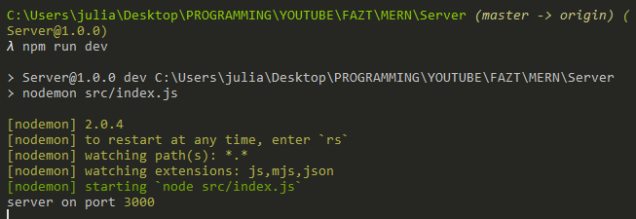

REST Client visual studio ectension was installed to replace Postman or Insominia

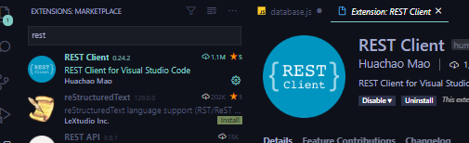

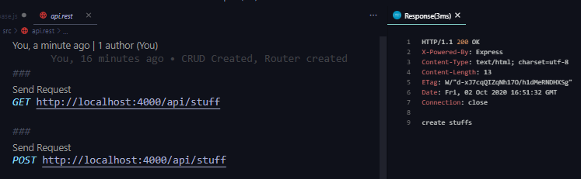

To connect to MONGODB we need to instal a library called Mongoose, to install type:

npm i mongoose