Synopsis

On

***AIRLINE RESERVATION SYSTEM***

Submitted in partial fulfillment of the requirements for the award of degree

#### Bachelor of Computer Application

#### From

Pt. Ravishankar Shukla University, Raipur (C.G.)

Year: 2019 -20



**Submitted by:**

Vandana Dewangan

BCA – 3rd

**Guided by:**

Mr. Mukesh Kashyap

(Asst. Professor)

Submitted to

Pragati College

Pt. Ravishankar Shukla University, Raipur (C.G.)

**CERTIFICATE OF APPROVAL**

This is to certify that the Project work entitled **“Airline Reservation System”** is carried out by **Miss. Vandana Dewangan** a student of BCA-III year at **Pragati College** is here by approved as a credible work in here discipline of Computer Science & Information Technology for the award of degree of **Bachelor of Computer Application** during the year 2019-20 from **Pt. Ravishankar Shukla University, Raipur (C.G.).**

**Principal&HOD (Comp.Sc.)**

**Pragati College, Raipur**

**CERTIFICATE**

This is to certify that the Project work entitled **“Airline Reservation System”** Submitted to the **PRAGATI COLLEGE** by **Miss. Vandana Dewangan,** Roll No_____________ in partial fulfillment for the requirements relating to nature and standard of the award of **Bachelor of Computer Application** degree by **Pt. Ravishankar Shukla University, Raipur (C.G.)** for the academic year 2019-2020.

This project work has been carried put under my guidance.

**Mr. Mukesh Kashyap**

**Asst. Prof. (Comp. Sc.)**

**Pragati College Raipur**

**CERTIFICATE OF EVALUATION**

This is to certify that the Project work entitled **“Airline Reservation System”** is carried out by **Miss. Vandana Dewangan,** Roll no_____________ a student of BCA-III year at **PRAGATI COLLEGE** after proper evaluation and examination, is here by approved as a credible work in here discipline of Computer Science & Information Technology for the award of degree of **Bachelor of Computer Application** during the year 2019-20 from **Pt. Ravishankar Shukla University, Raipur (C.G.).**

**Internal Examiner External Examiner**

**DECLARATION**

This to certify that the Project report entitled **“Airline Reservation System”** which is submitted by me in the partial fulfillment for the award of the degree of **Bachelor of Computer Application, PRAGATI COLLEGE,** comprises the original work carried out by me. I further declare that the work reported in this project has not been submitted and will not be submitted, either in part or in full for the award of any other degree or diploma in this institute or any other institute or University.

**Place: Vandana Dewangan**

**Date: Roll No.**

**ACKNOWLEDGEMENT**

We felt great in expressing deep sense of gratitude to our guider and **Mr. Mukesh Kashyap** Mam for their valuable guidance and remarkable suggestions in completing our project on the **“Airline Reservation System”** is due to their encouragement and persistent motivation that we could extent the scope of project to any useful data processing and production of report.

We would like to take this opportunity to express my sincere thanks and deep sense of gratitude to our head of study center, family members and friends, who have helped me in some way or other or completion my project.

**Vandana Dewangan**

**BCA-III**

**CONTENTS**

* Objective and Scope of the project
* Definition of Problem
* Introduction
* Theoretical Background of project
* Detail of Hardware & Software Used
* Cost and Benefit Analysis
* Methodology adopted
* System Analysis and Design
* System Maintenance
* Detailed Life Cycle of the Project
  + ERD and DFD
  + User Interface
  + Methodology used for testing
  + Test Report, Print out of the code sheet
* User/Operational Manual
* Conclusion
* References
* Soft Copy of the Project

**OBJECTIVE OF THE PROJECT**

The primary goal of this software to provide is to help the passengers make flight reservation. the system will be able to find all the flights fulfilling a passenger’s needs .it is also capable to search all flights with the given origin and destination. The system displayed the arrival and departure time, the price, and the flight number for each flight it finds then ,the passenger will decide the flight reservation based on the displayed information.

The secondary goal of this software is to provide a means for the airline manager to manage the flights. The airline manage will be able to schedule flights , drop flights from the schedule and change the fare for a flight .

**SCOPE OF THE PROJECT**

This software provides options for viewing different flights available with different flights available with different timing for a particular date and provides customer with the facility to book a ticket, modify or cancel a particular reservation.

**DEFINITION OF PROBLEM**

The definition of our problem lies in manual system and afully automated system.

**Manual system** : The system is very time consuming and lazy. This system is more prone to errors and sometimes the approach to various problems is unstructured.

**Technical system** : With the advent of latest technology if we do not update our system then our business result in losses gradually with time. The technical systems contains the tools of latest trend i.e. computers printers, fax, Internet etc. The systems with this technology are very fast, accurate, user-friendly and reliable.

.

**Need of Airlines system**

A few factors that directs us to develop a new system are given below -:

1) Faster System

2) Accuracy

3) Reliability

4) Informative

**INTRODUCTION**

Airline Reservation System contains the details about flight schedules and its fare tariffs, passenger reservations and ticket records. An airline’s inventory contains all flights with their available seats. One of the core functions of the inventory management of airline reservations is the inventory control.

Airline reservation system is a computerized system used to store and retrieve information and conduct transactions related to air travel. The project is aimed at explosing the relevance and the importance of airline reservation system.

**THEORETICAL BACKGROUND OF THE PROJECT**

**FRONT END**

Java offers several benefits to the developer creating a front -end application for a database server. Java is ‘Write Once Run Everywhere’ language. This means that Java programs may be deployed without recompilation on any computer architectures and operating systems that possesses a Java Virtual Machine.

**JAVA DATABASE CONNECTIVITY (JDBC)**

The JDBC stands for Java Database Connectivity. It refers to several things, depending on context:

It is a specification for using data sources in Java applications. It’s an API for using low-level JDBC drivers. The JDBC defines every aspect of making data-aware Java applications and applets. The low-level JDBC drivers perform the database -specific translation to the high-level JDBC interface. This interface is used by the developer so he doesn’t need to worry about the database-specific syntax when connecting to and querying different databases. The JDBC is a package, much like other Java packages such as java.awt. It’s not currently a part of the standard Java Developer’s Kit (JDK) distribution, but it is slated to be included as a standard part of the general Java API as the java.sql package.

**BACK END**

**MS ACCESS :-**

MS Access is a database development package which helps us to create databases dynamically and easily. Using Microsoft Access, one can manage all the information from a single database file. Within the file, divide the data into separate storage containers called tables; view, add, and update table data using forms; find and retrieve just the data you want using queries; and analyze or print data in a specific layout using reports.

To store your data, create one table for each type of information you track. To bring the data from multiple tables together in a query, form, or report, you define relationships between the tables.

To find and retrieve just the data that meets conditions you specify, including data from multiple tables, create a query. A query can also update or delete multiple records at the same time, and perform built-in or custom calculations on your database.

**DETAIL OF HARDWARE AND SOFTWARE REQUIREMENTS**

Minimum Hardware Requirements:

* Processor – Pentium-IV based
* Monitor
  + Size – 15 Inch
  + Resolution – 1366 X 768
* RAM – 1 GB
* Hard disk – 2 GB
* Mouse: USB/PS2
* Keyboard : USB/PS2
* Printer: any
* Screen Resolution:1366 X 768
* Ram – 256 Mb,

Minimum Software Requirements:

* Operating System: Windows XP or above
* Front End: Java (jdk 1.8 version)
* Framework: Netbeans
* Back End : MS-ACCESS(2007)

**COST AND BENEFIT ANALYSIS**

**COST ANALYSIS:**

COCOMO consists of a hierarchy of three increasingly detailed and accurate forms. The first level, Basic COCOMO is good for quick, early, rough order of magnitude estimates of software costs, but its accuracy is limited due to its lack of factors to account for difference in project attributes (Cost Drivers). Intermediate COCOMO takes these Cost Drivers into account and Detailed COCOMO additionally accounts for the influence of individual project phases.

**Model Used:** Basic COCOMO Model for Organic Project

**Formulae:**

Effort Applied (E) = ab(KLOC)bb [ man-months ]

Development Time (D) = cb(Effort Applied)db [months]

People required (P) = Effort Applied / Development Time [count]

**Calculation:**

* Assuming an estimate of 4 KLOC.
* Using the following values of constants

|  |  |  |  |
| --- | --- | --- | --- |
| ab | bb | cb | db |
| 2.4 | 1.05 | 2.5 | 0.38 |

Effort Applied (E) = 2.4*(4)1.05 = 10.2890 [man-months]

Development Time (D) = 2.5*(10.2890)0.38 = 6.06 [months]

People required (P) = E/D = 10.2890/6.06 = 1.69

Salary: 2000/-

Cost = Effort Applied*Salary = 10.2890*2000 = 21000\-

**BENEFIT ANALYSIS:**

The user who’ll use this project will have the following benefits:

* The person will have a system for his Airline reservation management .
* The cost of stationary will be saved approx 1000Rs. .
* Less workload to the employee through which benefit of approx 6000Rs .
* If users further develop this project for personal use, and those changes if approved, can be implemented into the main system, hence making each change in the project global.
* As frontend is separated from backend, one backend can be deployed, and multiple client can use the backend easily, hence saving cost.
* In future, this project can earn by selling additional add-ons for paid access, or by advertisements.
* Total benefit=6000+1000=7000Rs.

**Calculation of Break-Even Point:**

The software provides an approximate profit of 7000/- (yearly) to the institution.

The software development charge = 21000/-

Total Profit generated in 3 years = 3*7000 = 21000

Break-Even Point = 3 years

**METHODOLOGY ADOPTED**

**Waterfall Model:**

The waterfall model is a sequential (non-iterative) design process, used in software development processes, in which progress is seen as flowing steadily downwards (like a waterfall) through the phases of conception, initiation, analysis, design, construction, testing, production/implementation and maintenance.

The following is the diagram of waterfall model:

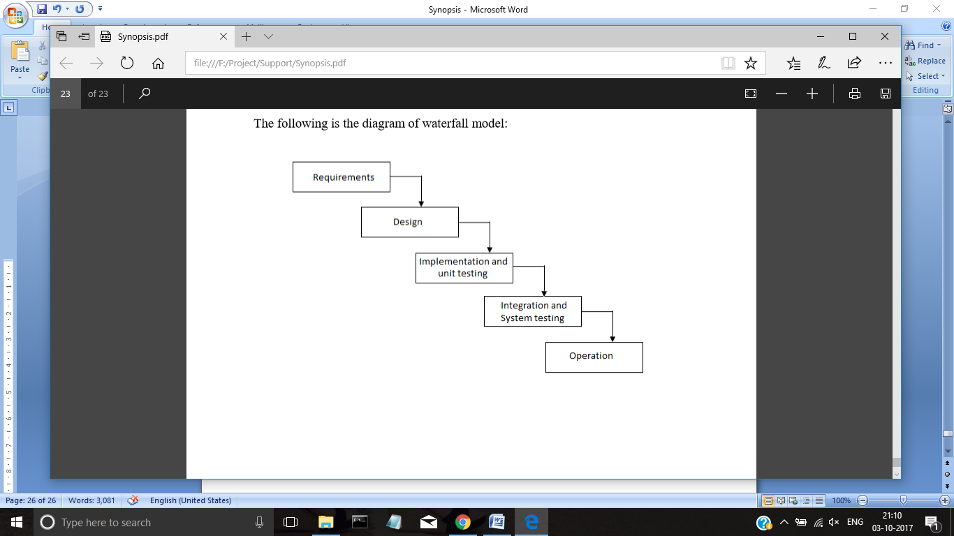

. It consists of the following sequential phases through which the development life cycle progresses:

**Requirement analysis:** In this phase, I gathered requirements from my uncle who is a caterer. He told me everything what he needed for the catering management so that he can book the orders in a more easier manner and keep the detailsof the customers and workers.

**System feasibility:** In this phase, after gathering requirements I checked whether the project “Airline Reservation system” can be made or not.

**System design:** The project “ Airline Reservation system” keeps the details of cutomer, reservations,cancellation,flight schedules .

The design of the project “Airline Reservation system” consists of the following forms:

* Login form
* MDI form
* Customer form
* flightsdetails form
* Reservation form
* Cancellation form
* Admin form

**Coding and unit testing:** In this phase, you write code for the modules that make up the system. You also review the code and individually test the functionality of each module.

**Integration and system testing:** In this phase, you integrate all of the modules in the system and test them as a single system for all of the use cases, making sure that the modules meet the requirements.

**Deployment and maintenance:** In this phase, you deploy the software system in the production environment. You then correct any errors that are identified in this phase, and add or modify functionality based on the updated requirements.

The waterfall model has the following advantages:

It allows you to compartmentalize the life cycle into various phases, which allows you to plan the resources and effort required through the development process.

It enforces testing in every stage in the form of reviews and unit testing. You conduct design reviews, code reviews, unit testing, and integration testing during the stages of the life cycle.

It allows you to set expectations for deliverables after each phase.

The waterfall model has the following disadvantages:

You do not see a working version of the software until late in the life cycle. For this reason, you can fail to detect problems until the system testing phase. Problems may be more costly to fix in this phase than they would have been earlier in the life cycle.

When an application is in the system testing phase, it is difficult to change something that was not carefully considered in the system design phase. The emphasis on early planning tends to delay or restrict the amount of change that the testing effort can instigate, which is not the case when a working model is tested for immediate feedback.

For a phase to begin the preceding phase must be complete; for example, the system design phase cannot begin until the requirement analysis phase is complete and the requirements are frozen. As a result, the waterfall model is not able to accommodate uncertainties that may persist after a phase is completed. These uncertainties may lead to delays and extended project schedules.

**SYSTEM ANALYSIS AND DESIGN**

**SYSTEM ANALYSIS**

Systems analysis is a process of collecting factual data, understand the processes involved, identifying problems and recommending feasible suggestions for improving the system functioning. This involves studying the business processes, gathering operational data, understand the information flow, finding out bottlenecks and evolving solutions for overcoming the weaknesses of the system so as to achieve the organizational goals. System Analysis also includes subdividing of complex process involving the entire system, identification of data store and manual processes.

Following are the features recognized on analyzing the problem:

* Customers’ entry
* Reservation entry
* Fight details
* Cancellation of tickets.
* Updation of flights details if any .
* Generates computerized ticket.
* Generate different types of report like Customer , flightschedule,reservesation,cancellation etc.
  1. **SYSTEM DESIGN**

Based on the user requirements and the detailed analysis of the existing system, the new system must be designed. This is the phase of system designing. It is the most crucial phase in the developments of a system. The logical system design arrived at as a result of systems analysis is converted into physical system design. Normally, the design proceeds in two stages:

* **Preliminary or General Design**: In the preliminary or general design, the features of the new system are specified. The costs of implementing these features and the benefits to be derived are estimated. If the project is still considered to be feasible, we move to the detailed design stage.
* **Structured or Detailed Design**: In the detailed design stage, computer oriented work begins in earnest. At this stage, the design of the system becomes more structured. Structure design is a blue print of a computer system solution to a given problem having the same components and inter-relationships among the same components as the original problem. Input, output, databases, forms, codification schemes and processing specifications are drawn up in detail.

In the design stage, the programming language and the hardware and software platform in which the new system will run are also decided. There are several tools and techniques used for describing the system design of the system. These tools and techniques are:

• Flowchart

• Data flow diagram (DFD)

• Data dictionary

• Structured English

• Decision table

• Decision tree

**System Maintenance**

**Maintenance:**

The IEEE 1219-1998 software standards document defines software maintenance as "the modification of a software product after delivery to correct faults, to improve performance or other attributes, or to adapt the product to a modified environment." Software maintenance is the concluding part of the software development process or "life cycle." They categorized maintenance activities into four classes:

• Adaptive – modifying the system to cope with changes in the software environment.

• Perfective – implementing new or changed user requirements which concern functional enhancements to the software.

• Corrective – diagnosing and fixing errors, possibly ones found by users.

• Preventive – increasing software maintainability or reliability to prevent problems in the future.

Evaluation:

• The software should be delivered on time.

• The software should be in the budget of the customer.

• It should respond frequently to the user’s request.

• Customer will check whether s/he is convenient to the environment in which it is developed.

• The software should be capable of healing virus instead of getting affected or destroyed.

**DETAILED LIFE CYCLE OF THE PROJECT**

**Entity Relationship Diagram for airline reservation system**

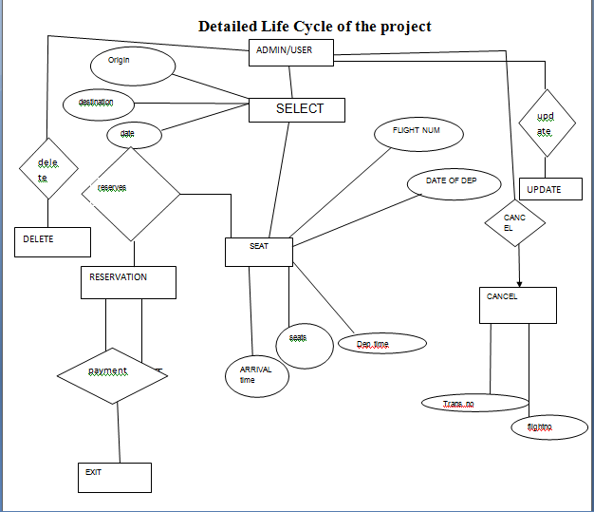

Fig: Entity Relationship Diagram

**Data Flow Diagram**

**Level 0 [Context Level] DFD:**

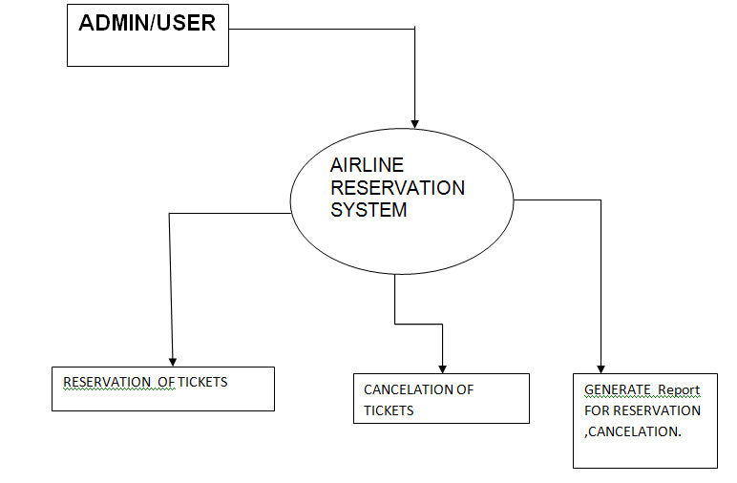

Fig: Data Flow Diagram [Level 0]

**Level 1:**

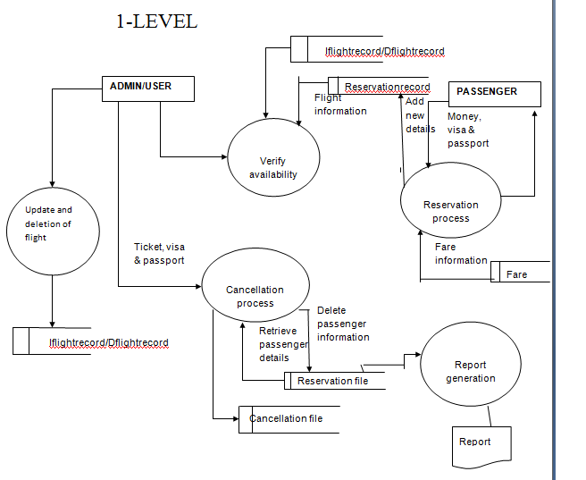

Fig: Data Flow Diagram [Level 1]

**Methodology used for testing**

**Testing:**

Testing is very vital for any system to be successfully implemented. The common view is that it is performed to prove that there are no errors in a program. Therefore the most useful and practical approach is with the explicit intention of finding the errors. The system is tested experimentally to ensure that the software does not fail. The system is run according to its specifications and in the way the user expects. Following testing practices are used. The system will process as normal input preparation of test-sample data.

The methodology used for testing the software is **White Box Testing**.

**White Box Testing**

White box testing: Testing based on an analysis of the internal structure of the component or system. Procedure to derive or select test cases based on an analysis of the internal structure of a component or system.

White-box testing is a verification technique software engineers can use to examine if their Code works as expected.

White-box testing is also known as structural testing, clear box testing, and glass box testing (Beizer, 1995). The connotations of “clear box” and “glass box” appropriately indicate that you have full visibility of the internal workings of the software product, specifically, the logic and the structure of the code.

For Example: A tester, usually a developer as well, studies the implementation code of a certain field on a software, determines all legal (valid and invalid) and illegal inputs and verifies the outputs against the expected outcomes, which is also determined by studying the implementation code.

**Levels**

* **Unit testing:** White-box testing is done during unit testing to ensure that the code is working as intended, before any integration happens with previously tested code. White-box testing during unit testing catches any defects early on and aids in any defects that happen later on after the code is integrated with the rest of the application and therefore prevents any type of errors later on.
* **Integration testing:** White-box testing at this level is written to test the interactions of each interface with each other. The Unit level testing made sure that each code was tested and working accordingly in an isolated environment and integration examines the correctness of the behaviour in an open environment through the use of white-box testing for any interactions of interfaces that are known to the programmer.

**Basic Procedure**

White-box testing's basic procedures involve the understanding of the source code that you are testing at a deep level to be able to test them. The programmer must have a deep understanding of the application to know what kinds of test cases to create so that every visible path is exercised for testing. Once the source code is understood then the source code can be analyzed for test cases to be created. These are the three basic steps that white-box testing takes in order to create test cases:

* Input, involves different types of requirements, functional specifications, detailed designing of documents, proper source code, security specifications. This is the preparation stage of white-box testing to layout all of the basic information.
* Processing Unit involves performing risk analysis to guide whole testing process, proper test plan, execute test cases and communicate results. This is the phase of building test cases to make sure they thoroughly test the application the given results are recorded accordingly.
* Output; prepare final report that encompasses all of the above preparations and results.

**Advantages**

White-box testing is one of the two biggest testing methodologies used today. It primarily has three advantages:

* Side effects of having the knowledge of the source code are beneficial to thorough testing.
* Optimization of code by revealing hidden errors and being able to remove these possible defects.
* Gives the programmer introspection because developers carefully describe any new implementation.

**Disadvantages**

Although White-box testing has great advantages, it is not perfect and contains some disadvantages. It has two disadvantages:

* White-box testing brings complexity to testing because to be able to test every important aspect of the program, you must have great knowledge of the program. White-box testing requires a programmer with a high-level of knowledge due to the complexity of the level of testing that needs to be done.
* On some occasions, it is not realistic to be able to test every single existing condition of the application and some conditions will be untested.

**DATABASE DESIGN**

There is only one database used for accomplishing the project. Following are the tables included in the database.

**Login-:**

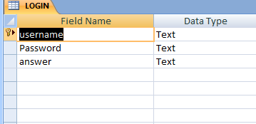

**Iflights records-:**

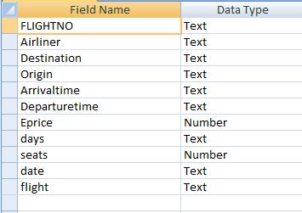

**Dflights records-:**

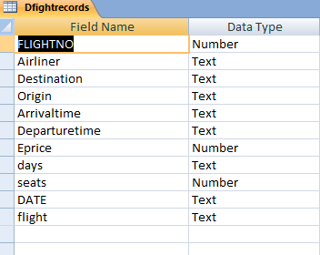

**Customer-:**

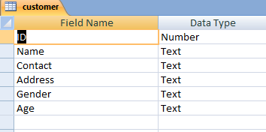

**Cancellation-:**

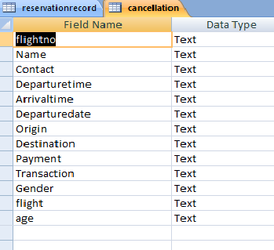

**ReserveRecord-:**

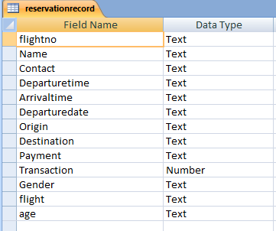

**INPUT AND OUTPUT SCREEN DESIGN**

**LOGIN-:**

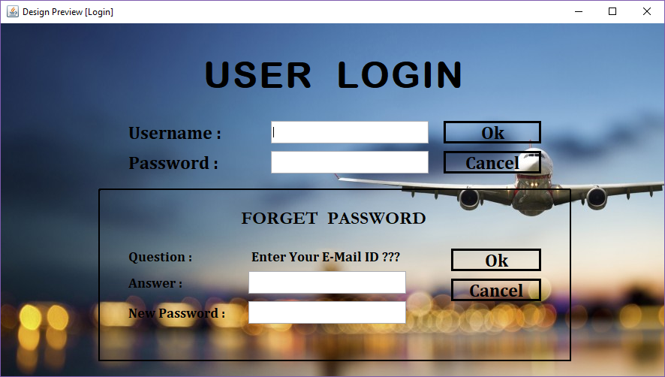

**New user and Change password-:**

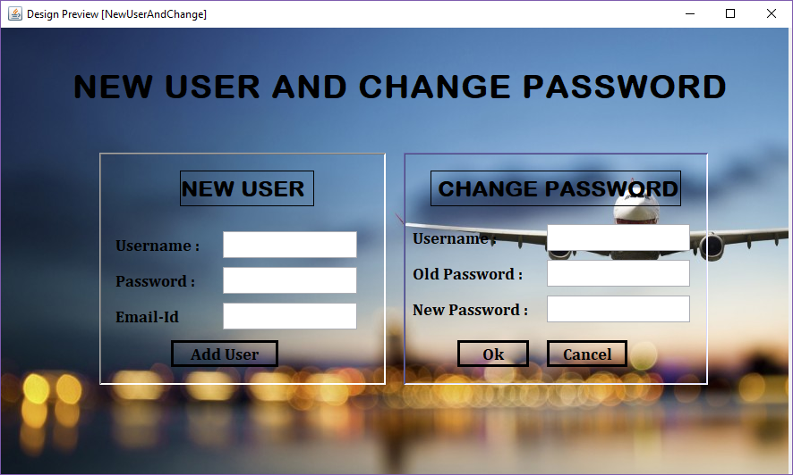

**Home Page-:**

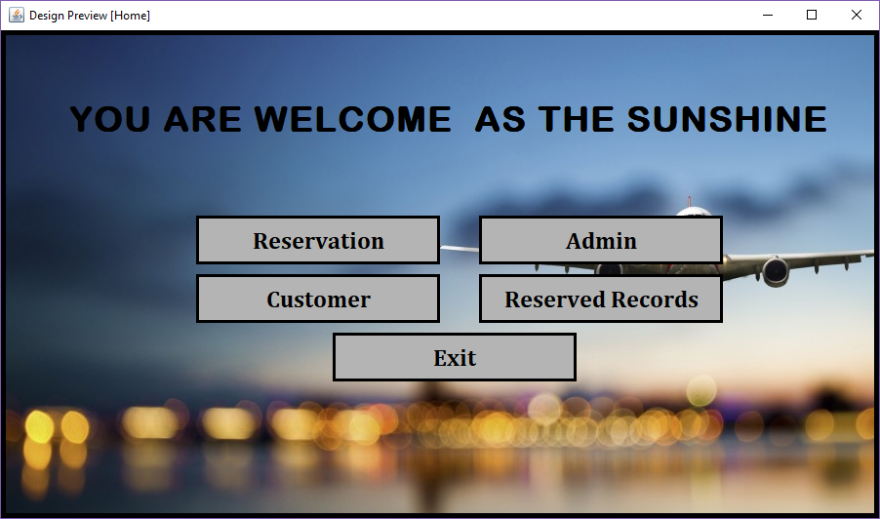

**Customer Detail Form**

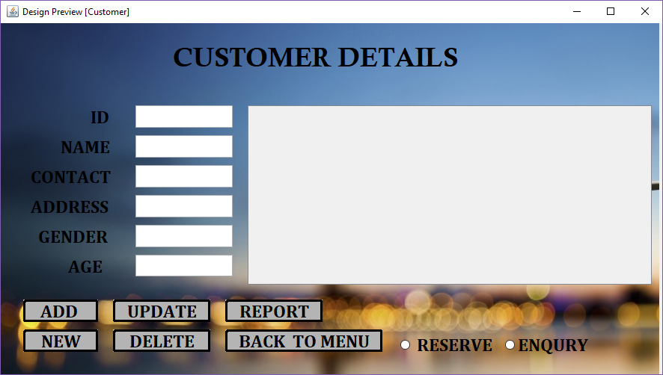

**Select Flight Form-:**

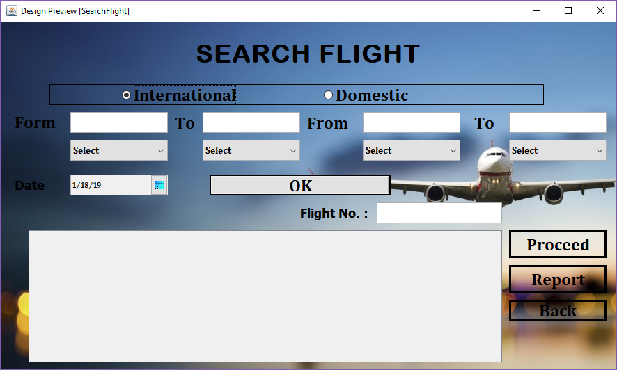

**Booking Detail Form**

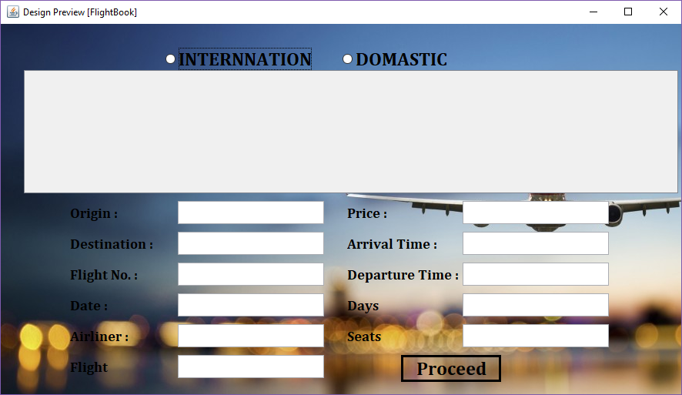

**Reservation Detail Form**

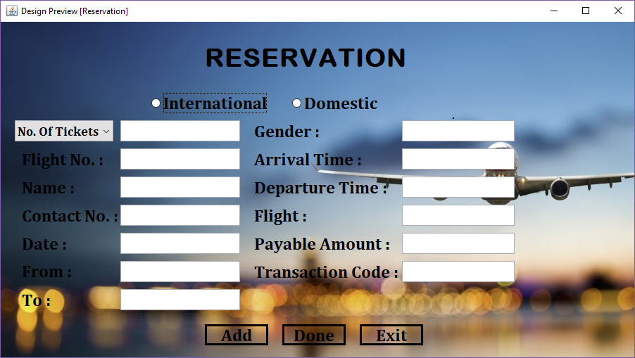

**Admin Form**

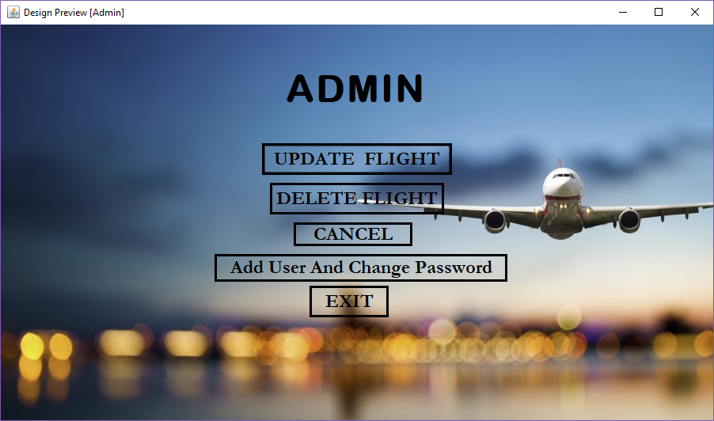

**Update flight Form**

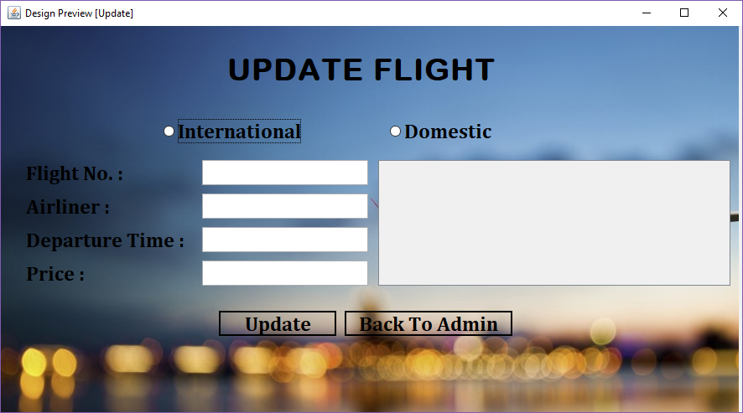

**Delete flight Form**

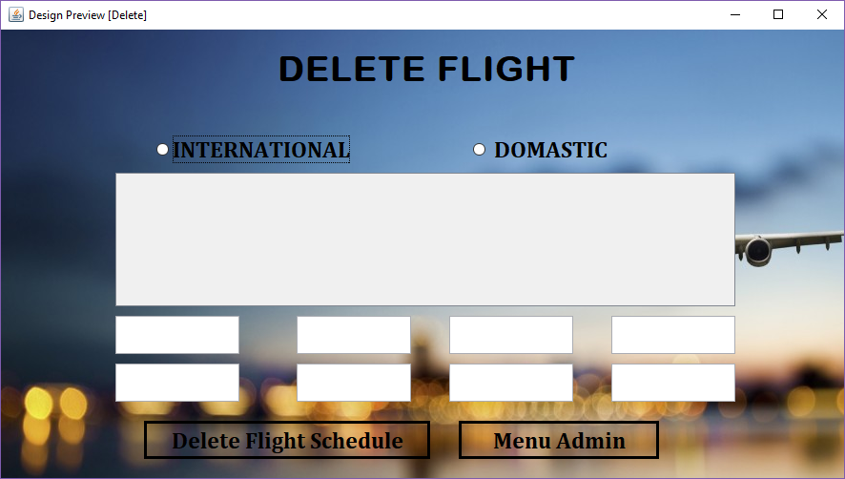

**Cancel flight Form**

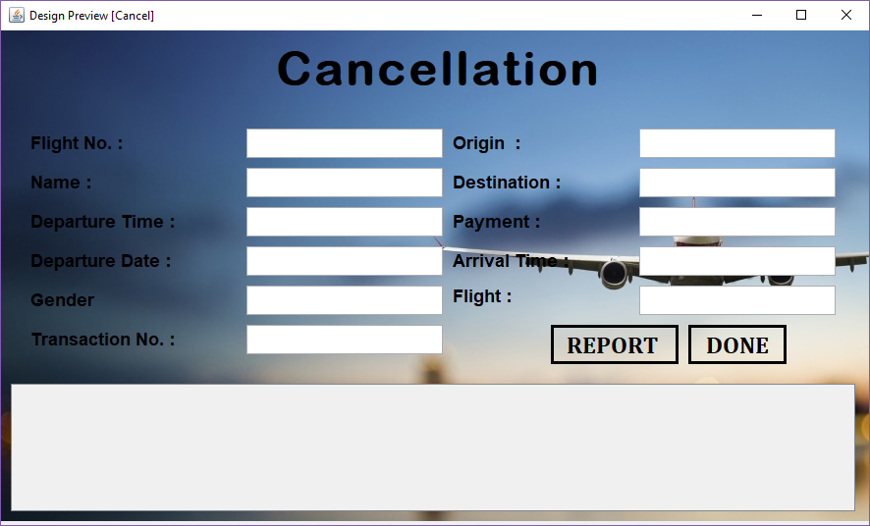

**Reserve Record Form**

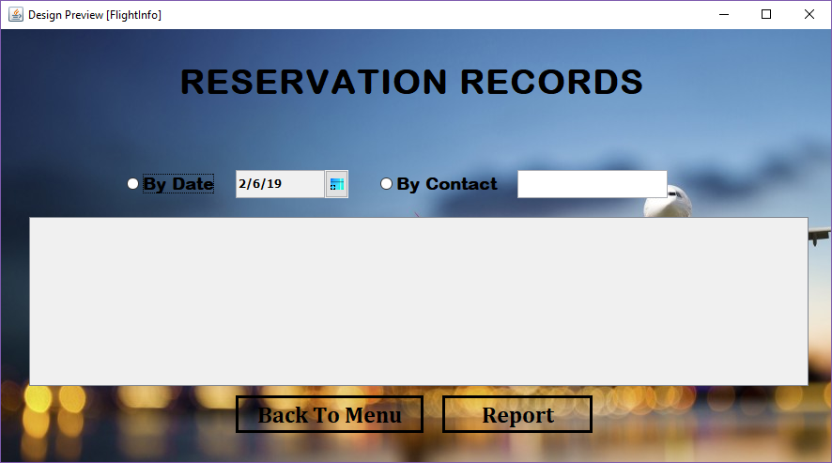

**Reports Generated**

**CUSTOMER REPORT**

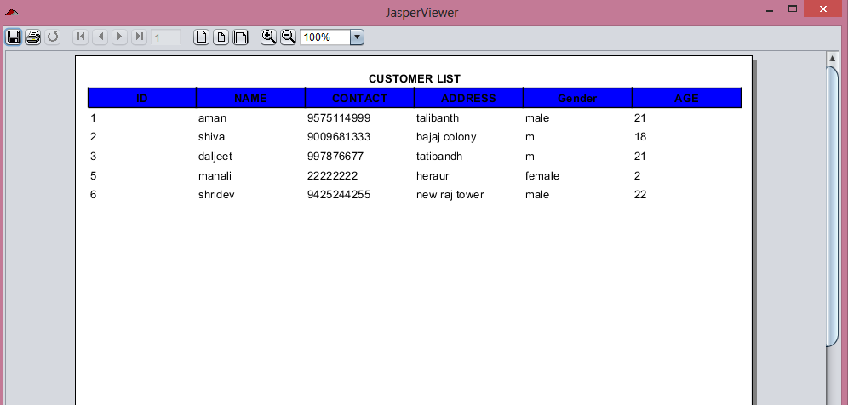

**CANCELLATION REPORT**

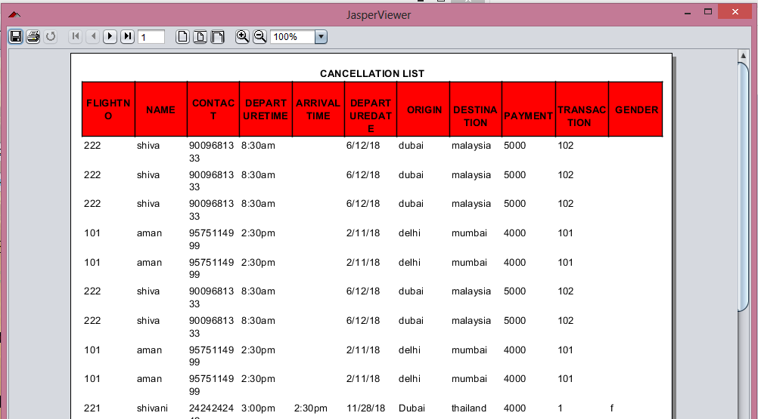

**TICKET REPORT**

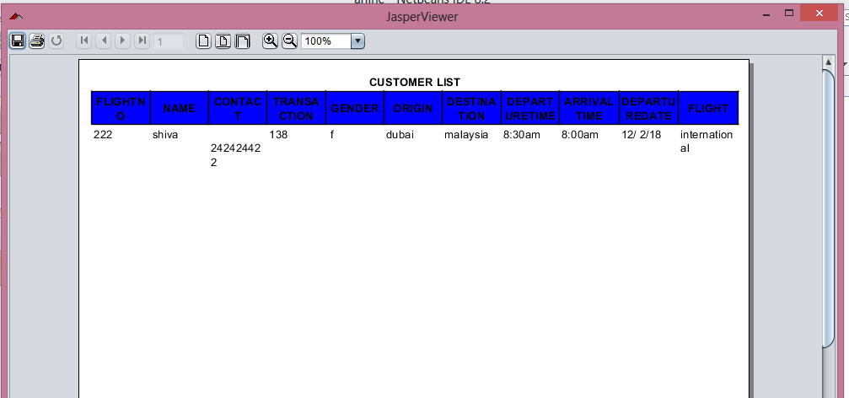

**RESERVATION REPORT**

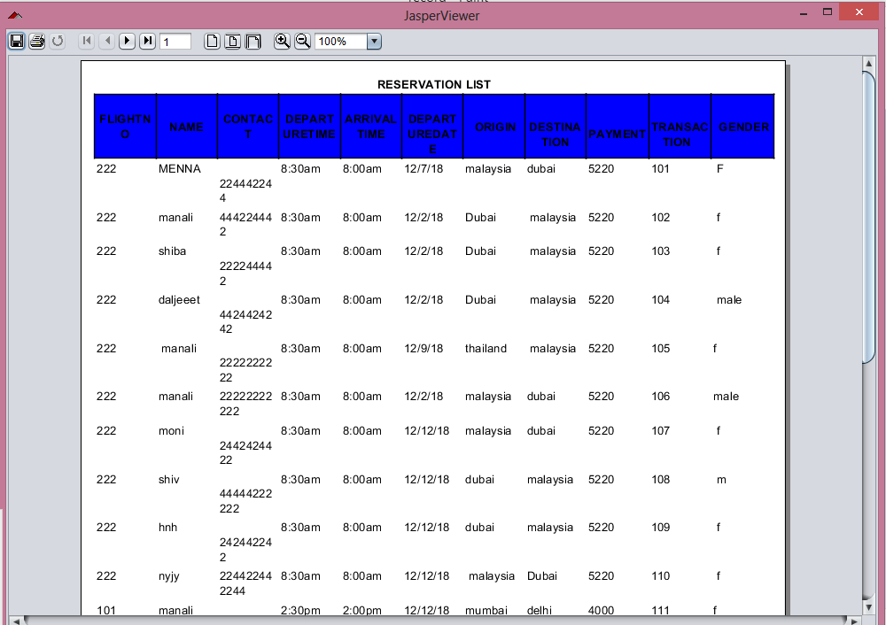

**PRINTOUT OF THE CODE SHEET**

void login()

{

Connection con = null;

PreparedStatement pr = null;

String url = null;

String qry= null;

ResultSet rs = null;

try{

File path= new File(System.getProperty("user.dir"));

url="jdbc:ucanaccess://"+path.getPath()+"/airlines.accdb";

qry="SELECT * FROM LOGIN where username=? and Password =? ";

con=DriverManager.getConnection(url);

pr= con.prepareStatement(qry);

pr.setString(1,my .getText());

pr.setString(2,my2.getText());

rs= pr.executeQuery();

if(rs.next())

{

JOptionPane.showMessageDialog(null,"successfully login");

A l =new A();

JDesktopPane desktopPane = getDesktopPane();

desktopPane.add(l);

l.setVisible(true);

this.dispose();

}

else

{

JOptionPane.showMessageDialog(null," login failed");

}

}catch(Exception e){

JOptionPane.showMessageDialog(rootPane, e);

}

}

void forget()

{

Connection con = null;

PreparedStatement pr = null;

String url = null;

String qry= null;

try{

File path= new File(System.getProperty("user.dir"));

url="jdbc:ucanaccess://"+path.getPath()+"/airlines.accdb";

qry="update LOGIN set Password = '"+oo.getText()+ "' where answer ='"+jTextField1.getText()+ "'";

con=DriverManager.getConnection(url);

pr=con.prepareStatement(qry);

int result=pr.executeUpdate();

JOptionPane.showMessageDialog(null,"successfully changed");

}catch(Exception e){

JOptionPane.showMessageDialog(rootPane, e);

}

}

**Home:-**

package arline;

import javax.swing.JOptionPane;

import java.text.DateFormat;

import java.text.SimpleDateFormat;

import java.util.Calendar;

import java.util.Date;

import javax.swing.JLabel;

import javax.swing.JOptionPane;

import javax.swing.JPasswordField;

import javax.swing.JTextField;

public class home extends javax.swing.JFrame {

public home() {

initComponents();

}

private void initComponents() {

jPanel1 = new javax.swing.JPanel();

jPanel2 = new javax.swing.JPanel();

jLabel2 = new javax.swing.JLabel();

jPanel3 = new javax.swing.JPanel();

jButton1 = new javax.swing.JButton();

jButton2 = new javax.swing.JButton();

jButton3 = new javax.swing.JButton();

jButton4 = new javax.swing.JButton();

jButton5 = new javax.swing.JButton();

jButton6 = new javax.swing.JButton();

jLabel1 = new javax.swing.JLabel();

menuBar = new javax.swing.JMenuBar();

helpMenu = new javax.swing.JMenu();

contentMenuItem = new javax.swing.JMenuItem();

aboutMenuItem = new javax.swing.JMenuItem();

editMenu = new javax.swing.JMenu();

cutMenuItem = new javax.swing.JMenuItem();

copyMenuItem = new javax.swing.JMenuItem();

pasteMenuItem = new javax.swing.JMenuItem();

deleteMenuItem = new javax.swing.JMenuItem();

fileMenu = new javax.swing.JMenu();

openMenuItem = new javax.swing.JMenuItem();

saveMenuItem = new javax.swing.JMenuItem();

saveAsMenuItem = new javax.swing.JMenuItem();

exitMenuItem = new javax.swing.JMenuItem();

setDefaultCloseOperation(javax.swing.WindowConstants.EXIT_ON_CLOSE);

jPanel1.setBackground(new java.awt.Color(204, 204, 204));

jPanel1.setLayout(null);

jPanel2.setOpaque(false);

jPanel2.setLayout(null);

jLabel2.setBackground(new java.awt.Color(51, 255, 255));

jLabel2.setFont(new java.awt.Font("Cambria", 1, 36)); // NOI18N

jLabel2.setText("YOU ARE WELCOME AS THE SUNSHINE........... !!");

jPanel2.add(jLabel2);

jLabel2.setBounds(20, 0, 1032, 220);

jPanel1.add(jPanel2);

jPanel2.setBounds(30, 20, 750, 220);

jPanel3.setOpaque(false);

jPanel3.setLayout(null);

jButton1.setFont(new java.awt.Font("Cambria", 1, 24)); // NOI18N

jButton1.setText(" RESERVATION");

jButton1.setContentAreaFilled(false);

jButton1.addActionListener(new java.awt.event.ActionListener() {

public void actionPerformed(java.awt.event.ActionEvent evt) {

jButton1ActionPerformed(evt);

}

});

jPanel3.add(jButton1);

jButton1.setBounds(-50, 100, 320, 77);

jButton2.setFont(new java.awt.Font("Cambria", 1, 24)); // NOI18N

jButton2.setText("ADMIN");

jButton2.setToolTipText("");

jButton2.setContentAreaFilled(false);

jButton2.addActionListener(new java.awt.event.ActionListener() {

public void actionPerformed(java.awt.event.ActionEvent evt) {

jButton2ActionPerformed(evt);

}

});

jPanel3.add(jButton2);

jButton2.setBounds(270, 100, 236, 77);

jButton3.setFont(new java.awt.Font("Cambria", 1, 24)); // NOI18N

jButton3.setText(" CUSTOMER");

jButton3.setContentAreaFilled(false);

jButton3.addActionListener(new java.awt.event.ActionListener() {

public void actionPerformed(java.awt.event.ActionEvent evt) {

jButton3ActionPerformed(evt);

}

});

jPanel3.add(jButton3);

jButton3.setBounds(-30, 170, 230, 73);

jButton4.setFont(new java.awt.Font("Cambria", 1, 24)); // NOI18N

jButton4.setText(" EXIT");

jButton4.setContentAreaFilled(false);

jButton4.addActionListener(new java.awt.event.ActionListener() {

public void actionPerformed(java.awt.event.ActionEvent evt) {

jButton4ActionPerformed(evt);

}

});

jPanel3.add(jButton4);

jButton4.setBounds(260, 160, 240, 70);

jButton5.setFont(new java.awt.Font("Cambria", 1, 24)); // NOI18N

jButton5.setText("RESERVED RECORDS");

jButton5.setContentAreaFilled(false);

jButton5.addActionListener(new java.awt.event.ActionListener() {

public void actionPerformed(java.awt.event.ActionEvent evt) {

jButton5ActionPerformed(evt);

}

});

jPanel3.add(jButton5);

jButton5.setBounds(120, 220, 280, 60);

jButton6.setFont(new java.awt.Font("Cambria", 1, 24)); // NOI18N

jButton6.setText("ADD NEW USER AND CHANGE PASSWORD");

jButton6.setContentAreaFilled(false);

jButton6.addActionListener(new java.awt.event.ActionListener() {

public void actionPerformed(java.awt.event.ActionEvent evt) {

jButton6ActionPerformed(evt);

}

});

jPanel3.add(jButton6);

jButton6.setBounds(20, 290, 510, 50);

jPanel1.add(jPanel3);

jPanel3.setBounds(100, 170, 610, 350);

jLabel1.setBackground(new java.awt.Color(153, 204, 255));

jLabel1.setIcon(new javax.swing.ImageIcon(getClass().getResource("/arline/airplane-for-dribbble.gif"))); // NOI18N

jPanel1.add(jLabel1);

jLabel1.setBounds(0, 0, 980, 550);

desktopPane.add(jPanel1);

jPanel1.setBounds(0, -30, 950, 780);

helpMenu.setMnemonic('h');

helpMenu.setText(" ");

contentMenuItem.setMnemonic('c');

contentMenuItem.setText("Contents");

helpMenu.add(contentMenuItem);

aboutMenuItem.setMnemonic('a');

aboutMenuItem.setText("About");

helpMenu.add(aboutMenuItem);

editMenu.setMnemonic('e');

editMenu.setText(" ");

cutMenuItem.setMnemonic('t');

cutMenuItem.setText("Cut");

editMenu.add(cutMenuItem);

copyMenuItem.setMnemonic('y');

copyMenuItem.setText("Copy");

editMenu.add(copyMenuItem);

pasteMenuItem.setMnemonic('p');

pasteMenuItem.setText("Paste");

editMenu.add(pasteMenuItem);

deleteMenuItem.setMnemonic('d');

deleteMenuItem.setText("Delete");

editMenu.add(deleteMenuItem);

fileMenu.setMnemonic('f');

fileMenu.setText(" ");

openMenuItem.setMnemonic('o');

openMenuItem.setText("Open");

fileMenu.add(openMenuItem);

saveMenuItem.setMnemonic('s');

saveMenuItem.setText("Save");

fileMenu.add(saveMenuItem);

saveAsMenuItem.setMnemonic('a');

saveAsMenuItem.setText("Save As ...");

saveAsMenuItem.setDisplayedMnemonicIndex(5);

fileMenu.add(saveAsMenuItem);

exitMenuItem.setMnemonic('x');

exitMenuItem.setText("Exit");

exitMenuItem.addActionListener(new java.awt.event.ActionListener() {

public void actionPerformed(java.awt.event.ActionEvent evt) {

exitMenuItemActionPerformed(evt);

}

});

fileMenu.add(exitMenuItem);

editMenu.add(fileMenu);

helpMenu.add(editMenu);

menuBar.add(helpMenu);

setJMenuBar(menuBar);

javax.swing.GroupLayout layout = new javax.swing.GroupLayout(getContentPane());

getContentPane().setLayout(layout);

layout.setHorizontalGroup(

layout.createParallelGroup(javax.swing.GroupLayout.Alignment.LEADING)

.addComponent(desktopPane, javax.swing.GroupLayout.PREFERRED_SIZE, 814, javax.swing.GroupLayout.PREFERRED_SIZE)

);

layout.setVerticalGroup(

layout.createParallelGroup(javax.swing.GroupLayout.Alignment.LEADING)

.addComponent(desktopPane, javax.swing.GroupLayout.PREFERRED_SIZE, 522, javax.swing.GroupLayout.PREFERRED_SIZE)

);

pack();

}// </editor-fold>

private void exitMenuItemActionPerformed(java.awt.event.ActionEvent evt) {

}

private void jButton3ActionPerformed(java.awt.event.ActionEvent evt) {

CUSTOMER e= new CUSTOMER();

desktopPane.add(e);

e.setVisible(true);

}

private void jButton2ActionPerformed(java.awt.event.ActionEvent evt) {

DONE s= new DONE();

desktopPane.add(s);

s.setVisible(true);

}

private void jButton1ActionPerformed(java.awt.event.ActionEvent evt) {

// TODO add your handling code here:

SELECT c= new SELECT();

desktopPane.add(c);

c.setVisible(true);

}

private void jButton4ActionPerformed(java.awt.event.ActionEvent evt) {

// TODO add your handling code here:

System.exit(0);}

private void jButton5ActionPerformed(java.awt.event.ActionEvent evt) {

fLIGHTINFO c= new fLIGHTINFO();

desktopPane.add(c);

c.setVisible(true);

}

private void jButton6ActionPerformed(java.awt.event.ActionEvent evt) {

ADDSEAT c= new ADDSEAT();

desktopPane.add(c);

c.setVisible(true);

}

public static void main(String args[]) {

try {

for (javax.swing.UIManager.LookAndFeelInfo info : javax.swing.UIManager.getInstalledLookAndFeels()) {

if ("Nimbus".equals(info.getName())) {

javax.swing.UIManager.setLookAndFeel(info.getClassName());

break;

}

}

} catch (ClassNotFoundException ex) {

java.util.logging.Logger.getLogger(home.class.getName()).log(java.util.logging.Level.SEVERE, null, ex);

} catch (InstantiationException ex) {

java.util.logging.Logger.getLogger(home.class.getName()).log(java.util.logging.Level.SEVERE, null, ex);

} catch (IllegalAccessException ex) {

java.util.logging.Logger.getLogger(home.class.getName()).log(java.util.logging.Level.SEVERE, null, ex);

} catch (javax.swing.UnsupportedLookAndFeelException ex) {

java.util.logging.Logger.getLogger(home.class.getName()).log(java.util.logging.Level.SEVERE, null, ex);

java.awt.EventQueue.invokeLater(new Runnable() {

public void run() {

new home().setVisible(true);

}

});

}

**Customer**

package arline;

import java.awt.Color;

import java.io.File;

import java.sql.Connection;

import java.sql.DriverManager;

import java.sql.PreparedStatement;

import java.sql.ResultSet;

import java.sql.ResultSetMetaData;

import java.util.Vector;

import javax.swing.JDesktopPane;

import javax.swing.JOptionPane;

import javax.swing.table.DefaultTableModel;

import static net.sf.dynamicreports.examples.Templates.boldCenteredStyle;

import net.sf.dynamicreports.jasper.builder.JasperReportBuilder;

import net.sf.dynamicreports.report.builder.DynamicReports;

import static net.sf.dynamicreports.report.builder.DynamicReports.stl;

import net.sf.dynamicreports.report.builder.column.Columns;

import net.sf.dynamicreports.report.builder.component.Components;

import net.sf.dynamicreports.report.builder.datatype.DataTypes;

import net.sf.dynamicreports.report.builder.style.StyleBuilder;

import net.sf.dynamicreports.report.constant.HorizontalTextAlignment;

import net.sf.dynamicreports.report.exception.DRException;

public class CUSTOMER extends javax.swing.JInternalFrame {

private final DefaultTableModel model;

public CUSTOMER( ) {

model = new DefaultTableModel();

initComponents();

showData();

getMaxId();

}

private void initComponents() {jPanel1 = new javax.swing.JPanel();

jPanel2 = new javax.swing.JPanel();

jLabel2 = new javax.swing.JLabel();

jPanel3 = new javax.swing.JPanel();

jLabel3 = new javax.swing.JLabel();

jTextField1 = new javax.swing.JTextField();

jLabel4 = new javax.swing.JLabel();

jLabel5 = new javax.swing.JLabel();

jLabel6 = new javax.swing.JLabel();

jLabel7 = new javax.swing.JLabel();

jLabel8 = new javax.swing.JLabel();

jTextField2 = new javax.swing.JTextField();

jTextField3 = new javax.swing.JTextField();

jTextField4 = new javax.swing.JTextField();

jTextField5 = new javax.swing.JTextField();

jTextField6 = new javax.swing.JTextField();

jButton1 = new javax.swing.JButton();

jScrollPane2 = new javax.swing.JScrollPane();

jTable1 = new javax.swing.JTable();

jButton2 = new javax.swing.JButton();

jButton3 = new javax.swing.JButton();

jButton4 = new javax.swing.JButton();

jButton5 = new javax.swing.JButton();

jButton6 = new javax.swing.JButton();

jRadioButton1 = new javax.swing.JRadioButton();

jRadioButton2 = new javax.swing.JRadioButton();

jLabel1 = new javax.swing.JLabel();

jButton7 = new javax.swing.JButton();

jPanel1.setLayout(null);

jPanel2.setOpaque(false);

jPanel2.setLayout(null);

jLabel2.setFont(new java.awt.Font("Calisto MT", 1, 36)); // NOI18N

jLabel2.setText("CUSTOMER DETAILS");

jPanel2.add(jLabel2);

jLabel2.setBounds(0, 0, 430, 60);

jPanel1.add(jPanel2);

jPanel2.setBounds(50, 10, 680, 60);

jPanel3.setOpaque(false);

jPanel3.setLayout(null);

jLabel3.setFont(new java.awt.Font("Cambria", 1, 24)); // NOI18N

jLabel3.setText("ID");

jPanel3.add(jLabel3);

jLabel3.setBounds(34, 36, 120, 36);

jPanel3.add(jTextField1);

jTextField1.setBounds(267, 36, 91, 36);

jLabel4.setFont(new java.awt.Font("Cambria", 1, 24)); // NOI18N

jLabel4.setText("NAME");

jPanel3.add(jLabel4);

jLabel4.setBounds(34, 98, 150, 47);

jLabel5.setFont(new java.awt.Font("Cambria", 1, 24)); // NOI18N

jLabel5.setText("CONTACT");

jPanel3.add(jLabel5);

jLabel5.setBounds(34, 173, 140, 48);

jLabel6.setFont(new java.awt.Font("Cambria", 1, 24)); // NOI18N

jLabel6.setText("ADDRESS");

jPanel3.add(jLabel6);

jLabel6.setBounds(34, 227, 140, 52);

jLabel7.setFont(new java.awt.Font("Cambria", 1, 24)); // NOI18N

jLabel7.setText("GENDER");

jPanel3.add(jLabel7);

jLabel7.setBounds(34, 313, 130, 37);

jLabel8.setFont(new java.awt.Font("Cambria", 1, 24)); // NOI18N

jLabel8.setText("AGE");

jPanel3.add(jLabel8);

jLabel8.setBounds(30, 370, 80, 40);

jPanel3.add(jTextField2);

jTextField2.setBounds(270, 100, 90, 40);

jTextField3.addActionListener(new java.awt.event.ActionListener() {

public void actionPerformed(java.awt.event.ActionEvent evt) {

jTextField3ActionPerformed(evt);

}

});

jPanel3.add(jTextField3);

jTextField3.setBounds(269, 180, 90, 40);

jPanel3.add(jTextField4);

jTextField4.setBounds(270, 240, 90, 52);

jPanel3.add(jTextField5);

jTextField5.setBounds(270, 310, 90, 41);

jPanel3.add(jTextField6);

jTextField6.setBounds(270, 390, 90, 29);

jButton1.setFont(new java.awt.Font("Cambria", 1, 24)); // NOI18N

jButton1.setText("ADD ");

jButton1.setContentAreaFilled(false);

jButton1.addActionListener(new java.awt.event.ActionListener() {

public void actionPerformed(java.awt.event.ActionEvent evt) {

jButton1ActionPerformed(evt);

}

});

jPanel3.add(jButton1);

jButton1.setBounds(360, 290, 160, 30);

jTable1.setModel(model);

jTable1.addMouseListener(new java.awt.event.MouseAdapter() {

public void mouseClicked(java.awt.event.MouseEvent evt) {

jTable1MouseClicked(evt);

}

});

jTable1.addKeyListener(new java.awt.event.KeyAdapter() {

public void keyReleased(java.awt.event.KeyEvent evt) {

jTable1KeyReleased(evt);

}

});

jScrollPane2.setViewportView(jTable1);

jPanel3.add(jScrollPane2);

jScrollPane2.setBounds(400, 10, 280, 200);

jButton2.setFont(new java.awt.Font("Cambria", 1, 24)); // NOI18N

jButton2.setText("DELETE");

jButton2.setContentAreaFilled(false);

jButton2.addActionListener(new java.awt.event.ActionListener() {

public void actionPerformed(java.awt.event.ActionEvent evt) {

jButton2ActionPerformed(evt);

}

});

jPanel3.add(jButton2);

jButton2.setBounds(520, 350, 160, 30);

jButton3.setFont(new java.awt.Font("Cambria", 1, 24)); // NOI18N

jButton3.setText("UPDATE");

jButton3.setContentAreaFilled(false);

jButton3.addActionListener(new java.awt.event.ActionListener() {

public void actionPerformed(java.awt.event.ActionEvent evt) {

jButton3ActionPerformed(evt);

}

});

jPanel3.add(jButton3);

jButton3.setBounds(520, 290, 170, 30);

jButton4.setFont(new java.awt.Font("Cambria", 1, 24)); // NOI18N

jButton4.setText("BACK TO MENU");

jButton4.setContentAreaFilled(false);

jButton4.addActionListener(new java.awt.event.ActionListener() {

public void actionPerformed(java.awt.event.ActionEvent evt) {

jButton4ActionPerformed(evt);

}

});

jPanel3.add(jButton4);

jButton4.setBounds(340, 350, 220, 30);

jButton5.setFont(new java.awt.Font("Cambria", 1, 24)); // NOI18N

jButton5.setText("NEW");

jButton5.setContentAreaFilled(false);

jButton5.addActionListener(new java.awt.event.ActionListener() {

public void actionPerformed(java.awt.event.ActionEvent evt) {

jButton5ActionPerformed(evt);

}

});

jPanel3.add(jButton5);

jButton5.setBounds(360, 320, 170, 30);

jButton6.setFont(new java.awt.Font("Cambria", 1, 24)); // NOI18N

jButton6.setText("REPORT");

jButton6.setContentAreaFilled(false);

jButton6.addActionListener(new java.awt.event.ActionListener() {

public void actionPerformed(java.awt.event.ActionEvent evt) {

jButton6ActionPerformed(evt);

}

});

jPanel3.add(jButton6);

jButton6.setBounds(540, 320, 130, 30);

jRadioButton1.setFont(new java.awt.Font("Cambria", 1, 18)); // NOI18N

jRadioButton1.setText(" RESERVE");

jRadioButton1.setContentAreaFilled(false);

jRadioButton1.addActionListener(new java.awt.event.ActionListener() {

public void actionPerformed(java.awt.event.ActionEvent evt) {

jRadioButton1ActionPerformed(evt);

}

});

jPanel3.add(jRadioButton1);

jRadioButton1.setBounds(440, 380, 140, 40);

jRadioButton2.setFont(new java.awt.Font("Cambria", 1, 18)); // NOI18N

jRadioButton2.setText("ENQURY");

jRadioButton2.setContentAreaFilled(false);

jRadioButton2.addActionListener(new java.awt.event.ActionListener() {

public void actionPerformed(java.awt.event.ActionEvent evt) {

jRadioButton2ActionPerformed(evt);

}

});

jPanel3.add(jRadioButton2);

jRadioButton2.setBounds(590, 380, 120, 40);

jPanel1.add(jPanel3);

jPanel3.setBounds(20, 80, 730, 430);

jLabel1.setIcon(new javax.swing.ImageIcon(getClass().getResource("/arline/airplane-wallpaper-2.jpg"))); // NOI18N

jPanel1.add(jLabel1);

jLabel1.setBounds(0, 0, 820, 510);

jButton7.setText("RESERVATION");

jPanel1.add(jButton7);

jButton7.setBounds(540, -10, 103, 23);

javax.swing.GroupLayout layout = new javax.swing.GroupLayout(getContentPane());

getContentPane().setLayout(layout);

layout.setHorizontalGroup(

layout.createParallelGroup(javax.swing.GroupLayout.Alignment.LEADING)

.addComponent(jPanel1, javax.swing.GroupLayout.DEFAULT_SIZE, 774, Short.MAX_VALUE)

);

layout.setVerticalGroup(

layout.createParallelGroup(javax.swing.GroupLayout.Alignment.LEADING)

.addComponent(jPanel1, javax.swing.GroupLayout.DEFAULT_SIZE, 581, Short.MAX_VALUE));

pack();

private void jButton1ActionPerformed(java. // TODO add your handling code here:

insert();

showData();

}

private void jButton4ActionPerformed(java.awt.event.ActionEvent evt) {

home kent34 = new home();

this.dispose();

kent34.setVisible(true);

}

private void jButton3ActionPerformed(java.awt.event.ActionEvent evt) {

updateData();

showData();

}

private void jButton2ActionPerformed(java.awt.event.ActionEvent evt) {

// TODO add your handling code here:

deleteData();

showData();

}

private void jTable1MouseClicked(java.awt.event.MouseEvent evt) {

// TODO add your handling code here:

loadData();

}

private void jButton5ActionPerformed(java.awt.event.ActionEvent evt) {

// TODO add your handling code here:

getMaxId();

clearData();

}

private void jTable1KeyReleased(java.awt.event.KeyEvent evt) {

// TODO add your handling code here:

}

private void jButton6ActionPerformed(java.awt.event.ActionEvent evt) {

// TODO add your handling code here:

generateReport();

}

private void jTextField3ActionPerformed(java.awt.event.ActionEvent evt) {

// TODO add your handling code here:

}

private void jRadioButton2ActionPerformed(java.awt.event.ActionEvent evt) {

// TODO add your handling code here:

System.exit(0);

}

private void jRadioButton1ActionPerformed(java.awt.event.ActionEvent evt) {

// TODO add your handling code here:

SELECT v =new SELECT();

JDesktopPane desktopPane = getDesktopPane();

desktopPane.add(v);

v.setVisible(true);

this.dispose();

}

void clearData()

{

jTextField4.setText("");

jTextField2.setText("");

jTextField3.setText("");

jTextField6.setText("");

jTextField5.setText("");

}

void insert(){

Connection con = null;//initializing connection object

PreparedStatement pr=null;

String qry;

String url;

try{

File path = new File(System.getProperty("user.dir"));

qry = "insert into Customer(id,name,contact,address,Gender,Age) values(?,?,?,?,?,?)";

url = "jdbc:ucanaccess://"+path.getPath()+"/airlines.accdb";

con = DriverManager.getConnection(url);

pr=con.prepareStatement(qry);

pr.setInt(1,Integer.parseInt(jTextField1.getText()));

pr.setString(2,jTextField2.getText());

pr.setString(3,jTextField3.getText());

pr.setString(4,jTextField4.getText());

pr.setString(5,jTextField5.getText());

pr.setInt(6,Integer.parseInt(jTextField6.getText()));

int result=pr.executeUpdate();

if(result>0)

JOptionPane.showMessageDialog(rootPane, "inserted");

con.close();

}catch(Exception e){

JOptionPane.showMessageDialog(rootPane, e);

}

}

void showData(){

int row_count = model.getRowCount();

if(row_count>0)

for( int i = row_count-1;i>=0;i--)

model.removeRow(i);

model.setColumnCount(0);

Connection con = null;

PreparedStatement pr = null;

String url = null;

String qry= null;

ResultSet rs = null;

try{

File path= new File(System.getProperty("user.dir"));

url="jdbc:ucanaccess://"+path.getPath()+"/airlines.accdb";

qry="SELECT * FROM customer ";

con=DriverManager.getConnection(url);

pr= con.prepareStatement(qry);

rs= pr.executeQuery();

ResultSetMetaData rsmd = rs.getMetaData();

int col_count= rsmd.getColumnCount();

for( int i = 0;i< col_count;i++){

String col_name= rsmd.getColumnName(i+1);

model.addColumn(col_name);

}

while(rs.next()){

Vector v= new Vector();

for (int i=0;i<col_count;i++)

v.add(rs.getString(i+1));

model.addRow(v);

}

}catch(Exception e){

JOptionPane.showMessageDialog(rootPane, e);

}

}

void loadData(){

DefaultTableModel m1 = (DefaultTableModel) jTable1.getModel();

jTextField1.setEditable(true);

int rowindex = jTable1.getSelectedRow();

jTextField1.setText(m1.getValueAt(rowindex, 4).toString());

jTextField2.setText(m1.getValueAt(rowindex, 0).toString());

jTextField3.setText(m1.getValueAt(rowindex, 1).toString());

jTextField4.setText(m1.getValueAt(rowindex,2).toString());

jTextField5.setText(m1.getValueAt(rowindex,3).toString());

jTextField6.setText(m1.getValueAt(rowindex, 5).toString());

jTextField1.setEditable(false);

}

void deleteData(){

Connection con = null;

PreparedStatement pr = null;

String url = null;

String qry= null;

DefaultTableModel m1 = (DefaultTableModel) jTable1.getModel();

int rowindex = jTable1.getSelectedRow();

if(rowindex<0)

{

JOptionPane.showMessageDialog(rootPane, "No value is selected to delete");

return;

}

int id= Integer.parseInt(m1.getValueAt(rowindex, 4).toString());

try{

File path= new File(System.getProperty("user.dir"));

url="jdbc:ucanaccess://"+path.getPath()+"/airlines.accdb";

qry="delete from Customer where id = "+jTextField1.getText() ;

con=DriverManager.getConnection(url);

pr=con.prepareStatement(qry);

//pr.setInt(0,id);

int result= pr.executeUpdate();

JOptionPane.showMessageDialog(rootPane, "Successfully Deleted");

}catch(Exception e){

JOptionPane.showMessageDialog(rootPane, e);

}

}

void updateData( ){

Connection con = null;

PreparedStatement pr = null;

String url = null;

String qry= null;

try{

File path= new File(System.getProperty("user.dir"));

url="jdbc:ucanaccess://"+path.getPath()+"/airlines.accdb";

qry="update Customer set Name='"+jTextField2.getText()+"' ,Contact ='"+jTextField3.getText()+ "', Address ='"+jTextField4.getText()+"' ,Gender='"+jTextField5.getText()+"' , Age= '"+jTextField6.getText()+"' where ID='"+jTextField1.getText()+"'";

con=DriverManager.getConnection(url);

pr=con.prepareStatement(qry);

int result= pr.executeUpdate();

JOptionPane.showMessageDialog(rootPane, "Successfully Updated");

}catch(Exception e){

JOptionPane.showMessageDialog(rootPane, e);

}

}

void getMaxId(){

jTextField1.setEditable(true);

Connection con = null;

PreparedStatement pr = null;

String url = null;

String qry= null;

ResultSet rs = null;

try{

File path= new File(System.getProperty("user.dir"));

url="jdbc:ucanaccess://"+path.getPath()+"/airlines.accdb";

qry="select MAX( id)+1 from Customer";

con=DriverManager.getConnection(url);

pr= con.prepareStatement(qry);

rs= pr.executeQuery();

while(rs.next()){

jTextField1 .setText(rs.getString(1));

}

}catch(Exception e){

JOptionPane.showMessageDialog(rootPane, e);

}

}

private void generateReport() {

Connection con = null;

PreparedStatement pr = null;

String url = null;

String qry= null;

ResultSet rs = null;

try {

File path= new File(System.getProperty("user.dir"));

url="jdbc:ucanaccess://"+path.getPath()+"/airlines.accdb";

// SELECT QUERY

qry="select * from Customer";

con=DriverManager.getConnection(url);

} catch (Exception e) {

e.printStackTrace();

return;

}

StyleBuilder columnTitleStyle = stl.style(boldCenteredStyle)

.setBorder(stl.pen1Point())

.setBackgroundColor(Color.BLUE);

JasperReportBuilder report = DynamicReports.report();//a new report

report

.setColumnTitleStyle(columnTitleStyle)

// .setColumnStyle(boldStyle)

.columns(

Columns.column("ID", "id", DataTypes.stringType()),

Columns.column("NAME", "Name", DataTypes.stringType()),

Columns.column("CONTACT", "Contact", DataTypes.stringType()),

Columns.column("ADDRESS", "Address", DataTypes.stringType()),

Columns.column("Gender", "Gender", DataTypes.stringType()),

Columns.column("AGE", "Age", DataTypes.stringType())

)

.title(//title of the report

Components.text(" CUSTOMER LIST ")

.setStyle(boldCenteredStyle)

.setHorizontalTextAlignment(HorizontalTextAlignment.CENTER)

)

.setColumnTitleStyle(columnTitleStyle)

.pageFooter(Components.pageXofY())//show page number on the page footer

.pageFooter(Components.pageXofY())//show page number on the page footer

// SET DATA SOURCE

.setDataSource(qry, con);

try {

//show the report

report.show(false);

//export the report to a pdf file

//report.toPdf(new FileOutputStream("c:/report.pdf"));

} catch (DRException e) {

e.printStackTrace();

}

}

**Select**

package arline;

import java.awt.Color;

import java.io.File;

import java.sql.Connection;

import java.sql.DriverManager;

import java.sql.PreparedStatement;

import java.sql.ResultSet;

import java.sql.ResultSetMetaData;

import java.util.Vector;

import javax.swing.JDesktopPane;

import javax.swing.JOptionPane;

import javax.swing.table.DefaultTableModel;

import javax.swing.table.TableModel;

import static net.sf.dynamicreports.examples.Templates.boldCenteredStyle;

import net.sf.dynamicreports.jasper.builder.JasperReportBuilder;

import net.sf.dynamicreports.report.builder.DynamicReports;

import static net.sf.dynamicreports.report.builder.DynamicReports.stl;

import net.sf.dynamicreports.report.builder.column.Columns;

import net.sf.dynamicreports.report.builder.component.Components;

import net.sf.dynamicreports.report.builder.datatype.DataTypes;

import net.sf.dynamicreports.report.builder.style.StyleBuilder;

import net.sf.dynamicreports.report.constant.HorizontalTextAlignment;

import net.sf.dynamicreports.report.exception.DRException;

public class SELECT extends javax.swing.JInternalFrame {

private final DefaultTableModel model;

String Flight,Origin,Destination, Flightno,Date;

public SELECT() {

model = new DefaultTableModel();

initComponents()

}

private void initComponents() {

jPanel1 = new javax.swing.JPanel();

jPanel5 = new javax.swing.JPanel();

jButton2 = new javax.swing.JButton();

jScrollPane1 = new javax.swing.JScrollPane();

jTable1 = new javax.swing.JTable();

jTextField5 = new javax.swing.JTextField();

jLabel7 = new javax.swing.JLabel();

jButton3 = new javax.swing.JButton();

jButton1 = new javax.swing.JButton();

dates = new datechooser.beans.DateChooserCombo();

jPanel4 = new javax.swing.JPanel();

jLabel5 = new javax.swing.JLabel();

jTextField3 = new javax.swing.JTextField();

jLabel6 = new javax.swing.JLabel();

jTextField4 = new javax.swing.JTextField();

jComboBox3 = new javax.swing.JComboBox<>();

jComboBox4 = new javax.swing.JComboBox<>();

jRadioButton2 = new javax.swing.JRadioButton();

jLabel3 = new javax.swing.JLabel();

jTextField1 = new javax.swing.JTextField();

jLabel4 = new javax.swing.JLabel();

jTextField2 = new javax.swing.JTextField();

jComboBox1 = new javax.swing.JComboBox<>();

jComboBox2 = new javax.swing.JComboBox<>();

jPanel3 = new javax.swing.JPanel();

jPanel2 = new javax.swing.JPanel();

jRadioButton1 = new javax.swing.JRadioButton();

jLabel2 = new javax.swing.JLabel();

jLabel1 = new javax.swing.JLabel();

jPanel1.setLayout(null);

jPanel5.setOpaque(false);

jPanel5.setLayout(null);

jButton2.setFont(new java.awt.Font("Cambria", 1, 24)); // NOI18N

jButton2.setText("PROCEED");

jButton2.setContentAreaFilled(false);

jButton2.addActionListener(new java.awt.event.ActionListener() {

public void actionPerformed(java.awt.event.ActionEvent evt) {

jButton2ActionPerformed(evt);

}

});

jPanel5.add(jButton2);

jButton2.setBounds(450, 150, 200, 50);

jTable1.setModel(model);

jTable1.addMouseListener(new java.awt.event.MouseAdapter() {

public void mouseClicked(java.awt.event.MouseEvent evt) {

jTable1MouseClicked(evt);

}

public void mouseEntered(java.awt.event.MouseEvent evt) {

jTable1MouseEntered(evt);

}

});

jScrollPane1.setViewportView(jTable1);

jPanel5.add(jScrollPane1);

jScrollPane1.setBounds(10, 30, 460, 190);

jTextField5.setText(" ");

jPanel5.add(jTextField5);

jTextField5.setBounds(170, 220, 180, 40);

jLabel7.setText("Flightno");

jPanel5.add(jLabel7);

jLabel7.setBounds(30, 220, 130, 40);

jButton3.setFont(new java.awt.Font("Cambria", 1, 24)); // NOI18N

jButton3.setText("REPORT");

jButton3.setContentAreaFilled(false);

jButton3.addActionListener(new java.awt.event.ActionListener() {

public void actionPerformed(java.awt.event.ActionEvent evt) {

jButton3ActionPerformed(evt);

}

});

jPanel5.add(jButton3);

jButton3.setBounds(450, 200, 200, 50);

jButton1.setFont(new java.awt.Font("Cambria", 1, 24)); // NOI18N

jButton1.setText("OK");

jButton1.addActionListener(new java.awt.event.ActionListener() {

public void actionPerformed(java.awt.event.ActionEvent evt) {

jButton1ActionPerformed(evt);

}

});

jPanel5.add(jButton1);

jButton1.setBounds(150, 0, 70, 30);

dates.addSelectionChangedListener(new datechooser.events.SelectionChangedListener() {

public void onSelectionChange(datechooser.events.SelectionChangedEvent evt) {

datesOnSelectionChange(evt);

}

});

jPanel5.add(dates);

dates.setBounds(500, 30, 155, 40);

jPanel1.add(jPanel5);

jPanel5.setBounds(60, 250, 680, 390);

jPanel4.setOpaque(false);

jPanel4.setLayout(null);

jLabel5.setFont(new java.awt.Font("Cambria", 1, 24)); // NOI18N

jLabel5.setText("FROM");

jPanel4.add(jLabel5);

jLabel5.setBounds(40, 70, 70, 40);

jTextField3.setText(" ");

jTextField3.addActionListener(new java.awt.event.ActionListener() {

public void actionPerformed(java.awt.event.ActionEvent evt) {

jTextField3ActionPerformed(evt);

}

});

jPanel4.add(jTextField3);

jTextField3.setBounds(120, 70, 140, 40);

jLabel6.setFont(new java.awt.Font("Cambria", 1, 24)); // NOI18N

jLabel6.setText("TO");

jPanel4.add(jLabel6);

jLabel6.setBounds(260, 70, 50, 30);

jTextField4.setText(" ");

jTextField4.addKeyListener(new java.awt.event.KeyAdapter() {

public void keyReleased(java.awt.event.KeyEvent evt) {

jTextField4KeyReleased(evt);

}

});

jPanel4.add(jTextField4);

jTextField4.setBounds(300, 70, 140, 40);

jComboBox3.setFont(new java.awt.Font("Cambria", 1, 14)); // NOI18N

jComboBox3.setModel(new javax.swing.DefaultComboBoxModel<>(new String[] { "select", "DUBAI", "THAILAND", "MALAYSAI", "SINGAUR", "LONDON" }));

jComboBox3.setToolTipText("");

jComboBox3.addActionListener(new java.awt.event.ActionListener() {

public void actionPerformed(java.awt.event.ActionEvent evt) {

jComboBox3ActionPerformed(evt);

}

});

jPanel4.add(jComboBox3);

jComboBox3.setBounds(120, 120, 140, 40);

jComboBox4.setFont(new java.awt.Font("Cambria", 1, 14)); // NOI18N

jComboBox4.setModel(new javax.swing.DefaultComboBoxModel<>(new String[] { "select", "DUBAI", "THAILAND", "MALAYSAI", "SINGAUR", "LONDON" }));

jComboBox4.addActionListener(new java.awt.event.ActionListener() {

public void actionPerformed(java.awt.event.ActionEvent evt) {

jComboBox4ActionPerformed(evt);

}

});

jPanel4.add(jComboBox4);

jComboBox4.setBounds(300, 120, 140, 40);

jRadioButton2.setFont(new java.awt.Font("Cambria", 1, 24)); // NOI18N

jRadioButton2.setText("DOMESTIC ");

jRadioButton2.setContentAreaFilled(false);

jRadioButton2.addActionListener(new java.awt.event.ActionListener() {

public void actionPerformed(java.awt.event.ActionEvent evt) {

jRadioButton2ActionPerformed(evt);

}

});

jPanel4.add(jRadioButton2);

jRadioButton2.setBounds(440, 0, 240, 50);

jLabel3.setFont(new java.awt.Font("Cambria", 1, 24)); // NOI18N

jLabel3.setText("FROM");

jPanel4.add(jLabel3);

jLabel3.setBounds(440, 70, 70, 30);

jTextField1.setText(" ");

jPanel4.add(jTextField1);

jTextField1.setBounds(510, 70, 120, 40);

jLabel4.setFont(new java.awt.Font("Cambria", 1, 24)); // NOI18N

jLabel4.setText("TO");

jPanel4.add(jLabel4);

jLabel4.setBounds(630, 70, 60, 40);

jTextField2.setText(" ");

jPanel4.add(jTextField2);

jTextField2.setBounds(670, 70, 120, 40);

jComboBox1.setFont(new java.awt.Font("Cambria", 1, 14)); // NOI18N

jComboBox1.setModel(new javax.swing.DefaultComboBoxModel<>(new String[] { "select", "mumbai", "delhi", "bhopal", "lucknow", "jaipur" }));

jComboBox1.addActionListener(new java.awt.event.ActionListener() {

public void actionPerformed(java.awt.event.ActionEvent evt) {

jComboBox1ActionPerformed(evt);

}

});

jPanel4.add(jComboBox1);

jComboBox1.setBounds(510, 120, 120, 40);

jComboBox2.setFont(new java.awt.Font("Cambria", 1, 14)); // NOI18N

jComboBox2.setModel(new javax.swing.DefaultComboBoxModel<>(new String[] { "select", "mumbai", "delhi", "jaipur", "bhopal", "lucknow" }));

jComboBox2.addActionListener(new java.awt.event.ActionListener() {

public void actionPerformed(java.awt.event.ActionEvent evt) {

jComboBox2ActionPerformed(evt);

}

});

jPanel4.add(jComboBox2);

jComboBox2.setBounds(670, 120, 120, 40);

jPanel3.setOpaque(false);

jPanel3.setLayout(null);

jPanel2.setOpaque(false);

jPanel2.setLayout(null);

jPanel3.add(jPanel2);

jPanel2.setBounds(90, -20, 730, 70);

jRadioButton1.setFont(new java.awt.Font("Cambria", 1, 24)); // NOI18N

jRadioButton1.setText("INTERNATIONAL");

jRadioButton1.setContentAreaFilled(false);

jRadioButton1.addActionListener(new java.awt.event.ActionListener() {

public void actionPerformed(java.awt.event.ActionEvent evt) {

jRadioButton1ActionPerformed(evt);

}

});

jPanel3.add(jRadioButton1);

jRadioButton1.setBounds(100, 20, 230, 50);

jPanel4.add(jPanel3);

jPanel3.setBounds(60, -20, 710, 60);

jLabel2.setText("jLabel2");

jPanel4.add(jLabel2);

jLabel2.setBounds(530, 130, 34, 14);

jPanel1.add(jPanel4);

jPanel4.setBounds(-40, 80, 790, 220);

jLabel1.setIcon(new javax.swing.ImageIcon(getClass().getResource("/arline/airplane-wallpaper-2.jpg"))); // NOI18N

jPanel1.add(jLabel1);

jLabel1.setBounds(0, 0, 1600, 590);

javax.swing.GroupLayout layout = new javax.swing.GroupLayout(getContentPane());

getContentPane().setLayout(layout);

layout.setHorizontalGroup(

layout.createParallelGroup(javax.swing.GroupLayout.Alignment.LEADING)

.addGroup(layout.createSequentialGroup()

.addComponent(jPanel1, javax.swing.GroupLayout.DEFAULT_SIZE, 805, Short.MAX_VALUE)

.addContainerGap())

);

layout.setVerticalGroup(

layout.createParallelGroup(javax.swing.GroupLayout.Alignment.LEADING)

.addGroup(layout.createSequentialGroup()

.addComponent(jPanel1, javax.swing.GroupLayout.PREFERRED_SIZE, 609, javax.swing.GroupLayout.PREFERRED_SIZE)

.addGap(0, 0, Short.MAX_VALUE))

);

private void jTextField3ActionPerformed(java.awt.event.ActionEvent evt) {

// TODO add your handling code here:

}

private void jButton2ActionPerformed(java.awt.event.ActionEvent evt) {

// TODO add your handling code here:

if(( jComboBox1.getSelectedIndex())==( jComboBox2.getSelectedIndex()) && (jComboBox3.getSelectedIndex())==(jComboBox4.getSelectedIndex())){

JOptionPane.showMessageDialog(null,"Your Origin and Destination are the same !! ");

}

else{

Flightno=jTextField5.getText();

Date= dates.getText();

if( jRadioButton1.isSelected()){

Origin=jTextField3.getText();

Destination=jTextField4.getText();

}

if( jRadioButton2.isSelected()){

Origin=jTextField1.getText();

Destination=jTextField2.getText();

}

seat y=new seat();

JDesktopPane desktopPane = getDesktopPane();

desktopPane.add( y );

y.FlightDetails(Flightno,Origin,Destination,Date);

y.setVisible(true);

this.dispose();

}}

private void jComboBox4ActionPerformed(java.awt.event.ActionEvent evt) {

switch(jComboBox4 .getSelectedIndex()){

case 0:

jTextField4.setText("");

break;

case 1:

Origin = "Dubai";

jTextField4.setText(Origin);

break;

case 2:

Origin = "thailand";

jTextField4.setText(Origin);

break;

case 3:

Origin = "malaysia";

jTextField4.setText(Origin);

break;

case 4:

Origin = "singapur";

jTextField4.setText(Origin);

break;

case 5:

Origin = "london";

jTextField4.setText(Origin);

break;

}

}

private void jRadioButton1ActionPerformed(java.awt.event.ActionEvent evt) {

// TODO add your handling code here:

if(jRadioButton1.isSelected()){

Flight ="INTERNATIONAL";

jRadioButton2.setSelected(false);

jComboBox3.setSelectedIndex(0);

jComboBox4.setSelectedIndex(0);

jComboBox1.setEnabled(false);

jComboBox2.setEnabled(false);

jComboBox3.setEnabled(true);

jComboBox4.setEnabled(true);

}

else{

jComboBox1.setSelectedIndex(0);

jComboBox2.setSelectedIndex(0);

jComboBox3.setEnabled(false);

jComboBox4.setEnabled(false);

}

}

private void jComboBox3ActionPerformed(java.awt.event.ActionEvent evt) {

// TODO add your handling code here:

switch(jComboBox3 .getSelectedIndex()){

case 0:

jTextField3.setText("");

break;

case 1:

Destination = "dubai";

jTextField3.setText(Destination);

break;

case 2:

Destination = "thailand";

jTextField3.setText(Destination);

break;

case 3:

Destination = " malaysia";

jTextField3.setText(Destination);

break;

case 4:

Destination = "singapur";

jTextField3.setText(Destination);

break;

case 5:

Destination = " london";

jTextField3.setText(Destination);

break;

}

}

private void jRadioButton2ActionPerformed(java.awt.event.ActionEvent evt) {

// TODO add your handling code here:

if( jRadioButton2.isSelected()){

Flight ="DOMESTIC";

jRadioButton1.setSelected(false);

jComboBox3.setSelectedIndex(0);

jComboBox4.setSelectedIndex(0);

jComboBox3.setEnabled(false);

jComboBox4.setEnabled(false);

jComboBox1.setEnabled(true);

jComboBox2.setEnabled(true);

}

else{

jComboBox1.setSelectedIndex(0);

jComboBox2.setSelectedIndex(0);

jComboBox1.setEnabled(false);

jComboBox2.setEnabled(false);

}

}

private void jComboBox1ActionPerformed(java.awt.event.ActionEvent evt) {

// TODO add your handling code here:

switch(jComboBox1.getSelectedIndex()){

case 0:

jTextField1.setText("");

break;

case 1:

Destination = "mumbai";

jTextField1.setText(Destination);

break;

case 2:

Destination = "delhi";

jTextField1.setText(Destination);

break;

case 3:

Destination = "bhopal";

jTextField1.setText(Destination);

break;

case 4:

Destination = "lucknow";

jTextField1.setText(Destination);

break;

case 5:

Destination = "jaipur";

jTextField1.setText(Destination);

break;

}

}

private void jComboBox2ActionPerformed(java.awt.event.ActionEvent evt) {

// TODO add your handling code here:

switch(jComboBox2.getSelectedIndex()){

case 0:

jTextField2.setText("");

break;

case 1:

Destination = "mumbai";

jTextField2.setText(Destination);

break;

case 2:

Destination = "delhi";

jTextField2.setText(Destination);

break;

case 3:

Destination = "jaipur";

jTextField2.setText(Destination);

break;

case 4:

Destination = "bhopal";

jTextField2.setText(Destination);

break;

case 5:

Destination = "lucknow";

jTextField2.setText(Destination);

break;

}

}

private void jTable1MouseClicked(java.awt.event.MouseEvent evt) {

loadData();

}

private void jButton3ActionPerformed(java.awt.event.ActionEvent evt) {

// TODO add your handling code here:

generateReport();

}

private void jTextField4KeyReleased(java.awt.event.KeyEvent evt) {

}

private void jTable1MouseEntered(java.awt.event.MouseEvent evt) {

// TODO add your handling code here:

}

private void jButton1ActionPerformed(java.awt.event.ActionEvent evt) {

// TODO add your handling code here:

showData1();

}

private void datesOnSelectionChange(datechooser.events.SelectionChangedEvent evt) {

}

void showData1(){

int row_count = model.getRowCount();

if(row_count>0)

for( int i = row_count-1;i>=0;i--)

model.removeRow(i);

model.setColumnCount(0);

Connection con = null;

PreparedStatement pr = null;

String url = null;

String qry= null;

ResultSet rs = null;

try{

File path= new File(System.getProperty("user.dir"));

url="jdbc:ucanaccess://"+path.getPath()+"/airlines.accdb";

if(jRadioButton1.isSelected())

{

qry="SELECT Iflightrecords.* FROM Iflightrecords where Destination ='"+jTextField3.getText()+"' and Origin='"+jTextField4.getText()+"' ";

}

if(jRadioButton2.isSelected()) {

qry="SELECT Dfightrecords.* FROM Dfightrecords where Destination='"+jTextField1.getText()+"' and Origin='"+jTextField2.getText()+"' ";

}

con=DriverManager.getConnection(url);

pr= con.prepareStatement(qry);

rs= pr.executeQuery();

ResultSetMetaData rsmd = rs.getMetaData();

int col_count= rsmd.getColumnCount();

for( int i = 0;i< col_count;i++){

String col_name= rsmd.getColumnName(i+1);

model.addColumn(col_name);

}

while(rs.next()){

Vector v= new Vector();

for (int i=0;i<col_count;i++)

v.add(rs.getString(i+1));

model.addRow(v);

}

}catch(Exception e){

JOptionPane.showMessageDialog(rootPane, e);

}

}

void loadData(){

String qry= null;

DefaultTableModel m1 = (DefaultTableModel) jTable1.getModel();

int rowindex = jTable1.getSelectedRow();

if(jRadioButton1.isSelected())

{

qry="select * from Iflightrecords" ;

jTextField5.setText(m1.getValueAt(rowindex, 6).toString());

}

if(jRadioButton2.isSelected()){

qry="select * from Dfightrecords";

jTextField5.setText(m1.getValueAt(rowindex, 0).toString());

}

}

private void generateReport() {

Connection con = null;

PreparedStatement pr = null;

String url = null;

String qry= null;

ResultSet rs = null;

try {

File path= new File(System.getProperty("user.dir"));

url="jdbc:ucanaccess://"+path.getPath()+"/airlines.accdb";

// SELECT QUERY

if(jRadioButton1.isSelected())

{

qry="select * from Iflightrecords" ;

}

if(jRadioButton2.isSelected()){

qry="select * from Dfightrecords";

}

con=DriverManager.getConnection(url);

} catch (Exception e) {

e.printStackTrace();

return;

}

net.sf.dynamicreports.report.builder.style.StyleBuilder columnTitleStyle = stl.style(boldCenteredStyle)

.setBorder(stl.pen1Point())

.setBackgroundColor(Color.RED);

net.sf.dynamicreports.jasper.builder.JasperReportBuilder report = DynamicReports.report();//a new report

report

.setColumnTitleStyle(columnTitleStyle)

// .setColumnStyle(boldStyle)

.columns(

Columns.column("FLIGHTNO", "flightno", DataTypes.stringType()),

Columns.column("Airliner", "Airliner", DataTypes.stringType()),

Columns.column("Destination", "Destination", DataTypes.stringType()),

Columns.column("Origin", "Origin", DataTypes.stringType()),

Columns.column("Arrivaltime", "Arrivaltime", DataTypes.stringType()),

Columns.column("Departuretime", "Departuretime", DataTypes.stringType()) ,Columns.column(" Eprice", "Eprice", DataTypes.stringType()),

Columns.column(" days", "days", DataTypes.stringType()),

Columns.column(" seats", "seats", DataTypes.stringType()),

Columns.column(" date", "date", DataTypes.stringType())

)

.title(//title of the report

Components.text(" FLIGHT DETAILS LIST ")

.setStyle(boldCenteredStyle)

.setHorizontalTextAlignment(HorizontalTextAlignment.CENTER)

)

.setColumnTitleStyle(columnTitleStyle)

.pageFooter(Components.pageXofY())//show page number on the page footer

.pageFooter(Components.pageXofY())//show page number on the page footer

// SET DATA SOURCE

.setDataSource(qry, con);

try {

//show the report

report.show(false);

//export the report to a pdf file

//report.toPdf(new FileOutputStream("c:/report.pdf"));

} catch (DRException e) {

e.printStackTrace();

}

}

**SEAT**

package arline;

import java.io.File;

import java.sql.Connection;

import java.sql.DriverManager;

import java.sql.PreparedStatement;

import java.sql.ResultSet;

import java.sql.ResultSetMetaData;

import java.util.Vector;

import javax.swing.JDesktopPane;

import javax.swing.JOptionPane;

import javax.swing.table.DefaultTableModel;

public class seat extends javax.swing.JInternalFrame {

String flightno2,Origin2,Destination2,date2,des,Avt,cst,pay,flg ,date;

private final DefaultTableModel model;

public seat() {

model = new DefaultTableModel();

initComponents();

}

public void FlightDetails(String Flightno,String Origin,String Destination ,String date){

jTextField1.setText(Origin);

jTextField3.setText(Destination);

jTextField2.setText(Flightno);

jTextField10.setText(date);

Origin2 = Origin;

Destination2 = Destination;

flightno2= Flightno;

date2=date;

}

private void initComponents() {

jPanel1 = new javax.swing.JPanel();

jPanel2 = new javax.swing.JPanel();

jLabel3 = new javax.swing.JLabel();

jTextField2 = new javax.swing.JTextField();

jScrollPane1 = new javax.swing.JScrollPane();

jTable1 = new javax.swing.JTable();

jButton2 = new javax.swing.JButton();

jRadioButton1 = new javax.swing.JRadioButton();

jRadioButton2 = new javax.swing.JRadioButton();

jLabel2 = new javax.swing.JLabel();

jLabel4 = new javax.swing.JLabel();

jTextField1 = new javax.swing.JTextField();

jTextField3 = new javax.swing.JTextField();

jLabel5 = new javax.swing.JLabel();

jTextField4 = new javax.swing.JTextField();

jLabel6 = new javax.swing.JLabel();

jTextField5 = new javax.swing.JTextField();

jLabel7 = new javax.swing.JLabel();

jTextField6 = new javax.swing.JTextField();

jLabel8 = new javax.swing.JLabel();

jTextField7 = new javax.swing.JTextField();

jLabel9 = new javax.swing.JLabel();

jTextField8 = new javax.swing.JTextField();

jLabel10 = new javax.swing.JLabel();

jTextField9 = new javax.swing.JTextField();

jLabel11 = new javax.swing.JLabel();

jTextField10 = new javax.swing.JTextField();

jLabel12 = new javax.swing.JLabel();

jTextField11 = new javax.swing.JTextField();

jLabel1 = new javax.swing.JLabel();

jPanel1.setLayout(null);

jPanel2.setOpaque(false);

jPanel2.setLayout(null);

jLabel3.setFont(new java.awt.Font("Cambria", 1, 18)); // NOI18N

jLabel3.setText("FLIGHT NO");

jPanel2.add(jLabel3);

jLabel3.setBounds(70, 140, 190, 40);

jTextField2.addActionListener(new java.awt.event.ActionListener() {

public void actionPerformed(java.awt.event.ActionEvent evt) {

jTextField2ActionPerformed(evt);

}

});

jPanel2.add(jTextField2);

jTextField2.setBounds(300, 140, 190, 40);

jTable1.setModel(model);

jTable1.addMouseListener(new java.awt.event.MouseAdapter() {

public void mouseClicked(java.awt.event.MouseEvent evt) {

jTable1MouseClicked(evt);

}

});

jScrollPane1.setViewportView(jTable1);

jPanel2.add(jScrollPane1);

jScrollPane1.setBounds(80, 290, 400, 180);

jButton2.setFont(new java.awt.Font("Cambria", 1, 24)); // NOI18N

jButton2.setText("Proceed");

jButton2.setContentAreaFilled(false);

jButton2.addActionListener(new java.awt.event.ActionListener() {

public void actionPerformed(java.awt.event.ActionEvent evt) {

jButton2ActionPerformed(evt);

}

});

jPanel2.add(jButton2);

jButton2.setBounds(120, 470, 320, 40);

jRadioButton1.setFont(new java.awt.Font("Cambria", 1, 24)); // NOI18N

jRadioButton1.setText("INTERNNATION");

jRadioButton1.setContentAreaFilled(false);

jRadioButton1.addActionListener(new java.awt.event.ActionListener() {

public void actionPerformed(java.awt.event.ActionEvent evt) {

jRadioButton1ActionPerformed(evt);

}

});

jPanel2.add(jRadioButton1);

jRadioButton1.setBounds(70, 260, 210, 40);

jRadioButton2.setFont(new java.awt.Font("Cambria", 1, 24)); // NOI18N

jRadioButton2.setText("DOMASTIC");

jRadioButton2.setContentAreaFilled(false);

jRadioButton2.addActionListener(new java.awt.event.ActionListener() {

public void actionPerformed(java.awt.event.ActionEvent evt) {

jRadioButton2ActionPerformed(evt);

}

});

jPanel2.add(jRadioButton2);

jRadioButton2.setBounds(300, 250, 170, 40);

jLabel2.setFont(new java.awt.Font("Cambria", 1, 18)); // NOI18N

jLabel2.setText("destination");

jPanel2.add(jLabel2);

jLabel2.setBounds(70, 100, 140, 30);

jLabel4.setFont(new java.awt.Font("Cambria", 1, 18)); // NOI18N

jLabel4.setText("origin");

jPanel2.add(jLabel4);

jLabel4.setBounds(70, 50, 110, 40);

jTextField1.setText(" ");

jPanel2.add(jTextField1);

jTextField1.setBounds(300, 40, 190, 40);

jTextField3.setText(" ");

jPanel2.add(jTextField3);

jTextField3.setBounds(300, 90, 190, 40);

jLabel5.setFont(new java.awt.Font("Cambria", 1, 18)); // NOI18N

jLabel5.setText("Airliner");

jPanel2.add(jLabel5);

jLabel5.setBounds(500, 40, 100, 40);

jTextField4.setText(" ");

jPanel2.add(jTextField4);

jTextField4.setBounds(610, 40, 150, 40);

jLabel6.setFont(new java.awt.Font("Cambria", 1, 18)); // NOI18N

jLabel6.setText("Arrival Time");

jPanel2.add(jLabel6);

jLabel6.setBounds(500, 90, 160, 40);

jTextField5.setText(" ");

jPanel2.add(jTextField5);

jTextField5.setBounds(610, 90, 150, 40);

jLabel7.setFont(new java.awt.Font("Cambria", 1, 18)); // NOI18N

jLabel7.setText("Departure Time");

jPanel2.add(jLabel7);

jLabel7.setBounds(500, 140, 140, 40);

jTextField6.setText(" ");

jPanel2.add(jTextField6);

jTextField6.setBounds(640, 140, 120, 40);

jLabel8.setFont(new java.awt.Font("Cambria", 1, 18)); // NOI18N

jLabel8.setText("Price");

jPanel2.add(jLabel8);

jLabel8.setBounds(500, 190, 100, 40);

jTextField7.setText(" ");

jPanel2.add(jTextField7);

jTextField7.setBounds(610, 190, 150, 40);

jLabel9.setFont(new java.awt.Font("Cambria", 1, 18)); // NOI18N

jLabel9.setText(" Days");

jPanel2.add(jLabel9);

jLabel9.setBounds(500, 260, 90, 30);

jTextField8.setText(" ");

jPanel2.add(jTextField8);

jTextField8.setBounds(610, 250, 140, 40);

jLabel10.setFont(new java.awt.Font("Cambria", 1, 18)); // NOI18N

jLabel10.setText(" Seats");

jPanel2.add(jLabel10);

jLabel10.setBounds(500, 360, 70, 30);

jTextField9.setText(" ");

jPanel2.add(jTextField9);

jTextField9.setBounds(610, 350, 140, 40);

jLabel11.setFont(new java.awt.Font("Cambria", 1, 18)); // NOI18N

jLabel11.setText("DATE");

jPanel2.add(jLabel11);

jLabel11.setBounds(70, 210, 60, 30);

jTextField10.setText(" ");

jPanel2.add(jTextField10);

jTextField10.setBounds(300, 210, 190, 40);

jLabel12.setFont(new java.awt.Font("Cambria", 1, 18)); // NOI18N

jLabel12.setText("FLIGHT");

jPanel2.add(jLabel12);

jLabel12.setBounds(500, 450, 70, 20);

jTextField11.setText(" ");

jPanel2.add(jTextField11);

jTextField11.setBounds(610, 450, 110, 40);

jLabel1.setIcon(new javax.swing.ImageIcon(getClass().getResource("/arline/airplane-wallpaper-2.jpg"))); // NOI18N

jLabel1.setText("jLabel1");

jPanel2.add(jLabel1);

jLabel1.setBounds(0, 10, 830, 520);

jPanel1.add(jPanel2);

jPanel2.setBounds(0, 0, 760, 600);

javax.swing.GroupLayout layout = new javax.swing.GroupLayout(getContentPane());

getContentPane().setLayout(layout);

layout.setHorizontalGroup(

layout.createParallelGroup(javax.swing.GroupLayout.Alignment.LEADING)

.addComponent(jPanel1, javax.swing.GroupLayout.DEFAULT_SIZE, 820, Short.MAX_VALUE)

);

layout.setVerticalGroup(

layout.createParallelGroup(javax.swing.GroupLayout.Alignment.LEADING)

.addComponent(jPanel1, javax.swing.GroupLayout.DEFAULT_SIZE, 603, Short.MAX_VALUE)

);

pack();

}// </editor-fold>

private void jButton2ActionPerformed(java.awt.event.ActionEvent evt) {

// TODO add your handling code here:

des=jTextField6.getText() ;

Avt=jTextField5.getText() ;

flg=jTextField11.getText();

pay=jTextField7.getText() ;

date2 =jTextField10.getText();

RESERVATION i=new RESERVATION();

JDesktopPane desktopPane = getDesktopPane();

desktopPane.add( i);

i.show(flightno2,Origin2,Destination2,date2,des,Avt ,pay,flg);

i.setVisible(true);

this.dispose();

}

private void jRadioButton2ActionPerformed(java.awt.event.ActionEvent evt) {

// TODO add your handling code here:

showData1();

}

private void jRadioButton1ActionPerformed(java.awt.event.ActionEvent evt) {

// TODO add your handling code here:

showData1();

}

private void jTextField2ActionPerformed(java.awt.event.ActionEvent evt) {

}

private void jTable1MouseClicked(java.awt.event.MouseEvent evt) {

// TODO add your handling code here:

loadData();

}

void showData1(){

int row_count = model.getRowCount();

if(row_count>0)

for( int i = row_count-1;i>=0;i--)

model.removeRow(i);

model.setColumnCount(0);

Connection con = null;

PreparedStatement pr = null;

String url = null;

String qry= null;

ResultSet rs = null;

try{

File path= new File(System.getProperty("user.dir"));

url="jdbc:ucanaccess://"+path.getPath()+"/airlines.accdb";

if(jRadioButton1.isSelected())

{

qry="SELECT * FROM Iflightrecords where flightno='"+jTextField2.getText()+"' and date='"+jTextField10.getText()+"' ";

} if(jRadioButton2.isSelected())

{

qry="SELECT * FROM Dfightrecords where flightno='"+jTextField2.getText()+"' and date='"+jTextField10.getText()+"' ";

}

con=DriverManager.getConnection(url);

pr= con.prepareStatement(qry);

rs= pr.executeQuery();

ResultSetMetaData rsmd = rs.getMetaData();

int col_count= rsmd.getColumnCount();

for( int i = 0;i< col_count;i++){

String col_name= rsmd.getColumnName(i+1);

model.addColumn(col_name);

}

while(rs.next()){

Vector v= new Vector();

for (int i=0;i<col_count;i++)

v.add(rs.getString(i+1));

model.addRow(v);

}

}catch(Exception e){

JOptionPane.showMessageDialog(rootPane, e);

}

}

void loadData(){

DefaultTableModel m1 = (DefaultTableModel) jTable1.getModel();

int rowindex = jTable1.getSelectedRow();

if(jRadioButton1.isSelected())

{

jTextField4.setText(m1.getValueAt(rowindex, 0).toString());

jTextField3.setText(m1.getValueAt(rowindex, 1).toString());

jTextField1.setText(m1.getValueAt(rowindex, 2).toString());

jTextField5.setText(m1.getValueAt(rowindex, 3).toString());

jTextField6.setText(m1.getValueAt(rowindex, 4).toString());

jTextField7.setText(m1.getValueAt(rowindex,10).toString());

jTextField8.setText(m1.getValueAt(rowindex, 5).toString());

jTextField2.setText(m1.getValueAt(rowindex, 6).toString());

jTextField9.setText(m1.getValueAt(rowindex, 8).toString());

jTextField11.setText(m1.getValueAt(rowindex,9).toString());

}

if(jRadioButton2.isSelected())

{

jTextField2.setText(m1.getValueAt(rowindex, 0).toString());

jTextField4.setText(m1.getValueAt(rowindex, 1).toString());

jTextField3.setText(m1.getValueAt(rowindex, 2).toString());

jTextField1.setText(m1.getValueAt(rowindex, 3).toString());

jTextField5.setText(m1.getValueAt(rowindex, 4).toString());

jTextField6.setText(m1.getValueAt(rowindex,5).toString());

jTextField7.setText(m1.getValueAt(rowindex, 6).toString());

jTextField8.setText(m1.getValueAt(rowindex, 7).toString());

jTextField9.setText(m1.getValueAt(rowindex, 8).toString());

jTextField11.setText(m1.getValueAt(rowindex, 9).toString());

}

}

**RESERVATION**

package arline;

import java.awt.Color;

import java.io.File;

import java.sql.Connection;

import java.sql.DriverManager;

import java.sql.PreparedStatement;

import java.sql.ResultSet;

import java.sql.ResultSetMetaData;

import java.util.Vector;

import javax.swing.JOptionPane;

import javax.swing.table.DefaultTableModel;

import static net.sf.dynamicreports.examples.Templates.boldCenteredStyle;

import net.sf.dynamicreports.jasper.builder.JasperReportBuilder;

import net.sf.dynamicreports.report.builder.DynamicReports;

import static net.sf.dynamicreports.report.builder.DynamicReports.stl;

import net.sf.dynamicreports.report.builder.column.Columns;

import net.sf.dynamicreports.report.builder.component.Components;

import net.sf.dynamicreports.report.builder.datatype.DataTypes;

import net.sf.dynamicreports.report.builder.style.StyleBuilder;

import net.sf.dynamicreports.report.constant.HorizontalTextAlignment;

import net.sf.dynamicreports.report.exception.DRException;

public class RESERVATION extends javax.swing.JInternalFrame {

String flightno2,Origin2,Destination2, des2,Avt2,date2 ,pay2,flg2;

public RESERVATION() {

initComponents();

getMaxId();

}

public void show(String Flightno,String Origin,String Destination,String Date,String ds,String Avt, String pay,String flg){

jTextField6.setText(Origin);

jTextField7.setText(Destination);

jTextField11.setText(Flightno);

jTextField5.setText(Date);

jTextField4.setText(ds);

jTextField2.setText(Avt);

jTextField13.setText(flg);

jTextField8.setText(pay);

Origin2 = Origin;

Destination2 = Destination;

flightno2= Flightno;

date2=Date;

des2=ds;

Avt2=Avt;

flg2=flg;

pay2=pay;

}

private void initComponents() {

jComboBox1 = new javax.swing.JComboBox<>();

jPanel1 = new javax.swing.JPanel();

jPanel2 = new javax.swing.JPanel();

jLabel2 = new javax.swing.JLabel();

jPanel3 = new javax.swing.JPanel();

jLabel3 = new javax.swing.JLabel();

jTextField1 = new javax.swing.JTextField();

jLabel4 = new javax.swing.JLabel();

jLabel10 = new javax.swing.JLabel();

jLabel11 = new javax.swing.JLabel();

jLabel12 = new javax.swing.JLabel();

jLabel13 = new javax.swing.JLabel();

jLabel5 = new javax.swing.JLabel();

jLabel14 = new javax.swing.JLabel();

jButton1 = new javax.swing.JButton();

jLabel6 = new javax.swing.JLabel();

jTextField2 = new javax.swing.JTextField();

jTextField4 = new javax.swing.JTextField();

jTextField5 = new javax.swing.JTextField();

jTextField6 = new javax.swing.JTextField();

jTextField7 = new javax.swing.JTextField();

jTextField8 = new javax.swing.JTextField();

jTextField9 = new javax.swing.JTextField();

jTextField10 = new javax.swing.JTextField();

jLabel7 = new javax.swing.JLabel();

jTextField11 = new javax.swing.JTextField();

jLabel15 = new javax.swing.JLabel();

jTextField12 = new javax.swing.JTextField();

jRadioButton1 = new javax.swing.JRadioButton();

jLabel8 = new javax.swing.JLabel();

jRadioButton2 = new javax.swing.JRadioButton();

jTextField13 = new javax.swing.JTextField();

jButton2 = new javax.swing.JButton();

jComboBox2 = new javax.swing.JComboBox<>();

jTextField14 = new javax.swing.JTextField();

jButton3 = new javax.swing.JButton();

jButton4 = new javax.swing.JButton();

jComboBox3 = new javax.swing.JComboBox<>();

jLabel1 = new javax.swing.JLabel();

jComboBox1.setModel(new javax.swing.DefaultComboBoxModel<>(new String[] { "Item 1", "Item 2", "Item 3", "Item 4" }));

jPanel1.setLayout(null);

jPanel2.setOpaque(false);

jPanel2.setLayout(null);

jLabel2.setFont(new java.awt.Font("Cambria", 1, 48)); // NOI18N

jLabel2.setText(" RESERVATION");

jPanel2.add(jLabel2);

jLabel2.setBounds(0, 0, 650, 60);

jPanel1.add(jPanel2);

jPanel2.setBounds(70, 10, 650, 60);

jPanel3.setOpaque(false);

jPanel3.setLayout(null);

jLabel3.setFont(new java.awt.Font("Cambria", 1, 24)); // NOI18N

jLabel3.setText("Name");

jPanel3.add(jLabel3);

jLabel3.setBounds(60, 80, 147, 47);

jPanel3.add(jTextField1);

jTextField1.setBounds(210, 80, 410, 39);

jLabel4.setFont(new java.awt.Font("Cambria", 1, 24)); // NOI18N

jLabel4.setText("Contact No:");

jPanel3.add(jLabel4);

jLabel4.setBounds(40, 160, 150, 50);

jLabel10.setFont(new java.awt.Font("Cambria", 1, 24)); // NOI18N

jLabel10.setText("Departure Time:");

jPanel3.add(jLabel10);

jLabel10.setBounds(230, 150, 190, 50);

jLabel11.setFont(new java.awt.Font("Cambria", 1, 24)); // NOI18N

jLabel11.setText("Date");

jPanel3.add(jLabel11);

jLabel11.setBounds(610, 150, 90, 50);

jLabel12.setFont(new java.awt.Font("Cambria", 1, 24)); // NOI18N

jLabel12.setText("From:");

jPanel3.add(jLabel12);

jLabel12.setBounds(29, 253, 90, 50);

jLabel13.setFont(new java.awt.Font("Cambria", 1, 24)); // NOI18N

jLabel13.setText("To:");

jPanel3.add(jLabel13);

jLabel13.setBounds(321, 259, 60, 39);

jLabel5.setFont(new java.awt.Font("Cambria", 1, 24)); // NOI18N

jLabel5.setText("Payable Amount :");

jPanel3.add(jLabel5);

jLabel5.setBounds(30, 300, 220, 50);

jLabel14.setFont(new java.awt.Font("Cambria", 1, 24)); // NOI18N

jLabel14.setText("Transaction Code :");

jPanel3.add(jLabel14);

jLabel14.setBounds(240, 300, 210, 50);

jButton1.setFont(new java.awt.Font("Cambria", 1, 24)); // NOI18N

jButton1.setText("Done");

jButton1.setContentAreaFilled(false);

jButton1.addMouseListener(new java.awt.event.MouseAdapter() {

public void mouseClicked(java.awt.event.MouseEvent evt) {

jButton1MouseClicked(evt);

}

});

jButton1.addActionListener(new java.awt.event.ActionListener() {

public void actionPerformed(java.awt.event.ActionEvent evt) {

jButton1ActionPerformed(evt);

}

});

jPanel3.add(jButton1);

jButton1.setBounds(140, 400, 288, 37);

jLabel6.setFont(new java.awt.Font("Cambria", 1, 24)); // NOI18N

jLabel6.setText(" Arrival Time");

jPanel3.add(jLabel6);

jLabel6.setBounds(430, 150, 160, 50);

jTextField2.setForeground(new java.awt.Color(153, 153, 153));

jTextField2.setText(" ");

jPanel3.add(jTextField2);

jTextField2.setBounds(440, 200, 140, 30);

jTextField4.setText(" ");

jPanel3.add(jTextField4);

jTextField4.setBounds(230, 200, 190, 30);

jTextField5.setText(" ");

jPanel3.add(jTextField5);

jTextField5.setBounds(600, 200, 100, 30);

jTextField6.setText(" ");

jPanel3.add(jTextField6);

jTextField6.setBounds(100, 260, 190, 40);

jTextField7.setText(" ");

jPanel3.add(jTextField7);

jTextField7.setBounds(400, 260, 200, 40);

jTextField8.setText(" ");

jPanel3.add(jTextField8);

jTextField8.setBounds(30, 350, 190, 30);

jTextField9.setText(" ");

jPanel3.add(jTextField9);

jTextField9.setBounds(240, 350, 200, 30);

jTextField10.setText(" ");

jTextField10.addKeyListener(new java.awt.event.KeyAdapter() {

public void keyReleased(java.awt.event.KeyEvent evt) {

jTextField10KeyReleased(evt);

}

});

jPanel3.add(jTextField10);

jTextField10.setBounds(30, 200, 160, 40);

jLabel7.setFont(new java.awt.Font("Cambria", 1, 24)); // NOI18N

jLabel7.setText("Flightno");

jPanel3.add(jLabel7);

jLabel7.setBounds(10, 20, 110, 30);

jTextField11.setText(" ");

jPanel3.add(jTextField11);

jTextField11.setBounds(110, 20, 100, 30);

jLabel15.setFont(new java.awt.Font("Cambria", 1, 24)); // NOI18N

jLabel15.setText("Gender");

jPanel3.add(jLabel15);

jLabel15.setBounds(230, 20, 130, 30);

jTextField12.setText(" ");

jPanel3.add(jTextField12);

jTextField12.setBounds(330, 20, 120, 30);

jRadioButton1.setFont(new java.awt.Font("Cambria", 1, 18)); // NOI18N

jRadioButton1.setText("INTERNATIONAL");

jRadioButton1.setContentAreaFilled(false);

jPanel3.add(jRadioButton1);

jRadioButton1.setBounds(470, 10, 170, 31);

jLabel8.setFont(new java.awt.Font("Cambria", 1, 24)); // NOI18N

jLabel8.setText("Flight:");

jPanel3.add(jLabel8);

jLabel8.setBounds(470, 310, 120, 30);

jRadioButton2.setFont(new java.awt.Font("Cambria", 1, 18)); // NOI18N

jRadioButton2.setText("DOMESTIC");

jRadioButton2.setContentAreaFilled(false);

jPanel3.add(jRadioButton2);

jRadioButton2.setBounds(470, 50, 170, 30);

jTextField13.setText(" ");

jPanel3.add(jTextField13);

jTextField13.setBounds(460, 350, 160, 30);

jButton2.setFont(new java.awt.Font("Cambria", 1, 24)); // NOI18N

jButton2.setText("ADD");

jButton2.setContentAreaFilled(false);

jButton2.addActionListener(new java.awt.event.ActionListener() {

public void actionPerformed(java.awt.event.ActionEvent evt) {

jButton2ActionPerformed(evt);

}

});

jPanel3.add(jButton2);

jButton2.setBounds(63, 400, 100, 37);

jComboBox2.setFont(new java.awt.Font("Cambria", 1, 14)); // NOI18N

jComboBox2.setModel(new javax.swing.DefaultComboBoxModel<>(new String[] { "NO. Of TICKETS", "1", "2", "3" }));

jPanel3.add(jComboBox2);

jComboBox2.setBounds(630, 310, 130, 30);

jTextField14.setText(" ");

jPanel3.add(jTextField14);

jTextField14.setBounds(640, 350, 110, 30);

jButton3.setFont(new java.awt.Font("Cambria", 1, 24)); // NOI18N

jButton3.setText("EXIT");

jButton3.setContentAreaFilled(false);

jButton3.addActionListener(new java.awt.event.ActionListener() {

public void actionPerformed(java.awt.event.ActionEvent evt) {

jButton3ActionPerformed(evt);

}

});

jPanel3.add(jButton3);

jButton3.setBounds(440, 403, 110, 30);

jButton4.setFont(new java.awt.Font("Cambria", 1, 24)); // NOI18N

jButton4.setText("ok ");

jButton4.setContentAreaFilled(false);

jButton4.addMouseListener(new java.awt.event.MouseAdapter() {

public void mouseClicked(java.awt.event.MouseEvent evt) {

jButton4MouseClicked(evt);

}

});

jButton4.addActionListener(new java.awt.event.ActionListener() {

public void actionPerformed(java.awt.event.ActionEvent evt) {

jButton4ActionPerformed(evt);

}

});

jPanel3.add(jButton4);

jButton4.setBounds(640, 100, 80, 37);

jComboBox3.setModel(new javax.swing.DefaultComboBoxModel<>(new String[] { "name", "Aman", "daljeet", "shiva", "manali" }));

jComboBox3.addActionListener(new java.awt.event.ActionListener() {

public void actionPerformed(java.awt.event.ActionEvent evt) {

jComboBox3ActionPerformed(evt);

}

});

jPanel3.add(jComboBox3);

jComboBox3.setBounds(210, 130, 410, 20);

jPanel1.add(jPanel3);

jPanel3.setBounds(10, 70, 760, 450);

jLabel1.setIcon(new javax.swing.ImageIcon(getClass().getResource("/arline/airplane-wallpaper-2.jpg"))); // NOI18N

jLabel1.setToolTipText("");

jPanel1.add(jLabel1);

jLabel1.setBounds(3, 5, 830, 580);

javax.swing.GroupLayout layout = new javax.swing.GroupLayout(getContentPane());

getContentPane().setLayout(layout);

layout.setHorizontalGroup(

layout.createParallelGroup(javax.swing.GroupLayout.Alignment.LEADING)

.addComponent(jPanel1, javax.swing.GroupLayout.DEFAULT_SIZE, 770, Short.MAX_VALUE)

);

layout.setVerticalGroup(

layout.createParallelGroup(javax.swing.GroupLayout.Alignment.LEADING)

.addComponent(jPanel1, javax.swing.GroupLayout.DEFAULT_SIZE, 512, Short.MAX_VALUE)

);

pack();

}// </editor-fold>

private void jButton1ActionPerformed(java.awt.event.ActionEvent evt) {

{

total() ;

}

generateReport();

}

private void jButton1MouseClicked(java.awt.event.MouseEvent evt) {

}

private void jButton2ActionPerformed(java.awt.event.ActionEvent evt) {

insert();

reserve();

clearData();

}

private void jButton3ActionPerformed(java.awt.event.ActionEvent evt) {

home kent34 = new home();

this.dispose();

kent34.setVisible(true);

}

private void jTextField10KeyReleased(java.awt.event.KeyEvent evt) {

}

private void jButton4ActionPerformed(java.awt.event.ActionEvent evt) {

}

private void jButton4MouseClicked(java.awt.event.MouseEvent evt) {

}

private void jComboBox3ActionPerformed(java.awt.event.ActionEvent evt) {

}

void getMaxId(){

jTextField9 .setEditable(true);

Connection con = null;

PreparedStatement pr = null;

String url = null;

String qry= null;

ResultSet rs = null;

try{

File path= new File(System.getProperty("user.dir"));

url="jdbc:ucanaccess://"+path.getPath()+"/airlines.accdb";

qry="select MAX(Transaction)+1 from reservationrecord";

con=DriverManager.getConnection(url);

pr= con.prepareStatement(qry);

rs= pr.executeQuery();

while(rs.next()){

jTextField9.setText(rs.getString(1));

}

}catch(Exception e){

JOptionPane.showMessageDialog(rootPane, e);

}

}

void insert(){

Connection con = null;

PreparedStatement pr=null;

String qry;

String url;

try{

File path = new File(System.getProperty("user.dir"));

qry = "insert into reservationrecord(flightno,name,contact, Departuretime,Arrivaltime ,Departuredate,Origin,Destination,Payment,Transaction,Gender ,flight) values( ?,?,?,?,?,?,?,?,?,?,?,? )";

url = "jdbc:ucanaccess://"+path.getPath()+"/airlines.accdb";

con = DriverManager.getConnection(url);

pr=con.prepareStatement(qry);

pr.setString(1,jTextField11.getText());

pr.setString(2,jTextField1.getText());

pr.setString(3,jTextField10.getText());

pr.setString(4,jTextField4.getText());

pr.setString(5,jTextField2.getText());

pr.setString(6,jTextField5.getText());

pr.setString(7,jTextField6.getText());

pr.setString(8,jTextField7.getText());

pr.setInt(9,Integer.parseInt(jTextField8.getText()));

pr.setInt(10,Integer.parseInt(jTextField9.getText()));

pr.setString(11,jTextField12.getText());

pr.setString(12,jTextField13.getText());

int result=pr.executeUpdate();

if(result>0)

JOptionPane.showMessageDialog(rootPane, "Thank YOu FOr BooKinG");

con.close();

}catch(Exception e){

JOptionPane.showMessageDialog(rootPane, e);

}

}

void reserve()

{

Connection con = null;

PreparedStatement pr = null;

String url = null;

String qry= null;

try{

File path= new File(System.getProperty("user.dir"));

url="jdbc:ucanaccess://"+path.getPath()+"/airlines.accdb";

if(jRadioButton2.isSelected())

{

qry="update Dfightrecords set seats = seats - 1 where flightno ='"+jTextField11.getText()+ "'";

}

if(jRadioButton1.isSelected())

{ qry="update Iflightrecords set seats = seats - 1 where flightno ='"+jTextField11.getText()+ "'";

}

con=DriverManager.getConnection(url);

pr=con.prepareStatement(qry);

int result= pr.executeUpdate();

}catch(Exception e){

JOptionPane.showMessageDialog(rootPane, e);

}

}

void total() {

String tickets;

int total;

switch(jComboBox2.getSelectedIndex()){

case 0:

jTextField14.setText("");

break;

case 1:

tickets = "1";

jTextField14.setText(tickets);

total=Integer.parseInt( jTextField8.getText())*1;

JOptionPane.showMessageDialog(null, "total" +total);

jTextField8.setText(""+total);

break;

case 2:

tickets = "2";

jTextField14.setText(tickets);

total=Integer.parseInt( jTextField8.getText())*2;

JOptionPane.showMessageDialog(null, "total" +total);

jTextField8.setText(""+total);

break;

case 3:

tickets = "3";

jTextField2.setText(tickets);

total=Integer.parseInt( jTextField8.getText())*3;

JOptionPane.showMessageDialog(null, "total" +total);

jTextField8.setText(""+total);

case 4:

JOptionPane.showMessageDialog(null, "only three tickets can be booked " );

}

}

void clearData()

{

jTextField1.setText("");

jTextField12.setText("");

}

private void generateReport() {

Connection con = null;

PreparedStatement pr = null;

String url = null;

String qry= null;

ResultSet rs = null;

try {

File path= new File(System.getProperty("user.dir"));

url="jdbc:ucanaccess://"+path.getPath()+"/airlines.accdb";

// SELECT QUERY

qry="SELECT reservationrecord.* FROM reservationrecord where Transaction= '"+jTextField9.getText()+ "' ";

con=DriverManager.getConnection(url);

} catch (Exception e) {

e.printStackTrace();

return;

}

StyleBuilder columnTitleStyle = stl.style(boldCenteredStyle)

setBorder(stl.pen1Point())

.setBackgroundColor(Color.BLUE);

JasperReportBuilder report = DynamicReports.report();//a new report

report

.setColumnTitleStyle(columnTitleStyle)

// .setColumnStyle(boldStyle)

.columns(

Columns.column("FLIGHTNO", "flightno", DataTypes.stringType()),

Columns.column("NAME", "Name", DataTypes.stringType()),

Columns.column("CONTACT", "Contact", DataTypes.stringType()),

Columns.column("TRANSACTION", "Transaction", DataTypes.stringType()),

Columns.column("AGE", "age", DataTypes.stringType()),

Columns.column("GENDER", "Gender", DataTypes.stringType()),

Columns.column("ORIGIN", "Origin", DataTypes.stringType()),

Columns.column("DESTINATION", "Destination", DataTypes.stringType()),

Columns.column("DEPARTURETIME", "Departuretime", DataTypes.stringType()),

Columns.column("ARRIVALTIME", "Arrivaltime", DataTypes.stringType()),

Columns.column("DEPARTUREDATE", "Departuredate", DataTypes.stringType()),

Columns.column("FLIGHT", "flight", DataTypes.stringType())

.title(//title of the report

Components.text(" CUSTOMER LIST ")

.setStyle(boldCenteredStyle)

.setHorizontalTextAlignment(HorizontalTextAlignment.CENTER)

)

.setColumnTitleStyle(columnTitleStyle)

.pageFooter(Components.pageXofY())//show page number on the page footer

.pageFooter(Components.pageXofY())//show page number on the page footer

// SET DATA SOURCE

.setDataSource(qry, con);

try {

//show the report

report.show(false);

//export the report to a pdf file

//report.toPdf(new FileOutputStream("c:/report.pdf"));

} catch (DRException e) {

e.printStackTrace();

}

}

**User/Operational Manual**

**Steps to install software:**

1. Insert the given CD of software into the computer system.

2. Then open the folder and run the project “airlines” .

**Steps to use the software:**

1. When the you run the software a home page(main page) will be opened throught this page all the works like reservation,cancellation etc can be done.

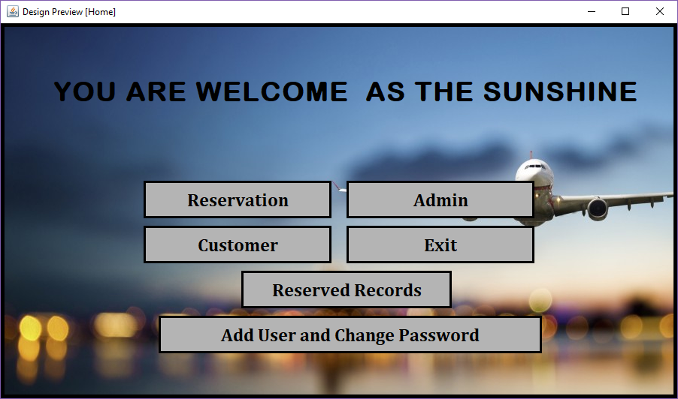

1. In this home page there are 5 button .
2. Reservation.
3. Admin.
4. Customer.
5. Reservation record.
6. Exit.
7. By clicking on RESERVATION button the flight reservation process is to be done for the selected origin ,destination ,date and price by the customer .
8. By clicking in CUSTOMER button the information of the customer is added, updated, deleted and the list of customer is generated as a report.
9. By clicking in ADMIN button the login process will be done and after that the user /admin is able to cancel the ticket of a particular customer aur delete/update the flight information.by this form new user can be added or the password of any existing user can be changed.
10. By clicking in RESERVERECORD button the list of all reservation of the customer is displayed and printed in the form of report.
11. By clicking in EXIT button the software will be closed.

**CONCLUSION**

The project Work entitled “AIRLINE RESERVATION SYSTEM” is a solution for any airline organisation. The software saves efforts and resources involved in the process of managing and maintaining reservation of flights for a particular date .

It was a wonderful and learning experience for us while working on this project. This project took me through the various phases of project development and gave us real insight into the world of software engineering.

It was due to this project I came to know how professional softwares are designed and what precaution should be taken. The project has led the path to the depth of the subject that requires a thorough study. No stone has been left unturned while developing this soft ware and making it easy to understand, easy to navigate through the forms.

With the conclusion of project i hope that my work will be proved helpful and will help the manager to manange the reservation of any flight providing procedure easy and fast error proof management process.

**REFERENCES**

**Books:**

1. Software Engineering – Author: Pankaj Jalote

2. Software Engineering – Author: Roger S Pfressman

3.Java :the complete reference – Author: Helbert schildt

4.Database system concept – Author: Henry F.korth

**Website:**

1. www.Stackoverflow.com
2. [www.tutorialspoint.com](http://www.tutorialspoint.com)
3. www.w3schools.com