MARKS : 100

Assessment

1. LINUX QUESTION: (Total marks : 20)
2. CREATE BLANK FILE NAMED TEST.TXT
3. ADD SOME CONTENT IN THAT TEST.TXT
4. DELETE THE FILE
5. CREATE ANOTHER FILE TEST1.TXT
6. CREATE A DIRECTORY NAMED “SANLAM”
7. COPY THE FILE TEST1.TXT IN THE DIRECTORY SANLAM
8. How you can rename test1.txt to abc.txt
9. Get inside the directory (Sanlam)
10. Come out of directory (sanlam)
11. Delete the directory (with the file inside it)
12. Delete the blank directory

GIT: (20 marks)

1. Create a clone of <https://github.com/akshu20791/java-tomcat-sample-docker-project>
2. Fork <https://github.com/akshu20791/java-tomcat-sample-docker-project>
3. Difference between clone and fork ?
4. Create a new private repository on github named assessmentrepo
5. Create some files in local repo and push it to assesmentrepo
6. Edit the assessmentrepo and make some changes ….also in local repo make some changes…now try to push the code from local to remote..you will get an error ..how to resolve the error.
7. Create a file named file10.txt …now push that file to assementrepo
8. Make some changes (add content hello world) to file10.txt and add it to local repo …also via assessmentrepo ..change file10.txt and add content (hii Akshat) … now push the code from local to remote. The conflict error will come . how to resolve it?
9. Create a 3 branches and make 5 commits in that ….and try to make the structure like below

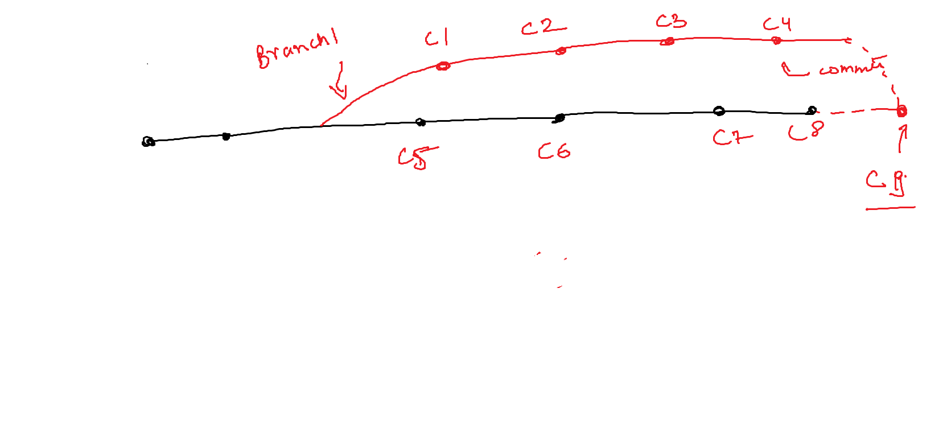

JENKINS (20 marks)

1. Create a Automated CI/CD pipeline for car api repo : <https://github.com/akshu20791/car-api-project> (use windows Jenkins …and declarative pipeline)
2. Create a scripted pipeline for car api repo : <https://github.com/akshu20791/car-api-project> (use windows Jenkins)
3. Create a automated CI/Cd pipeline for car api repo: <https://github.com/akshu20791/car-api-project> (on linux Jenkins – declrative pipeline)
4. Create a automated CI/Cd pipeline for car api repo: <https://github.com/akshu20791/car-api-project> (on linux Jenkins and scripted pipeline )
5. Create users in Jenkins and assign roles to the users

Ansible: (20 marks)

1. Launch ansible in linux (one ansible server and two nodes) with demo group and ansible user.
2. With the use of adhoc commands install httpd software in the nodes
3. With the use of adhoc commands create blank files in nodes
4. Via ansible playbook launch a apache website in nodes
5. Via playbook create a directory in nodes