Nagios

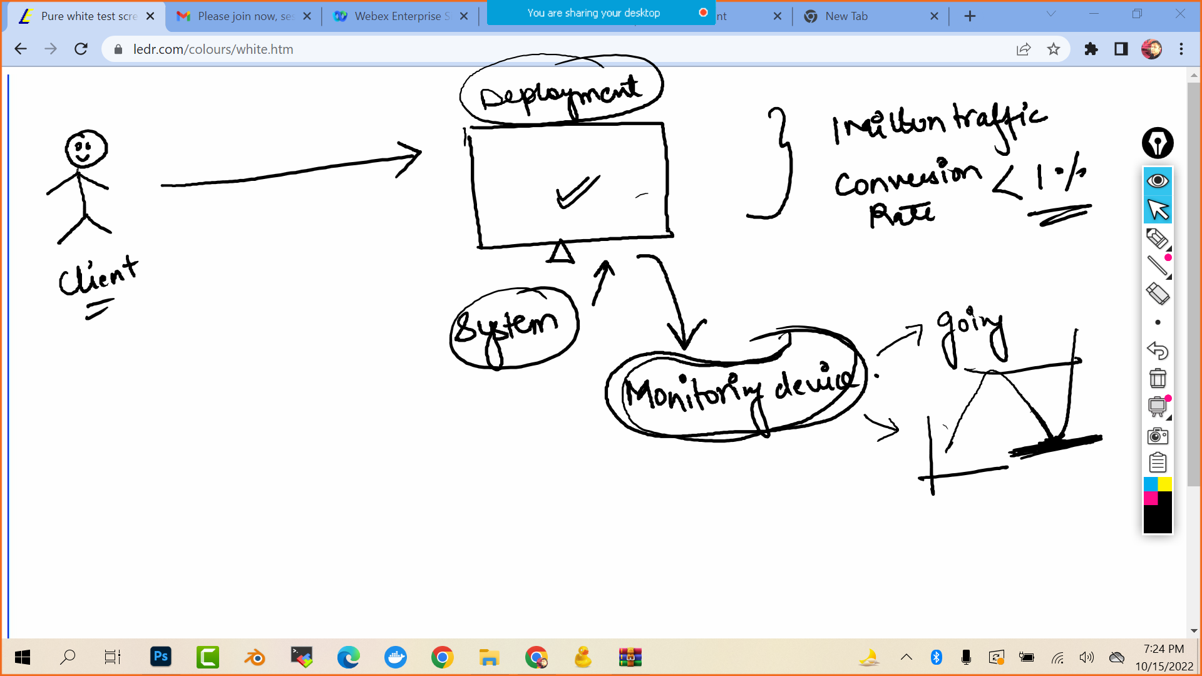

* Nagios is a open source software for continuos monitoring of systems ,networks and infrastructure.
* It runs plugins stored on a server which is connected with the host or another server on your network or the internet.



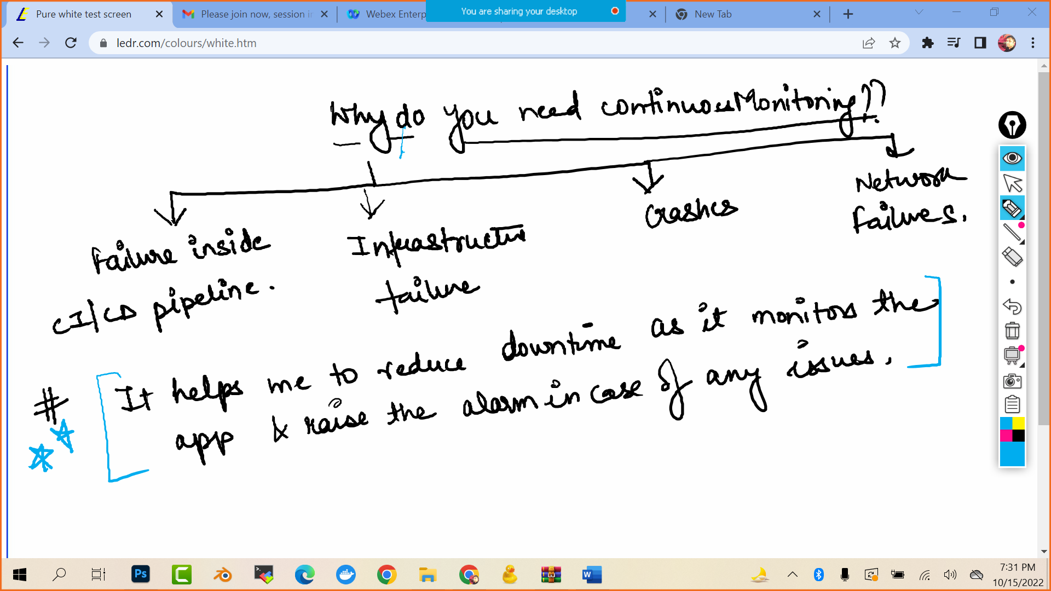

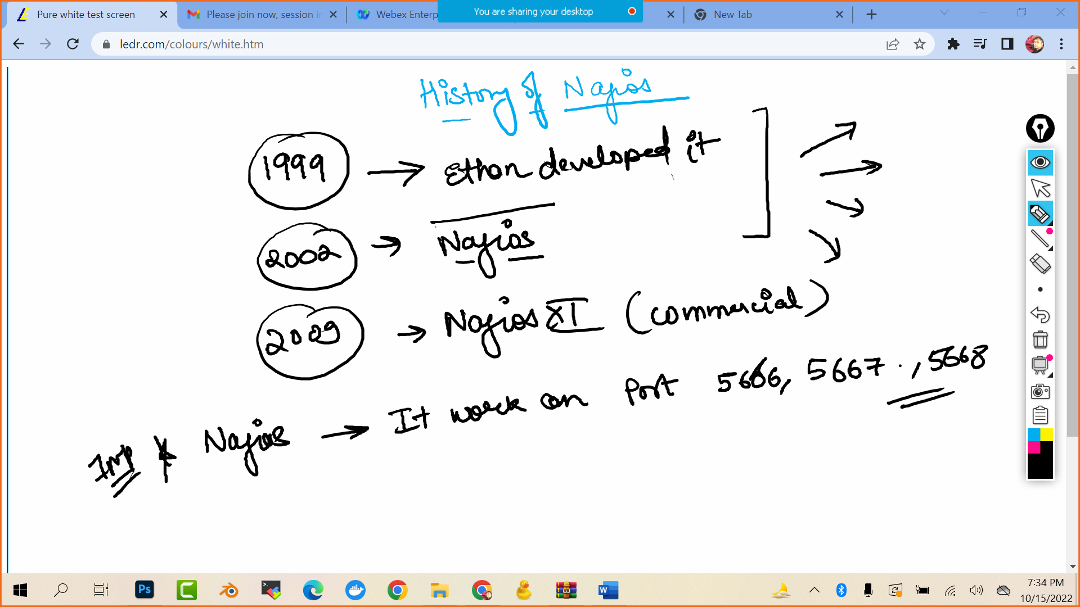

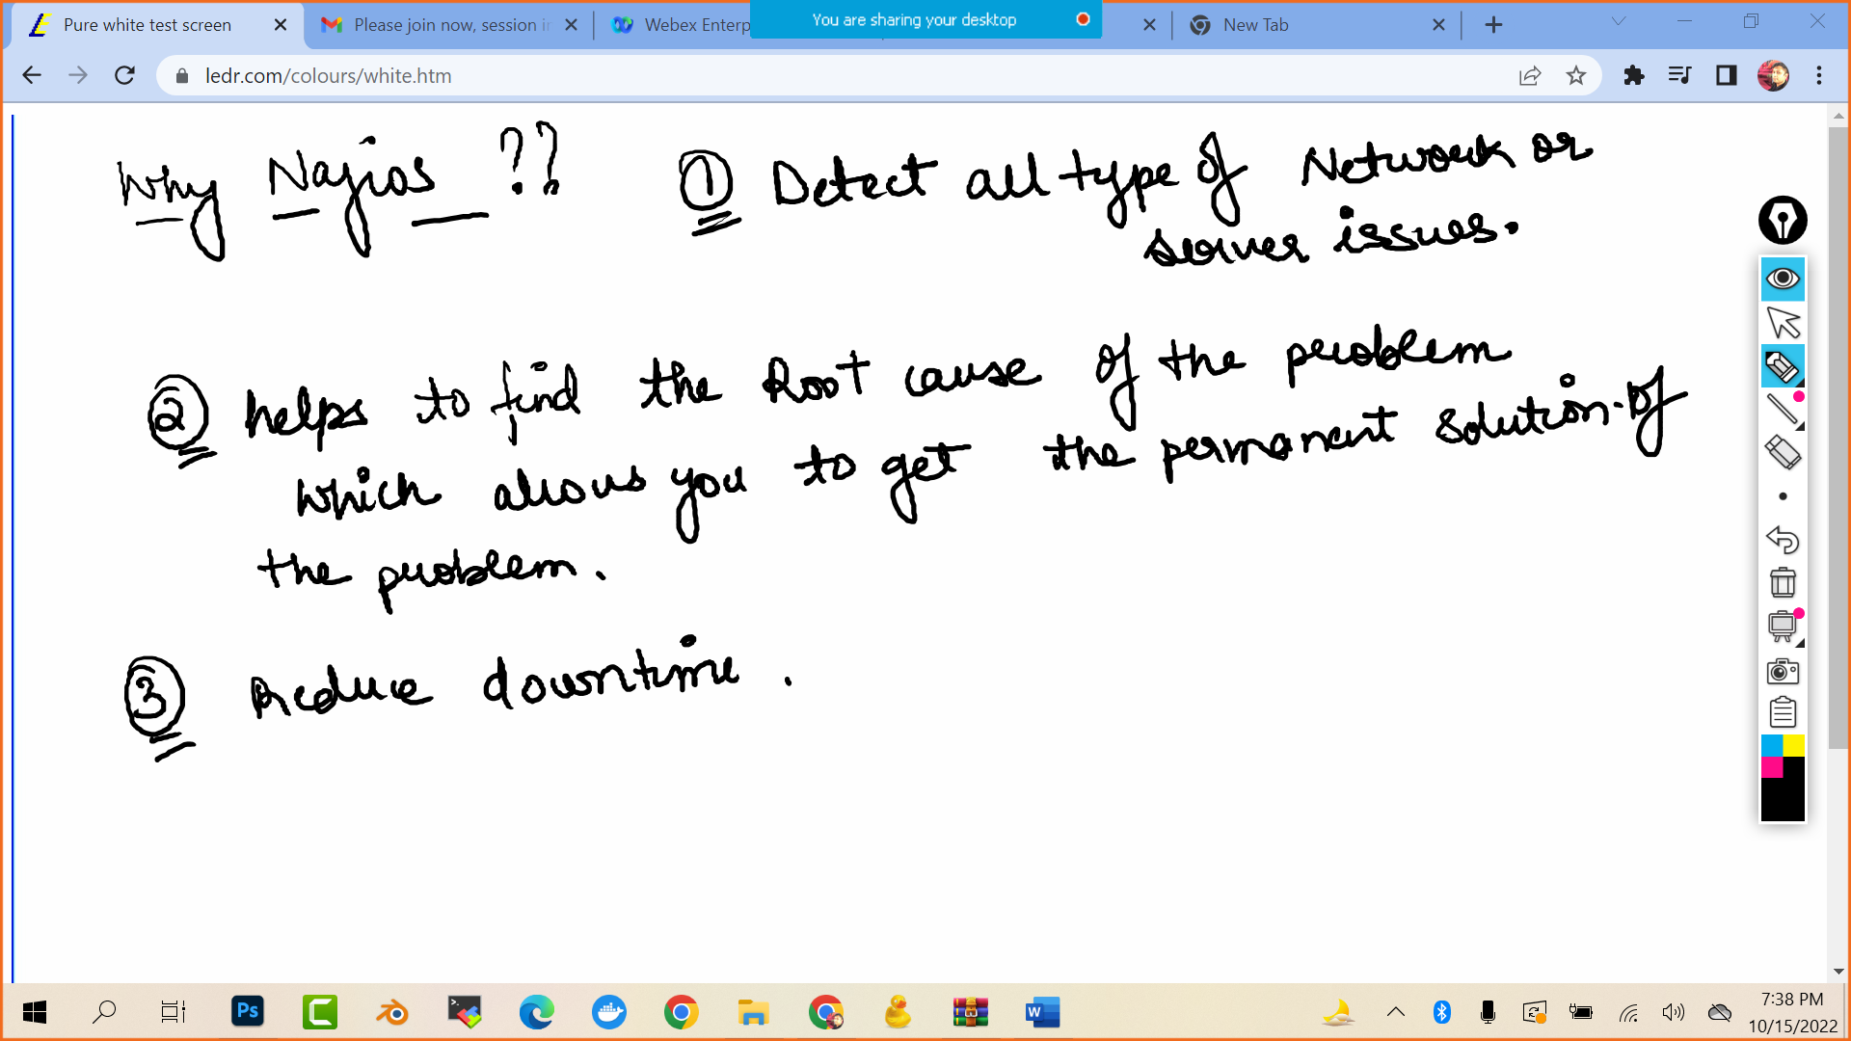

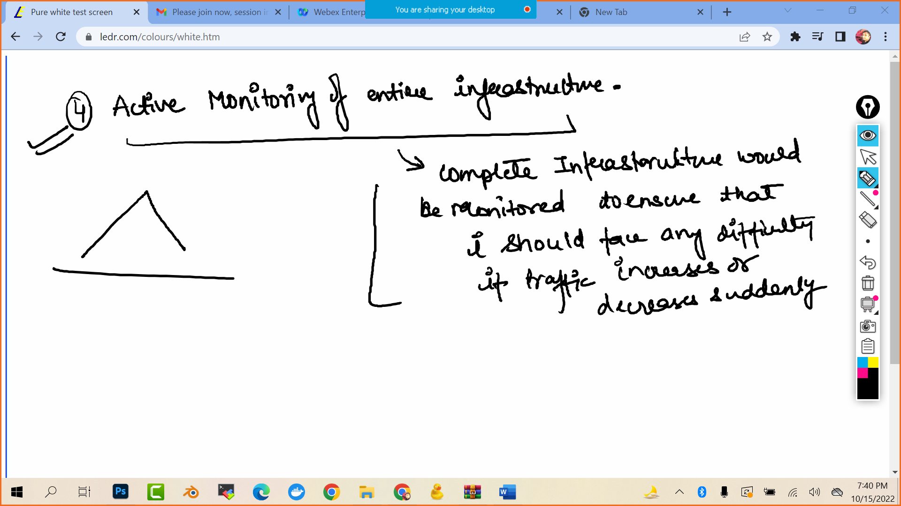

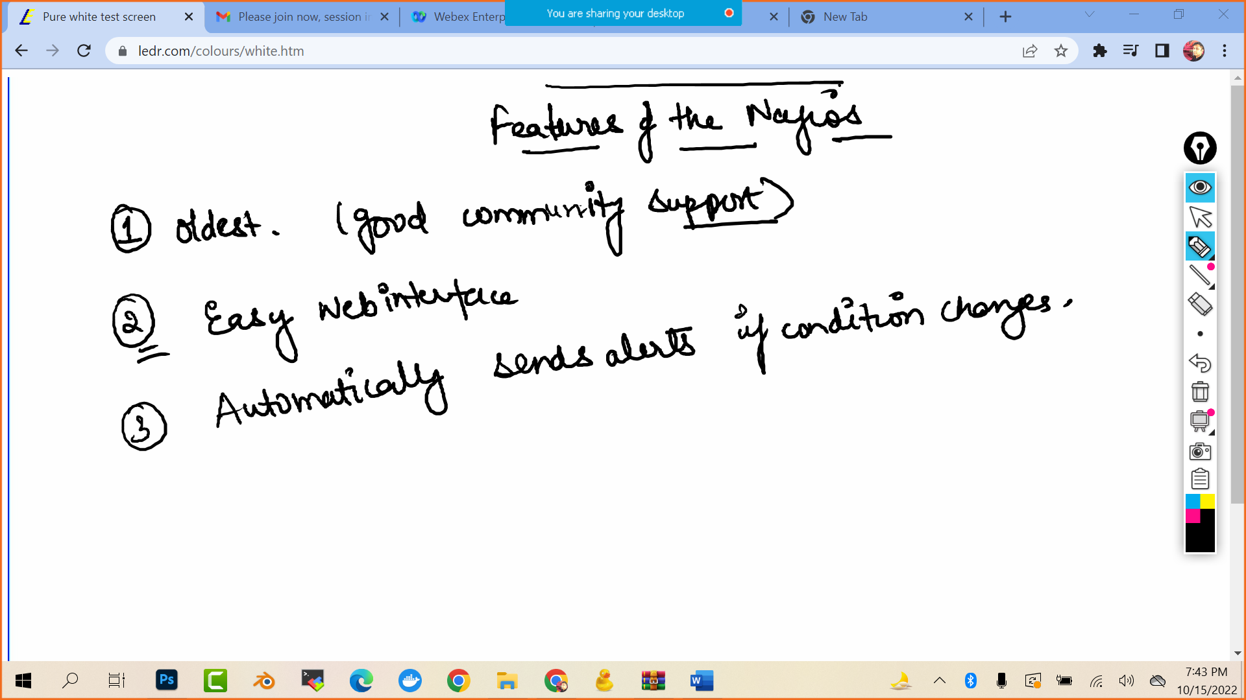

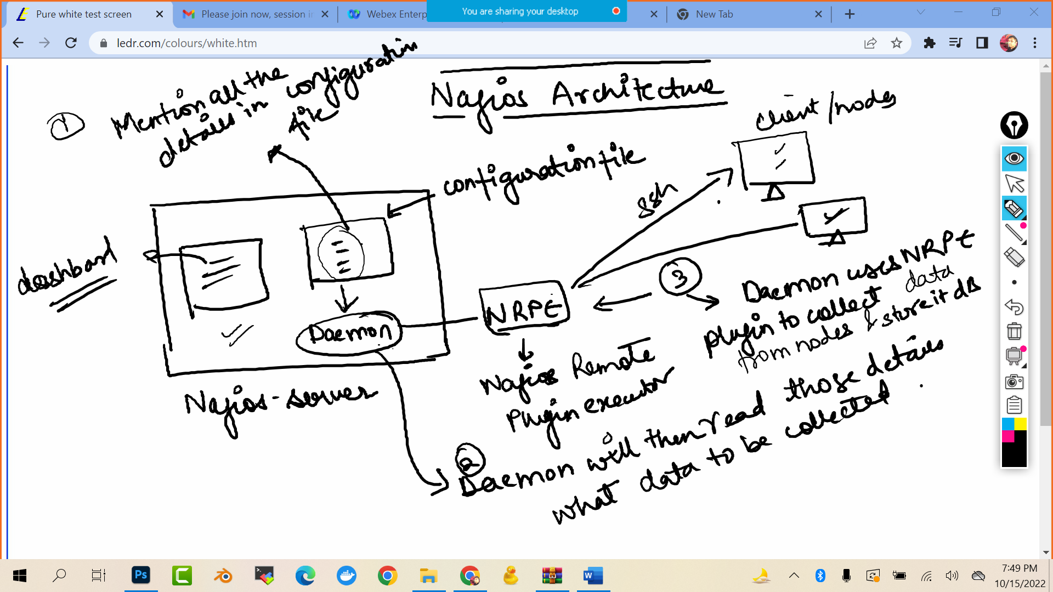

Lab:

Launch aws linux machine

Establish ssh connection via mobaxterm

Follow along the documentation

<https://drive.google.com/file/d/14wfJDFKueH7EsUdM4yDBvGSs4c_G7ZsA/view?usp=sharing>

and at the last

<<public ip >>/nagios

It will ask for username: nagiosadmin

Pass:

