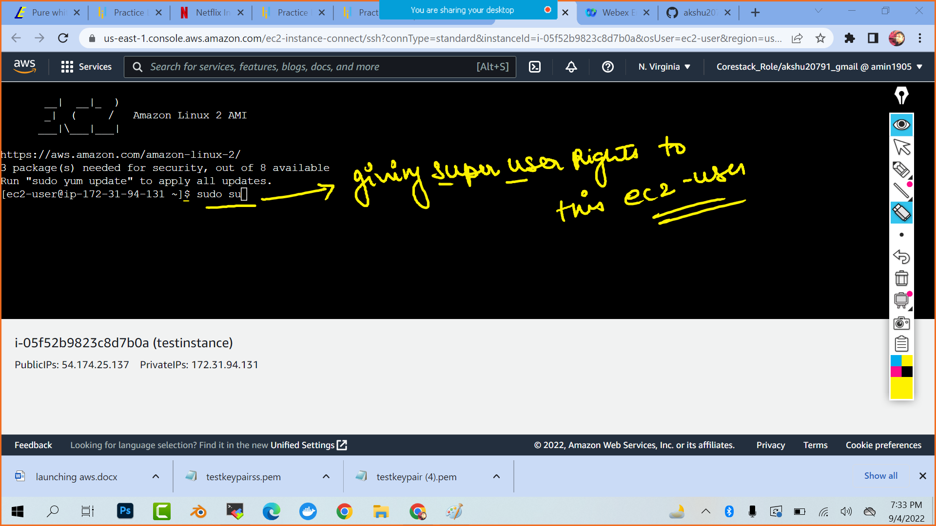

You can clear your screen by pressing ctrl l

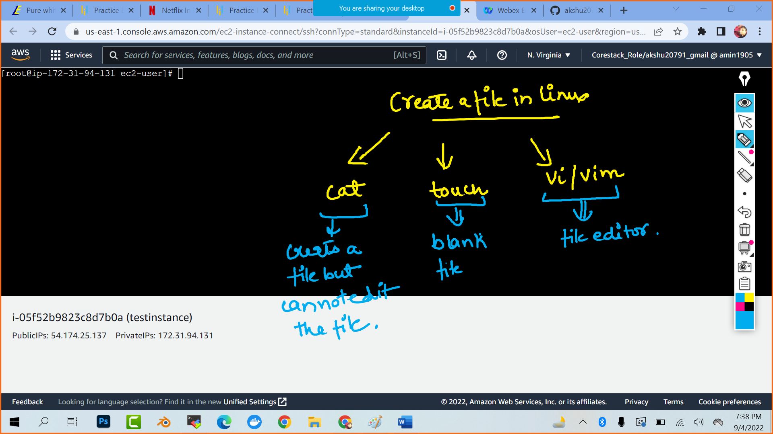

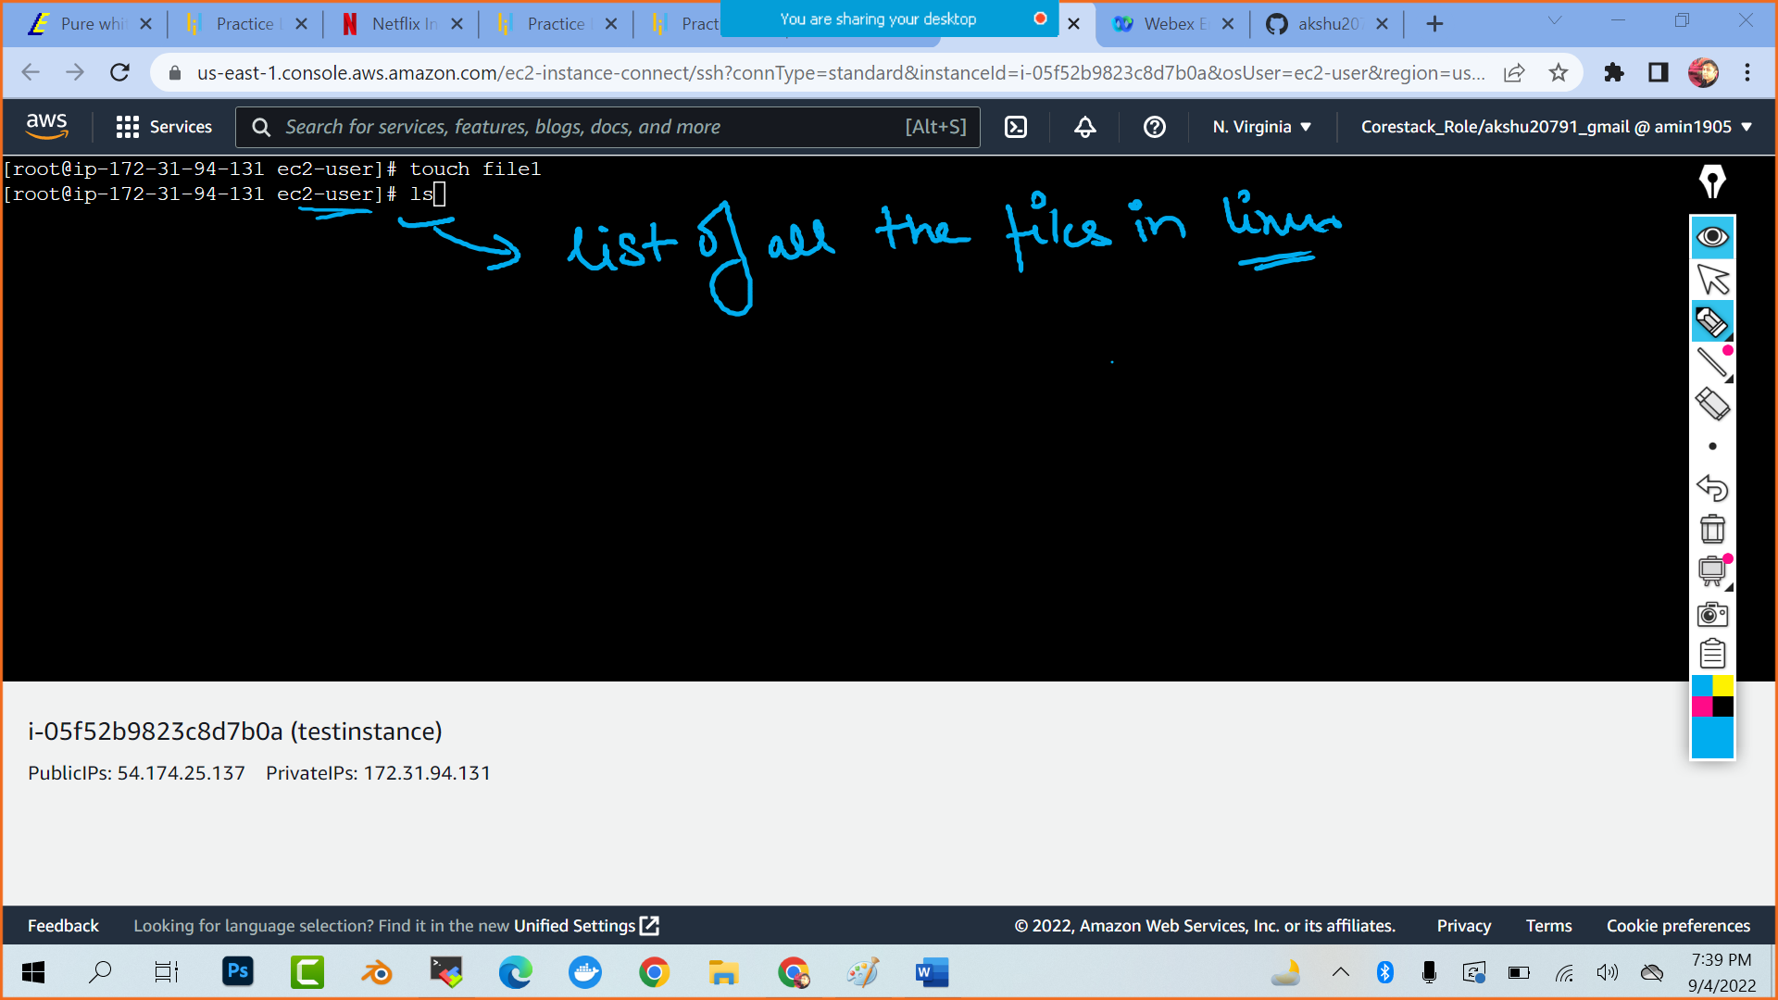

###Create multiple files

touch file2 file3 file4 file5

###to list the files and folder

ls

##create a file with some content

cat > file6 (press enter)

add content (pres enter)

(to exit press ctrl d )

ls

cat file6 (to check the content of any particular file)

################USE OF FILE EDITOR

cat > file7 (press enter)

hello world

(press enter and ctrl d)

vi file7 (press enter and file editor will open)

hello world (existing content would be there) (to start editing press i which is insert )

my name is Akshat

(to exit press escape and :wq) (:w- save q – quit)

cat file7

o/p :

hello world

my name is Akshat

#to see the stats of the file1

stat file1 (stat <<filename>>)

# to check my current working directory



pwd

### directory /folder in linux

mkdir testname (creates a directory with name testname)

ls

cd testname (cd <<directory name>> to get inside the directory)

cd .. (to go back to previous directory)

#######################################

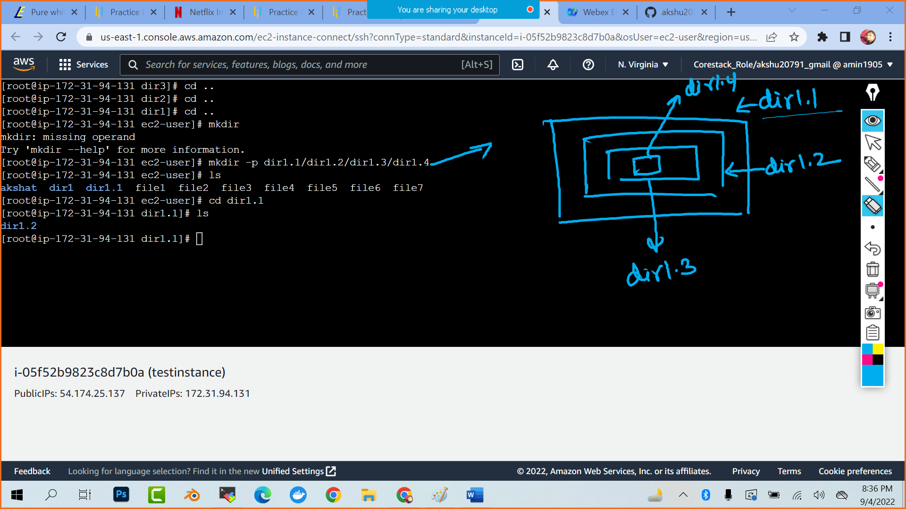

mkdir -p dir1.1/dir1.2/dir1.3/dir1.4

ls

cd dir1.1

ls

cd dir1.2

and so on

####to create multiple directories

mkdir dira dirb dirc dird

ls

##############COPY FILES ################

touch filenew

mkdir testdir1

cp filenew testdir1 (it will copy the filenew in testdir1)

cd testdir1

ls

(o/p : filenew)

########## CUT A FILE AND PUT IT IN DIRECTORY ##############

touch file90

mkdir directoryakshat

mv file90 directoryakshat (it will cut the file90 and move it to directoryakshat)

ls

cd directoryakshat

ls