**Steps to setup git and Jenkins on IBMi**

Using SSH connection is a preferred way to communicate with PASE rather that QP2TERM, but for this basic steps you can use wither. I have used PuTTY for SSH connection.

To get started with open source you should have yum package manager in you IBMi

1. **Check if YUM package manager is installed or not.**

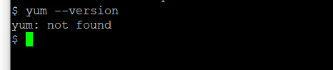

1. **Check if the home directory has a folder with your profile name, if not then create one with `mkdir userProfile` and create a hidden file in it with command `touch .profile` (dot profile).**

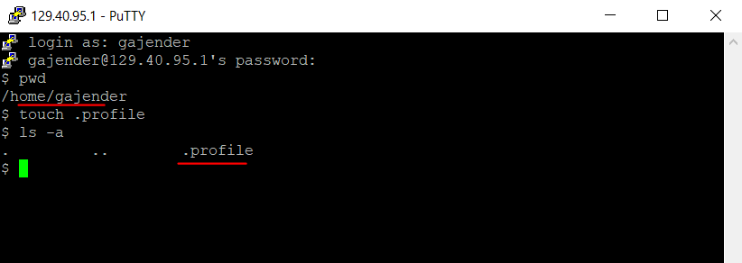

1. **Use the following link if you don’t have yum setup already**

<https://github.com/Programmersio-IBMi/OSSonIBMi>

1. Execute bootstap.sql from acs. Even if it shows fail at the end do not panic it ran fine.   
     
   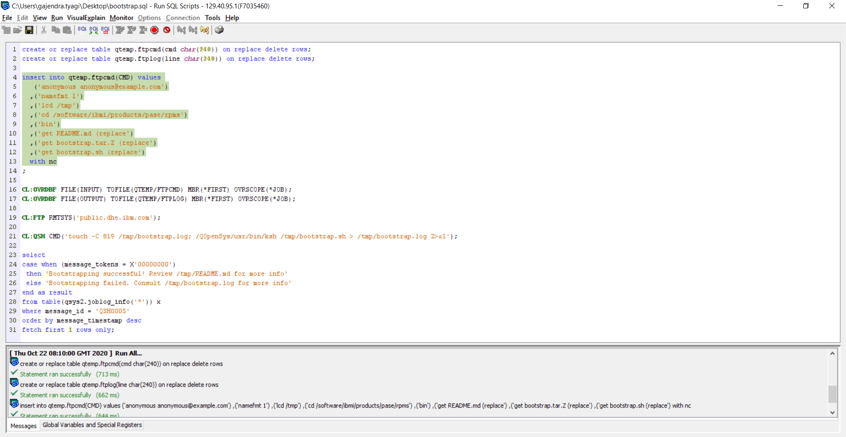
2. Run this command after acs has ran.

* echo 'PATH=/QOpenSys/pkgs/bin:$PATH' >> $HOME/.profile && echo 'export PATH' >> $HOME/.profile

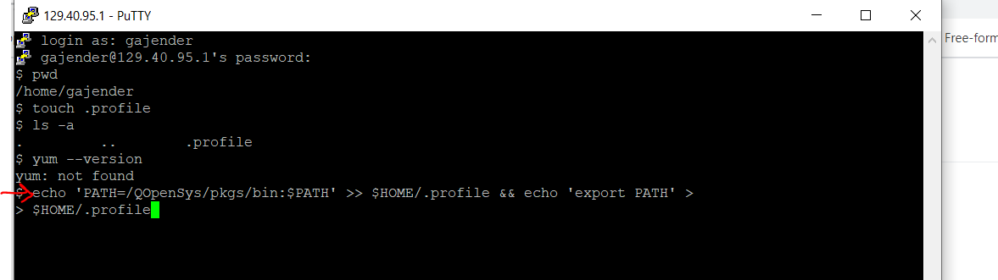

1. 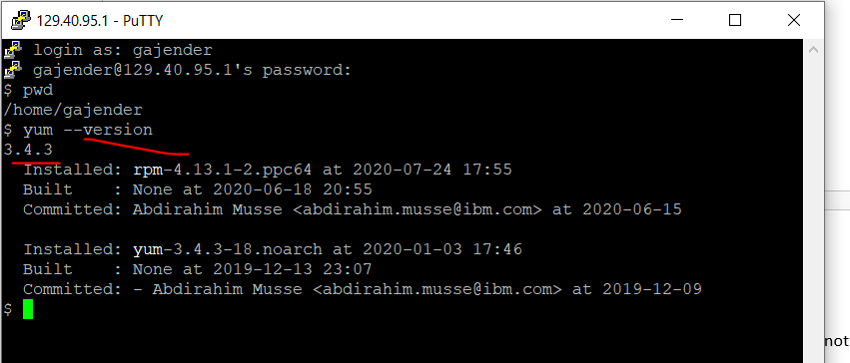
2. Some YUM commands you must know <https://access.redhat.com/sites/default/files/attachments/rh_yum_cheatsheet_1214_jcs_print-1.pdf>
3. **Install git using YUM**

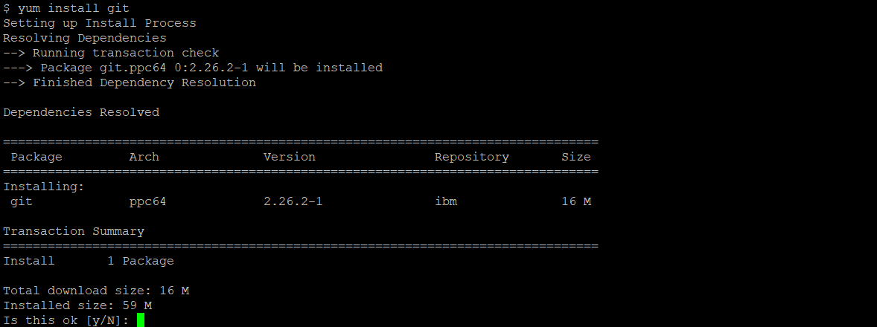

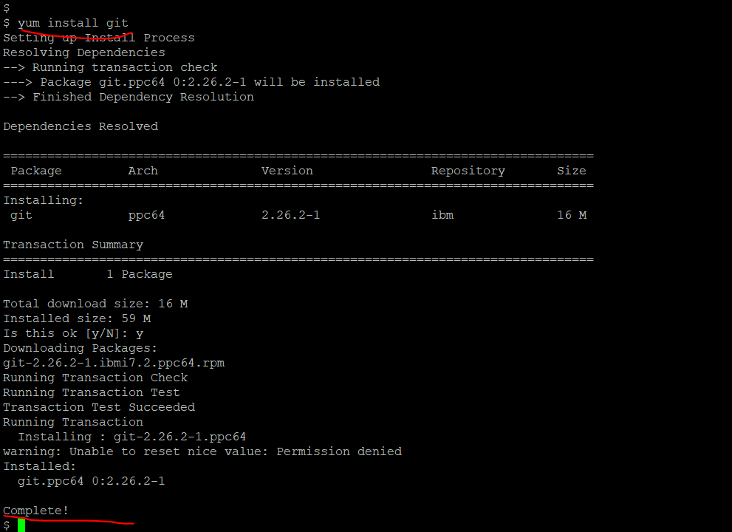



1. **Now git can be used locally on IBMi but it can be used on IFS objects only**, git cannot track native sources from libraries. All sources have to be moved to ifs in a structured manner.
2. **To use remote repository like from GitHub we need to have SSH key setup which can be done following these steps -**https://docs.github.com/en/free-pro-team@latest/github/authenticating-to-github/generating-a-new-ssh-key-and-adding-it-to-the-ssh-agent   
     
   Without SSH setup you won’t be able to clone remote repositories.  
     
   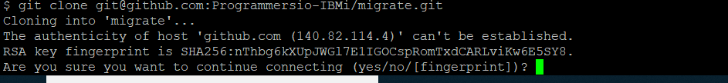
3. **If you are using SSH connection then run this command first :**   
   /QOpenSys/pkgs/bin/bash
4. **If you have followed all steps properly then you are good to go.**   
     
   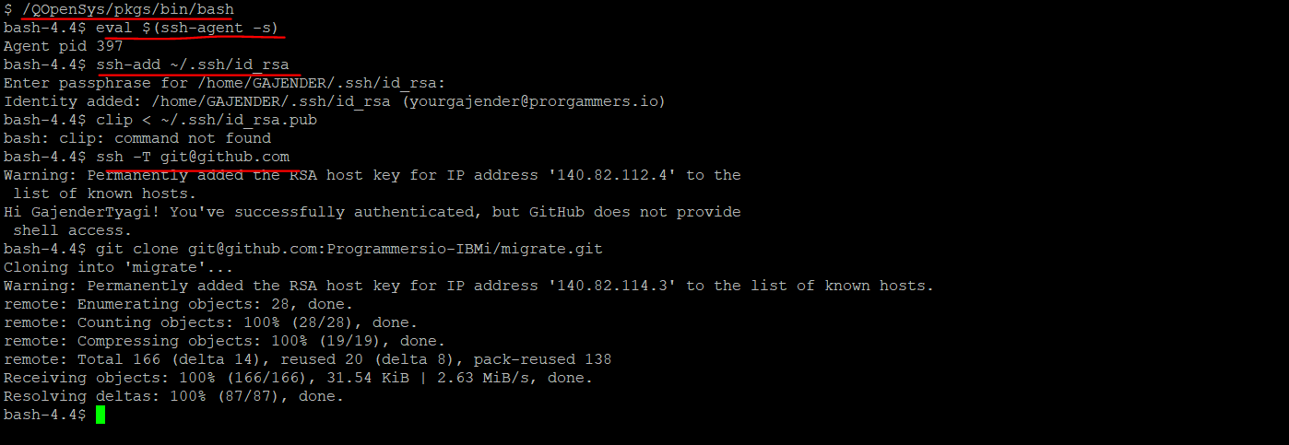
5. **Setup Jenkins, reference link** : <https://github.com/worksofliam/blog/issues/43>
6. `wget <http://mirrors.jenkins.io/war-stable/latest/jenkins.war>`
7. **Once Jenkins is installed its time to run it.**

java -jar jenkins.war --httpPort=9090

1. **Use above command to run initially and do one time setup.**
2. **Complete the initial setup.**
3. **Once the initial setup is done we now should have a batch job running Jenkins so that we can monitor that.**  
     
   a. Move to the path where you have Jenkins setup   
     
   b. Create a shell file and paste the below content

**export** PATH=/QOpenSys/pkgs/bin:/home/gajender/.ssh:$PATH;

**export** TERM=xterm;

**export** SHELL=/QOpenSys/usr/bin/bsh;

**export** SHLVL=1;

cd /home/gajender/jenkins;

java -jar jenkins.war --httpPort=6123

change user Gajender with your user

c. Save this file and run the following command from 5250 session   
QSH CMD('/QOpenSys/pkgs/bin/bash /home/gajender/jenkins/runJenkins.sh')

1. **New Item is used to setup a job to perform the build process.**

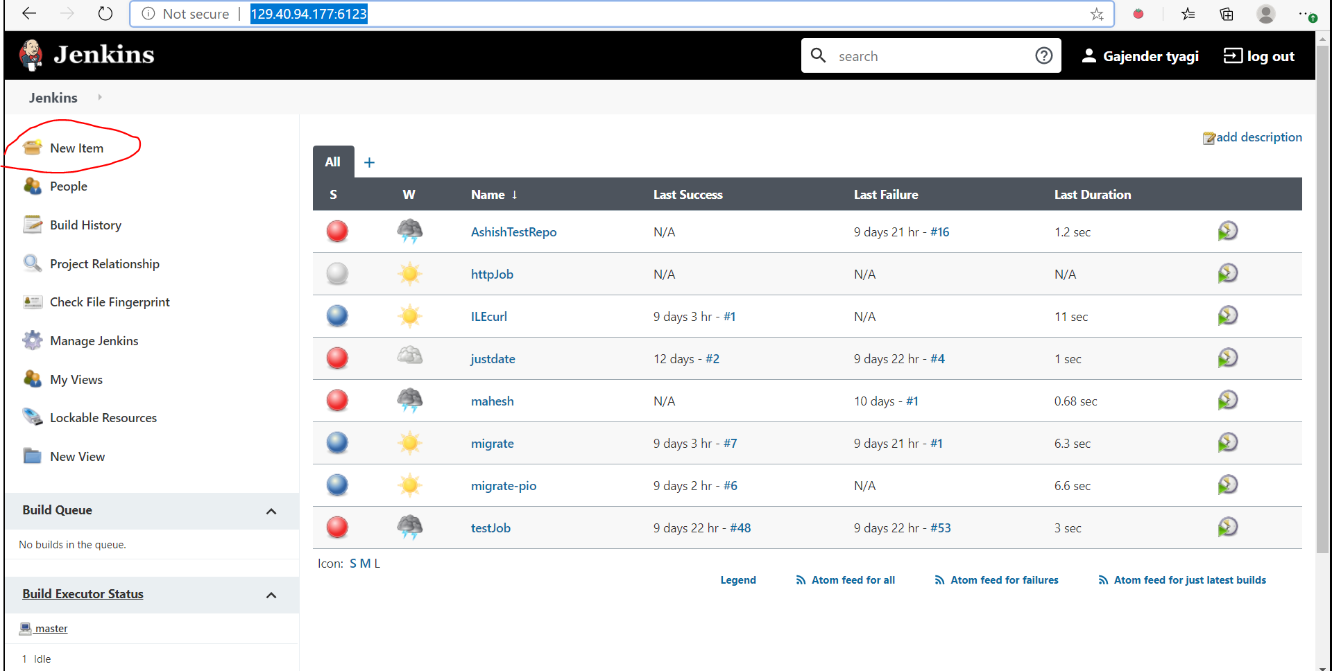

1. **Inside the item config you will mention the repo link and the user with correct authority.**

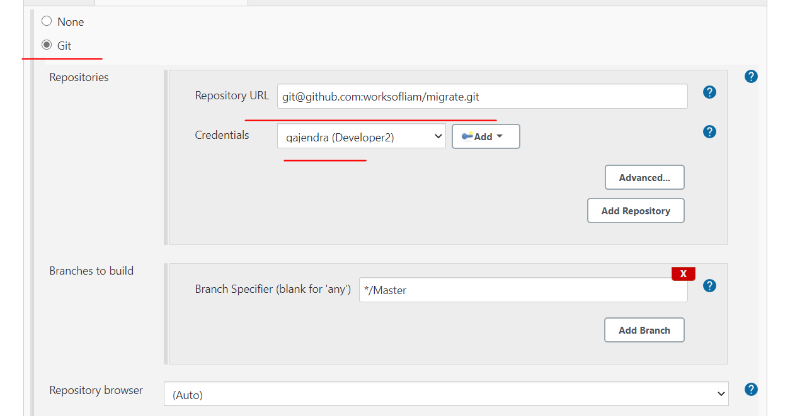

1. 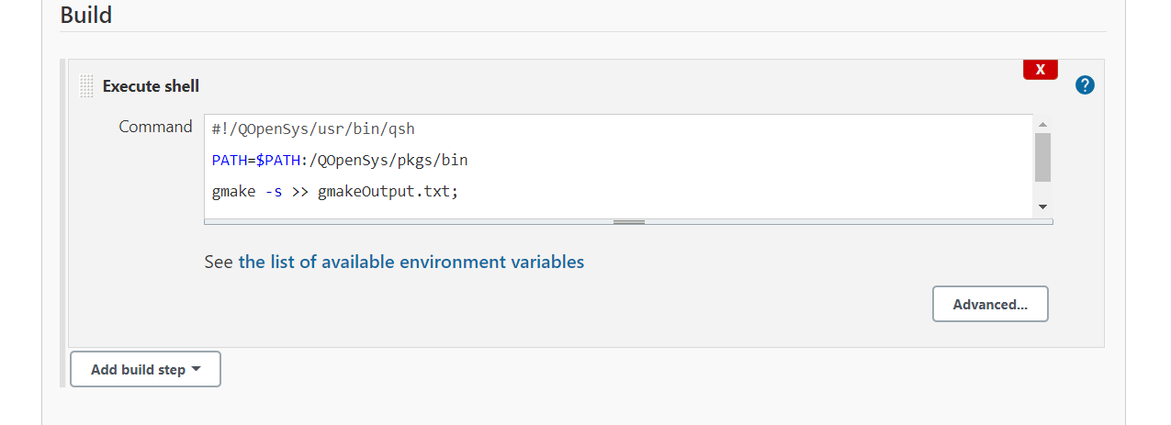
2. 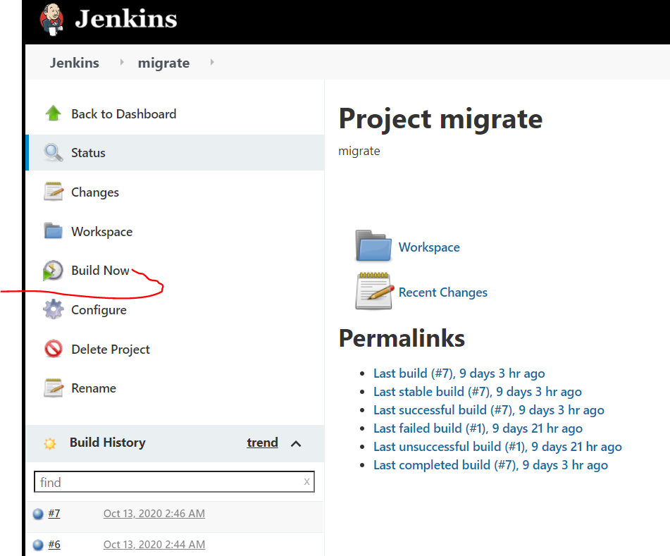
3. MAKEFILE lives in projects repository and the structure can be as shown below, MAKEFILE is configured as per requirement.

**A standard MAKEFILE**

SMY_ENV=DEV

DBGVIEW=*SOURCE

SHELL=/QOpenSys/usr/bin/qsh

BIN_LIB=PROFSRVDEV

DTA_LIB=$(BIN_LIB)

SRC_LIB=$(BIN_LIB)

MBR_PGM=QRPGLESRC

MBR_DDS=QDDSSRC

LIBLIST=$(BIN_LIB)  ASODTAPDEV AAPDTANEWT APODTANEWT AARDTANEWT CASPGM AWODTANEWT DSTPGMSMY APOPGMSMY AARPGMSMY AWOPGMSMY PUIDEV PJSDEV

all: rpdlssps.pgm bidyspsls.pgm bil12spsls.pgm rpl12spsls.pgm biwkspsls.pgm rpwkspsls.pgm

*# Daily sales person sales*

bidyspsls.pgm: bidyspsls.sqlrpglemod dlsspsrcd.sqlrpglemod

bidyspsls.sqlrpglemod: bidyspslsd.dspf

rpdlssps.pgm: rpdlssps.sqlrpglemod dlsspsrcd.sqlrpglemod

rpdlssps.sqlrpglemod: rpdlsspsp.prtf asoscmv1

asoscmv1:

    -db2 -t -f ./buildSrc/asoscmv1.sql $(DTA_LIB) | /usr/bin/iconv -t 819 -f 37;

    system "CPYFRMSTMF FROMSTMF('./buildSrc/asoscmv1.sql') TOMBR('/QSYS.lib/$(SRC_LIB).lib/$(MBR_DDS).file/asoscmv1.mbr') MBROPT(*replace)"

%.rpgle:

    liblist -d PROFSRVDEV; \

    liblist -al $(LIBLIST);\

    system "CRTRPGMOD MODULE($(BIN_LIB)/$*) SRCSTMF('./src/qrpglesrc/$*.rpgle') DBGVIEW($(DBGVIEW)) REPLACE(*YES)"

    system "CPYFRMSTMF FROMSTMF('./src/qrpglesrc/$*.rpgle') TOMBR('/QSYS.lib/$(SRC_LIB).lib/$(MBR_PGM).file/$*.mbr') MBROPT(*replace)"

%.c:

    system "CRTCMOD MODULE($(BIN_LIB)/$*) SRCSTMF('./src/$*.c') DBGVIEW($(DBGVIEW)) REPLACE(*YES)"

%.clle:

*#Can't compile CL from IFS on all OS versions... < 7.1*

    -system -q "CRTSRCPF FILE($(BIN_LIB)/$(MBR_PGM)) RCDLEN(112)"

    system "CPYFRMSTMF FROMSTMF('./src/$*.clle') TOMBR('/QSYS.lib/$(BIN_LIB).lib/$(MBR_PGM).file/$*.mbr') MBROPT(*replace)"

    system "CRTCLMOD MODULE($(BIN_LIB)/$*) SRCFILE($(BIN_LIB)/$(MBR_PGM)) DBGVIEW($(DBGVIEW))"

%.dspf:

    liblist -d PROFSRVDEV; \

    liblist -al $(LIBLIST); \

    system "CPYFRMSTMF FROMSTMF('./src/qddssrc/$*.dspf') TOMBR('/QSYS.lib/$(SRC_LIB).lib/$(MBR_DDS).file/$*.mbr') MBROPT(*replace)"

    system "CRTDSPF FILE($(BIN_LIB)/$*) SRCFILE($(SRC_LIB)/$(MBR_DDS)) SRCMBR($*) REPLACE(*YES)"

%.prtf:

    liblist -d PROFSRVDEV; \

    liblist -al $(LIBLIST); \

    system "CPYFRMSTMF FROMSTMF('./src/qddssrc/$*.prtf') TOMBR('/QSYS.lib/$(SRC_LIB).lib/$(MBR_DDS).file/$*.mbr') MBROPT(*replace)"

    system "CRTPRTF FILE($(BIN_LIB)/$*) SRCFILE($(SRC_LIB)/$(MBR_DDS)) SRCMBR($*) DEVTYPE(*AFPDS) IGCDTA(*N) IGCEXNCHR(*N) IGCCHRRTT(*N) IGCCPI(*N) IGCSOSI(*N) IGCCDEFNT(*SYSVAL) REPLACE(*YES) "

%.pgm:

    liblist -d PROFSRVDEV; \

    liblist -d PUIDEV;\

    liblist -al $(LIBLIST);\

    system "CRTPGM PGM($(BIN_LIB)/$*) MODULE($(patsubst %,$(BIN_LIB)/%,$(basename $^))) ENTMOD($(BIN_LIB)/$*) REPLACE(*YES)"

%.sqlrpglemod:

    liblist -d PROFSRVDEV;\

    liblist -d PUIDEV;\

    liblist -al $(LIBLIST);\

    system "CRTSQLRPGI OBJ($(BIN_LIB)/$*) SRCSTMF('./src/qrpglesrc/$*.sqlrpglemod') OBJTYPE(*MODULE) REPLACE(*YES)"

    system "CPYFRMSTMF FROMSTMF('./src/qrpglesrc/$*.sqlrpglemod') TOMBR('/QSYS.lib/$(SRC_LIB).lib/$(MBR_PGM).file/$*.mbr') MBROPT(*replace)"

%.sqlrpgle:

    liblist -d PROFSRVDEV;\

    liblist -d PUIDEV;\

    liblist -al $(LIBLIST);\

    system "CRTSQLRPGI OBJ($(BIN_LIB)/$*) SRCSTMF('./src/qrpglesrc/$*.sqlrpgle') OBJTYPE(*PGM) REPLACE(*YES)"

    system "CPYFRMSTMF FROMSTMF('./src/qrpglesrc/$*.sqlrpgle') TOMBR('/QSYS.lib/$(SRC_LIB).lib/$(MBR_PGM).file/$*.mbr') MBROPT(*replace)"

%.sql:

    sed -i.bak "s/DTA_LIB/$(DTA_LIB)/g" ./$*.sql

    system "RUNSQLSTM SRCSTMF('./src/$*.sql')"

all:

    @echo "Build finished!"

**EXECUTE shell script as used in Jenkins**

*#!/QOpenSys/usr/bin/qsh*

gmake -s >> gmakeOutput.txt;

exitCode="$?";

/usr/bin/iconv -t UTF-8 -f 819 gmakeOutput.txt > converted.txt;

/QOpenSys/usr/bin/sh ;

tail -20000 converted.txt | /usr/bin/iconv -t 37 -f 819;

rm gmakeOutput.txt;

rm converted.txt;

**if** test $exitCode -gt 0

**then**

    false

**else**

    true

**fi**