Measuring player impact on evolution of width phenotype

This experiment is meant for students just getting into scientific experiments and data manipulation. It is not intended to students younger than 8th grade, and should in many cases be an extended project rather than in-class due to the time it takes to run.

Evolution is a main driving force behind how a species changes and adapts to the environment, but it can become confusing when you introduce that species as a part of the environment. For example, our environment as human beings may include other humans, dogs, trees, birds, and even micro-organisms and bacteria, and we are in a constant state of involvement with each of those species in our environment. We influence the evolution of bacteria or dogs as much as they might influence our own evolution. A more visible example of one species affecting the environment of another would include the cutting down of rainforests. Our species is directly effecting the lifestyle of organisms within those environments, and in many cases, natural selection and evolution will force those animals to adapt and change to their new environments, or they will likely die. In order to determine how we can affect the evolution of another species, we will be comparing how multiple ways we interact with a specific environment can influence the overall change in a species, specifically the protean swarm in EvolveTD. Before we get started, though, there is a list of vocabulary words that need to be defined in order to better understand the experiment. All of the following terms can be found on this website, and will be important to understanding the experiment.

-Biome

-Ecosystem

-Sexual reproduction

-Mutation

-Genome

-Phenotype

-Genotype

-Evolution

-Genetic Diversity

-Control variable

-Independent variable

-Dependent variable

Now, it is time for you to create a hypothesis that you would like to test. What do you expect to happen? An example would be ‘As the tower targets creatures with lower width, the overall average width of the species will go down from generation to generation.’

Hypothesis:

**Methods**

To begin, start up EvolveTD until you get a biome that you desire (Snow, desert, grassland or swamp), and write down a single biome your experiment will utilize. This is important to keep consistency within the experiment with as little variability as possible. With your biome selected, follow the next few steps in order.

1.) Restart EvolveTD till you get the game to start with your chosen biome.

2.) Run EvolveTD through 20 generations with no tower or influence from yourself, the player.

3.) Take the data file located within the EvolveTD game folder, and rename it data1. This will be our control data.

4.) Restart EvolveTD till you get the game to start with your originally chosen biome.

5.) Once you have the available resources to build a tower, buy one for 300 resources and place it in the middle of the game map. Do not press any other keys. It should start firing automatically at the creature closest.

6.) Run this version of the game for 20 generations.

7.) Take the data file located within the EvolveTD game folder, and rename it data2.

8.) Restart EvolveTD till you get the game to start with your originally chosen biome (the biome that the other conditions have been run with).

9.) Once you have the available resources to build a tower, buy one for 300 resources and place it in the middle of the map. IMMEDIATELY after placing it, press the “7” key on the keyboard. This will make the tower target the creatures with the largest width.

10.) Run this version of the game for 20 generations.

11.) Take the data file located within the EvolveTD game folder, and rename it data3.

12.) Restart EvolveTD till you get the game to start with your originally chosen biome (the biome that the other conditions have been run with).

13.) Once you have the available resources to build a tower, buy one for 300 resources and place it in the middle of the map. IMMEDIATELY after placing it, press the “8” key on the keyboard. This will make the tower target the creatures with the smallest width.

14.) Run this version of the game for 20 generations.

15.) Take the data file located within the EvolveTD game folder, and rename it data4.

16.) Once you have collected the data for your 4 conditions, it is time to interpret it. Open up your data folders and open the c_avgs file. This is where you will find the data for that specific condition, under average width.

17.) Take the average values for width from each data set, select the first 20 generations, and select recommended graphs. You should be able to put the data into graphs for visual representation. There are pictorial examples below to help guide you through the process.

Step 1. Highlight the first 20 generations of average width values.

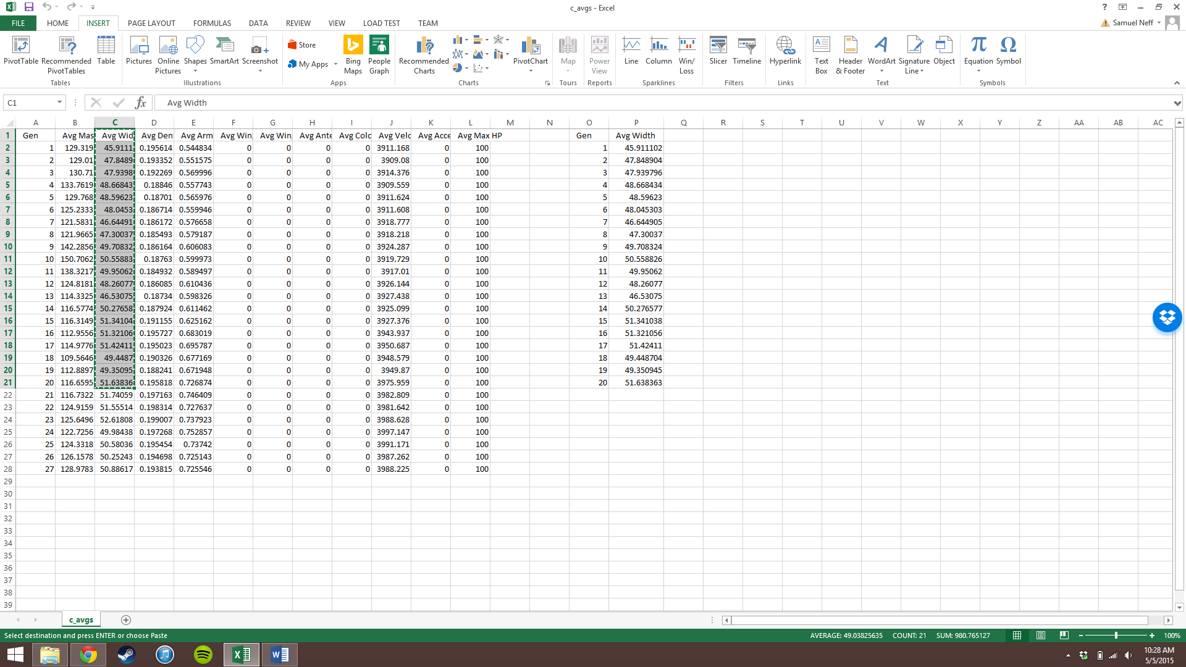

Step 2. Select recommended graphs on bar above, select all graph, line graph and select OK.

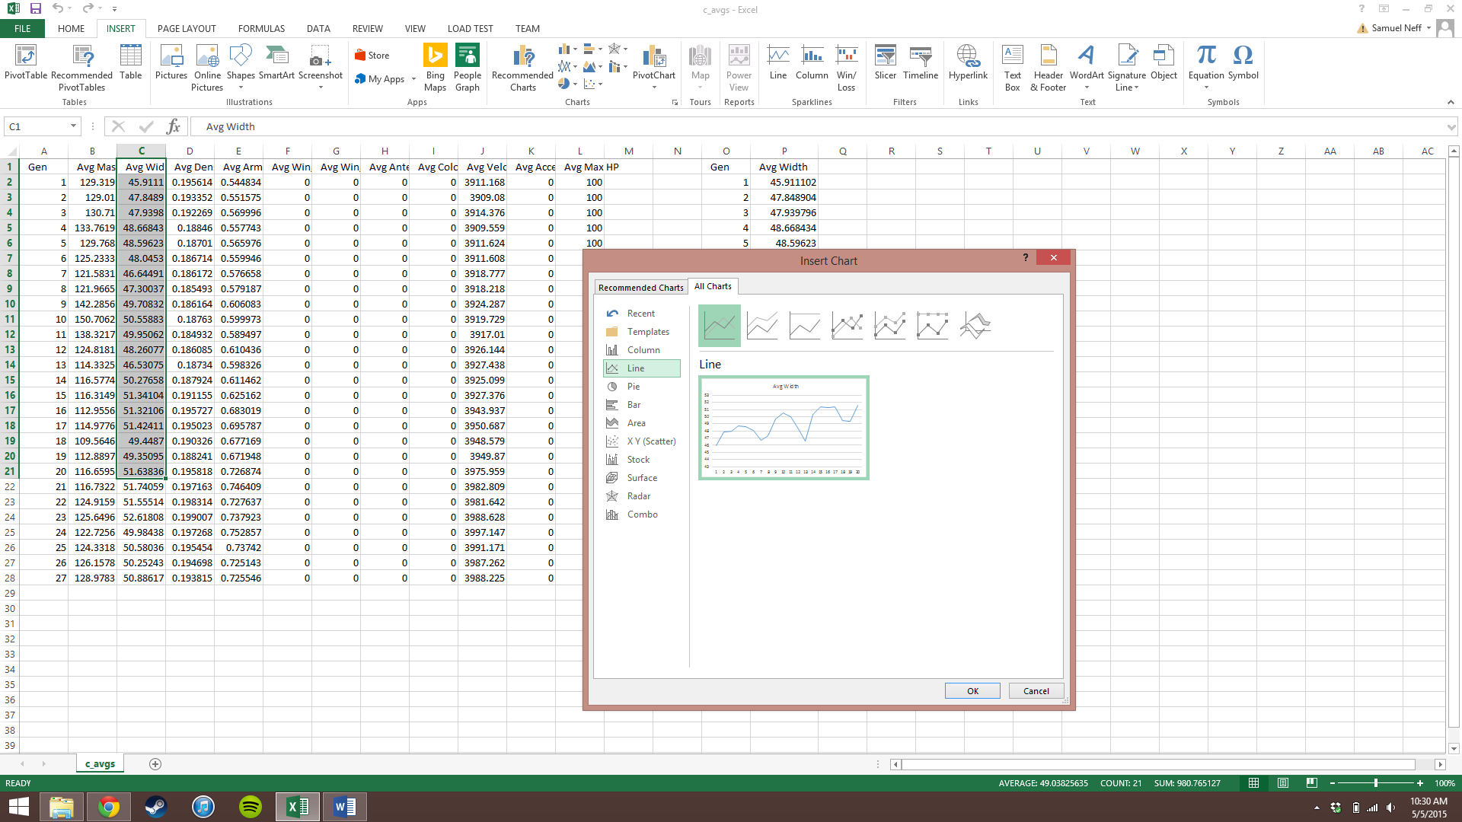

Step 3. At this point, your graph is present but not formatted correctly. Correct the title, as well as add axis labels to the graphs and rename them appropriately. You can do so by selecting the “+” sign attached to the graph.

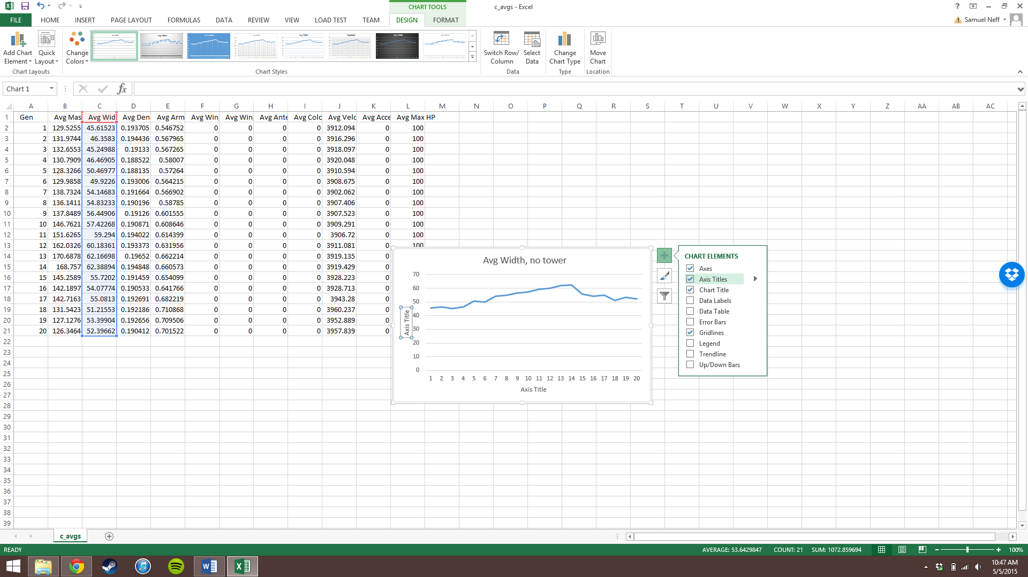

Step 4. Copy your graphs into a word document so that you can see them side by side.

17.) Describe your results. What types of differences can be seen between data sets?

18.) Compare your results with our own.

Now that you have your data, as well as visual representations of that data, it is time to analyze it. Answer the following questions based on the data you received.

1.) What was the Biome that you selected to use throughout the study? Why is it important to keep the Biome and other environmental variables consistent across multiple conditions of the experiment?

2.) What was your independent variable? What was your dependent variable? How did the independent variable impact the dependent variable within this experiment?

3.) What is a phenotype? Which phenotype are we measuring within this study? Does it change from generation to generation, and is it visible? What are some other phenotypes that you notice within EvolveTD?

4.) We may see genetic diversity from a few methods, but specifically within this experiment, we look at Mutation and sexual reproduction. How are sexual reproduction and mutation different and how are they similar? What would we expect to see if one or both of these mechanisms no longer existed within EvolveTD?

5.) In the condition where the tower targeted the highest width, was there a general change in average width values from one generation to the next, compared to the control condition? What about the condition where minimum width was selected?

6.) If we were to run this experiment again, what are some reasons we might not get the same data as we had before? Why?

7.) Overall in your experiment, did you find visible evidence that you were impacting the width of the Protean Swarm in any of the conditions? Which ones?

8.) Now run the experiment again, and compare your new results with your old. Why is this step important when coming to conclusions about data?