# /Taxi

# Created on October 18 2019

# Table of Contents

1.0. User

2.0. Admin

# 1.0. User

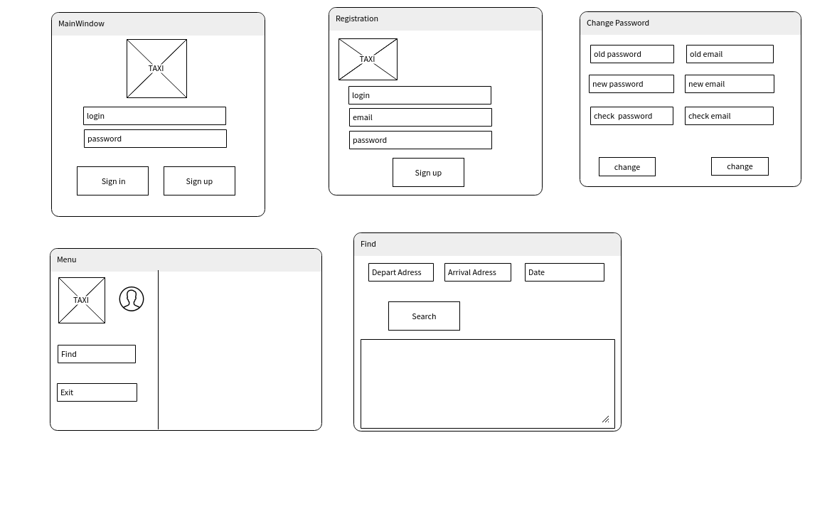

# 2.0. Admin

