Class Diagram  All questions in this exam are based on one app. | 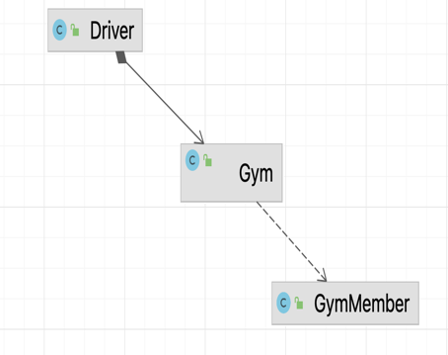
Skeleton Driver Code
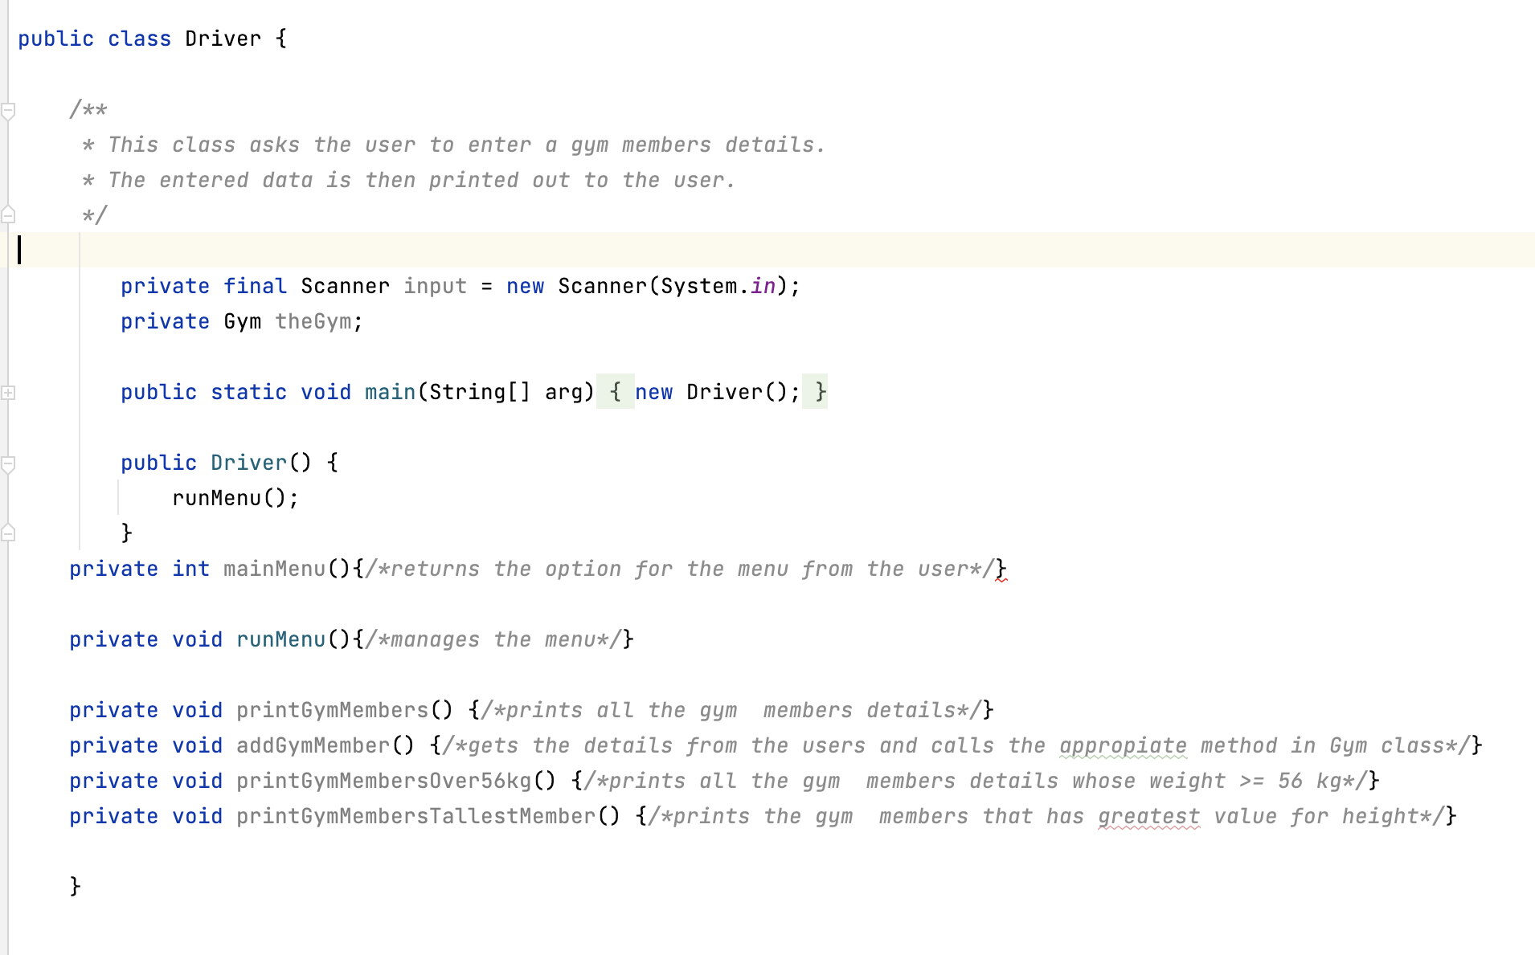

Skeleton Gym Code

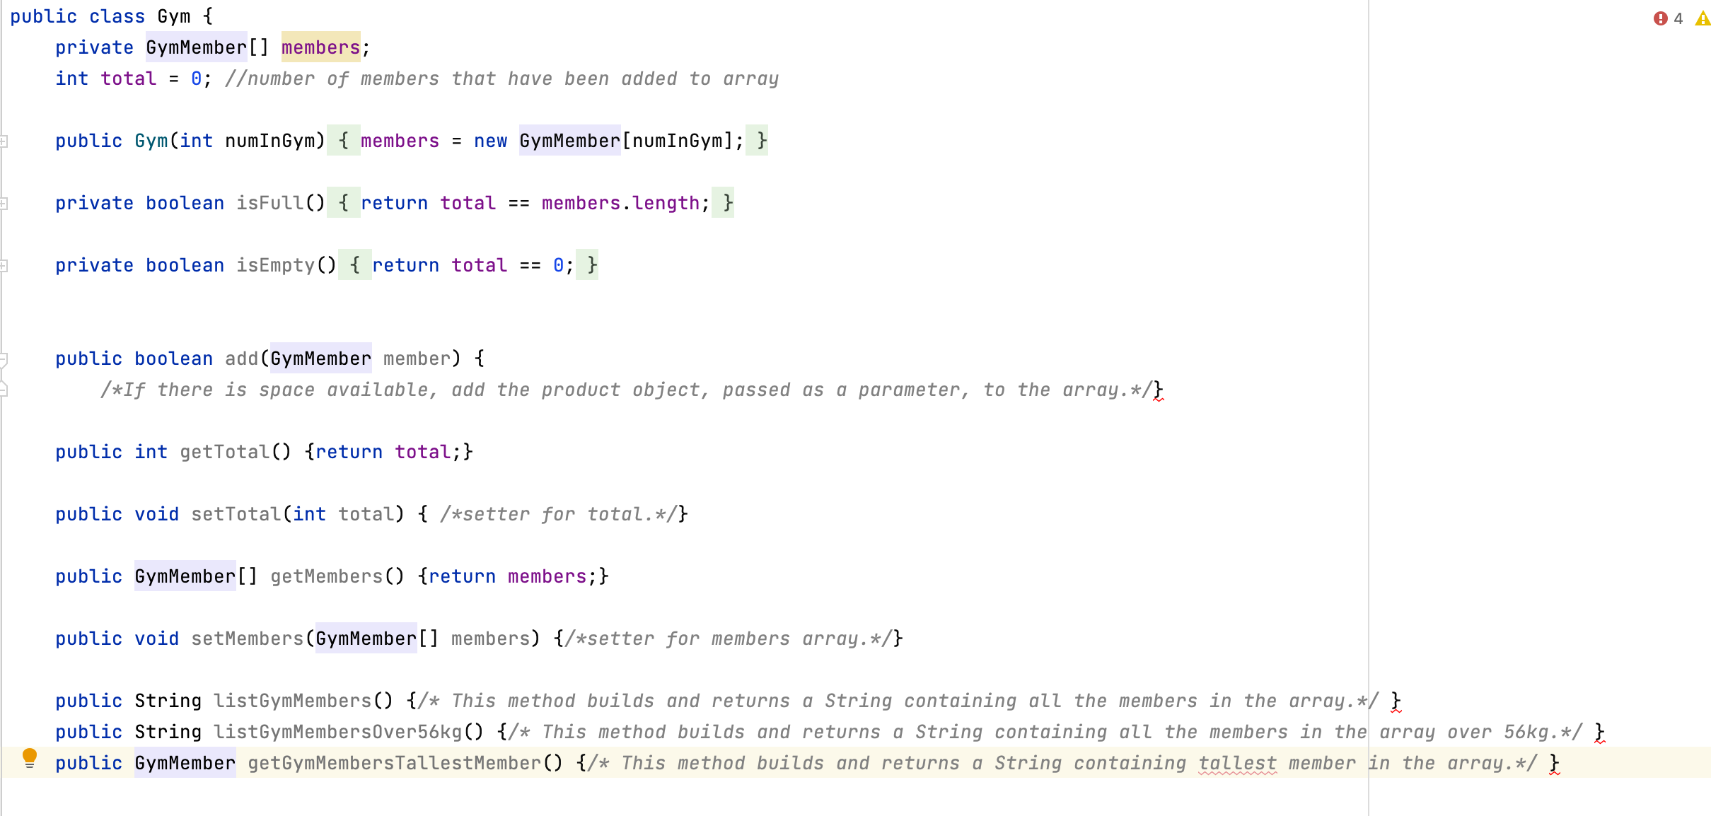

Skeleton Gym Member Code

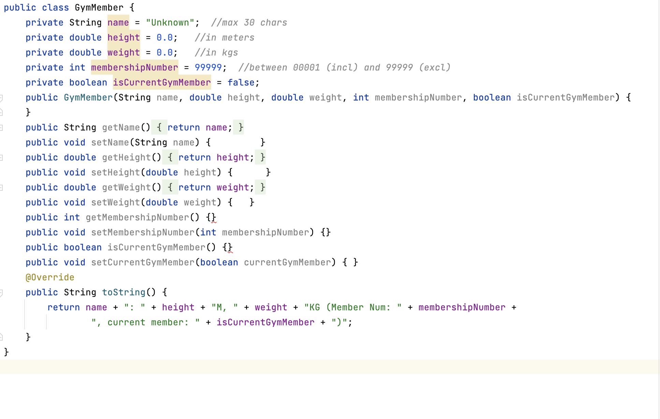

Programming Fundamentals 1 – in-class test – Sample Test

Name | Student Number | Course

Instructions:

- 1.5 hour exam.

- 3 Questions, answer all.

- Fill in your name, student number and course above.

- Complete the areas in this booklet and give it to your invigilator before leaving the room.

- Submit the section with your code as a complete booklet.

- You can write anywhere in this booklet and use the back of pages for additional code, rough work, etc.

With this exam, you are given class diagram
for the classes:
- Driver
- Gym
- GymMember
Which make up a Gym System.
You will be asked to write code for the following classes:
- GymMember
- Gym
- Driver

Question 1 – Gym Member Class:

Note: you do not have to define the fields or write the getters.

GymMember.java
//Code the the constructor, the setters and the toString() methods as defined in the comment in the following boxes.

// You should implement the following validation rules :
// For the member name field, this should be a maximum of 20 characters.
// In the case of the constructor, names with more than 20 characters
// should be cut to the first 20 characters.
//(Hint : You can use the String method substring to help you)
// In the case of the setter, do not update the value if it is more than //20 chars long.

// For the membership number field, the valid values are between 100 and 999 //(inclusive) . In the case of the constructor, if an invalid value is
// input, the default value of 999 should be used.
// In the case of the setter, do not update the value if it is outside
// the valid values.

// There is no validation needed for the isCurrentGymMember, height or weight fields.

1.1 Setters :

public void setName(String name) {// FILL IN CODE BELOW

}

public void setMembershipNumber(int membershipNumber)
{// FILL IN CODE BELOW

}

public void setCurrentGymMember(boolean currentGymMember)
{// FILL IN CODE BELOW

}

1.2 Constructor:
public GymMember(String name, double height, double weight, int membershipNumber, boolean isCurrentGymMember) {
//FILL IN THE CODE INCLUDING IMPLEMENTING VALIDATION RULES

}

1.3 toString()
public String toString() { // FILL IN CODE THAT RETURNS A STRING //VERSION OF THE OBJECT

}

2. The class diagram has a Gym class. In this class, there is an array of member objects, defined as follows:

private GymMember[] members;
int total = 0; //number of members that have been added to array

Gym.java
// Code each method as defined in the comment in the following boxes.

2.1 – add(..)
// If there is space available, add the GymMember object, passed as a parameter, to the array.
// parameter is gymMember which is a GymMember object to be added to the array.
// returns the Status of the add; true for success, false for fail.
public boolean add(GymMember gymMember) { //FILL IN CODE BELOW

}

2.2 listGymMembers()
//The return type is String.
// This method returns a list of the gym members stored in the array
// list. Each member should be on a new line and should be
// preceded by the index number e.g.
// 0: Member A ………
// 1: Member B ……
// If there are no members stored in the array list, return a
// string that contains "No Members in the Gym".
public String listGymMembers () { // FILL IN CODE BELOW

}

2.3 listGymMembersOver56kg()
// This method builds and returns a String containing all the
// members in the array
// whose weight is over 56
// returns a String containing all the members in the array whose
// whose weight is over 56or
// "No members are heavier than 56kg", // if none in the array.
// If there are no members in the array, the returned String
// contains "No Members in the Gym"
public String listGymMembersOver56kg () { FILL IN CODE BELOW

}
2.4 getGymMembersTallestMember()
/** This method goes through the array of members and returns the tallest member
* . If no members exist in the array, null should be returned.
*/
public GymMember getGymMembersTallestMember (){//FILL IN CODE BELOW

}

Question 3: Driver:

The class diagram has a Driver class. In this class, there is an object of the Gym class.

public class Driver {
private Scanner input = new Scanner(System.in);
private Gym theGym;
public static void main(String[] arg) {
new Driver();
}
public Driver() {
runMenu();
}

This class displays the menu of options that the user can choose from: | 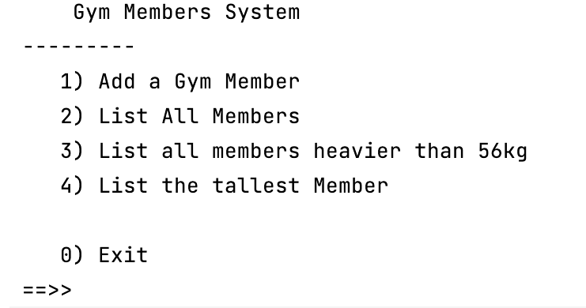
This class uses the Scanner class for reading from the console: | 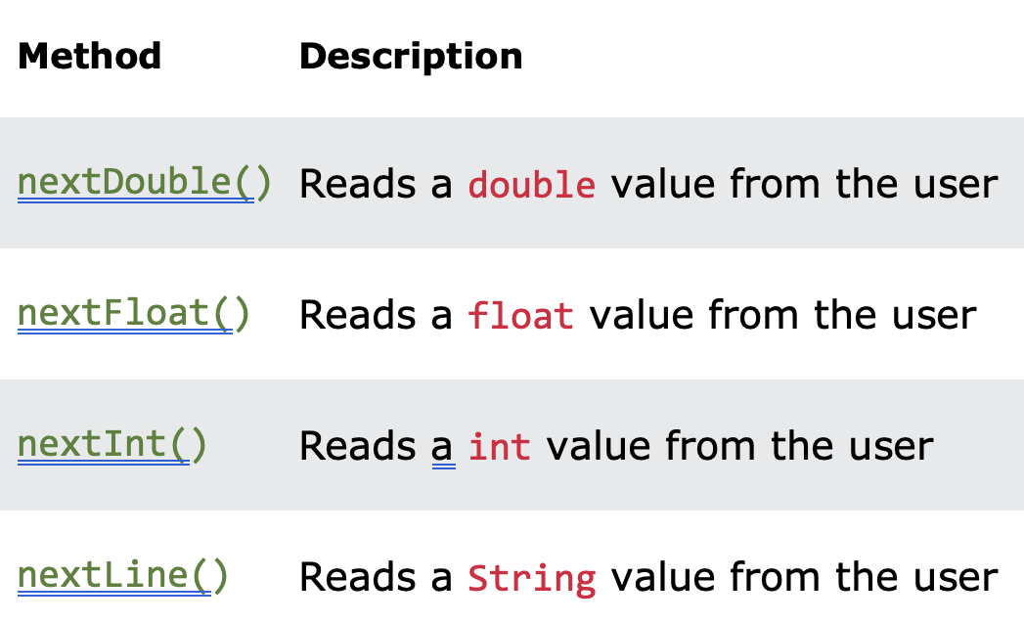

3.1 addGymMember()
In the following box, complete the code for the “Add a Gym Member” menu option. The add method that you will be calling in Gym has the following header:
private void addGymMember()

Driver.java
private void addGymMember(){
// TODO Write the code to read in the data for a
// GymMember and add it to the Gym.

}

