Section B – Long Questions (60 marks)
Answer ALL questions. Each question carries 15 marks.
These questions are based on material from the practical tutorials and are designed to test your ability to write and reason about Java programs.

Question 1 – Classes and Objects
Create a class called Person.
Write out definitions for the following fields:
- a field of type String called name
- a field of type int called age
- a field of type String called code
- a field of type int called credits
- a field of type boolean called applyDiscount
- add a setter and getter for name
- add a constructor that takes in the name, age, code, credits and applyDiscount

(Marks: 15)

Question 2 – Arrays
Write a method to read in 10 ‘wages’ into a double array (i.e. an array where each element is a double, for instance 2.33).
- Use Scanner class to take input from user.
- Calculate and print the average of the inputted wages.
- Only print out any wages over 100.
- Anyone who earns over 1000 will have a 10% wage reduction. Make this reduction, then print out all the final values

(Marks: 15)
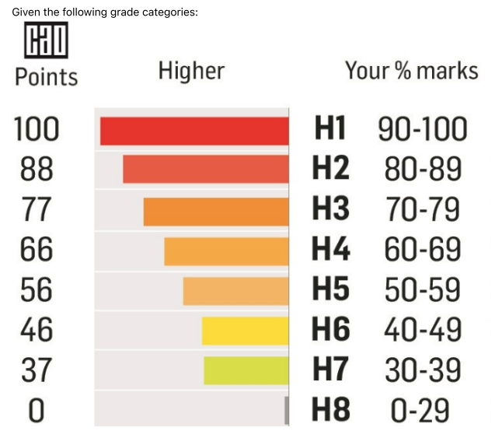

Question 3 – if-else-if
Marks and Grades
Given the following grade categories:

Write a method printGrade person's a given mark, prints the grade (e.g. "H1", "H2", etc.)

public void printGrade(int mark) {

}

(Marks: 15)

Question 4 – Loops
Write Java code for each of the following, you can use a for, while or do..while loop
1. Print the message "Hello World" five times using a loop.
2. Print the numbers from 1 to 10 (inclusive) on separate lines.
3. Print the numbers from 10 down to 1 (inclusive) on the same line, separated by spaces.
4. Print the numbers from 5 to 12 (inclusive) on separate lines.
5. Print the numbers from 20 down to 10 (inclusive) on the same line, separated by spaces.
6. Print the numbers from 2 to 17 (inclusive) in steps of 3 on separate lines

(Marks: 15)

