Programming Fundamentals 1
SAMPLE In Class Exam
TIME : 1 HR
There are two sections on this paper. All questions are mandatory.
Section A: (Multiple choice) is worth 40 Marks (2 marks per question)
Section B: (Writing code) is worth 60 marks (4 questions, 15 Marks each)

Student Name : __________________________________________
Student Number : ________________________________________
Programme (CS/Forensics/Physics) ________________________
Group (W1/W1/W3/W4/Physics) ___________________________

Section A – Multiple Choice Questions(40 marks)
Answer ALL questions. Each question carries 2 marks.
These questions are based on material from quizzes which are based on the slides.
In each case, select one option by circling the option letter.
Question 1. Which statement best describes a mutator (setter) method?
- It only prints information.
- It always returns a value.
- It changes the value of a field.
- It creates a new object.

Question 2. What is the effect of
System.out.println("# " + price + " cents.");
- Prints only the variable name.
- Adds price to a balance field.
- Concatenates the string and the value of price into output.
- Returns the value.

Question 3. Which list correctly names the three kinds of variables discussed in class design?
- Locals, packages, and modules
- Fields, arrays, and constants
- Parameters, methods, and classes
- Fields, parameters, and local variables

Question 4. What does the statement balance = balance + amount; do?
- Always resets balance to zero.
- Creates a new variable.
- Adds amount to the current value of balance.
- Swaps two values.

Question 5. What is wrong with the declaration Int number = 5;
- Value cannot be assigned at declaration
- Data type is case-sensitive
- Semicolon is missing
- Variable name is invalid

Question 6. In the method below, what value is returned?
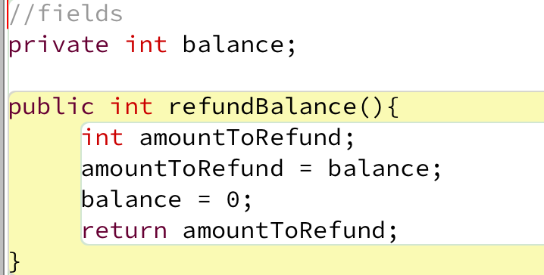
- The new value of balance
- Nothing is returned
- 0
- The old value of balance

Question 7. In Java, a ________is a small, meaningful piece of code such as a keyword, operator, literal, or identifier.
- token
- block
- method
- comment
Question 8. The scope of a field is:
- The whole class
- The block in which it is declared
- Limited to a single statement
- Only inside its method

Question 9. What does this statement do?:
x += 5;
- Multiplies x by 5
- Sets x to 5
- Divides x by 5
- Increases x by 5

Question 10. Given int a = 7, b = 2; what is the value of:
a / b

- 4
- Error
c. 3.5
d. 3.

Question 11. What is the final value of x after this executes (assume int x = 4;)?
x -= 6; // line 1
x += 3; // line 2
- -2
- -3
- 1
- 7

Question 12. What is wrong with this code?

if (x = 5) {
System.out.println("Five");
}
- Nothing is wrong
- Missing semicolon after if
- Should use === in Java
- Uses = instead of ==

Question 13. For input mark, when is this condition true?
(mark >= 0) && (mark <= 100)
- When mark is between 0 and 100 inclusive
- When mark is negative
- Always
- Only when mark is strictly between 0 and 100

Question 14. Which are valid Java boolean literals?
- true and false
- 1 and 0
- Yes and No
- "true" and "false"

Question 15 Java, which of these is not a type of loop?
- for
- do while
- while
- repeat until

Question 16 . What is the main purpose of using a loop in programming?
- To execute a set of statements only once
- To repeat a set of statements multiple times
- To compare two numbers
- To define a variable
Question 17. Which of the following for loop headers would create an infinite loop?
- for (int i = 0; i < 5; i++)
- for (int i = 1; i <= 10; i++)
- for (int i = 10; i > 0; i--)
- for ( ; ; )

Question 18. In a Person array, what does friends[i].printFirstName() do?
- Causes a compile error
- Accesses an element without printing anything
- Calls the printFirstName() method on the Person object stored at index i
- Creates a new Person

Question 19. In Java, how do you declare an array of 10 integers?
- int numbers = new int(10);
- int[] numbers = new int[10];
- numbers = new int[10];
- int numbers = [10];

Question 20. Which of the following is a valid declaration for an array of String objects?
- String[] words = new String[4];
- String words = new String(4);
- Both B and C
- String words[] = {"Dog", "Cat"};

Section B – Long Questions (60 marks)
Answer ALL questions. Each question carries 15 marks.
These questions are based on material from the practical tutorials and are designed to test your ability to write and reason about Java programs.

Question 1 – Classes and Objects. (15 Marks)
Create a class called Person.
Write out definitions for the following fields:
- a field of type String called name
- a field of type int called age
- a field of type String called code
- a field of type int called credits
- a field of type boolean called applyDiscount
- add a setter and getter for the field name
- add a constructor that takes in the name, age, code, credits and applyDiscount

Question 2 – Arrays (15 Marks)
Write a method / code snippets to
  - Set up a double array ‘wages’ of size 10 (i.e. an array where each element is a double, for instance 2.33).
  - Use Scanner class to take input from user (Assume input is already setup as a Scanner object)
  - Calculate and print the average of the inputted wages.
  - Only print out any wages over 100.
  - Anyone who earns over 1000 will have a 10% wage reduction. Make this reduction, then print out all the final values

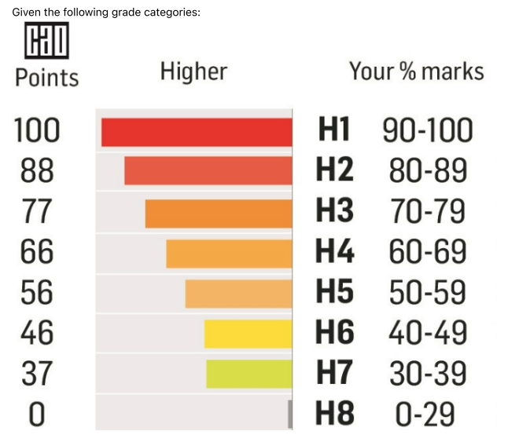
Question 3 – if-else-if
Marks and Grades
Given the grade categories as per diagram:

Write a method printGrade(int mark) which takes a person's given mark and prints the corresponding grade (e.g. "H1", "H2", etc.)
(You can leave out the Grades H4 - H6 inclusive - just write a comment like // ‘and so on’ )
public void printGrade(int mark) {

}
// printGrade() continued…

}

}
Question 4 – Loops. (15 Marks - 5 x 3)
Write Java code for each of the following, you can use a for or while loop:
  - Print the message "Hello World" five times using a loop.
  - Print the numbers from 10 down to 1 (inclusive) on the same line, separated by spaces.
  - Print the numbers from 5 to 12 (inclusive) on separate lines.
  - Print the numbers from 2 to 17 (inclusive) in steps of 3 on separate lines.
  - Print the numbers from 1 t0 100 that are multiples of 7.

