Tutorial Sheet - Topic 04

Programming Fundamentals 1

Selection - If-Else, Precedence of Operators, Logical Operators, compound assignment statements

Section 1: Arithmetic Operators & Order of Evaluation

Question 1.1: Basic Arithmetic
Calculate the results of the following expressions:

- 10 + 5 * 2
- (10 + 5) * 2
- 20 / 4 + 3
- 20 / (4 + 3)
- 15 % 4 + 2 * 3

Question 1.2: Compound Assignment
Rewrite the following statements using compound assignment operators:

- total = total + 10;
- count = count - 1;
- price = price * 1.2;
- score = score / 2;
- balance = balance + amount;

Question 1.3: What's the Value?
If x = 10 (before all of the following statements), what is the value of x after each statement?

- x += 5;
- x -= 3;
- x *= 2;
- x++;
- x--;

Section 2: Boolean Values & Conditions

Question 2.1: True or False?
Given: int age = 20; int price = 15; String name = "John";

Evaluate whether these conditions are true or false:

- age >= 18
- age < 18
- price == 15
- price != 15
- age > 20
- age <= 20
- price > 10 && price < 20
- age < 18 || age > 65

Question 2.1: Boolean Variables
Complete the code by creating appropriate boolean variables:

int temperature = 25; int humidity = 80;

// Create boolean variables boolean = temperature > 30; boolean = temperature < 0; boolean = humidity > 70; boolean = isHot && isHumid;

Section 3: Simple If Statements

Question 3.1: Write Simple If Statements
Write if statements for the following scenarios:

- If a person's age is 18 or over, print "You can vote"

- If the price is negative, print "Invalid price"

- If the score is 100, print "Perfect score!"

- If the balance is 0 or less, print "Insufficient funds"

Question 3.2: Complete the Code
Fill in the missing parts:

public void checkTemperature(int temp) { if ( ) { // temp is below 0
System.out.println("Freezing!");
}
}

public void validateAge(int age) {
if ( ) { // age is between 13 and 19 inclusive
System.out.println("Teenager");
}
}

Section 4: If-Else Statements

Question 4.1 Pass or Fail
Write a method that checks if a student passed or failed:

Score >= 40: Print "Pass" Score < 40: Print "Fail"

public void checkResult(int score) {
// Your code here

}

Question 4.3: Even or Odd
Write code to determine if a number is even or odd:

public void checkEvenOdd(int number) {
// Hint: Use the % operator
// Your code here

}

Section 5: If-Else-If Statements

Question 5.1: Marks and Grades
Given the following grade categories:
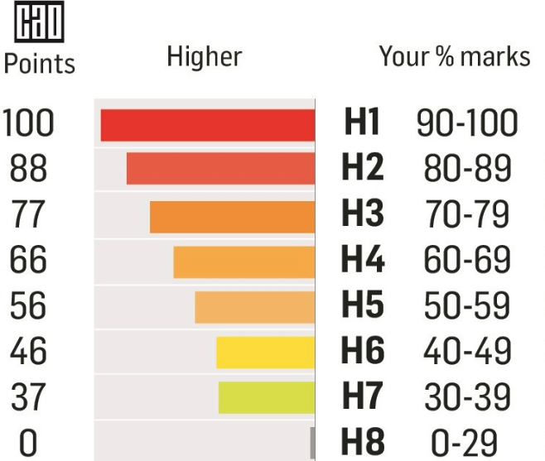

Write a method printGrade person's a given mark, prints thehe grade (e.g. "H1", "H2", etc.)

public void printGrade(int mark) {
// Your code here

}
`

Question 5.2: Ticket Pricing
A cinema charges different prices based on age:

Under 12: €6
12-64: €10
65 and over: €7
Write a method to calculate and print the ticket price:

public double getTicketPrice(int age) {
// Your code here

}

Section 6: Compound Conditions (AND &&)

Question 6.1: Valid Mark Range
Write code to check if a mark is valid (between 0 and 100 inclusive):

public void validateMark(int mark) {
// Your code here

}

Question 6.2: Valid Mark Range - boolean method
Write a method similar to validateMark as above except that in this case the method returns a boolean value - true if the mark is validbetween 0 and 100 inclusive and false otherwise.

public boolean validateAgeBoolean(int age) {
// Your code here

}

Question 6.3: Loan Eligibility
Write a method that checks (and prints) if a person is eligible for a loan. A person is eligible for a loan if:

Age is between 18 and 65 (inclusive) Has no existing loans

public void checkLoanEligibility(int age, boolean hasExistingLoan) {
// Your code here

}

Question 6.4: Loan Eligibility - boolean method
Write a method that checks if a person is eligible for a loan. A person is eligible for a loan if:

Age is between 18 and 65 (inclusive)

public boolean checkLoanEligibilityBoolean(int age, boolean hasExistingLoan) {
// Your code here

}
Has no existing loans The method returns a boolean value - true if the person is eligible for a loan and false otherwise

Section 7: Compound Conditions (OR ||)

Question 7.1: Invalid Mark
Write code to check if a mark is INVALID (less than 0 OR greater than 100):

public void checkInvalidMark(int mark) {
// Your code here

}

Question 7.2: Weekend Day
Write code to check if a day is a weekend day (Saturday or Sunday):

public void checkWeekend(String day) {
// Your code here

}

Question 7.3: Discount Eligibility
A customer gets a discount if they are a student OR a senior (65+):

public void checkDiscount(boolean isStudent, int age) {
// Your code here

}

Section 8: Compound Conditions (NOT !)

Question 8.1: Voting Ineligibility
Write code using the NOT operator:

boolean isEligible = false;

// If NOT eligible, print "Sorry you cannot vote"
// Your code here

Question 8.2: Not Raining
Write code to suggest outdoor activities if it's NOT raining:

public void suggestActivity(boolean isRaining) {
// Your code here

}

Question 8.3: Account Not Active
Write code to deny access if an account is NOT active:

public void checkAccess(boolean isActive) {
// Your code here

}

Debug 1: Find and Fix the Errors

public void checkAge(int age) {
if (age = 18) { // Error here
System.out.println("Exactly 18");
}
else if (age > 18) AND (age < 65) { // Error here
System.out.println("Adult");
}
else
System.out.println("Senior") // Error here
}

Debug 2: Logic Error
Why doesn't this code work as expected?

public void checkDiscount(int age, boolean isStudent) { if (isStudent) {
System.out.println("Student discount: 20%");
}
if (age >= 65) {
System.out.println("Senior discount: 15%");
}
else {
System.out.println("No discount");
}
}
// Problem: If someone is a student AND 65+, what happens?

Debug 3: Compound Assignment Error

int total = 100;
total =+ 50; // Is this correct?
System.out.println(total); // What prints?

