Section B – Long Questions (60 marks)
Answer ALL questions. Each question carries 15 marks.
These questions are based on material from the practical tutorials and are designed to test your ability to write and reason about Java programs.

Question 1 – Classes and Objects
1.1 Given the following code for the class TicketMachine: Write the code for a constructor for the TicketMachine class. The constructor should take one parameter. The first is of type int and is(or can be) can be called price. The other two fields should be initialised to 0.
public class TicketMachine{
// The price of a ticket from this machine. private int price;
// The amount of money entered by a customer so far. private int balance;
// The total amount of money collected by this machine. private int total;
: rest of code omitted
}

( 6 Marks)

1.2 Write a getter method getTotal() for the class TicketMaster to return the value of the total field.

- Marks)
1.3 Write a setter method setPrice(int x) that sets the field price to a value defined by the parameter x. Suggest a better name for x and write the code using this improved name.

(5 Marks)
(Total = 15 Marks)

Question 2 – Arrays
Write a method / code snippets to
  - Set up a double array ‘wages’ of size 20 (i.e. an array where each element is a double, for instance 13332.33).
(2 Marks)
  - Use Scanner class to take input from user. (Assume input is already setup as a Scanner object and assume you will take in 20 inputs) .
(3 Marks)
  - Calculate and print the average of the inputted wages.
(3 Marks)
  - Go through array and (only) print out any wages over 1000.
(3 Marks)

  - Anyone who earns over 1000 will have a 15% wage reduction. Make this reduction, then print out all the final values
(4 Marks)

Question 3 - Selection

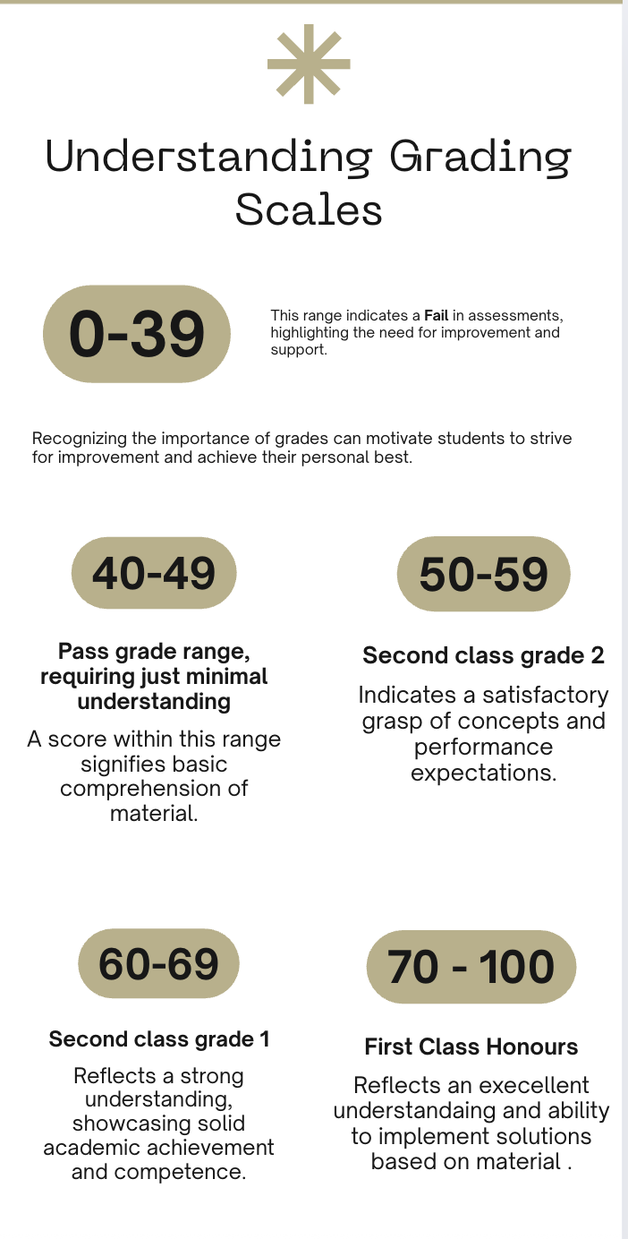
3.1 Given the f grade categories as above: Write a method printGrade(int mark) which takes a student’s given mark and prints the corresponding grade (e.g. "Fail”, "Pass", , etc.)
(9 Marks)
public void printGrade(int mark) {

}
//. public void printGrade(int mark) continued/

}
Question 3.2
Write code to check if a mark is valid (between 0 and 100 inclusive) and print the result, i.e. either “the mark is valid” or “the mark is invalid” :
public void validateMark(int mark) {
// Your code here

}

( 6 Marks)
(Total = 15 Marks)

Question 4 – Loops
Write Java code for each of the following, you can use a for or while loop:
  - Print the numbers from 20 down to 10 (inclusive) on separate lines.
(3 Marks)
  - Print the numbers from 2 to 17 (inclusive) in steps of 3 on separate lines
(3 Marks)

4.3 Write down exactly what is printed by the following code:

int i = 20;
while (i <= 27) {
System.out.println("Value of i: " + i);
i = i + 3;
}
System.out.println("Last value of i: " + i);

(5 Marks)

4.3. Write down exactly what is printed by the following code:
for (int i = 1; i <3; i++) {
for (int j = 0; j < 2; j++) {
System.out.println("i = " + i + ", j = " + j);
}
}

