Section B – Long Questions (60 marks)
Answer ALL questions. Each question carries 15 marks.
These questions are based on material from the practical tutorials and are designed to test your ability to write and reason about Java programs.

Question 1 – Classes and Objects
Create a class called Person.
Write out definitions for the following fields:
- a field of type String called name
- a field of type int called age
- a field of type String called code
- a field of type int called credits
- a field of type boolean called applyDiscount
- add a setter and getter for the field name
- add a constructor that takes in the name, age, code, credits and applyDiscount

(Marks: 15)

Question 2 – Arrays
Write a method / code snippets to
  - Set up a double array ‘wages’ of size 10 (i.e. an array where each element is a double, for instance 2.33).
  - Use Scanner class to take input from user (Assume input is already setup as a Scanner object)
  - Calculate and print the average of the inputted wages.
  - Only print out any wages over 100.
  - Anyone who earns over 1000 will have a 10% wage reduction. Make this reduction, then print out all the final values

(Marks: 15)
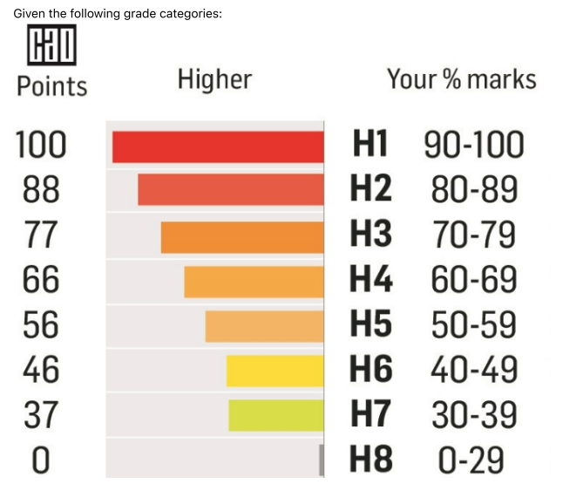

Question 3 – if-else-if
Marks and Grades
Given the following grade categories:

Write a method printGrade(int mark) which takes a person's given mark and prints the corresponding grade (e.g. "H1", "H2", etc.)
(You can leave out the Grades H4 - H6 inclusive - just write a comment like // ‘and so on’ )

public void printGrade(int mark) {

}
(Marks: 15)

Question 4 – Loops
Write Java code for each of the following, you can use a for or while loop:
  - Print the message "Hello World" five times using a loop.
  - Print the numbers from 10 down to 1 (inclusive) on the same line, separated by spaces.
  - Print the numbers from 5 to 12 (inclusive) on separate lines.
  - Print the numbers from 2 to 17 (inclusive) in steps of 3 on separate lines
  - Print the numbers

(Marks: 15 (5 x 3 Marks) )

