PROGRAMMING FUNDAMENTALS 1
IN CLASS EXAM
TIME : 1 HR
Monday November 4th 2025

There are two sections on this paper. All questions are mandatory.

Section A: (Multiple choice) is worth 40 Marks (2 marks per question)

Section B: (Writing code) is worth 60 marks (4 questions, 15 Marks each)

Student Name : __________________________________________

Student Number : ________________________________________

Programme (CS/Forensics/Physics) _________________________

Group (W1/W1/W3/W4/Physics) _____________________________

Section A –Multiple choice - Please circle your answer. Only one answer applies in each question.

QA.1. What does the statement balance = balance + amount; do?

- Adds amount to the current value of balance.
- Creates a new variable.
- Swaps two values.
- Always resets balance to zero.
QA.2. What must always be true about a constructor in Java?

- Its name must match the class name.
- It must always take at least one parameter.
- It must always return an int.
- It must always be private.
QA.3. Which of these is the best choice for a variable name?

- ticketPrice
- t5
- xyz123
- q
QA.4. In a constructor, parameters are typically used for what purpose?

- To initialize the fields of the new object.
- To create new methods.
- To declare the package.
- To print default messages.
QA.5. Which are valid Java boolean literals/ keywords?

- true and false
- "true" and "false"
- 1 and 0
- Yes and No
QA.6. Which expression tests equality of primitive ints correctly? int a = 5, b = 5;
- a = b
- a == b
- a != b
- a equals b

QA.7. For input mark, when is this condition true? (mark >= 0) && (mark <=100)

- When mark is between 0 and 100 inclusive
- Only when mark is strictly between 0 and 100
- When mark is negative
- Always

QA.8. For input mark, when is this condition true?
(mark < 0 ) || (mark > 100) ;

- When mark is invalid (outside 0..100)
- When mark is 0..100 inclusive
- Never
- Always

QA.9. Given
boolean isFriday = false;

what value has
!isFriday
- true
- false
- 0
- null

QA.10. What does this code print?
boolean canVote = (age >= 18);
if (canVote)
{
System.out.println("You can vote!");
}

- "You can vote!" when age >= 18
- It never prints
- It prints only when age == 18
- Compilation error
QA.11. Evaluate the following expression according to Java precedence:
3 + 6 * 5 - 2

- 37
- 31
- 49
- 25

QA.12. What is wrong with this code?
if (x = 5) {
System.out.println("Five");
}

- Uses = instead of ==
- Missing semicolon after if
- Should use === in Java
- Nothing is wrong
QA.13. Which condition matches “age is a teenager (13–19 inclusive) or a senior (65+)”?

- (age >= 13 && age <= 19 || age >= 65)
- (age > 13 && age 65)
- age >= 13 || age >= 65
- age = 65

QA.14. What is the effect of:
y *= 3;
- Adds 3 to y
- Multiplies y by 3
- Sets y to 3
- Divides y by 3

QA.15. Given int a = 7, b = 2; what is the value of:
a/b

- 3
- 3.5
- 4
- Error

QA.16. Given int a = 17, b = 5; what is:
a % b
- 2
- 3
- 5
- -2

QA.17. What is the final value of x after this executes (assume int x = 4;)?
x -= 6; // line 1
x += 3; // line

- 1
- -3
- -2
- 7

QA.18. In Java, how do you declare an array of 10 integers?

- int numbers = new int(10);
- int numbers[] = new int[10];
- numbers = new int[10];
- int numbers = [10];

QA.19. What does numbers.length return?

- The last index used
- The total capacity of the array
- The number of elements currently populated
- The sum of all elements

QA.20. Which of the following is a valid declaration for an array of String objects?

- String words = new String(4);
- String[] words = new String[4];
- String words[] = {"Dog", "Cat"};
- Both B and C

Section B – Long Questions (60 marks)
Answer ALL questions. Each question carries 15 marks.
You should write your answers on this sheet.

Question B.1 – Classes and Objects
QB.1.1 Given the following code for the class TicketMachine: Write the code for a constructor for the TicketMachine class. The constructor should take one parameter. The first is of type int and is(or can be) can be called price. The other two fields should be initialised to 0.
public class TicketMachine{
// The price of a ticket from this machine. private int price;
// The amount of money entered by a customer so far. private int balance;
// The total amount of money collected by this machine. private int total;
: rest of code omitted
}

( 6 Marks)

QB.1.2 Write a getter method getTotal() for the class TicketMaster to return the value of the total field.

- Marks)
QB.1.3 Write a setter method setPrice(int x) that sets the field price to a value defined by the parameter x. Suggest a better name for x and write the code using this improved name.

(5 Marks)
(Total = 15 Marks)

Question 2 – Arrays
Write a method / code snippets to
QB.2.1 Set up a double array ‘wages’ of size 20 (i.e. an array where each element is a double, for instance 13332.33).
( 2 Marks)
QB.2.2 Use Scanner class to take input from user. (Assume input is already setup as a Scanner object and assume you will take in 20 inputs) .
(3 Marks)
QB.2.3 Calculate and print the average of the inputted wages.
( 3 Marks)
QB.2.4 Go through array and (only) print out any wages over 1000.
( 3 Marks)

QB.2.5 Anyone who earns over 1000 will have a 15% wage reduction. Make this reduction, then print out all the final values
(4 Marks)
( Total = 15 Marks)

Question 3 - Selection

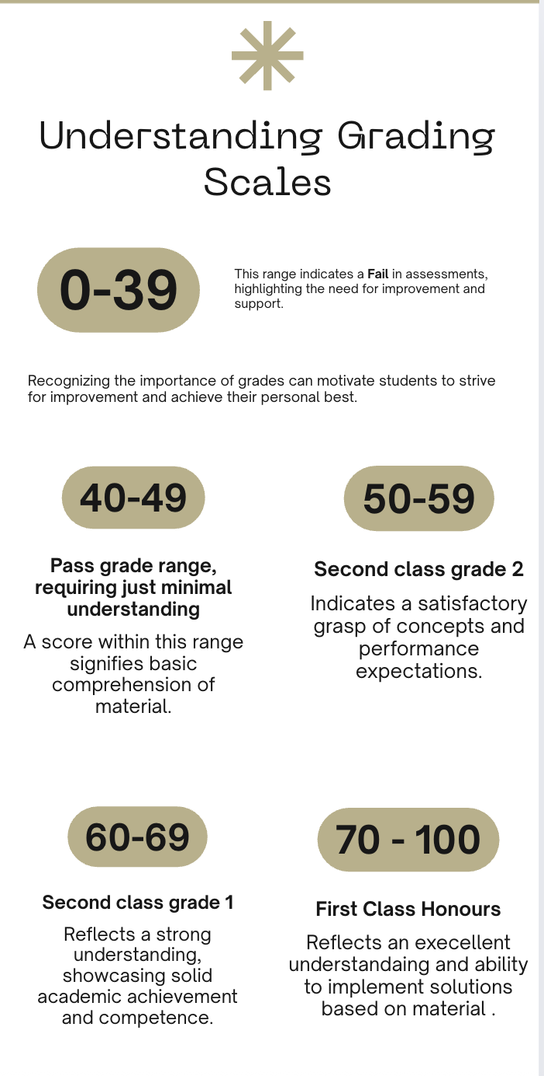

QB.3.1 Given the degree grade categories as above: Write a method printGrade(int mark) which takes a student’s given mark and prints the corresponding grade (e.g. "Fail”, "Pass", , etc.)
(10 Marks)
public void printGrade(int mark) {

}
//. public void printGrade(int mark) continued/

}

QB.3.2 Write code to check if a mark is valid (between 0 and 100 inclusive) and print the result, i.e. either
- “the mark is valid” or
- “the mark is invalid” :
(5 Marks)
(Total = 15 Marks)
public void validateMark(int mark) {
// Your code here

}

( 6 Marks)
(Total = 15 Marks)

Question 4 – Loops
Write Java code for each of the following, you can use a for or while loop:
QB.4.1 Print the numbers from 20 down to 10 (inclusive) on separate lines.
( 3 Marks)
QB.4.2 Print the numbers from 2 to 17 (inclusive) in steps of 3 on separate lines
(3 Marks)

QB.4.3 Write down exactly what is printed by the following code snippet:

int i = 20;
while (i <= 27) {
System.out.println("Value of i: " + i);
i = i + 3;
}
System.out.println("Last value of i: " + i);

(4 Marks)

QB.4.3 Write down exactly what is printed by the following code snippet:
for (int i = 1; i <3; i++) {
for (int j = 0; j < 2; j++) {
System.out.println("i = " + i + ", j = " + j);
}
}
(5 Marks)
(Total = 15 Marks)

