Tutorial Sheet – Exceptions and XML (Revision)
Programming Fundamentals 1
Topic: Exceptions and XML in Java
Purpose: Consolidation and revision before progressing to larger programs

Part A: Understanding Exceptions
1. What Are Exceptions?
Answer the following questions:
- What is an exception in Java?
- Give one example of a runtime exception.
- Why is exception handling important in real-world programs?

2. Predicting Output (Try–Catch)
Consider the following code:
try {
int[] numbers = {10, 20, 30};
System.out.println(numbers[3]);
} catch (ArrayIndexOutOfBoundsException e) {
System.out.println("Index error");
}
Answer the following:
a. Does the program crash?
b. What is printed to the console?

3. Identifying the Exception
For each of the following scenarios, state which exception would occur:
- Dividing a number by zero
- Accessing a file that does not exist
- Trying to access an element outside the bounds of an array

4. Writing a Try–Catch Block
Write Java code that:
- Asks the user to enter two integers
- Divides the first number by the second
- Uses a try–catch block to handle division by zero

5. Handling Multiple Exceptions in One Try Block
Consider the following scenario: A program asks the user to enter an integer and then accesses an element in an array using that number as an index.
- Name two different exceptions that could occur in this situation.
- Write Java code that uses one try block and multiple catch blocks to handle these exceptions.
- Explain why handling multiple exceptions improves program robustness.

Part B: Working with XML
6. Understanding XML Structure
Consider the following XML snippet:
<student>
<name>Alice</name>
<course>Computing</course>
</student>
Answer the following:
- What is the root element?
- Name two child elements.
- Why is XML useful for storing data?

7. XML Syntax Rules
State whether each statement is true or false:
- XML tags are case-sensitive.
- Every opening tag must have a closing tag.
- XML is used mainly for program logic.

8. Reading Data from XML (Conceptual)
Answer the following:
- Why might a Java program read data from an XML file?
- Name one advantage of storing data in XML instead of hard-coding it.

Part C: CRUD Operations with XML
8. Understanding CRUD
Answer the following:
- What does CRUD stand for?
- Give one example of a CRUD operation in the context of an XML file.

9. Matching CRUD Operations
Match each operation with its description:
- Create
- Read
- Update
- Delete
Descriptions:
a. Removing an element from an XML file
b. Adding a new element to an XML file
c. Changing the value of an existing element
d. Displaying data stored in an XML file

10. Thinking in Steps (Algorithm)
Describe, in plain English, the steps a program would take to:
- Read an XML file
- Display all student names stored in the file

11. Error Handling with Files
Answer the following:
- Why is file handling often placed inside a try–catch block?
- What might happen if file-related exceptions are not handled?

12. Using try..catch
The following method is written in Store.
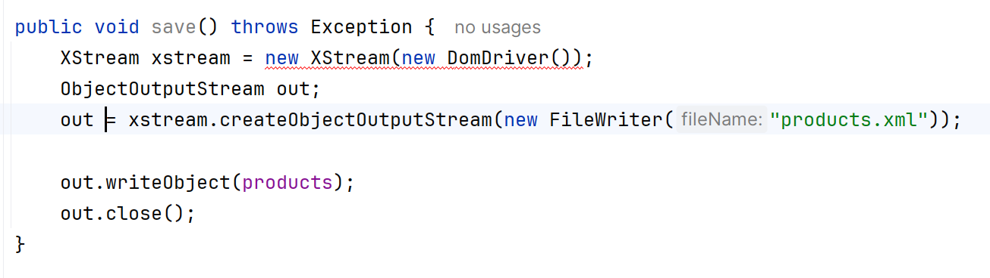
The following code is going to call it, but has an error.
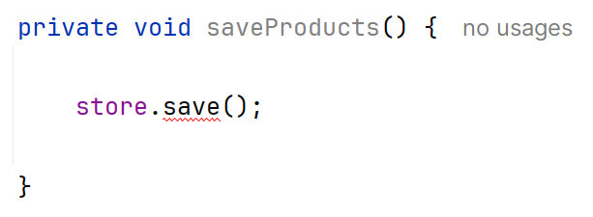
- What is the error?
- Rewrite the code correctly.

13. Thinking Challenge
Answer the following:
- Why might a program use both exceptions and XML together?
- Give one example of a program that could benefit from this combination.

public void save() throws Exception {
XStream xstream = new XStream(new DomDriver());
ObjectOutputStream out =
xstream.createObjectOutputStream(new FileWriter("products.xml"));
out.writeObject(products);
out.close();
}

