Class Diagram  All questions in this exam are based on one app. | 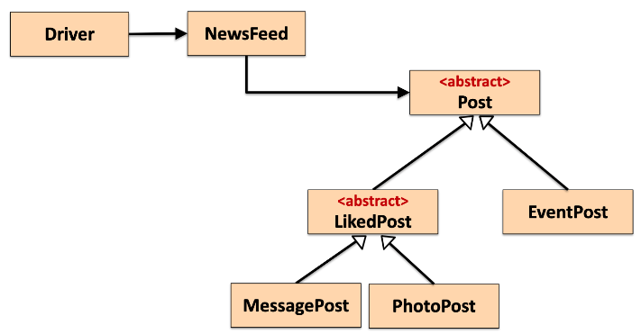

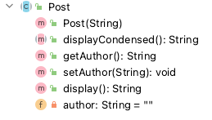 | 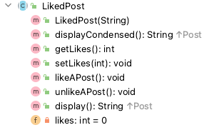
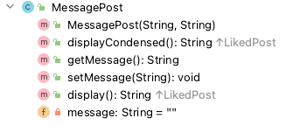 | 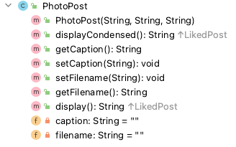
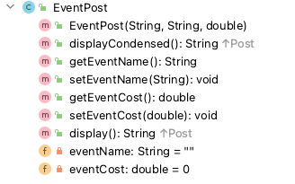

You may detach this page from the booklet.

Name | Student Number | Course

Instructions:

- 2 hour exam.

- 4 Questions, answer all.

- Fill in your name, student number and course above.

- Complete the areas in this booklet and give it to your invigilator before leaving the room.

- Except for the front page, don’t tear pages from this booklet; submit as a complete booklet.

- You can write anywhere in this booklet and use the back of pages for additional code, rough work, etc.

Question 1 - Models:

With this exam, you are given an inheritance hierarchy and the structure (UML) for the classes in the hierarchy. For the Post, LikedPost and MessagePost classes, code the following:
- The class definition
- The constructor
- The toString() method

Note: you do not have to define the fields or write the getters/setters.

Post.java

LikedPost.java

MessagePost.java
Question 2 - Controllers:

The class diagram has a NewsFeed class. In this class, there is an ArrayList<Post> defined:

public class NewsFeed {
private ArrayList<Post> posts;
public NewsFeed() {
posts = new ArrayList<Post>();
}
}

Each box below has a comment in it. Code each method as defined in the comment.

NewsFeed.java
// Write a public method, listAllPosts(). The return type is String.
// This method returns a list of the posts stored in the array list.
// Each post should be on a new line and should be preceded by the
// index number e.g.
// 0: Post 1 Details
// 1: Post 2 Details
// If there are no posts stored in the array list, return a string
// that contains "No Posts".

NewsFeed.java
// Write a public method, numberOfMessagePosts(). The return type
// is int. This method returns the number of MessagePost objects
// stored in the array list.
// If there are none stored, zero is returned.

NewsFeed.java
// Write a public method, listAllPostsByAuthor(String author).
// The return type is String.
//
// This method returns a list of the posts written by an author that
// are stored in the array list (i.e. that match the parameter value).
//
// Each matching post should be on a new line and should be preceded
// by the index number e.g.
// 1: Post 2 Details
// 4: Post 5 Details
//
// If there are no posts stored in the array list, return a string
// that contains "No Posts".
//
// If there are no posts matching the author, the return string should
// have "No posts for that author".

NewsFeed.java
// If you included the sort functionality in your submitted code
// base, please write the code to sort the array list by any criteria // you wish e.g. author name ascending.

Question 3 – Junit Tests:

This JUnit test class for NewsFeed contains test fixture data:

public class NewsFeedTest {
private MessagePost janeMessage1, joeMessage1;
private PhotoPost janePhoto1, joePhoto1;
private NewsFeed newsFeedPopulated = new NewsFeed();
private NewsFeed newsFeedEmpty = new NewsFeed();
@BeforeEach
void setUp() {
//Creating four post objects, 2 MessagePost and 2 PhotoPost.
janeMessage1 = new MessagePost("Jane Doe", "Jane's first post");
joeMessage1 = new MessagePost("Joe Soap", "Joe's first post");
janePhoto1 = new PhotoPost("Jane Doe", "Jane's Profile", "jane.jpg");
joePhoto1 = new PhotoPost("Joe Soap", "Joe's Profile", "joe.jpg");
//adding the four objects to the newsFeedPopulated object
newsFeedPopulated.addPost(janeMessage1);
newsFeedPopulated.addPost(joeMessage1);
newsFeedPopulated.addPost(janePhoto1);
newsFeedPopulated.addPost(joePhoto1);
// Note that no posts are added to the newsFeedEmpty object
}
}

Write the two test methods that are specified in the box below.

Note:
- You can assume that you don’t have to write import statements.
- You can name the test methods anything you wish.

NewsFeedTest.java
In a previous question, you were asked to write a method called numberOfMessagePosts().
- This method returned the number of MessagePost objects stored
in the array list.
- If there were none stored, zero is returned.

Using the test fixture data given above, write the two test methods, detailed below.

Test Method 1: This test method should verify that zero is returned by numberOfMessagePosts() when no message posts are stored in the NewsFeed object.

Test Method 2: This test method should verify that the correct number of message posts is returned by numberOfMessagePosts() when message posts are stored in the NewsFeed object.

Question 4: Driver:

The class diagram has a Driver class. In this class, there is an object of the NewsFeed class.

public class Driver {
private NewsFeed newsFeed = new NewsFeed();
public static void main(String[] args) {
new Driver();
}
}

This class displays the menu of options that the user can choose from:
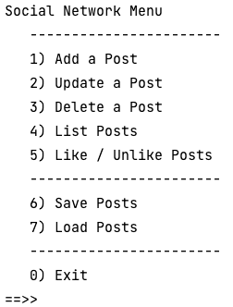

In the box below, complete the code for the “Add a Post” menu option.

Use the ScannerInput class for reading from the console:

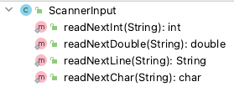

The add method that you will be calling in NewsFeed is this format:



Driver.java
private void addPost(){
int option = ScannerInput.readNextInt("""
---------------------------
| 1) Add a Message Post |
| 2) Add a Photo Post |
| 3) Add an Event Post |
---------------------------
==>> """);
switch (option) {
case 1 -> {
// TODO Write the code to read in the data for a
// Message Post and add it to the NewsFeed.

case 2 -> {
// TODO Write the code to read in the data for a
// Photo Post and add it to the NewsFeed.

}
case 3 -> {
// TODO Write the code to read in the data for an
// Event Post and add it to the NewsFeed.

}
default -> System.out.println("Invalid option: " + option);
}
}

