Programming Fundamentals 2
Mid Semester Examination
Section B
Answer ALL questions in this section.

Question 1 – ArrayLists (15 marks)
(a) Declaring and Adding (4 marks)
Write Java code to:
- Declare and create an ArrayList<String> called modules.
- Add the following values:
  - "Programming"
  - "Databases"
  - "Web Development"

(b) Predicting Output (3 marks)
What is printed by the following code?
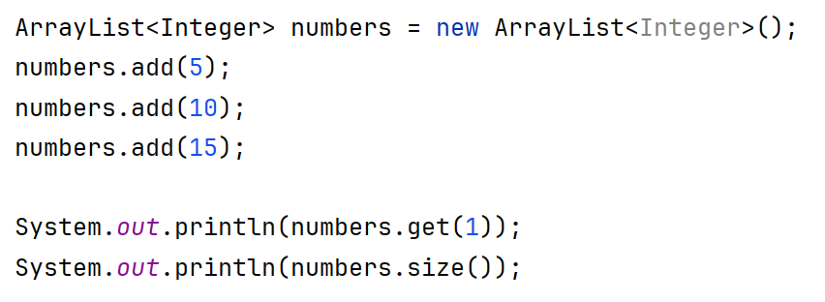
Write the exact output.

(c) Looping and Logic (3 marks)
The following code contains an error:
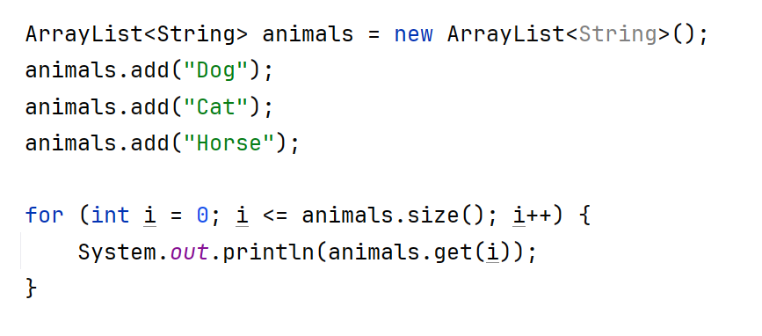
- Explain what is wrong with the loop condition.
- Rewrite the loop correctly.

(d) Finding the Lowest Value (5 marks)
You are given the following ArrayList containing five integer values:
prices
25 | 40 | 15 | 60 | 30
0 | 1 | 2 | 3 | 4
(Assume the values are stored in an ArrayList<Integer> in the order shown.)
- Pseudocode
Write pseudocode that describes the steps needed to find the lowest value in the ArrayList. Your pseudocode should: - Make an initial assumption - Compare values one at a time - Update the lowest value when needed
- Java Code
Using your pseudocode as a guide, write Java code to find and print the lowest value in the prices ArrayList.

Question 2 – Exceptions (15 marks)
(a) Understanding Exceptions (4 marks)
- What is an exception in Java?
- Name one runtime exception.
- Why is exception handling important?

(b) Try–Catch (6 marks)
Write Java code that:
- Asks the user to enter two integers
- Divides the first by the second
- Uses a try–catch block to handle division by zero

(c) Multiple Exceptions (5 marks)
A program asks the user to enter an integer and then uses it as an index in an array.
- Name two exceptions that could occur.
- Write a try block with two separate catch blocks to handle them.

Question 3 – XML and CRUD (15 marks)
(a) XML Structure (3 marks)
Consider the XML:
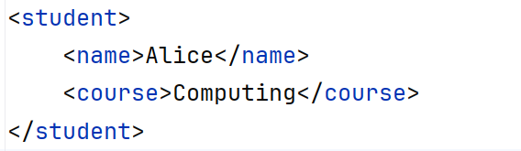
- What is the root element?
- Name two child elements.
- State one reason why XML is useful.

(b) CRUD (4 marks)
- What does CRUD stand for?

- Match each term with its meaning:
- Create  - Read  - Update  - Delete | a. Remove data  b. Add new data  c. Display data  d. Modify existing data

(c) Thinking Question (3 marks)
Explain, using pseudocode, the steps a program would take to:
- Read an XML file
- Display all student names stored in it

(d) Using try..catch (5 Marks)
The following method is written in Store.
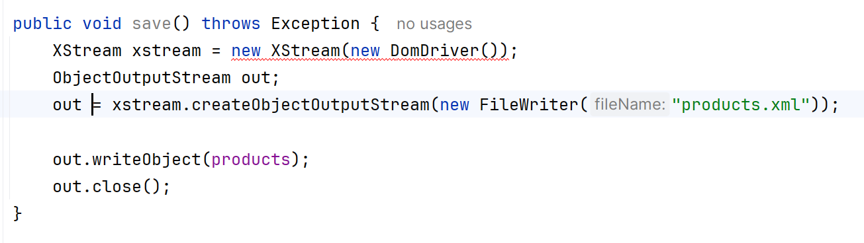
The following code is going to call it, but has an error.
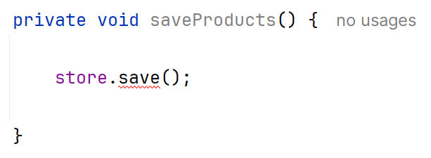
- What is the error?
- Rewrite the code correctly.

