PROGRAMMING FUNDAMENTALS 1
IN CLASS EXAM
TIME : 1 HR
Week 6, semester 3 2026

There are two sections on this paper. All questions are mandatory.

Section A: (Multiple choice) is worth 30 Marks (3 marks per question)

Section B: (Writing code) is worth 60 marks (4 questions, 15 Marks each)

Student Name : __________________________________________

Student Number : ________________________________________

Programme (CS/Forensics/Physics) _________________________

Group (W1/W2/W3/W4/Physics) _____________________________

Section A –Multiple choice - Please circle your answer. Only one answer applies in each question.

Section A - multiple choice. (30 Marks)
Each question is worth 3 Marks. There is exactly one correct answer in each question.

- What does the size() method of an ArrayList return?
  - The number of elements currently stored
  - The maximum capacity
  - The last valid index
  - The memory size

- What happens to ArrayList indexing when an element is removed?
- Elements after it shift left
- Indices remain unchanged
- The list becomes empty
- A runtime error occurs

- Which is a limitation of the for-each loop when used with ArrayLists?
- You cannot safely remove elements
- You must use an index
- It can only loop backwards
- It cannot access elements

- What does persistence mean in programming?
- Data continues to exist beyond the life of the program
- Data stored temporarily in memory
- Data stored in variables only
- Data displayed on a web page

- What is object serialization?
- Converting objects into a stream of bytes for storage
- Displaying objects on screen
- Sorting objects in an ArrayList
- Validating user input

- What happens to program data stored only in memory when the program closes?
A. The data is lost because memory is volatile
B. The data is saved automatically
C. The data is converted to XML
D. The data is cached permanently

- What is a static variable in Java?
A. A variable that belongs to each object separately
B. A variable shared by all instances of a class
C. A variable that cannot be changed
D. A variable declared inside a method

- How should a static method typically be called?
A. By creating an object and calling the method on it
B. Using the keyword this
C. Using the class name without creating an instance
D. It cannot be called directly

- In Javadoc, which symbol starts a documentation comment?

A. /*
B. //
C. /**
D. #

- Why are utility methods often declared static?

A. They need to store object state
B. They must override superclass methods
C. They can be called without creating an object
D. They cannot return values

Section B – Long Questions (60 marks)
Answer ALL questions. Each question carries 15 marks.
You should write your answers on this sheet.

Question B.1 – ArrayLists (15 Marks)
QB.1.1 Write Java code to:
- Declare and create an ArrayList<String> called modules. (2 Marks)

- Add the following values:
  - "Programming"
  - "Databases"
  - "Web Development" (3 Marks)

QB1.2 Given an integer n, write code to
  - Check that n is a valid index for ‘modules’
  - If so, delete the String at that position (5 marks)

QB1.3 Using the code on previous page (to start with), write a boolean method
‘removeModule(int n)’
that tries to delete the String at position and returns
  - true if the delete was successful
  - false otherwise (5 Marks)

Question B2 - Looping (15 Marks)
- Loops with ArrayLists
Write code to print out all the values of modules (as added in question B1) (one line per module) using :
- While loop (3 marks) | - For-each loop. (3 Marks)

- Given a (populated) primitive array of integers, write a method
‘int findLargest(int[] a) ‘
Which takes in an array a and returns the position of the largest element in the array. You can assume that the array is non-empty. (4 Marks)

- Using the same algorithm, write a method to find the product with the highest unit cost using the Shop running example used in class. The method,
‘Product findMostExpensive()’
Should return the product with the highest unit Cost. You may assume that the method
- Is written in the Store class
- Has available to it (as a field)
‘products’
which is an ArrayList of Product.
You can also assume that you have the method
‘getUnitCost()’
available to you in the Product class (returns the unit cost of a Product object)
(5 Marks)

Question B3 - Misc (21 Marks)

- Given the following:
public class Employee
{
private double salary;
private double deductions;
private double netSalary;
//
//
public void calculateNetSalary()
{
netSalary = salary – deductions;
}
public void setSalary(double salary)
{
this.salary = salary;
}
}

This Employee class has three fields. The value of netSalary depends entirely on the current values of ‘salary’ and ‘deductions’ (netSalary = salary - deductions).
Describe what problems can arise from this data design. Also show how you would fix this problem. (note we need to be able to see/use what the netSalary is from time to time).
(5 Marks)

- Given the following definition of GRAVITY

Describe what each of the words mean in this context :
private :

static :

final :

(5 Marks)
- Write a method that takes in three integer values (low, high, value) and returns
- true if the value of value is between low and high (inclusive)
- false otherwise

Be careful to name the method appropriately and to use appropriate variable names. (5 Marks)

- Given the following code:
int x[]={5,6,7};int q = 1;for (int y = 0; y <= 2; y++)q*=x[y]; System.out.println(q);

a: What (exactly) is printed when this code is executed?
b: Rewrite the code using indentation and better variable names.
(6 Marks)

Question 4 - XML (19 Marks)

The following method is written in Store.
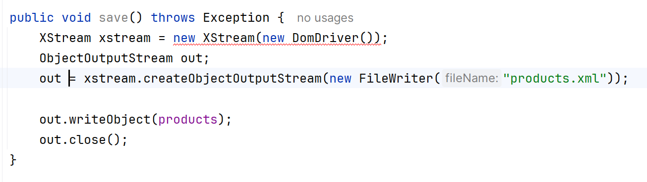
The following code is going to call it, but has an error.
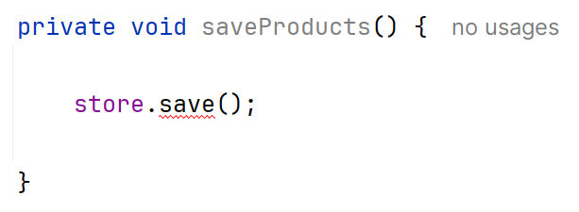
- What is the error?
- Rewrite the code correctly. (5 Marks)

- Try–Catch (6 marks)
Write Java code that:
- Asks the user to enter two integers
- Divides the first by the second
- Uses a try–catch block to handle division by zero

QB4.3 CRUD What does CRUD stand for? (4 Marks)

QB4.4 Match each term with its meaning, using either lines or writing it down: (4 Marks)
- Create  - Read  - Update  - Delete | - Remove data  - Add new data  - Display data  - Modify existing data

