 | class |  |  | method
 | abstract class |  |  | abstract method
 | private |  |  | static method
 | public |  |  | field
 |  |  |  | static and final field

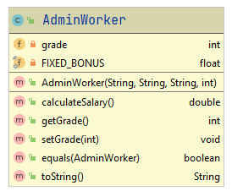
Class Name
Constructor
Methods
Instance fields
Methods – return type
Instance field – data type
Constructor – name and parameter list
Methods – name and parameter list
Instance field – variable name

