Class Diagram  All questions in this exam are based on one app. | 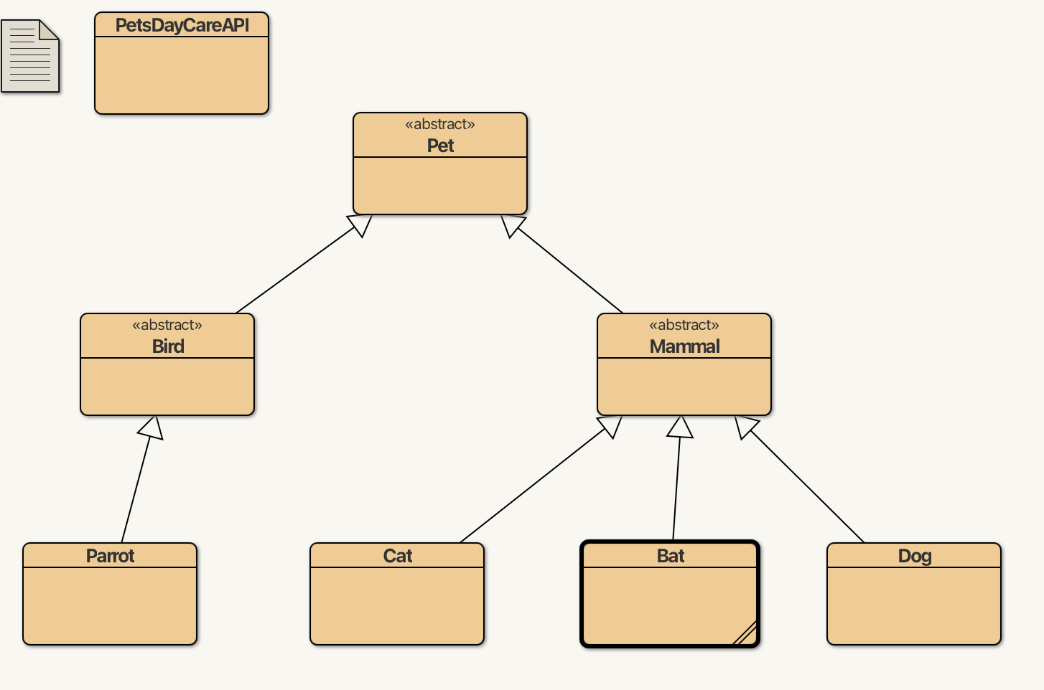
New class

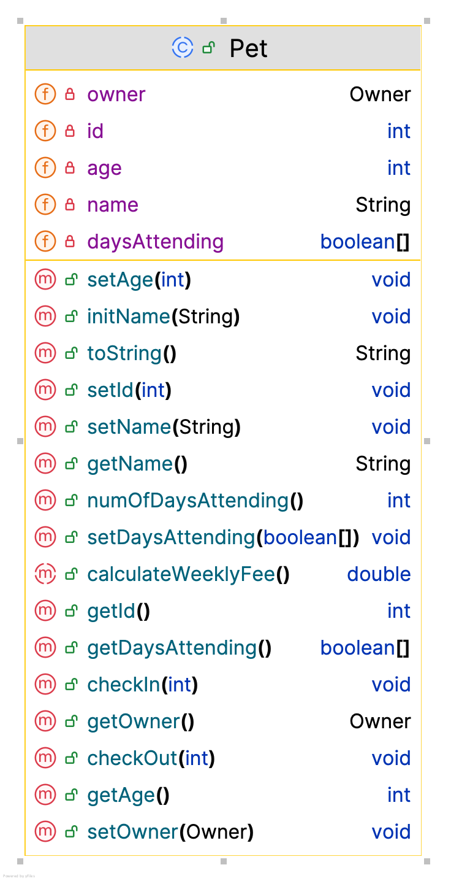 | 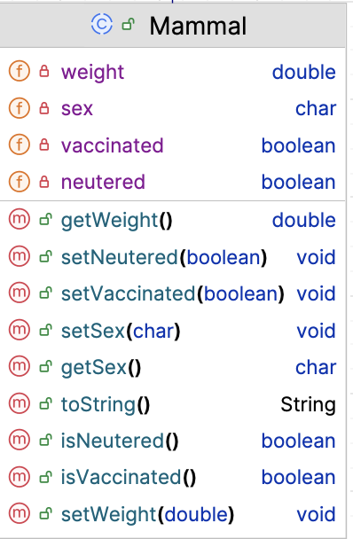
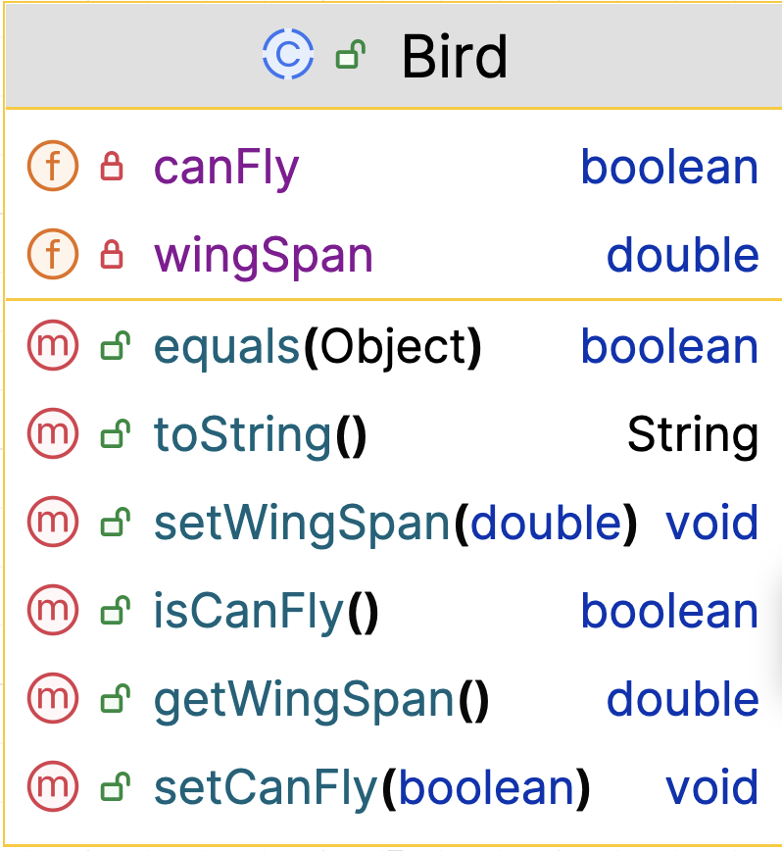 | 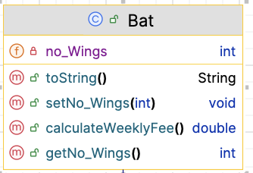

You may detach this page from the booklet.

Name | Student Number | Course

Instructions:

- 2 hour exam.

- 4 Questions, answer all.

- Fill in your name, student number and course above.

- Complete the areas in this booklet and give it to your invigilator before leaving the room.

- Except for the front page, don’t tear pages from this booklet; submit as a complete booklet.

- You can write anywhere in this booklet and use the back of pages for additional code, rough work, etc.

Question 1 - Models:

With this exam, you are given an inheritance hierarchy and the structure (UML) for the classes in the hierarchy. For the Pet, Mammal and Bat classes, code the following:
- The class definition
- The constructor
- The toString() method

Note: you do not have to define the fields or write the getters/setters.

Pet.java

Mammal.java

Bat.java
Question 2 - Controllers:

The class diagram has a PetDayCareAPI class. In this class, there is an ArrayList<Pet> defined:

public class PetDayCareAPI {
private ArrayList<Pet> pets;
public PetDayCareAPI () {
pets = new ArrayList<Pet>();
}
}

Each box below has a comment in it. Code each method as defined in the comment.

Pet.java
// Write a public method, listAllPets(). The return type is String.
// This method returns a list of the pets stored in the array list.
// Each post should be on a new line and should be preceded by the
// index number e.g.
// 0: Pet 1 Details
// 1: Pet 2 Details
// If there are no posts stored in the array list, return a string
// that contains "No Posts".

PetDayCareAPI.java
// Write a public method, numberOfDogs(). The return type
// is int. This method returns the number of Dog objects
// stored in the array list.
// If there are none stored, zero is returned.

PetDayCareAPI.java
// Write a public method, listAllParrots().
// The return type is String.
//
// This method returns a list of the parrots that
// are stored in the array list
//
// Each matching post should be on a new line and should be preceded
// by the index number e.g.
// 1: Pet 2 Details
// 4: Pet 5 Details
//
// If there are no pets stored in the array list, return a string
// that contains "No Pets".
//
// If there are no bats in the list, the return string should
// have "No parrots here".

PetDayCareAPI.java
// If you included the sort functionality in your submitted code
// base, please write the code to sort the array list by any criteria // you wish e.g. pet age.

Question 3 – Junit Tests:

This JUnit test class for PetsDayCareAPI contains test fixture data:

public class PetsDayCareAPITest {
PetsDayCareAPI validAPI, emptyAPI;
Owner owner_1;
Dog doggie;
Cat cattie;
@BeforeEach
void setUp() {
file = new File("test.xml");
validAPI = new PetsDayCareAPI("HappyPets", 30, “pets-1.xml”);
emptyAPI = new PetsDayCareAPI("NothingHere", 20, “pets-2.xml”);
owner_1 = new Owner(100, "Siobhan", "087-999");
Dog doggie = new Dog("Buddy",12, owner_1, 12, 'M', true, 23, false, "BEAGLE", false);
Cat cattie = new Cat("kitty", 3, owner_1, 22, 'F', true, 5, true, true, "FEATHER WAND");
validAPI.addPet(doggie);
validAPI.addPet(cattie);
}

Write the two test methods that are specified in the box below.

Note:
- You can assume that you don’t have to write import statements.
- You can name the test methods anything you wish.

NewsFeedTest.java
In a previous question, you were asked to write a method called numberOfDogs().
- This method returned the number of Dog objects stored
in the array list.
- If there were none stored, zero is returned.

Using the test fixture data given above, write the two test methods, detailed below.

Test Method 1: This test method should verify that zero is returned by numberOfDogs() when no pets are stored in the PetsDayCareAPI object.

Test Method 2: This test method should verify that the correct number of dog objects stored is returned by numberOfDogs() when dog objects are stored in the PetsDayCareAPI object.

Question 4: Driver - runMenu()

In your assignment, you had a Driver class. If we take a simplified version of the menu you wrote, we just want the user to print out a message to the user each time an option is chosen. The usual structure for menu applies - loop until exit value is entered (use 0 as exit)

public class Driver {
public static void main(String[] args) {
new Driver();
}
public Driver(){
runMenu(); //TODO Write runMenu()
}
}

This class displays the menu of options that the user can choose from - see the menu and a running of it below:
