- Binary Message

CS Concept: Data Representation

01110011 01101111 01100011 01101011 01100101 01110100

Instructions
- Convert each 8-bit number to its ASCII character
Binary (8-bit) | ASCII (Decimal) | Character
01110011 | 115 | s
01101111 | 111 | o
01100011 | 99 | c
01101011 | 107 | k
01100101 | 101 | e
01110100 | 116 | t

- – Code Tracing (Reversed Data)
CS Concept: Arrays, Indexing & Iteration
Instructions: Trace the Java code to determine the output.
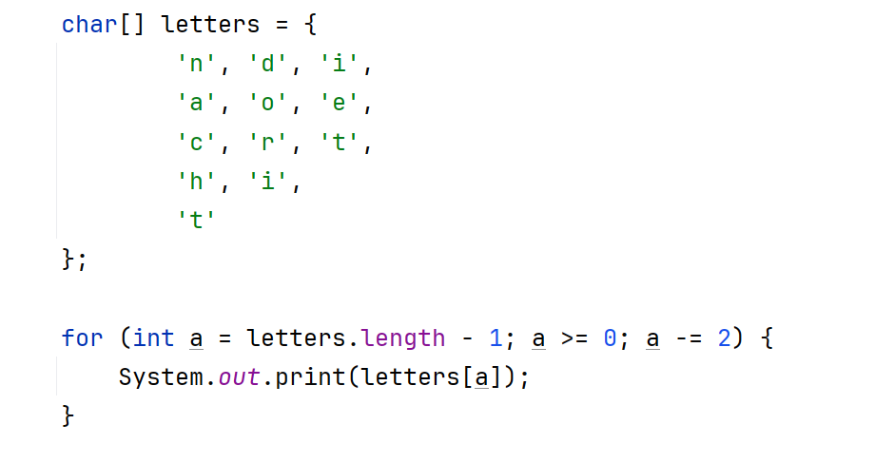Output:
thread

- Caesar Cipher
CS Concept: Encryption & Security

Instructions: Decode the message using a single-letter shift. Punctuation is unchanged.

Ibmmly

Should produce:
buffer
(shift -7, can hand out the cipher sheets from last year)
Letter | Shift −7 | Result
i | h g f e d c b | b
b | a z y x w v u | u
m | l k j i h g f | f
m | l k j i h g f | f
l | k j i h g f e | e
y | x w v u t s r | r

4. Riddle
I have a name but I am not a person.
I have an extension but I do not stretch.
I hold knowledge but cannot think.
Open me and secrets appear.
What am I?
Option 2:
I live inside a folder but I’m not a directory.
I hold the words machines obey.
I may end in .java, .txt, or .png.
Without opening me, you cannot see what I contain.
What am I?
Answer: File

