- Puzzle 1 - Binary Message

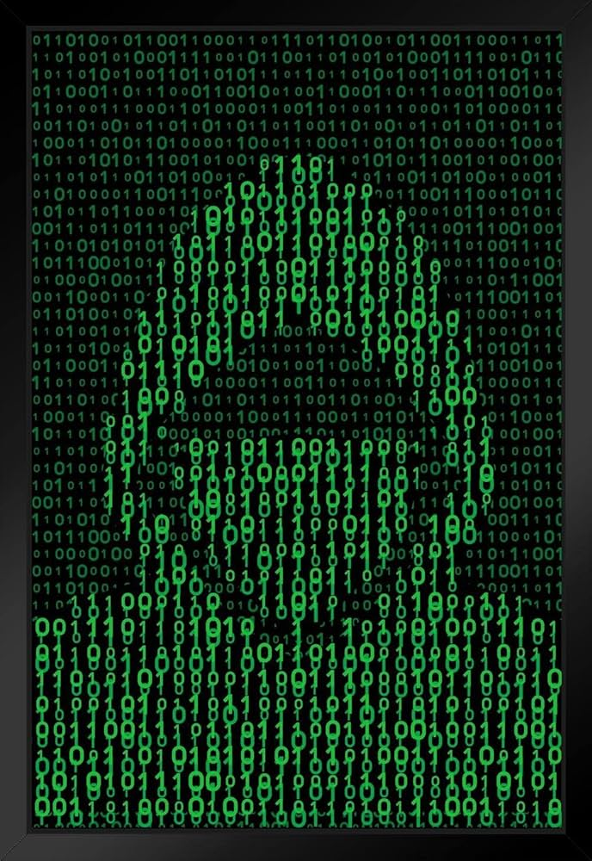
CS Concept: Data Representation
Computers store information using binary (0s and 1s). Each group of 8 bits represents a character using the ASCII encoding system.

🔐 Binary Message
01110011 01101111 01100011 01101011 01100101 01110100

Instructions
- Convert each 8-bit binary number to its decimal value.
- Use the ASCII table to find the corresponding character.
- Write the characters below to reveal the hidden word.

Binary (8-bit) | ASCII (Decimal) | Character

- Puzzle 2 – Code Tracing (Reversed Data)


CS Concept: Arrays, Indexing & Iteration
Understanding how programs run step-by-step is an important programming skill.

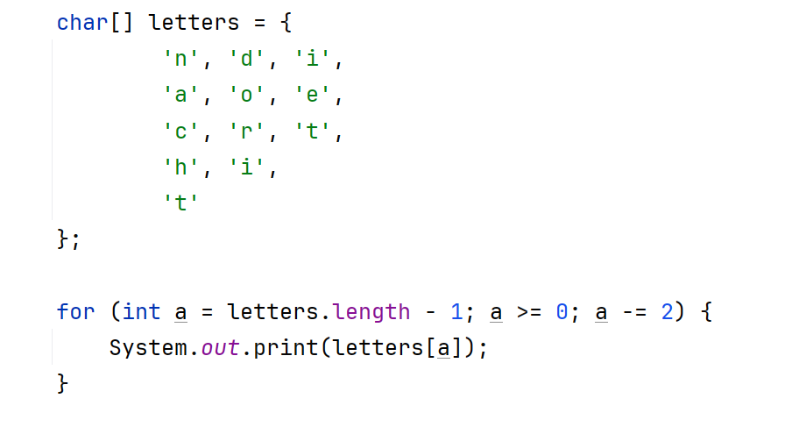

Instructions:
- Carefully trace the Java code and determine what will be printed to the screen.

Output:

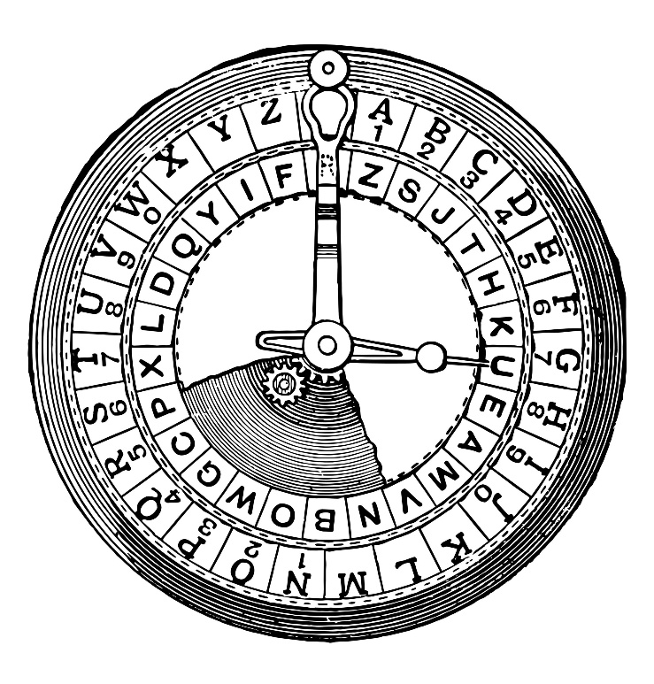
- Puzzle 3 - Caesar Cipher

CS Concept: Encryption & Security

One of the earliest encryption techniques is the Caesar Cipher, where each letter is shifted a fixed number of places in the alphabet.

🔐 Encrypted Message

ibmmly

Instructions:
- Decode the message using a single-letter shift. Punctuation is unchanged.
- Do you know the shift value? Is there someone you can ask?

Output:

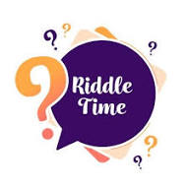
- Puzzle 4 – Riddle

You might use me to smooth rough nails,
Or to store papers in an office pile.
But I live inside a folder, not a drawer.
I hold the words machines obey.
I may end in .java, .txt, or .png.
Open me, and my contents appear.

What am I?

Answer:

