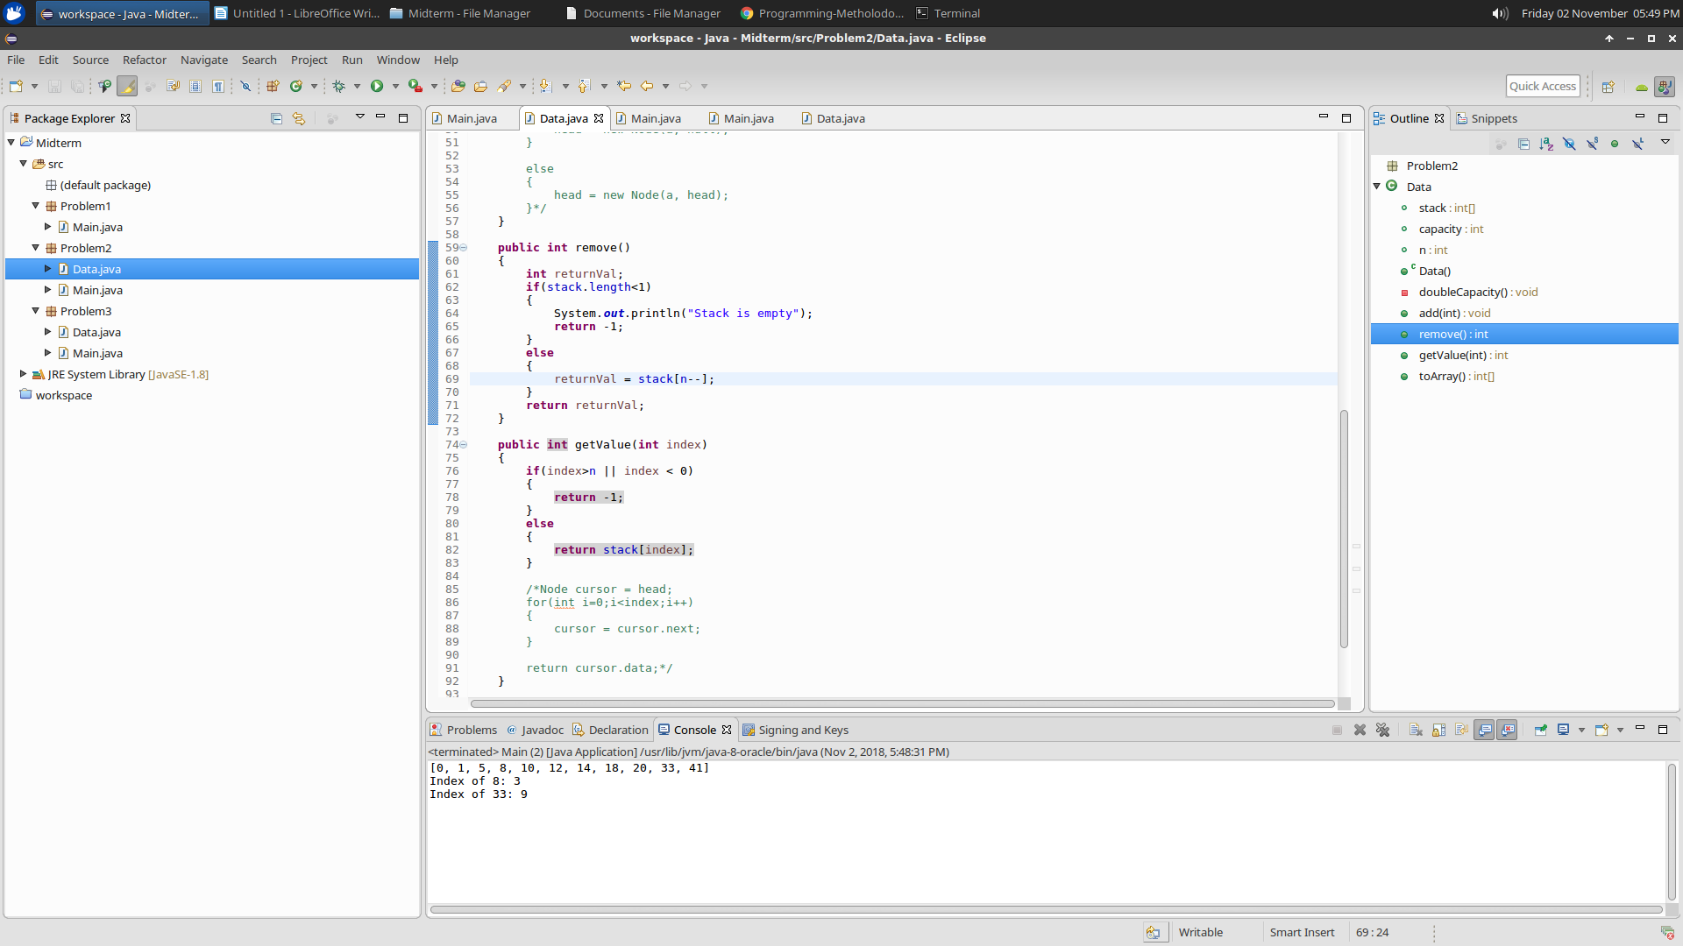

1. As shown in the highlighted code snippets, the remove and getValue methods are implementing using array access. Accessing elements in array is done in constant time.

2. **private** **void** doubleCapacity()

{

**int**[] temp = **new** **int**[capacity*2];

**for**(**int** i=0;i<capacity;i++)

{

temp[i]=stack[i];

}

stack = temp;

}

**public** **void** add(**int** a)

{

**if**(n+1>capacity) doubleCapacity();

stack[++n] = a;

/*if(head == null)

{

head = new Node(a, null);

}

else

{

head = new Node(a, head);

}*/

}

add() achieves O(N) time because there is posibility that the array has to be doubled to increase capacity. Doubling the array requires iterating through each element in the array, hence it is achieved in O(N) time.