**Created with an evaluation copy of Aspose.Words. To remove all limitations, you can use Free Temporary License <https://products.aspose.com/words/temporary-license/>**

**1.2 Computer-System Organization 7**

is increasing. Mobile operating systems often include not only a core kernel but also **middleware** a set of software frameworks that provide additional services to application developers. For example, each of the two most promi- nent mobileoperatingsystems Apple siOS and Google s Android features



a core kernel along with middlewarethat supports databases, multimedia,and graphics (to name a only few).

1.2 Computer-System Organization

Before we can explore the details of how computer systems operate, we need general knowledge of the structure of a computer system. In this section, we look at several parts of this structure. The section is mostly concerned with computer-system organization, so you can skim or skip it if you already understand the concepts.

1.2.1 Computer-System Operation

A modern general-purpose computer system consists of one or more CPUs and a number of device controllers connected through a common bus that provides access to shared memory (Figure 1.2). Each device controller is in charge of a speci c type of device (for example, disk drives, audio devices, or video displays). The CPU and the device controllers can execute in parallel, competing for memory cycles. To ensure orderly access to the shared memory, a memory controller synchronizes access to the memory.



For a computer to start running for instance, when it is powered up or rebooted it needs to have an initial program to run. This initial program, or **bootstrap program**, tends to be simple. Typically, it is stored within the computer hardware in read-only memory (**ROM**) or electrically erasable programmable read-only memory (**EEPROM**), known by the general term  **rmware**. It initializes all aspects of the system, from CPU registers to device controllerstomemorycontents.Thebootstrapprogrammustknowhowtoload the operating system and how to start executing that system. To accomplish

mouse keyboard printer monitor

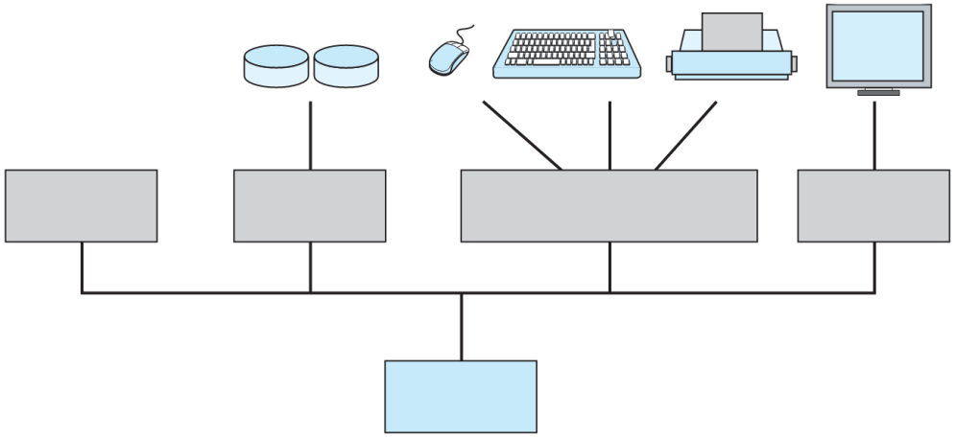

disks on-line

CPU disk USB controller graphics controller adapter

memory

Figure 1.2 A modern computer system.