CPU Torrent – Quantitative Analysis

Initial Case with Assumptions
Let,

where,

where,

With CPU Torrent, we can improveby using the time spent on the queue, to process the offloadable components elsewhere. Thus, letbe the time taken to complete an entire process with the CPU Torrent.

From Queuing Theory, we can assume the M/M/1 Model, with
- 1 Server with,
Service Time as
- Poisson Arrivals
- Exponential Service Time Distribution
The Average Waiting Timeis given by,

Thus, from the above equations, we have,

We know that,

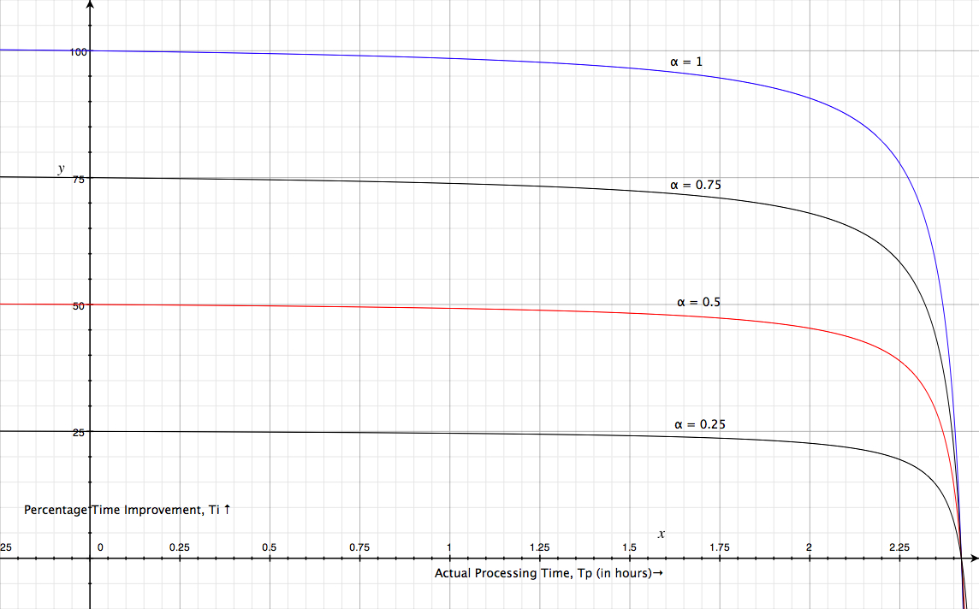Illustration 1: Actual Processing Time, Tp vs Percentage Time Improvement, Ti

Interesting Observations

This basically means that as the time spent on the queue increases, the time improvement is of diminishing importance. This is even more so if
e.g.
However,

If
There have been many times during which the current PredictProtein System has had its queue empty

With an empty queue, there are no time improvements gained by offloading some computation, in fact, it may actually increase the time required due to the network latencies, etc. However, the load on the local system can still be reduced by the CPU Torrent at the cost of a marginally slower response timeinstead of.
Let,

Let,

Let,

For the current PredictProtein system to be stable (from a Queuing Theory point of view),

