Punchy Punchy Design Guide

Datalust

Maria Bourg

Contents

Punchy Punchy Concept 3

Punchy Punchy Game Mechanics 3

Knockback 3

“Rooms” and Camera Design 3

Level Objects & Design 4

Level 1 4

Level 2 5

Level 3 5

Player Mechanics 5

Punching 5

Jumping 6

Punchy Punchy Look/Feel/UX 6

Punchy Punchy Game Flow 7

Main Menu 7

Level Select Menu 7

Loadout Menu 7

Fight Start 7

Camera Update 7

Knockback Update 7

Fight End 7

Punchy Punchy Input and Controls 8

HUD Elements 8

Minimap 8

Knockback Indicator 8

Design References 11

# Punchy Punchy Concept

Punchy Punchy is a 2D side-scrolling fighter featuring two intergalactic robot tanks equipped with extendable boxing gloves trying to punch their opponent outside of the huge arena.

The arena is segmented into rooms the size of the screen, which inhibit progression. To reach the end of the arena, players must punch their opponent multiple times to send them flying through the edges of the screen. To top it all off fights get zanier as time goes on, because every time you get hit, you get knocked back even further.

# Punchy Punchy Game Mechanics

## Knockback

The biggest differentiator from Punchy Punchy from any other fighting platformer is the fact that there is no health. Literally the only indication of player success or failure that they have to pay attention to is their current position on the map. This opens up access to our target audience, the casual player. By taking all attacks and making them equal in “damage” (in quotes since there really is no damage in Punchy Punchy), players don’t have added information to process when choosing which attack to use.

## “Rooms” and Camera Design

The Punchy Punchy arena is huge, and is segmented into five different “rooms” worth of screen space. Every fight starts off in the center of the five rooms, and the goal is to push your opponent off the edge of the final room, opposite of your spawned position.

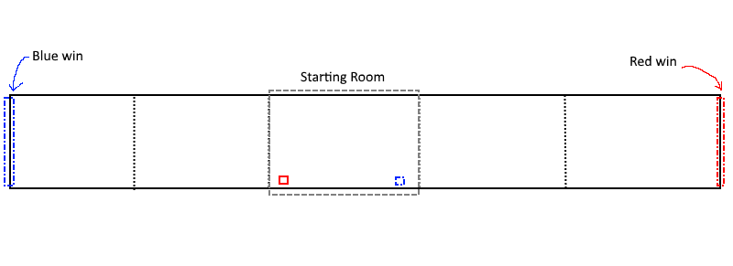

The camera of Punchy Punchy is a special mechanic that forces player interaction. Players cannot move from a room unless someone is sent flying through the screen boundaries. The camera only moves left or right when the right player is smashed through the boundary. The red player can only be smashed through the left side of the screen at all times. Likewise, the blue player can only be smashed through the right side of the screen. If a player is smashed against the wrong boundary, they simply reflect off the wall.

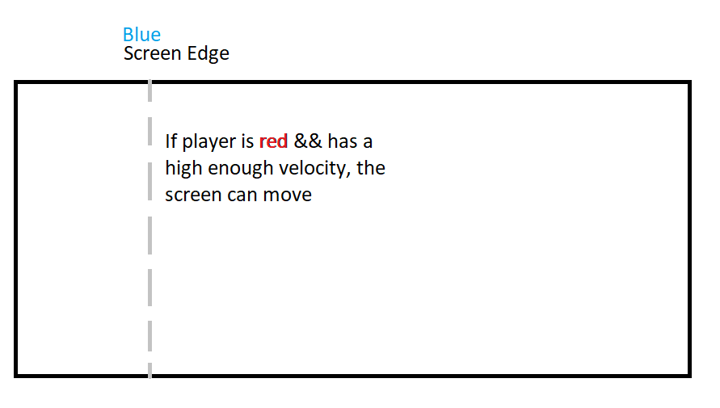

## Level Objects & Design

The levels of Punchy Punchy have similar physical structures, featuring different physics-based rules of the world. The dimensions of the levels are all the same, at a 16:9 screen size ratio at all times. The levels will always be 5-screen widths length. The platforms themselves also form themselves to the screen size, as well as any other object in the game.

Another shared similarity between all levels include the arena end goals for each player. They are unmarked, except for the indication made by the end of the arena floor half-way through the final screen. When the correct player is tossed off the end of the arena, the fight ends and the game is over. Otherwise, the pit is treated like the other pits and the player’s knockback scalar is increased while they are moved back to the arena platform.

The platforms that are normal (no sort of effect on the player) are all semi-solid. This means a player can jump through them upwardly, but land on them solidly. Players cannot move downward through the platforms however, and must move off of them if they want to be on the ground.

### Level 1

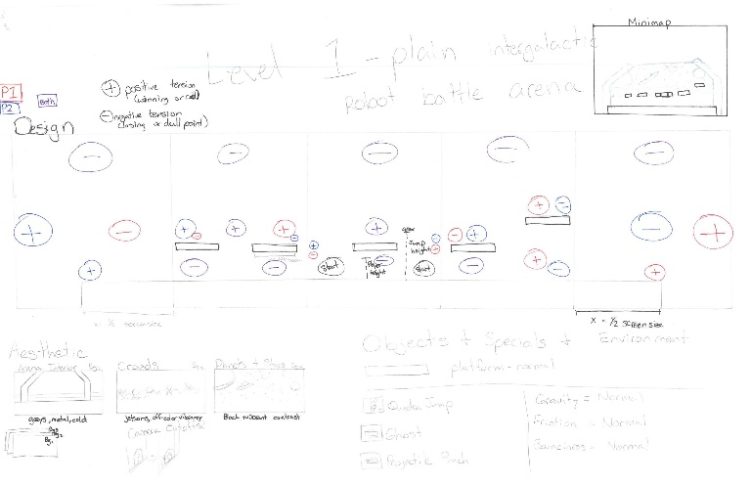

Level 1 is the introductory plain level. This level features several semi-solid platforms with normal gravity, bounciness, and friction levels. This is the run-of-the-mill intergalactic robot battle arena.

### Level 2

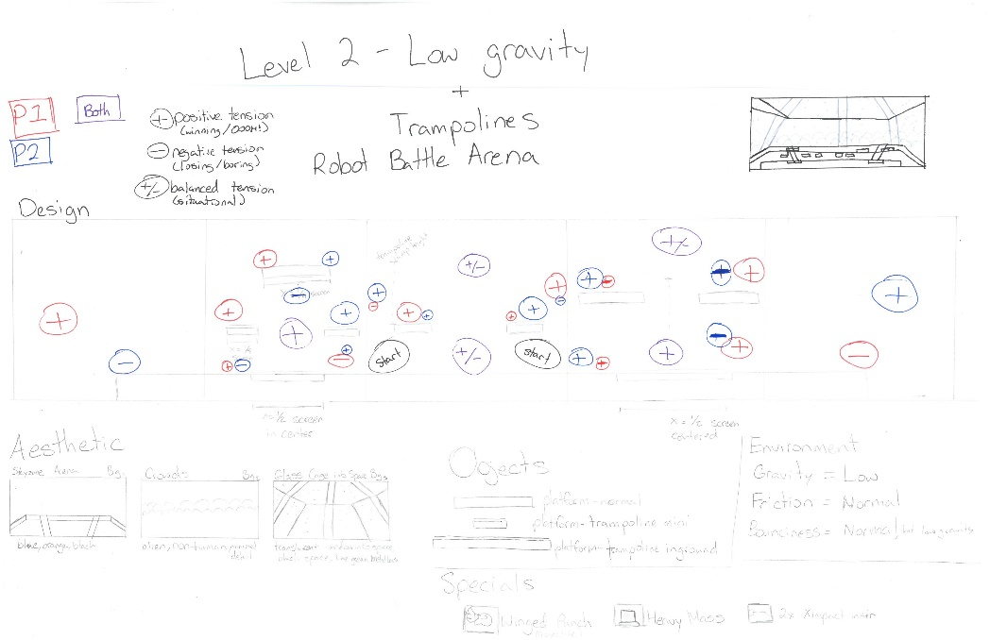

Level 2 spices things up with low gravity and trampoline platforms. This specifically targets mid-air combat and livens the heatmap from the bottom-third of the screen to all three sections.

### Level 3

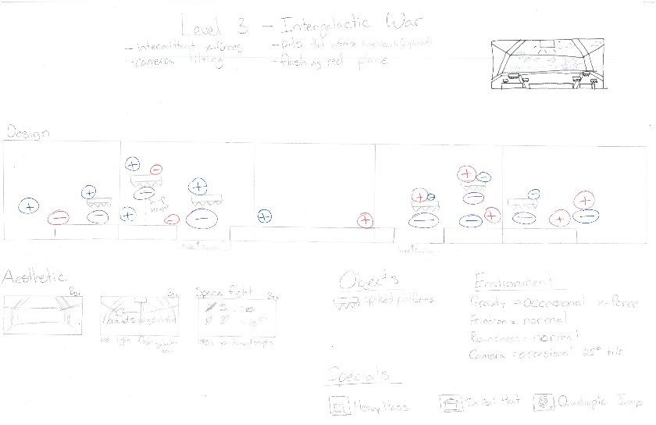

Level 3 is the final and hardest stage, focusing on the environment’s ability to deal damage to the players. Included are pits that increase players’ knockback scalars, but throw them back onto the stage, and spiked platforms that also increases the player’s knockback scalar.

## Player Mechanics

### Punching

For semester 1, players only have 1 attack – a forward punch that lunges from whichever way the player is facing.

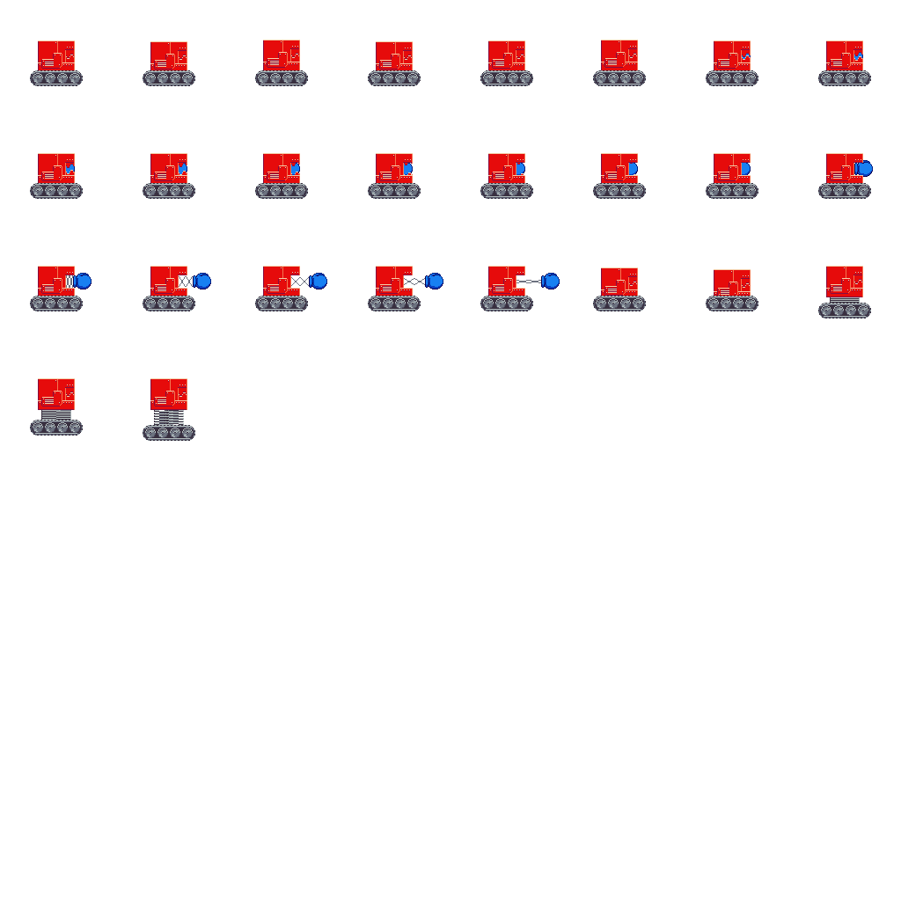

Semester 2 will include this forward-facing punch, a downward attack, and an angled attack that pushes players into the air. These allow player choices and more fighting capability in mid-air combat.

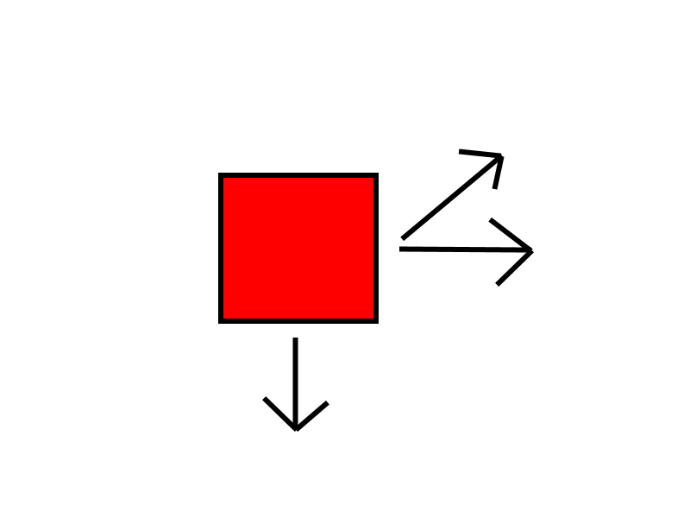

### Jumping

Both players can jump twice in one instance. If a player only taps the input to jump, they will still jump the full height.

# Punchy Punchy Look/Feel/UX

The aesthetics of Punchy Punchy contrast 16-bit graphics with realism, and bright, saturated colors against dark backgrounds and peripherals. The theme is set in an intergalactic space arena, which lends itself to metal and glass materials. Technology is NOT a part of this theme, and is replaced with toy aspects. For example, what should be some high tech attacking mechanism attached to the tank is a child’s extendable boxing glove toy. The spikey underbelly of the spike platforms are not high tech, and are cartoonish and childlike in style.

# Punchy Punchy Game Flow

## Main Menu

2 players are necessary to play the game. When the game launches, either player can maneuver through the menus with their own controllers (or, either player can input commands from the keyboard). To start a match a player must navigate from the main menu to the 2-player battle mode.

## Level Select Menu

This will lead the players to the level select screen. If this is the first playthrough, everything will be locked except for level 1. Otherwise, players can choose which level they want to battle on simultaneously. If the players select two different levels, the level will be selected randomly out of the two.

## Loadout Menu

Once the level has been selected, the loadout menu is next to come up. The loadout menu is interactable, and forces players to learn the controls before entering a match if it is their first time playing. The level features two separate containers for the players to prep themselves in, with a breakable object in the way of them readying themselves for battle. The general flow of the menu is “Pick a special -> punch the glass -> ready for battle”. The level selected previously has specified powerups available for the players to choose from. If the player selects nothing on their own and immediately readies for battle, they will have a default power selected for them.

## Fight Start

Once both players have readied, the level is loaded and a countdown begins. When the countdown is done, players are available to move and punch freely. The camera at this point is locked into position, and neither player can escape to either side. Players must fight each other. To make progress through the level, a player must hit their opponent so hard that they fly through the camera’s edge. This means a player must land at least 2 hits before being able to progress to the next screen. The easiest scenario is player 1 hits player 2 to the edge of the screen twice without any input from player 2. The third hit will generate enough force to break through the camera’s edge, and both players will be moved to the next screen.

## Camera Update

Both players are moved in this specific fashion: The knockbacked player lands where they land, most likely in the middle of the next room. The camera’s edge will align with the next room’s end. At that moment, the camera will zoom out to its farthest position, so that both players are still visible on screen. Here is where the winning player must move forward, as moving backward will be disabled. As the player moves forward into the second room, the camera zooms in to its default setting. The other player will not be able to leave the room, and has to wait for their opponent to enter the room before the fight can start again.

## Knockback Update

The player who is successful in hitting their opponent to the next room reduces their knockback multiplier by 1.

## Fight End

This continues back and forth through screens until one player is knocked off the edge of the level, ending the fight. A “You’ve won!” screen pops up on top of the level, blurring out the game behind it, which allows players to either retry immediately or go back to the loadout, level select, or main menu screens. If the loadout screen or level select has unlocked a new level or special, the player will be notified with an animated unlock on top of the button to go back.

# Punchy Punchy Input and Controls

Punchy Punchy allows for two different inputs for both players. One is the keyboard, WASD for movement and F to punch for player 1 and 8456 for movement and ‘ to punch for player 2. Otherwise, the game allows for xbox controller support with the joystick for movement and facing and A for punching on both players. Specials for each player are on the V key and the / key respectively, otherwise on the X button on both controllers.

# HUD Elements

## Minimap

To indicate progress for both players, at the top center is a minimap reflecting the state of the fight. As the players move from screen to screen, the minimap updates a rectangle circled around the current position of the screen compared to the level.

## Knockback Indicator

As players get hit in the fight, they get knocked back further and further via a scaling multiplier. To indicate this for both players, an emblem at the bottom left and right corners shows that mechanic. Both players start off filled up to the top of their silhouetted square tank. As they get hit, the fill is lowered by a sixth. By the sixth hit, the silhouette is completely empty and blinking red to indicate real danger.

# Second Semester Planning

|  |  |  |  |
| --- | --- | --- | --- |
| Weeks | 1-3 | 4-10 | 11-14 |
| Topic | Refactoring | Content | SFX & Polish |
| Specifics | * Allowing the programmers to restructure specialized “jank code” that was for the demo into generalized, healthy code. * Training new recruits/non-programmers on the engine. * Objects needed for levels added | * Levels 1/2/3 in engine. * Menus (main, options, pause, etc) in engine. * Locked content * Abilities in engine | * Particles in engine * Music/Art finalized and in engine. * Screen shake in engine * Winning “confetti” in engine * Screen fading between menus and states. |