Research

# 9/24/17

What makes a fighting game worth playing? <https://youtu.be/0U6ahedifJE>

* Franchising makes it easier
* Tiers of players – Button smashers -> got a couple of combos -> thousands of hours analyzing the game
* Simplified mechanics still works
* Accessibility can counterbalance games without a franchise
* SSB removed more difficult moves to appeal to more casual audiences, didn’t work.

Concepts every 2d fighting game player should know <https://youtu.be/nd9sEB6ku14>

* Normals, buttons, classified in light, medium, heavy
* Footsies and pokes are for without combos, generally safe damage
* Links – opponent is hitstunned, can add another attack
* Cancels
* Chains time the hits correctly are automatic
* Counter hit – beat opponents tack with timing of your own.
* Hit stun and block stun
* Chip damage
* Tech – both grab at the same time
* Cross up – change attack height to get through blocking
* “There’s no such thing as a dropped combo, just a happy little reset”
* Reversal – special performed out of recovery
* DPs – anti air uppercuts

Analysis: The Simplist Fighting Games <https://youtu.be/-sUVNqNSo5M>

* DiveKick – 2 buttons, no joysticks.
* Accessibility causes tension with experienced players who want “depth”
* The more decisions you make your players make, the more decision fatigue they have, the worse decisions they make later, ending up in quitting your game.
* Rising thunder – specials have a cooldown time
* Fantasy Strike – “Looks at Dive Kick’s accessibility and says ‘hold my beer’”, only jump, no crouch or upper air attacks. Throws are countered by doing literally nothing
* “Intentionality” button mashing vs knowing actually what you’re doing

EC James recommends divekick <https://youtu.be/M7okQ6xfETI>

* Not about how many moves memorized, or how many hours
* Timing, positioning, strategy
* Psyching out your opponent – Chess match

The Fighting Game Problem <https://youtu.be/n_xG1Yg_QoM>

* Way too much barrier to entry to make informed decisions
* Tutorials are not good enough
* Breaking up how many moves a player has access to at one time allows players to get comfy with their character and feel empowered and knowledgeable.
* Emphasize strategic play with rewards

James Recommends one finger death punch <https://youtu.be/81NAuduXWZ8>

* Combat DDR
* Rhythm focused instead of strategy

Nidhogg Steam Rolled <https://youtu.be/WsFSXvhGBkM>

* Pixel graphics
* Tournament mode
* Run to the other side of the map, tension in the control of the camera.
* Upper and lower “move” of sword
* Sword can drop.
* Camera is controlled by the last winner of fight
* Without sword, player can jump, kick and punch
* Instakill with player on ground
* Can throw sword, dodge roll.
* Spawns at different screens
* Doors block projectiles if closed
* Suicides go to the other player

Nidhogg 2 Chilled vs Ze <https://youtu.be/vhxop9VIHWg>

* Updated graphics = more violent
* Now including a bow and a dagger
* Indicator up above to show how many rooms are left
* Can kick back bows
* Untouchable frames don’t let you fall down
* Ranged can be countered, not thrown weapons
* If player is too far on the screen, enemy will spawn on other side from where they normally would spawn

Questions for team:

How are we not going to be above E10?

Who is the target audience? Professional, actually knows combat games, casual players?

What input methods do we have? Controller, keyboard, 2 keyboards?

What’s the tone of the game? “Praise the Nidhogg” vs “Smash tournament” seriousness

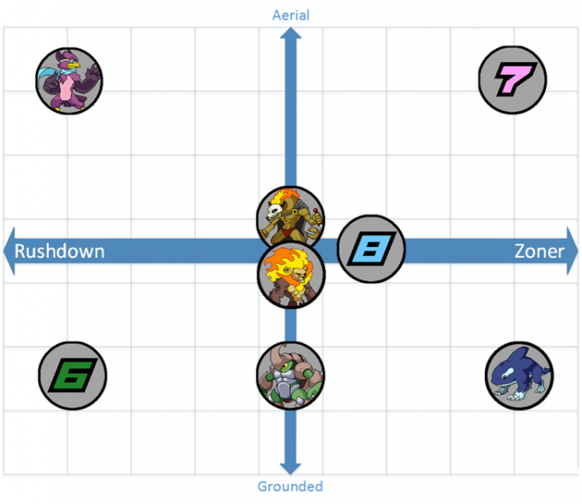

Nidhogg where instead of one hit kills, the more you hit, the harder they fly to their side of the screen.

# 9/27/17

A *Super Smash Bros-*inspired design, designed backwards https://www.gamasutra.com/view/news/256312/A_Super_Smash_

Brosinspired_design_designed_backwards.php

* Design move sets, then design characters – Bottom-up design

Unbalanced Design of SSB <https://blog.forrestthewoods.com/the-unbalanced-design-of-super-smash-brothers-3fbc9b346e15>

* Characters may seem unbalanced at the time, but it takes years, decades for things to actually settle.

Sakurai on Smash Bros character roster <https://www.wired.com/2008/02/sakurai-talks-a/>

* Character individuality is #1
* Cohesiveness in art and design is necessary
* Phases of a move = standby, windup, strike, and follow-through

# 10/4/2017

Better Jumping in Unity with Four Lines of Code <https://youtu.be/7KiK0Aqtmzc>

* Mario-like jumping.

# 11/4/17

How to use Joystick controller input <https://youtu.be/384_g0f7K_I>

Tutorial on using Unity with controller input

# 11/17/17

GIT: Merging and Workflow <https://youtu.be/0iuqXh0oojo>

* Teaching myself how to merge and how git works

Jetson – the family of the future <https://youtu.be/1oDaHRbIDH8>

* Documentary with creator commentary
* Reference research on cute futuristic art and design style

11/29/17

How to create pixel art in adobe Illustrator

<https://design.tutsplus.com/tutorials/how-to-create-pixel-art-icons-in-adobe-illustrator--cms-22941>

* unify all art assets into a certain style.

Toy story Buzz and Woody inside of Pizza planet <https://youtu.be/dGwgLVpYttM>

* exact representation of the game feel according to Maria

The Making of Metal Slug <https://www.retrogamer.net/retro_games90/the-making-of-tempest-2000/>

* exact representation of the game feel according to everyone else.

Metal slug tank war <https://youtu.be/sNJLGAPdkW4>

* video reference for game theme aesthetic

Metal Slug 3 – Space Flight <https://www.youtube.com/watch?v=d5Lstp-Fw7I>

* metal slug in space