Playtest reports m3

Maria Bourg

Datalust

Punchy Punchy

# Prototype 1 – POP Game Flow Prototype

**Overview**

<https://marvelapp.com/2hfg129>

This prototype featured hand drawn sketches of a linear flow of the game. With eight different screens of gameplay, I used the POP app to create interactive buttons that allowed testers to “play” the game. This prototype was not a complete image of the game, but simple a 30-minute sketching of a sample playthrough just to get it out there and see what people thought.

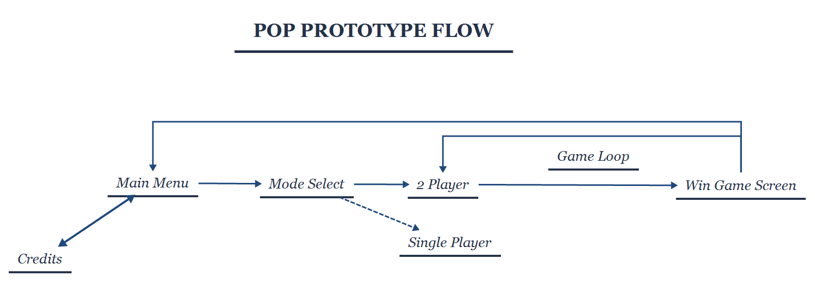

A picture containing text, whiteboard

Description generated with high confidenceA screenshot of a computer

Description generated with high confidence

**POP Prototype Sample Images**

This prototype came with four different questions that were tested in the playtests.

1. Do you see/know what the minimap is?
2. Do you see/know what the damage marker is?
3. How many times do you “play through” the game to understand what is happening?
4. Is the format of the prototype too distracting from testing the game?

I play tested this prototype with 4 different people. Here are the results:

## Playtest 1 – Mor Haba

Date: 9/28/17

Time Tested: 11:07 am – 11:12 am

Where: Edison team space

Observations:

Mor initially noted the title, muttering “Punchy Punchy”.

Mor touched the start button without any guidance and surprised himself saying “Oh, it reacts!”

He then was in the mode select screen, and attempted to select the “Single Player” button, tapping 4 times on it. The POP app highlights all available buttons, which showed Mor that only the “2 Player” button was available.

Mor went through the game fairly quickly, since the button to progress through the game shots was in the same place every time. On the second game screen Mor became confused at the image of what was going on, because I had chosen to show the enemy being kicked in the air in the same frame, saying “Wait, did I not already kick him?”

Mor continued through the second round of the fight without saying anything, and progressed to the win screen. He laughed and showed me, “Aww, that guy is really sad about all this. And I’m like really happy.”

More then hit the main menu button and went to the credits. He laughed at my credits drawing, returned to the main menu, and went back into another game. He went through a game loop quickly another time, without saying anything.

He hit the “Play Again” button one time, so I took this third run as a chance to ask questions.

I asked him what the minimap was, and he responded, “It looks like a health box maybe? Or maybe a timed attack you know where I have to hit at the right time.” Then he gasped and said, “Oh no it’s like a map like Nidhogg.” I asked him how he figured that out, and he said, “I saw the blue and red win text on the sides, and the platforms on the map match the actual screen here.”

I then asked him what the damaged bars were and he said, “I don’t know what the bars are actually. Health? Energy? There’s nothing really telling me what they are.”

In total he went through the game loop four times before handing the prototype back to me.

## Playtest 2 – Joshua Hammond

Date: 9/28/17

Time Tested: 11:13 am – 11:16 am

Where: Edison team space

Observations:

Josh started off by pressing the start button immediately without any instruction. He immediately went to the mode selection screen and pressed the “Single Player” button three times, saying “But… but I want single player!” He then clicked on 2 player and went through the entire game cycle quickly without any pause. He then hit the replay to start the gameplay over.

Josh pointed out, “I didn’t notice anything else because I was busy punching a guy.” He went through once again and noticed the minimap at the top, pointing out a discrepancy between the third screen and it’s minimap image. I asked him how he knew what the minimap was, and he said, “I figured it was a minimap because of the second screen, where the highlighted segment turned out to be the current page.”

After the second playthrough, Josh clicked the main menu button and went to the credits page quickly and remarked that it was “beautiful” before returning back to play another game.

On his third playthrough, Josh said he wanted to jump on a platform but was unable to since he had no autonomy over the gameplay. He then pointed out some confusion between the second and third gameplay screen where the enemy can be seen lying on the ground, then up again on the next page taking what looks like a punch to the face. Josh tilted his head and said, “He’s dead – but he’s back up again?” because he recognized the player laying down as being dead, not stunned.

Again he hit the replay button once more to solidify his knowledge, and I asked him the focus questions. When I pointed to the damage bars, he said, “I would assume those are health. It went down when I hit him…. Not quite sure.”

Josh went to the picture of the punch move, and Josh noted “Not sure if this is a punch. It looks like an airbending move or a projectile. That would be so cool, if there was airbending in your game because that would work as to why people are flying across the screen!”

## Playtest 3 – Elsbeth Larkin

Date: 9/28/17

Time Tested: 11:16 am – 11:20 am

Where: Edison team space

Observations:

Elsbeth didn’t have as much time as the previous testers, so the test was fairly sparse of information.

Elsbeth asked what she should do, because she thought the prototype was just a picture. I simply told her, “Start the game” so she tapped the start button and gasped when the button actually worked. She also tapped the single player mode button 4 times, saying “I wanna go single player! This is an incomplete prototype!”

She started the 2 player mode, and asked, “What do I do? How do I know that I have to hit the other player?” She clicked on the screen randomly until POP showed the blue square to where she needed to press to continue. She did this several times for the other gameplay screens as well, without saying anything.

She exited the game, and checked out the credits, saying “Oh, look at them credits.”

I asked her to run through the gameplay one more time and tell me what both the minimap and damage trackers were to her. Since she knew what Nidhogg was, she pointed out that the map was exactly like the one in Nidhogg. Then when describing the damage markers she said “If I could guess, I’d say health maybe?”

## Playtest 4 – Zayd Gaudet

Date: 9/28/17

Time Tested: 11:21 am – 11:23 am

Where: Edison team space

Observations:

Zayd is my team member, so I wanted his impressions on if I captured the game’s vision correctly in the prototype.

When I showed him that the prototype was on my phone, his eyebrows raised and he said suspiciously, “Mobile controls?” He asked he how to start the game, and I simply responded, “I don’t know, how would you start the game?

Zayd then pressed the start button with a “bam” and gasped when it worked. He said, “Oh, I was not expecting that.”

He then was transported to the mode selection screen, and tapped on the single player screen 3 times, before saying out loud, “Oh, there’s only 2 player.”

I noticed he initially had no trouble clicking the fight on the first gameplay slide to progress, but his natural reaction was to click the flying projection on the second gameplay slide. After he realized that the button to progress was elsewhere, his timing on pressing the progression button got faster significantly.

At the end of the gameplay, Zayd exited to the main menu and checked the credits, remarking them as “nice”. He returned to the main menu and tried to click the exit button. He laughed, and said, “There is no exit button, you can’t escape!”

Instead of asking Zayd what he thought the minimap and damage trackers were, I asked him what I could do to improve the prototype to capture the vision of the game. He shrugged and said, “I’m not sure. More pictures – animation – I guess?”

## Playtest 5-10 – Informal playtests

After Zayd I also informally tested with the rest of my teammates and some friends of mine. These are considered informal because these were very quick “what do you think?” moments after I had already gleaned most of the useful information I could get from the previous playtests, and I did not record full information such as last names and unconscious reactions.

Who:

Leo

Casey Ho

Sam

Christopher Christiansen

Eli

Taylor Osmond

Date: 9/28/17

Time Tested: 11:30 am – 12:00 pm

Where: Edison team space

Summary:

Most of these playtests were happily surprised at the medium of the prototype. Nearly everyone struggled with the single player button. People who had a previous knowledge of Nidhogg recognized the theming and mechanics. Everyone at least played through the game twice because there was a play again function.

**Conclusions**

## Repeated Playthroughs

Something I noticed immediately was that players were repeating the gameplay experience multiple times, even if they understood the prototype the first time or didn’t have enough time to fully go through the prototype. The instinct to hit the “play again” option even if there was no change to the playthrough was so ingrained that the players themselves didn’t realize they had played it 3+ times.

## Moments of Confusion

There were key moments in the prototype that nearly every player got snagged up on. The most prevalent moment is the “single player” button not being able to play, especially when there was only one person testing the prototype at the time. This problem occurred because 1) the prototype was just a small portion of the full scope and 2) I did not predict people would want to play single player as the main focus of the game is multiplayer. This can be fixed simply by fleshing out the prototype or not giving testers the illusion that they have a choice in that mode selection screen.

Another place where testers had trouble was interpreting the 4th screen, or the second gameplay screen. This screen depicts the player kicking the enemy, which results in the enemy flying through the air on the same shot. Any confusion usually resulted in either a “Is that another guy?” or “Did I kick that guy?” statement. To prevent this from happening, these shots will have to be separate and clearer with coloring and better drawing skills.

Out of the 10 people I surveyed, no one understood what the damage markers were. This is understandable because without any context, the bars without any animation or updating in the gameplay really only resembled health bars. This wasn’t initially thought out, and in the future will be reworked completely.

The one thing that had an even spread of comprehension was the minimap. Those who had been exposed to Nidhogg previously immediately knew what the picture was trying to portray. Those who had no experience with Nidhogg sometimes guessed the wrong concept, but figured it out through logical thinking and replaying the prototype, although some took more time than others to understand this concept.

## Format of the Prototype

I’m not sure having a POP prototype was successful. Generally, playtesters commented on the format of the prototype more often than the prototype itself. Another designer even came up to me to ask what app I was using to make this prototype. Since the prototype was in such an incomplete state, focus drifted from the prototype and to the form, since it was unexpected and cool. Either I have to format the next prototype in a different way, or completely flesh out a prototype that can stand up to the shock and awe of POP.

# Prototype 2 – Paper Prototype V1 – Combat Mechanics

**Overview**

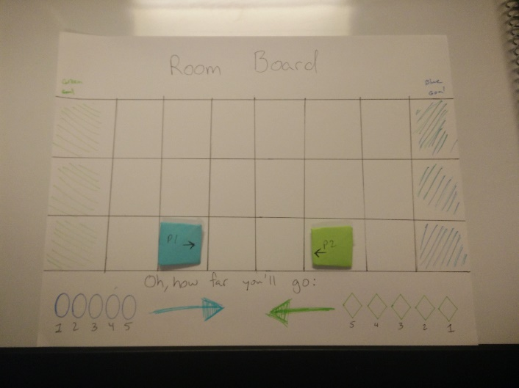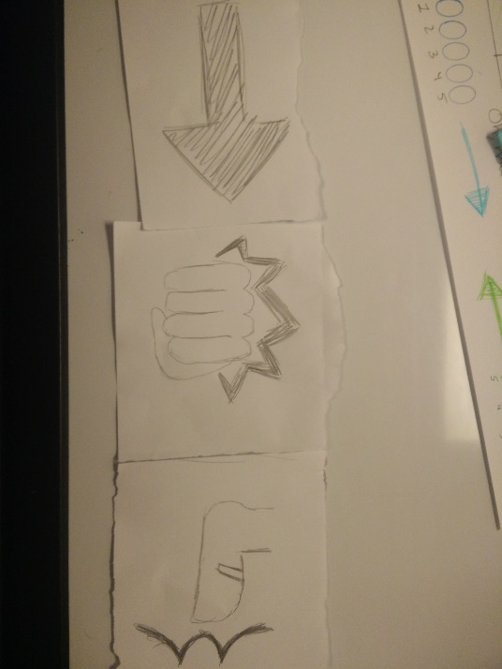The paper prototype for Punchy Punchy is effective for deciding the intricacies of combat. Although not in real time, damage amounts, player actions, and movement abilities can all be translated easily through this type of prototype while I hone my programming skills.

**Paper Prototype Sample Images**

This prototype came with two different questions that were tested in the playtests.

1. How do you feel about the punch and kick ranges?
2. Is the snowballing effect good or bad to you and why?

I play tested this prototype one time this milestone. Here are the results:

## Playtest 1 – Joshua Hammond and Maria Bourg

Date: 10/8/17

Time Tested: 7:20 pm – 7:37 pm

Where: Edison team space

Observations:

After explaining the rules openly and setting up the game, I started recording data based on actions made during turns:

Turn 1:

* Maria – Nothing and jump up
* Josh – Nothing and kick
* Resolution – Nothing happened

I was worried that this would lead to pointing out my mechanics were broken and the game was not mechanically sound. I didn’t say anything, but continued with the playtest while Josh said, “Okaaaay…”. It was a good practice turn to understand the game flow.

Turn 2:

* Maria – Gravity pulled player down + punch and kick
* Josh – Jump up and punch
* Resolution – Nothing happened

Again, I was worried that the mechanics weren’t sound, but in terms of a real-time prototype, jumping in place while throwing kicks and punches would result in the same effect. Josh and I both decided it was time to move in closer.

Turn 3:

* Maria – Diagonal jump and kick
* Josh – Gravity pulled player down + jump up and punch
* Resolution – Maria’s kick hit, resulting in pushing Josh back 1 space mid-air and upping his fly-back meter to 3 spaces for the next hit

A spike in engagement happened as finally someone landed a hit. Both players caught on as to how the game should be played, and translating this to a real-time space makes sense.

A picture containing shoji

Description generated with very high confidenceTurn 4:

* Maria – Diagonal jump and kick
* Josh – Jump diagonal twice
* Resolution – Nothing hit.

This turn, nothing made contact but there was still a spike in engagement. Above is an image of what the game state looked like, with Josh right on top of me in midair. We both started carefully planning our next moves at this moment.

Turn 5:

* Maria – Gravity pulled player down + move left and do nothing
* Josh – Gravity pulled player down + move left and punch
* Resolution – Josh’s punch hit Maria, resulting in pushing Maria back 1 space and upping her fly-back meter to 2 for the next hit

This turn let Josh get back into the game a nicely, and relatively reset the board just with higher fly-back spaces.

Turn 6:

* Maria – Punch diagonal and kick horizontally
* Josh – Move left and kick
* Resolution – Both kicks landed as there was only one space in between both players. Josh flew back 3 spaces to the room’s last column and Maria flew back 2 spaces. Both fly-back meters were upped by 2, leading to 5 and 4 respectively.

This was a high-tension moment, where both players could easily lose the game next turn. However, Josh being both a higher fly-back space and being right at the room’s edge gave him a severe disadvantage strategically.

Turn 7:

* Maria – Move 2 diagonally up and to the left
* Josh – Move right and kick
* Resolution – Nothing happened

This was a great rest in tension after that last turn.

T8:

* Maria – Move left and kick
* Josh – Move right and kick
* Resolution – Both kicks hit, flying Josh off the room stage. Maria won.

The final kick caused a bit of confusion because Josh thought the victory condition was the player had to get past the opponent off the screen. He still seemed a bit confused even after explaining, but still was engaged.

I then took the time to ask him some questions.

Q: “How do you feel the paper prototype represents a real-time environment?”

A: “I don’t think the phases and simultaneous play does a very good job. I would rather have a coin or die flip to see who gets to go first, you know, since fighting games are based on reaction time. The phases were a bit confusing at first and heavy mechanically.”

Q: “How do you feel about the punch and kick spread?”

A: “I actually think they should be reversed. Like, you can’t punch straight down, but you can kick straight down.”

Q: “How do you feel about the snowballing in the game? Is it good, bad?”

A: “This game snowballs really fast, like it took what, three hits? I think it’s a good thing though, especially with the slow start that we had.”

**Conclusions**

## Peaks and Valleys of Tension

This game was great with the amount of tension created moment by moment. Although there were a majority of turns where nothing happened, both players were emotionally invested even after those turns because of the state of the game.

## Moments of Confusion

### The Victory Condition

Josh did not understand the victory condition even after explanation. He understood that we are basing our game off Nidhogg, and he pointed out “you can just run and jump over your opponent to win in that game”. I explained that to be able to do that in Nidhogg, you must at least defeat your opponent once. He didn’t have a full understanding of Nidhogg, so he just nodded. With more rooms and explaining “breaking” the room in the instructions, hopefully this will not be confused by any other playtester again.

### The Phases

Josh and I both noticed how heavy-handed the three phases were just to “simulate” real-time interactions. Although this is supposed to make it so that players cannot base their decisions on what their opponent does, it happened anyway and having three phases made it more confusing. This needs to be restructured, possibly to just the targeting and resolution phases.

## Success with Format

I tried my best to design this to formulate combat with real-time interaction in mind, which I believe I’ve accomplished. I’m honestly surprised it worked as well as it did, and believe it is an accurate prototype that I can expand upon to incorporate other features that we want in the game, like platforms. This was a modest success.

# Prototype 3 – UI Prototype – Knockback Indicator

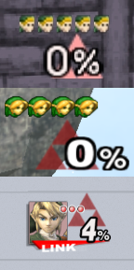**Overview**

A big design decision that hasn’t been made yet for the game is how exactly we’re going to communicate a player’s knockback scalar. The mechanic, based on *Super Smash Bros.*’s mechanic to knock a player out of the screen, has been displayed by a percentage that grows in size and turns red to indicate danger (as seen in the picture to the right). This could work, but I am hesitant to use such a UI for several reasons.

Our system will not match up to *SSB*’s damage system. Where our system is designed to take five hits to be maxed out, *SSB* has several different hits that do different amounts of damage. Our percentages would be static, and therefore more data to consume (people having to read numbers) for little payoff.

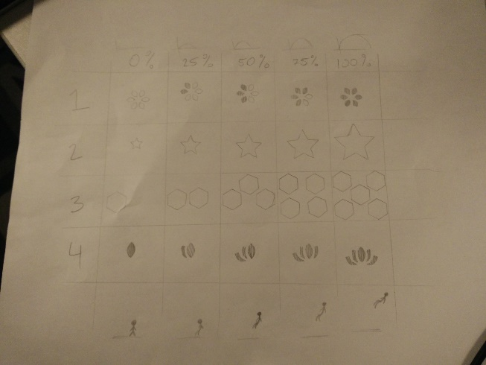As such, I have designed four different options of potential UI (see below). All four of them have five various stages, to highlight the change of how far a player will fly if hit again. The first set starts with an outlined flower shape that progressively fills in through each stage. The second one is a star shape that grows. The third accumulates hexagons (a favorite shape of the team) for how many stages there are. The fourth is a second example of the first set, but without an outlined shape. Since our game is themeless, I had a lot of creative freedom in what the icon would look like, so nothing is especially similar.

For the playtests with my team and people who already knew the mechanic I was testing, I showed them all four at once. For people who didn’t know what was going on, I showed them one set at a time and asked for their thoughts. These are the questions I asked specifically for the playtests that applied:

1. Which is your favorite and why?
2. What do you think this icon is explaining?
3. Do any of these explain the knockback mechanic?
4. What colors would you use for the icon you liked?
5. Knowing the mechanic, what kind of icon would you like to see?

## Playtest 1 – The Datalust team – Taylor Osmond, Leo Ryoo, Sam Cook, Zayd Gaudet

Date: 10/18/17

Time Tested: 6:05 – 6:15

Where: Edison Teamspace

Observations:

As Taylor is my team’s director, I handed the samples to him and let the rest observe. I asked them what they thought about the different types, and they responded accordingly:

Taylor: Well I thought we were just going to use percentages.

Leo: I like the first one a lot.

Me: Yeah, the percentages can work, but it’s not preferable. Our hits don’t have variable damage, and I’m assuming the design will always take five hits to max out, unless that’s not the case. We don’t really have enough time to work out those behaviors before pre-grading though.

Sam: The first one is good. I like the outlining to see how much progression there is.

Taylor: But isn’t there more effort in counting up how many petals you’ve got? Percentages just let you know right away.

Sam: It’s less about the petals.

Me: Think of it like a pie chart. The petals are just dramatic feel.

Taylor nods: Alright. That’ll work I guess. (Taylor makes a rotating motion) Make it a hexagon shape! That way people have a clear idea of where it’s going to start.

Since it was a rather informal playtest, I did not record data such as facial expressions or other minute details. The playtest was less a playtest and more receiving my team’s input and opening communication with them about the designs.

## Playtest 2 – Marc Wafford

Date: 10/20/17

Time Tested: 11:05 – 11:12

Where: Edison Teamspace

Observations:

I asked Marc if he knew what my game, because I wanted people who were unfamiliar with the core concept of the game. He said no, so I deliberately covered all of the information on the playtest except for the first set of icons and asked him what exactly he thought the icons were. He hummed and tilted his head, and guessed, “health? Or mana pips? They look like you can spend these pips for like spells that are more expensive as time goes on. And with the progression, it looks like there are sets of combinations. It might even be a rotation based puzzle? It reminds me of the Witness and lockpicking.”

I then uncovered the second set, and told him, “These two different lines represent the same thing. What do you think they represent now?” He immediately said, “Well now I know they’re some sort of quantitative marker.” He then pointed to the petals of the first set, “It doesn’t look like this one is the same quantitatively because the petals are filled in 0/2/3/4/5 instead of 0/1/2/3/4.”

I uncovered the third set and asked if that changed the context of the sets. He said, “These remind me of you know, those asteroid powerups. You have to collect so many and then they make you shoot differently. They’re pattern specific, and lock on to different parts of the ship.”

I uncovered the whole sheet of paper and Marc looked it all over. He noticed the stick figure on the bottom and pointed to it, “Oh, is this gravity? Like the more you collect the less gravity affects you.” I shrugged and he then pointed to the arc illustrations on the top. “Oh, maybe it’s like a knock back like in *Smash*.” He then went to the last set of icons and pointed to the 0% illustration. “I like the central pip. The whole thing is cool with the symmetry and asymmetry going on.” He then looked back to the top of the page with the percentages. “Oh, is this like the *Smash* percentages?” I asked him how he came to that conclusion, and he pointed toward the stick figure, “Well the percentages plus the distance off the ground there makes sense.”

I then asked him what his favorite was, and he said, “I like the idea of number 2, but it needs to be combined with something else. The size idea is good, but it needs something else with it. The circular bar of number 1 is good, as if I could say after 1 round ‘oh, I’ve already hit one revolution. I’m in dangerous territory now’. 4 is baddass, it looks like a Starcraft banner.”

## Playtest 3 – Trevor Anderson

Date: 10/20/17

Time Tested: 11:15 – 11:19

Where: Edison Teamspace

Observations:

Since Trevor already knew about the mechanic I was testing, I decided to show him the full paper without breaking up the information. I asked him which of the four sets communicated “this is how far you’ll be knocked back”. He said, “None of them really convey knock back. I mean, maybe the star (number 2), because it reminds me of whenever a character in an animation is dizzy, they get stars above their head?”

He angrily pointed at the 0% column and said, “Why do you even have a 0% icon!? That implies that there’s something there!” Pointing to the 100% column, he said, “There should be flashing at 100% if 100% is a maximum, and you can’t go over that. Basically you need to show that you don’t want to get touched anymore.”

Trevor then looked at the top row of my sketches of arches and noticed what it was, “Are those the knockback arches?”

I asked him if none of these looked like knockback indicators, what would he recommend. Trevor folded his arms and said, “I dunno. Something like 5 strikes, where you start at 5 and end at 0, so you’re losing something. More like life.”

Trevor then angrily pointed at the 100% status of the first set. “Also, there are five stages, but six petals! Why!? Why would you do this!”

He then recommended something like a divided star, a combination of sets 1, 2, and 4.

## Playtest 4 – Gwen Thompson

Date: 10/20/17

Time Tested: 11:32 – 11:35

Where: Edison Teamspace

Observations:

I handed Gwen the whole sheet without separating the data, and I explained the concept of the knockback system to her. Immediately she pointed out the discrepancy in the first set. “There’s five stages but six petals?”

She continued onto the other sets saying, “I don’t like the 0% stage for 2,3, and 4. It communicates that there is something there that isn’t.” She pointed to 4, and traced her finger from the 100% to 0%. “It would make more sense if you were losing petals instead of gaining them. That way you’re reinforcing things like you’re doing badly because you’re losing things. Instead of… gaining things cause you’re losing?”

I asked Gwen which set she liked the most, and she immediately said she liked set 4 the best, and pointed out set 3. “I hate this one the most though. Like it’s cluttered, and there’s five, but its hexagons. It’s gross!” even going so far as “It makes me die inside!”

I then asked her what color she would make set number 4, as it is her favorite. Immediately, she said, “Purple, because I expect it to be.” Then I asked, what if the color would change over time, what would she change it too. “Oh,” she paused, and crossed her arms. “That’s a great question. Well… I would say it starts at a rosy red and wilt down to a darker red. Something like that. Doesn’t *Smash* go from white to a dark red? Yeah, that works well.”

## Playtest 5 – Lindsey Price

Date: 10/20/17

Time Tested: 11:40 – 11:43

Where: Edison Teamspace

Observations:

I decided to give Lindsey the full sheet without hiding any of the information, alluding to the *Super Smash Bros.* knockback mechanic. I asked her opinion about each set.

“I think number 1 is the best, it shows progression easily and it’s easy to digest. Number 2 is bad because it’s referential to previous states, and this could impose change blindness. People may miss it completely. Number 3 is too much. There’s too much going on, and in such a tight space. I don’t like that one at all. Number 4 is so-so. It’s pretty, but it doesn’t really make sense.”

Once I recorded all of the information, I flipped the sheet upside down, and told her, “Now what do you think if you started at 100%, but decreased to the 0% state? What’s your favorite if that is the case?”

Her eyes widened, and her eyebrows raised. “Ooh, if that’s the case, number 4 is the best looking and I still like number 1’s progression. If you could mix those 2 that would be really cool.”

I then asked her what her favorite was if she could only pick 1, and she said, “I guess I pick number 1.” Then I asked her what colors she would use for number 1. She responded immediately with “red”. Then she said, “Or maybe the player’s color. You know like in *Smash*, depending on what player you are, that background image is either red, blue, yellow or green. That would make the most sense, especially if you’ve got more than one person.”

**Conclusions**

## Were These Icons Effective?

I’d have to say not really. Out of the four different people tested (not including the team), none of them necessarily understood what the icons were communicating without any prodding from the designer. Progression was communicated, but negative progression was not. People were interested in the icons, and had an opinion different between each set which was a good thing. Their ideas of combining them in many ways is a promising idea.

## The People’s Champion

I surveyed all the play testers for their favorites, and set 1 and 4 were the clear fan favorites, though many recommended integrating multiple sets together. Although not shown on the graph, most people voted for a combination of set 2 with either set 1 or set 4. Surprisingly, when offered to reverse the order of the sets (going from 100% to 0% instead of 0% to 100%), all of the play tester’s favorites stayed the same. Here are the results:

## The Next Iteration

For the next iteration of this prototype, I will be digitalizing the select sets and coloring them. Instead of having four different sets emphasizing different ways of showing progression, I will be combining size, color and icon sets of 1 and 4. Something mechanically different will be assuming it takes six hits to max out the knockback instead of five. This will normalize the icons from the playtests while keeping the team’s “mascot”, the hexagon.

# Prototype 4 – UI Prototype – Knockback Indicator V2

**Overview**

After the first prototype for the knockback indicator, I took the feedback I received and digitalized the most well-liked icons. Focusing on size and color, I created four new sets of icons.

This time however, I decided to go with the most random, informal playtest that I could, to truly show what people liked to my team. Most of my playtesters have biases and viewpoints. Most are friends with me, and designers. To be able to have valid data to convince my teammates that the *Super Smash Bros.* display is not designed well enough for a casual audience, I went around to people I had never talked to, including artists who had vague knowledge of *SSB* and diehard fans of the series.

I did not record names, times, or any detailed information, so this may not qualify as a playtest, but it is great pure quantitative data. I simply asked, “Our game has knockback. Which one of these is your favorite to represent that?”

All of the people I managed to get to vote I had never talked to before. The person who was a *SSB* enthusiast at first said the percentages were the best way, but then I informed him, “We only have one attack, and the percentages will be static.” He then said the color/size change was the best option.

# Prototype 5 – Digital Prototype – Unity Prototype

**Overview**

Since I started on team Datalust, I’ve been working on a Unity prototype that will effectively show the mechanics of the game. As of now, the prototype has 1 type of punch, a player and a sandbag, 1 giant platform, a themed background, scaling knockback, and a restart once someone falls off. After the first playtest I realized that there was not enough player feedback to have an engaging experience. Therefore, I took the time to create a screen shake script when the player hits the sandbag and a flashing text to indicate the final screen on the edges of the platform.

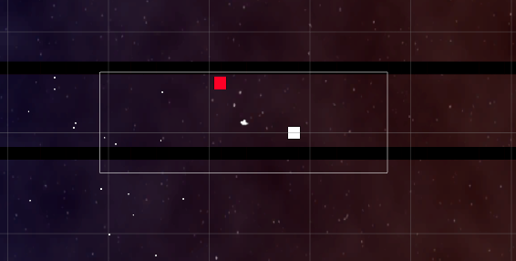

## Playtest 1 – Cameron Scott

Date: 10/27/17

Time Tested: 2:25 pm – 2:30 pm

Where: Edison Teamspace

Observations:

I told Cameron what the controls were, and he took off from there. He walked to the left and saw the camera move with him, making a lot of “oohs” and “aahs” as he jumped back and forth between the first and second screens. The first thing he noticed was the background, and how it changes from red to blue depending on his position.

He went back to the sandbag and started hitting it from screen to screen. He told me, “This almost looks like tug of war. This is cool.” He then purposefully hit the sandbag to one side of the level. Once the sandbag reached the reset-level object, the level restarted. Cameron blinked and tilted his head, saying “Uh, what? Oh did he die?”

This is when I realized that there wasn’t enough tension or feedback to really provide any engagement with the prototype. After an estimated 30-40 seconds of gameplay, the playtest was over. I asked Cameron a few questions.

Q: Where would you put the controls?

A: I think WASD and arrow keys are nice. I like them. And if you have more attacks, you can always make up and down do something.

Q: But what if the game is 2 players?

A: Ooh… Hmm… Well then probably have WASD and the arrow keys as movement for player one and two. But for punching… maybe shift and spacebar? And for player two they could have ctrl and alt as punches?

I then asked if he had any suggestions or concerns and he said, “Yeah! Actually, the end of the screen is hard to see. Like, the end of the level here.” Cameron then navigated to the end of the level to show me how the contrast between the dark background and the dark platforms. This was the reason why he was so confused when the level reset.

He then suggested that the final screen needed clarification. “I was confused about where the end was. And when it happened it was really sudden and confusing.”

## Playtest 2 – Elsbeth Larkin

Date: 10/27/17

Time Tested: 6:15 pm – 6:23 pm

Where: Edison Teamspace

Observations:

After I told Elsbeth the controls, she started going back and forth to test them out. Randomly, she would get stuck on the platform underneath her. She pressed the same direction key several times, jumped, moved back, and then everything was fine until she got caught on another block. She got frustrated and turned to me, “Why do I randomly freeze?”

Then she went to the edge of the screen and moved to the second screen to the left. “Oh, that’s interesting,” she commented, then went back. Then, the screen bugged out because the exe was full screen, and my values for changing the screen are currently hardcoded. Elsbeth stood in between both of the changing-screen-position objects, and turned to me with a raised eyebrow while the screen repeatedly jumped back and forth between positions.

She then went to go punch the bag, with some minor colliding issues along the way with the ground platform. She then punched the bag a few times to the right when the bag flew off the screen and off the platform, resetting the level even with Elsbeth only on the second screen. Elsbeth jerked her head back saying, “Wait, what? What just happened?”

Elsbeth reset the level six more times before she was done with the mechanics. She had playtested other prototypes, so she said, “You’re going for Nidhogg right? I can see it a little bit.” Then I took the opportunity to ask follow up questions.

First I asked her about how she felt about the camera shake. She looked at me confused, and said, “There was camera shake??” then started another round saying, “Oh, there *is* camera shake.” I asked her opinion about it. “Oh… It doesn’t last very long at all. But yeah, it is better than nothing happening at all.”

Elsbeth then took a round to simply push the other box off the edge of the map very slowly. After she did it, she turned to me with a smirk. “Maria… I just pushed him off the edge. Why is this allowed to happen?”

She then noticed the background and squinted her eyes. “Why is the background fuzzy? Like I see stars that are clear, but everything else is super fuzzy.” I told her it was simply because the object was stretched to a super big size and not to worry about it.

Then I asked her about where she would put two player controls. She sighed and tilted her head in thought, saying “F might be a good punch. F and shift maybe, with WASD. F and E? A and Q? For player two… Num pad or arrow keys for movement I think is the best way to go.

I asked her if the experience was satisfying and she said, “Egh, I need another player against me. I’m not doing so much here. And… and it’s kinda broken Maria.”

## Playtest 3 – Matthew Craig

Date:10/27/17

Time Tested: 6:25 pm – 6:30 pm

Where: Edison Teamspace

Observations:

After I told Matt how to play, he whispered under his breath, “Aww yeah” while he punched the sandbag around. Immediately he went to punch the sandbag off the level. When the level restarted automatically, he shook his head, saying, “Whoa what was that?”

After he started another round he looked at me and said, “I really want to be able to jump up and punch down so they fly up in the air. That would be so cool.”

He then went back to playing, and pointed out something with jumping, “I should be slower to change horizontally if I’m in the air. Like… I don’t know how to describe it. Just changing automatically doesn’t feel right.”

Matt also experienced a camera bug that I had not encountered. Instead of moving back and forth between two screens over and over, his moved twice the length to one side, without the player on screen. On top of that he also experienced the platform collision bug that Elsbeth encountered.

I asked him what he thought about the camera shake, if he even noticed it at all. “Yeah, yeah I noticed. It looks good. It needs variance though. Like a curve or something.”

I then asked him how he would lay out 2 player controls. He shrugged and said, “I’m not sure. Probably not arrows. Also I would only allow players to punch forward. They shouldn’t be able to punch their opponent to the wrong side of the map, you know?”

When asked about whether or not the experience was satisfying, he said, “Hmm… I’d say it was pretty satisfying. I mean, it wasn’t bad, but I’m not like hooked, you know? Like medium satisfied. It definitely needs more visual stuff when punching. More feedback. Then I think you’ll have something.”

Matt restarted the level 6 times.

**Conclusions**

## Restart Jump Scare

There definitely needs to be more of a warning to players that they are close or already have restarted the game. The flashing text that was supposed to help with that bugged out most times and wasn’t aligned correctly. Fixing this, and adding a fade-in/out for the restarting level would help tremendously. Even a “Player 1 wins” text with a fanfare effect would help a lot.

## More Feedback

On top of communicating the end of the level, the game in general needs more player feedback. Punch effects, UI and HUD elements that update, even music would really help the game get a boost in engagement. This is the top priority, after getting player two input ability into the prototype.

## Ready Player Two

Player 2 capability needs to be added to fully experience the tension in the game. Unfortunately, this will take longer than it should because the scripts I’ve written are based on the idea that there is only one player-controlled character on screen. A lot of the mechanics will have to be rewritten in the prototype, but the engine already supports two player actions.

## Stability

There are a lot of bugs in game that are simply due to logic problems. I really have to choose between fixing bugs and proving core game concepts. I’m going for the latter, simply because I don’t feel that my prototype does the game concept justice the way it is right now.

## Increase in Playability

Although only with a sample size of three people, I noticed a trend if I could call it that. Without small player feedback elements (screen shake and flashing text, etc.), Cameron only played through 2 rounds. With feedback, both Elsbeth and Matt played well over 5 times.

# Prototype 6 – Digital Prototype – Engine Prototype

**Overview**

## Playtest 1 & 2 – Josh Hammond and Mor Haba

Date: 12/6/17

Time Tested: 1:15 pm – 1:23 pm

Where: Edison Teamspace

Observations:

Both players at the beginning were not too excited to play the game. Initially, we had controller problems because the second controller could not connect to my computer due to USB port failure. After we fixed the issue, Mor and Josh started playing from the Visual Studio launch. Josh was playing the blue tank and Mor was playing the red tank.

Both players at first kept to themselves and tested out the mechanics of jumping and punching. After a few seconds they got their bearings and started getting closer to each other. They started punching each other, and Mor started to get the upper hand. They both turned their opponent’s damage indicator to red but the screen still did not move. Finally, Mor managed to hit Josh against the left side of the screen and it moved. Then the two switched positions and Mor managed to hit Josh against the right side of the screen, and was confused. “Wait, so how exactly does the screen move?” I explained to them the rules of the camera, and both “Oooh”-ed in understanding. Josh and Mor continued playing aggressively, engaged so much that they were talking smack to each other. Josh noticed, “You can’t hit me if I’m on top of you!” while he came up with a strategy.

Mor and Josh got so far into the game that the knockback only needed two hits to win the game at that point. Mor won the first level in that fashion.

The two were suddenly transported to the second level. The looping mechanic had some bugs associated with it. For example, looping sometimes transported a player, sometimes kept a player on the ceiling, and landed tanks *in* the floor. Still it did provide strategic ability. Josh eventually won the second round, but got a random passerby interested in what was going on in the battle, so I immediately got a second playtest.

## Playtest 3 & 4 – Mor Haba and Juan Ramos

Date: 12/6/17

Time Tested: 1:24 pm – 1:30 pm

Where: Edison Teamspace

Observations:

Mor faced off against Juan as the blue and red tanks respectively. Juan immediately wanted to be able to drop through the platform he was on.

Mor noticed that neither he nor Juan knew which way they should be trying to hit their opponent after a while in the middle of battle. Being in the center screen is a lot of time while waiting for damages to be high enough to move the camera. Josh from the last playtest was being a sportscaster for the two, and remarked that the game gets intense once there’s buildup.

Juan won the first round, and the game switched to the second level. Both were talking smack at this point, but they couldn’t move the camera for quite some time. Juan groaned, “I can’t tell which direction I’m actually looking.” In this playtest as well there were bugs with the looping through the level, being stuck in the ceiling and stuck in the floor. Eventually, Juan got tired of fighting and lost to Mor, possibly on purpose after fatigue.

Mor noted that he didn’t like how the tank stood still while punching. He recommended that players had reduced move speed, not a complete stop in control.

## Playtest 5 – Shaun Hill & Me

Date: 12/6/17

Time Tested: 3:03 – 3:09

Where: Edison Teamspace

Observations:

Shaun played the game in turn for playing his game, trading playtests. Shaun played the red tank and I played the blue. The controllers worked immediately this time, and the playtest overall was more calm between me and him. Still, the game was tense, after the stagnation of being stuck in the center for too long was released. Shaun grasped the controls quickly and our skills were on par.

He immediately started the strategy of trying to be on top of my tank, but wasn’t relatively successful. He too noticed the stagnation of the early game, but once we got rolling things were fun. He won the first level, and I let him win for the second level so that the game wouldn’t drag on too long.

I asked him what he liked and disliked about the game, and he said this: “Its cute. I really like your tanks and the arm thing… The looping seems a little buggy, and I didn’t really understand the concept of the moving camera until it worked. The beginning is really slow, and nothing really happens until both players are red when nothing really matters at that point if you’re skillful or not.”

**Conclusions**

The game is actually fun, which was a huge relief. The addition of controllers really allowed the design to flourish. The game was so interesting that it pulled Juan from his work to play the game once Josh and Mor were done with their playtest.

There are some problems with looping, and the second level was clearly not designed well, but overall all playtesters had a good experience.

There seems to be a preference of who has the advantage depending on the level. From the limited testing, it seems level one is always won by the red tank and level two is always won (at least when players haven’t given up) by the blue tank. This may be level design, or it may be punch-code resolution that needs to get fixed.