Peter Parianos – Azam Ashrabkhujaev
Assignment 3
CIS345 – Operating Systems

CODE DESCRIPTION:

The goal of this program is to use threads’ parallelism to compute the sum of square roots from 1 to n where n is a multiple of three and is defined by an argument parameter.
The grand sum should be a global variable that is shared by all threads. Each thread will compute a third of the total sum using a shared start_point array. To prevent any type of race conditions due to the concurrency of the threads, one has to use a mutex to lock the shared resource. This was done using the pthread mutex type that is built into pthreads.h. A separate method was created that would manage all the shared accesses and writes. The mutex lock was also initialized and destroyed according to POSIX standards. No unecessary overhead was created, because the mutex lock only encapulated the grand_sum and not local sums.
Threads were created using the standard POSIX system call named pthread_create(). Each thread was created in the main function, with memory allocated for their info to be passed in such a method. The data was structured in a Struct data type, which was passed as an argument to the do_partial() method (this is the method defined to be the start of the newly created thread). The main thread acted as the third thread in this program. Local variables defined in do_partial() are not affected by other thread sbecause they do not share the same stack, where local variables reside.
At the end of the program, all threads were joined into main thread per assignment specifications.
Argument parsing was fairly simple and did not include any error checking, as it was not required. Since arguments are read in as strings, it was needed to convert string to and integer using the built-in function called atoi().
Starting points were calculated as a double, then stored in an array as an integer. This removes everything after the decimal point.

Debugging:
Running problems that were fixed included:
1. The was sum was computed
2. Argument was not being passed
These problems were fixed.

Compilation and Output of the program:
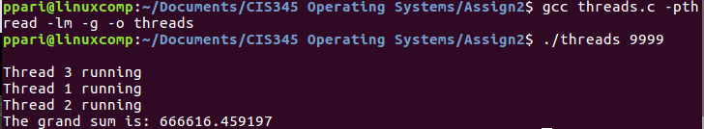
-pthread and -lm were needed because threads and sqrt() where used, respectively.

