Peter Parianos

Dan Gluth

Project 4

Grail ID: peparian

Question 1 Family Tree:

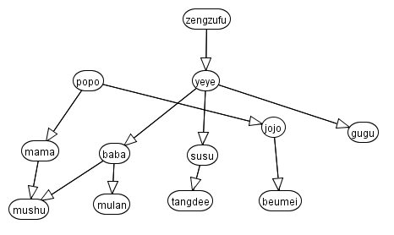

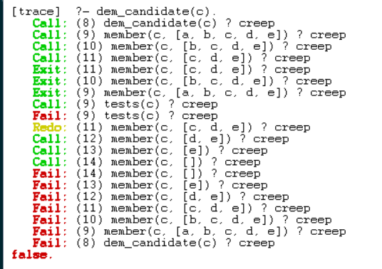

This is with the (!) operator:

