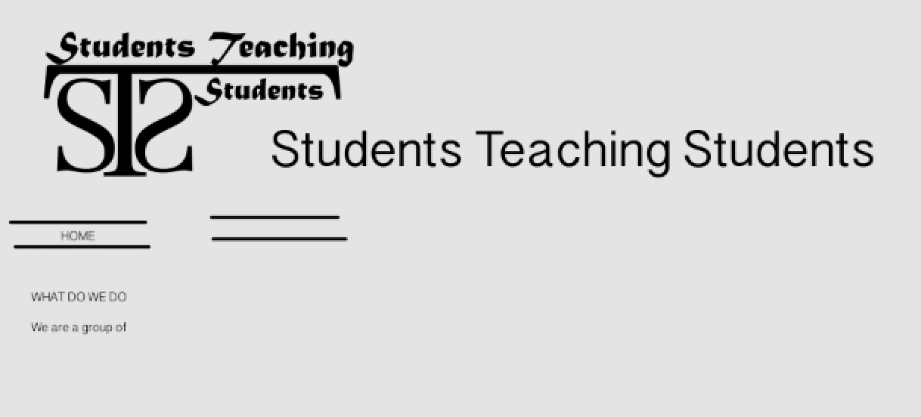

PICTURES HERE

okay so the headings are:

HOME

OUR TEAM

RESOURCES

EVENTS

CONTACT US

And the headings should go underneath the logo.

The background I used was RGB = 228, 228, 228

I was wondering if you could use the font OSWALD LIGHT for the text?

Anyways here is what it should say on the home page. Also if its easy could you put a grey box around the writing – or just make it all a darker grey (maybe 220 x3 RGB) underneath the home, our team etc buttons.

WHAT WE DO:

We are a **volunteer group** of **motivated** university students with a **passion** for teaching students from **elementary** to **secondary** school about our areas of study, ranging from the language arts and humanities to the various sciences. We enable students to draw **connections** between what they are learning in class and its applications in current worldwide issues.

GUEST LECTURES:

We act as guest lecturers, and can modify our presentations to fit the curriculum of a given class. The aim is to provide a **fresh new perspective** to the curriculum and also to be available to answer any potential questions about post-secondary pathways.

SCIENCE FAIR

We are hosting a **science fair** soon for grade 9 students. Each student will be provided with a mentor who has research experience in the hopes that one-on-one guidance will better prepare them for scientific research in the future.

Underneath this you could put the video we had.

And then put a button for contact us for a guest lecture

Let me know how this goes. For our team and the other pages could you have the same style for the page – increase the font size, get rid of colour etc.

THANKS let me know if you need more help.