Neuroscience

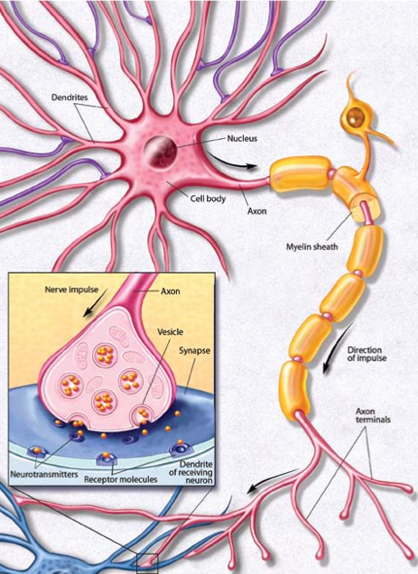

Question1?

___________________________________________

Question2?

How many neurons does the brain have? ____________

Question3?

________________________________________________________________________

How does the myelination of axons affect conduction velocity?

________________________________________________________________________

________________________________________________________________________

Why are there so many different symptoms of Multiple Sclerosis?

________________________________________________________________________

________________________________________________________________________

Question 4.. solution to MS?