2007年6月大学英语六级(CET-6)真题试卷

Part Ⅰ Writing (30 minutes)
注意：此部分试题在答题卡1上。
Directions: For this part, you are allowed 30 minutes to write a short essay entitled Should One Expect a Reward When Doing a Good Deed? You should write at least 150 words following the outline given below.
1. 有人做好事期望得到回报；
2. 有人认为应该像雷锋那样做好事不图回报；
3. 我的观点。
Should One Expect a Reward When Doing a Good Deed?

Part II Reading Comprehension (Skimming and Scanning) (15minutes)
Directions: In this part, you will have 15 minutes to go over the passage quickly and answer the questions on Answer Sheet 1.
For questions 1-4, mark
Y (for YES) if the statement agrees with the information given in the passage;
N (for NO) if the statement contradicts the information given in the passage;
NG (for NOT GIVEN) if the information is not given in the passage.
For questions 5-10, complete the sentences with the information given in the passage.
Seven Steps to a More Fulfilling Job
Many people today find themselves in unfulfilling work situations. In fact, one in four workers is dissatisfied with their current job, according to the recent “Plans for 2004” survey. Their career path may be financially rewarding, but it doesn’t meet their emotional, social or creative needs. They’re stuck, unhappy, and have no idea what to do about it, except move to another job.
Mary Lyn Miller, veteran career consultant and founder of the Life and Career Clinic, says that when most people are unhappy about their work, their first thought is to get a different job. Instead, Miller suggests looking at the possibility of a different life. Through her book, 8 Myths of Making a Living, as well as workshops, seminars and personal coaching and consulting, she has helped thousands of dissatisfied workers reassess life and work.
Like the way of Zen, which includes understanding of oneself as one really is, Miller encourages job seekers and those dissatisfied with work or life to examine their beliefs about work and recognize that “in many cases your beliefs are what brought you to where you are today.” You may have been raised to think that women were best at nurturing and caring and, therefore, should be teachers and nurses. So that’s what you did. Or, perhaps you were brought up to believe that you should do what your father did, so you have taken over the family business, or become a dentist “just like dad.” If this sounds familiar, it’s probably time to look at the new possibilities for your future.
Miller developed a 7-step process to help potential job seekers assess their current situation and beliefs, identify their real passion, and start on a journey that allows them to pursue their passion through work.
Step 1: Willingness to do something different.
Breaking the cycle of doing what you have always done is one of the most difficult tasks for job seekers. Many find it difficult to steer away from a career path or make a change, even if it doesn’t feel right. Miller urges job seekers to open their minds to other possibilities beyond what they are currently doing.
Step 2: Commitment to being who you are, not who or what someone wants you to be.
Look at the gifts and talents you have and make a commitment to pursue those things that you love most. If you love the social aspects of your job, but are stuck inside an office or “chained to your desk” most of the time, vow to follow your instinct and investigate alternative careers and work that allow you more time to interact with others. Dawn worked as a manager for a large retail clothing store for several years. Though she had advanced within the company, she felt frustrated and longed to be involved with nature and the outdoors. She decided to go to school nights and weekends to pursue her true passion by earning her master’s degree in forestry. She now works in the biotech forestry division of a major paper company.
Step 3: Self-definition.
Miller suggests that once job seekers know who they are, they need to know how to sell themselves. “In the job market, you are a product. And just like a product, you must know the features and benefits that you have to offer a potential client, or employer.” Examine the skills and knowledge that you have and identify how they can apply to your desired occupation. Your qualities will exhibit to employers why they should hire you over other candidates.
Step 4: Attain a level of self-honoring.
Self-honoring or self-love may seem like an odd step for job hunters, but being able to accept yourself, without judgment, helps eliminate insecurities and will make you more self-assured. By accepting who you are – all your emotions, hopes and dreams, your personality, and your unique way of being – you’ll project more confidence when networking and talking with potential employers. The power of self-honoring can help to break all the falsehoods you were programmed to believe – those that made you feel that you were not good enough, or strong enough, or intelligent enough to do what you truly desire.
Step 5: Vision.
Miller suggests that job seekers develop a vision that embraces the answer to “What do I really want to do?” one should create a solid statement in a dozen or so sentences that describe in detail how they see their life related to work. For instance, the secretary who longs to be an actress describes a life that allows her to express her love of Shakespeare on stage. A real estate agent, attracted to his current job because he loves fixing up old homes, describes buying properties that need a little tender loving care to make them more saleable.
Step 6: Appropriate risk.
Some philosophers believe that the way to enlightenment comes through facing obstacles and difficulties. Once people discover their passion, many are too scared to do anything about it. Instead, they do nothing. With this step, job seekers should assess what they are willing to give up, or risk, in pursuit of their dream. For one working mom, that meant taking night classes to learn new computer-aided design skills, while still earning a salary and keeping her day job. For someone else, it may mean quitting his or her job, taking out a loan and going back to school full time. You’ll move one step closer to your ideal work life if you identify how much risk you are willing to take and the sacrifices you are willing to make.
Step 7: Action.
Some teachers of philosophy describe action in this way, “If one wants to get to the top of a mountain, just sitting at the foot thinking about it will not bring one there. It is by making the effort of climbing up the mountain, step by step, that eventually the summit is reached.” All too often, it is the lack of action that ultimately holds people back from attaining their ideals. Creating a plan and taking it one step at a time can lead to new and different job opportunities. Job-hunting tasks gain added meaning as you sense their importance in your quest for a more meaningful work life. The plan can include researching industries and occupations, talking to people who are in your desired area of work, taking classes, or accepting volunteer work in your targeted field.
Each of these steps will lead you on a journey to a happier and more rewarding work life. After all, it is the journey, not the destination, that is most important.
注意：此部分试题请在答题卡1上作答。
1. According to the recent “Plans for 2004” survey, most people are unhappy with their current jobs.
2. Mary Lyn Miller’s job is to advise people on their life and career.
3. Mary Lyn Miller herself was once quite dissatisfied with her own work.
4. Many people find it difficult to make up their minds whether to change their career path.
5. According to Mary Lyn Miller, people considering changing their careers should commit themselves to the pursuit of ________.
6. In the job market, job seekers need to know how to sell themselves like ________.
7. During an interview with potential employers, self-honoring or self-love may help a job seeker to show ________.
8. Mary Lyn Miller suggests that a job seeker develop a vision that answers the question “________”
9. Many people are too scared to pursue their dreams because they are unwilling to ________.
10. What ultimately holds people back from attaining their ideals is ________.
Part III Listening Comprehension (35 minutes)

Section A
Directions: In this section, you will hear 8 short conversations and 2 long conversations. At the end of each conversation, one or more questions will be asked about what was said. Both the conversation and the questions will be spoken only once. After each question there will be a pause. During the pause, you must read the four choices marked [A], [B], [C] and [D], and decide which is the best answer. Then mark the corresponding letter on Answer Sheet 2 with a single line through the centre.
注意：此部分试题请在答题卡2上作答。

11. A) Surfing the net.
B) Watching a talk show.
C) Packing a birthday gift.
D) Shopping at a jewelry store.
12. A) He enjoys finding fault with exams.
B) He is sure of his success in the exam.
C) He doesn’t know if he can do well in the exam.
D) He used to get straight A’s in the exams he took.
13. A) The man is generous with his good comments on people.
B) The woman is unsure if there will be peace in the world.
C) The woman is doubtful about newspaper stories.
D) The man is quite optimistic about human nature.
14. A) Study for some profession.
B) Attend a medical school.
C) Stay in business.
D) Sell his shop.
15. A) More money.
B) Fair treatment.
C) A college education.
D) Shorter work hours.
16. A) She was exhausted from her trip.
B) She missed the comforts of home.
C) She was impressed by Mexican food.
D) She will not go to Mexico again.
17. A) Cheer herself up a bit.
B) Find a more suitable job.
C) Seek professional advice.
D) Take a psychology course.
18. A) He dresses more formally now.
B) What he wears does not match his position.
C) He has ignored his friends since graduation.
D) He failed to do well at college.
Questions 19 to 22 are based on the conversation you have just heard.
19. A) To go sightseeing.
B) To have meetings.
C) To promote a new champagne.
D) To join in a training program.
20. A) It can reduce the number of passenger complaints.
B) It can make air travel more entertaining.
C) It can cut down the expenses for air travel.
D) It can lessen the discomfort caused by air travel.
21. A) Took balanced meals with champagne.
B) Ate vegetables and fruit only.
C) Refrained from fish or meat.
D) Avoided eating rich food.
22. A) Many of them found it difficult to exercise on a plane.
B) Many of them were concerned with their well-being.
C) Not many of them chose to do what she did.
D) Not many of them understood the program.
Questions 23 to 25 are based on the conversation you have just heard.
23. A) At a fair.
B) At a cafeteria.
C) In a computer lab.
D) In a shopping mall.
24. A) The latest computer technology.
B) The organizing of an exhibition.
C) The purchasing of some equipment.
D) The dramatic changes in the job market.
25. A) Data collection.
B) Training consultancy.
C) Corporate management.
D) Information processing.

Section B
Directions: In this section, you will hear 3 short passages. At the end of each passage, you will hear some questions. Both the passage and the questions will be spoken only once. After you hear a question, you must choose the best answer from the four choices marked A), B), C) and D). Then mark the corresponding letter on Answer Sheet 2 with a single line through the centre.
Passage One
Questions 26 to 28 are based on the passage you have just heard.
26. A) Improve themselves.
B) Get rid of empty dreams.
C) Follow the cultural tradition.
D) Attempt something impossible.
27. A) By finding sufficient support for implementation.
B) By taking into account their own ability to change.
C) By constantly keeping in mind their ultimate goals.
D) By making detailed plans and carrying them out.
28. A) To show people how to get their lives back to normal.
B) To show how difficult it is for people to lose weight.
C) To remind people to check the calories on food bags.
D) To illustrate how easily people abandon their goals.

Passage Two
Questions 29 to 31 are based on the passage you have just heard.
29. A) Michael’s parents got divorced.
B) Karen was adopted by Ray Anderson.
C) Karen’s mother died in a car accident.
D) A truck driver lost his life in a collision.
30. A) He ran a red light and collided with a truck.
B) He sacrificed his life to save a baby girl.
C) He was killed instantly in a burning car.
D) He got married to Karen’s mother.
31. A) The reported hero turned out to be his father.
B) He did not understand his father till too late.
C) Such misfortune should have fallen on him.
D) It reminded him of his miserable childhood.

Passage Three
Questions 32 to 35 are based on the passage you have just heard.
32. A) Germany.
B) Japan.
C) The U.S.
D) The U.K.
33. A) By doing odd jobs at weekends.
B) By working long hours every day.
C) By putting in more hours each week.
D) By taking shorter vacations each year.
34. A) To combat competition and raise productivity.
B) To provide them with more job opportunities.
C) To help them maintain their living standard.
D) To prevent them from holding a second job.
35. A) Change their jobs.
B) Earn more money.
C) Reduce their working hours.
D) Strengthen the government’s role.

Section C
Directions: In this section, you will hear a passage three times. When the passage is read for the first time, you should listen carefully for its general idea. When the passage is read for the second time, you are required to fill in the blanks numbered from 36 to 43 with the exact words you have just heard. For blanks numbered from 44 to 46 you are required to fill in the missing information. For these blanks, you can either use the exact words you have just heard or write down the main points in your own words. Finally, when the passage is read for the third time, you should check what you have written.
注意：此部分试题请在答题卡2上作答。
Nursing, as a typically female profession, must deal constantly with the false impression that nurses are there to wait on the physician. As nurses, we are (36) ________ to provide nursing care only. We do not have any legal or moral (37) ________ to any physician. We provide health teaching, (38) ________ physical as well as emotional problems, (39) ________ patient-related services, and make all of our nursing decisions based upon what is best or suitable for the patient. If, in any (40) ________, we feel that a physician’s order is (41) ________ or unsafe, we have a legal (42) ________ to question that order or refuse to carry it out.
Nursing is not a nine-to-five job with every weekend off. All nurses are aware of that before they enter the profession. The emotional and physical stress, however, that occurs due to odd working hours is a (43) ________ reason for a lot of the career dissatisfaction. (44) _ _ _ _ _ _ _ _ _ _ _ _ _ _ _ _ _ _ _ _ _ _ _ _ _ _ _ _ _ _ _ _ _ _ _ _ _ _ _ _ _ _ _ _ _ _ _ _ _ _ _ _ _ _ _ _ _ _ _ _ _ _ _ _ _ _ _ _ _ _ _ _ _ _ _ _ _ _. That disturbs our personal lives, disrupts our sleeping and eating habits, and isolates us from everything except job-related friends and activities.
The quality of nursing care is being affected dramatically by these situations. (45) _ _ _ _ _ _ _ _ _ _ _ _ _ _ _ _ _ _ _ _ _ _ _ _ _ _ _ _ _ _ _ _ _ _ _ _ _ _ _ _ _ _ _ _ _ _ _ _ _ _ _ _ _ _ _ _ _ _ _ _ _ _ _ _ _ _ _ _ _ _ _ _ _ _ _ _ _ _. Consumers of medically related services have evidently not been affected enough yet to demand changes in our medical system. But if trends continue as predicted, (46) _ _ _ _ _ _ _ _ _ _ _ _ _ _ _ _ _ _ _ _ _ _ _ _ _ _ _ _ _ _ _ _ _ _ _ _ _ _ _ _ _ _ _ _ _ _ _ _ _ _ _ _ _ _ _ _ _ _ _ _ _ _ _ _ _ _ _ _ _ _ _ _ _ _ _ _ _ _.

Part IV Reading Comprehension （Reading in Depth） （25 minutes）

Section A
Directions: In this section, there is a short passage with 5 questions or incomplete statements. Read the passage carefully. Then answer the questions or complete statements in the fewest possible words. Please write your answers on Answer Sheet 2.
Questions 47 to 51 are based on the following passage.
Google is a world-famous company, with its headquarters in Mountain View, California. It was set up in a Silicon Valley garage in 1998, and inflated (膨胀) with the Internet bubble. Even when everything around it collapsed the company kept on inflating. Google’s search engine is so widespread across the world that search became Google, and google became a verb. The world fell in love with the effective, fascinatingly fast technology.
Google owes much of its success to the brilliance of S. Brin and L. Page, but also to a series of fortunate events. It was Page who, at Stanford in 1996, initiated the academic project that eventually became Google’s search engine. Brin, who had met Page at a student orientation a year earlier, joined the project early on. They were both Ph.D. candidates when they devised the search engine which was better than the rest and, without any marketing, spread by word of mouth from early adopters to, eventually, your grandmother.
Their breakthrough, simply put, was that when their search engine crawled the Web, it did more than just look for word matches; it also tallied (统计) and ranked a host of other critical factors like how websites link to one another. That delivered far better results than anything else. Brin and Page meant to name their creation Googol (the mathematical term for the number 1 followed by 100 zeroes), but someone misspelled the word so it stuck as Google. They raised money from prescient (有先见之明的) professors and venture capitalists, and moved off campus to turn Google into a business. Perhaps their biggest stroke of luck came early on when they tried to sell their technology to other search engines, but no one met their price, and they built it up on their own.
The next breakthrough came in 2000, when Google figured out how to make money with its invention. It had lots of users, but almost no one was paying. The solution turned out to be advertising, and it’s not an exaggeration to say that Google is now essentially an advertising company, given that that’s the source of nearly all its revenue. Today it is a giant advertising company, worth $100 billion.
注意：此部分试题请在答题卡2上作答。
47. Apart from a series of fortunate events, what is it that has made Google so successful?
48. Google’s search engine originated from ________ started by L. Page.
49. How did Google’s search engine spread all over the world?
50. Brin and Page decided to set up their own business because no one would ________.
51. The revenue of the Google company is largely generated from ________.

Section B
Directions: There are 2 passages in this section. Each passage is followed by some questions or unfinished statements. For each of them there are four choices marked A), B), C) and D). You should decide on the best choice and mark the corresponding letter on Answer Sheet 2 with a single line through the centre.

Passage One
Questions 52 to 56 are based on the following passage.
You hear the refrain all the time: the U.S. economy looks good statistically, but it doesn’t feel good. Why doesn’t ever-greater wealth promote ever-greater happiness? It is a question that dates at least to the appearance in 1958 of The Affluent (富裕的) Society by John Kenneth Galbraith, who died recently at 97.
The Affluent Society is a modern classic because it helped define a new moment in the human condition. For most of history, “hunger, sickness, and cold” threatened nearly everyone, Galbraith wrote. “Poverty was found everywhere in that world. Obviously it is not of ours.” After World War II, the dread of another Great Depression gave way to an economic boom. In the 1930s unemployment had averaged 18.2 percent; in the 1950s it was 4.5 percent.
To Galbraith, materialism had gone mad and would breed discontent. Through advertising, companies conditioned consumers to buy things they didn’t really want or need. Because so much spending was artificial, it would be unfulfilling. Meanwhile, government spending that would make everyone better off was being cut down because people instinctively—and wrongly—labeled government only as “a necessary evil.”
It’s often said that only the rich are getting ahead; everyone else is standing still or falling behind. Well, there are many undeserving rich—overpaid chief executives, for instance. But over any meaningful period, most people’s incomes are increasing. From 1995 to 2004, inflation-adjusted average family income rose 14.3 percent, to $43,200. People feel “squeezed” because their rising incomes often don’t satisfy their rising wants—for bigger homes, more health care, more education, faster Internet connections.
The other great frustration is that it has not eliminated insecurity. People regard job stability as part of their standard of living. As corporate layoffs increased, that part has eroded. More workers fear they’ve become “the disposable American,” as Louis Uchitelle puts it in his book by the same name.
Because so much previous suffering and social conflict stemmed from poverty, the arrival of widespread affluence suggested utopian (乌托邦式的) possibilities. Up to a point, affluence succeeds. There is much less physical misery than before. People are better off. Unfortunately, affluence also creates new complaints and contradictions.
Advanced societies need economic growth to satisfy the multiplying wants of their citizens. But the quest for growth lets loose new anxieties and economic conflicts that disturb the social order. Affluence liberates the individual, promising that everyone can choose a unique way to self-fulfillment. But the promise is so extravagant that it predestines many disappointments and sometimes inspires choices that have anti-social consequences, including family breakdown and obesity (肥胖症). Statistical indicators of happiness have not risen with incomes.
Should we be surprised? Not really. We’ve simply reaffirmed an old truth: the pursuit of affluence does not always end with happiness.
52. What question does John Kenneth Galbraith raise in his book The Affluent Society?
A) Why statistics don’t tell the truth about the economy.
B) Why affluence doesn’t guarantee happiness.
C) How happiness can be promoted today.
D) What lies behind an economic boom.
53. According to Galbraith, people feel discontented because ________.
A) public spending hasn’t been cut down as expected
B) the government has proved to be a necessary evil
C) they are in fear of another Great Depression
D) materialism has run wild in modern society
54. Why do people feel squeezed when their average income rises considerably?
A) Their material pursuits have gone far ahead of their earnings.
B) Their purchasing power has dropped markedly with inflation.
C) The distribution of wealth is uneven between the rich and the poor.
D) Health care and educational costs have somehow gone out of control.
55. What does Louis Uchitelle mean by “the disposable American” (Line 3, Para. 5)?
A) Those who see job stability as part of their living standard.
B) People full of utopian ideas resulting from affluence.
C) People who have little say in American politics.
D) Workers who no longer have secure jobs.
56. What has affluence brought to American society?
A) Renewed economic security.
B) A sense of self-fulfillment.
C) New conflicts and complaints.
D) Misery and anti-social behavior.

Passage Two
Questions 57 to 61 are based on the following passage.
The use of deferential (敬重的) language is symbolic of the Confucian ideal of the woman, which dominates conservative gender norms in Japan. This ideal presents a woman who withdraws quietly to the background, subordinating her life and needs to those of her family and its male head. She is a dutiful daughter, wife, and mother, master of the domestic arts. The typical refined Japanese woman excels in modesty and delicacy; she “treads softly (谨言慎行)in the world,” elevating feminine beauty and grace to an art form.
Nowadays, it is commonly observed that young women are not conforming to the feminine linguistic (语言的) ideal. They are using fewer of the very deferential “women’s” forms, and even using the few strong forms that are known as “men’s.” This, of course, attracts considerable attention and has led to an outcry in the Japanese media against the defeminization of women’s language. Indeed, we didn’t hear about “men’s language” until people began to respond to girls’ appropriation of forms normally reserved for boys and men. There is considerable sentiment about the “corruption” of women’s language—which of course is viewed as part of the loss of feminine ideals and morality—and this sentiment is crystallized by nationwide opinion polls that are regularly carried out by the media.
Yoshiko Matsumoto has argued that young women probably never used as many of the highly deferential forms as older women. This highly polite style is no doubt something that young women have been expected to “grow into”—after all, it is a sign not simply of femininity, but of maturity and refinement, and its use could be taken to indicate a change in the nature of one’s social relations as well. One might well imagine little girls using exceedingly polite forms when playing house or imitating older women—in a fashion analogous to little girls’ use of a high-pitched voice to do “teacher talk” or “mother talk” in role play.
The fact that young Japanese women are using less deferential language is a sure sign of change—of social change and of linguistic change. But it is most certainly not a sign of the “masculinization” of girls. In some instances, it may be a sign that girls are making the same claim to authority as boys and men, but that is very different from saying that they are trying to be “masculine.” Katsue Reynolds has argued that girls nowadays are using more assertive language strategies in order to be able to compete with boys in schools and out. Social change also brings not simply different positions for women and girls, but different relations to life stages, and adolescent girls are participating in new subcultural forms. Thus what may, to an older speaker, seem like “masculine” speech may seem to an adolescent like “liberated” or “hip” speech.
57. The first paragraph describes in detail ________.
A) the standards set for contemporary Japanese women
B) the Confucian influence on gender norms in Japan
C) the stereotyped role of women in Japanese families
D) the norms for traditional Japanese women to follow
58. What change has been observed in today’s young Japanese women?
A) They pay less attention to their linguistic behavior.
B) The use fewer of the deferential linguistic forms.
C) They confuse male and female forms of language.
D) They employ very strong linguistic expressions.
59. How do some people react to women’s appropriation of men’s language forms as reported in the Japanese media?
A) They call for a campaign to stop the defeminization.
B) They see it as an expression of women’s sentiment.
C) They accept it as a modern trend.
D) They express strong disapproval.
60. According to Yoshiko Matsumoto, the linguistic behavior observed in today’s young women ________.
A) may lead to changes in social relations
B) has been true of all past generations
C) is viewed as a sign of their maturity
D) is a result of rapid social progress
61. The author believes that the use of assertive language by young Japanese women is ________.
A) a sure sign of their defeminization and maturation
B) an indication of their defiance against social change
C) one of their strategies to compete in a male-dominated society
D) an inevitable trend of linguistic development in Japan today
Part V Cloze （15 minutes）
Directions: There are 20 blanks in the following passage. For each blank there are four choices marked A), B), C) and D) on the right side of the paper. You should choose the ONE that best fits into the passage. Then mark the corresponding letter on Answer Sheet 2 with a single line through the centre.
注意：此部分试题请在答题卡2上作答。
Historically, humans get serious about avoiding disasters only after one has just struck them. __62__ that logic, 2006 should have been a breakthrough year for rational behavior. With the memory of 9/11 still __63__ in their minds, Americans watched hurricane Katrina, the most expensive disaster in U.S. history, on __64__ TV. Anyone who didn’t know it before should have learned that bad things can happen. And they are made __65__ worse by our willful blindness to risk as much as our __66__ to work together before everything goes to hell.
Granted, some amount of delusion (错觉) is probably part of the __67__ condition. In A.D. 63, Pompeii was seriously damaged by an earthquake, and the locals immediately went to work __68__, in the same spot—until they were buried altogether by a volcano eruption 16 years later. But a __69__ of the past year in disaster history suggests that modern Americans are particularly bad at __70__ themselves from guaranteed threats. We know more than we __71__ did about the dangers we face. But it turns __72__ that in times of crisis, our greatest enemy is __73__ the storm, the quake or the __74__ itself. More often, it is ourselves.
So what has happened in the year that __75__ the disaster on the Gulf Coast? In New Orleans, the Army Corps of Engineers has worked day and night to rebuild the flood walls. They have got the walls to __76__ they were before Katrina, more or less. That’s not __77__, we can now say with confidence. But it may be all __78__ can be expected from one year of hustle (忙碌).
Meanwhile, New Orleans officials have crafted a plan to use buses and trains to __79__ the sick and the disabled. The city estimates that 15,000 people will need a __80__ out. However, state officials have not yet determined where these people will be taken. The __81__ with neighboring communities are ongoing and difficult.
62. A) To
B) By
C) On
D) For
63. A) fresh
B) obvious
C) apparent
D) evident
64. A) visual
B) vivid
C) live
D) lively
65. A) little
B) less
C) more
D) much
66. A) reluctance
B) rejection
C) denial
D) decline
67. A) natural
B) world
C) social
D) human
68. A) revising
B) refining
C) rebuilding
D) retrieving
69. A) review
B) reminder
C) concept
D) prospect
70. A) preparing
B) protesting
C) protecting
D) prevailing
71. A) never
B) ever
C) then
D) before
72. A) up
B) down
C) over
D) out
73. A) merely
B) rarely
C) incidentally
D) accidentally
74. A) surge
B) spur
C) surf
D) splash
75. A) ensued
B) traced
C) followed
D) occurred
76. A) which
B) where
C) what
D) when
77. A) enough
B) certain
C) conclusive
D) final
78. A) but
B) as
C) that
D) those
79. A) exile
B) evacuate
C) dismiss
D) displace
80. A) ride
B) trail
C) path
D) track
81. A) conventions
B) notifications
C) communications
D) negotiations
Part Ⅵ Translation (5 minutes)
Directions: Complete the sentences by translating into English the Chinese given in brackets. Please write your translation on Answer Sheet 2.
注意：此部分试题请在答题卡2上作答，只需写出译文部分。
82. The auto manufacturers found themselves ________________________ (正在同外国公司竞争市场的份额).
83. Only in the small town ________________________ (他才感到安全和放松).
84. It is absolutely unfair that these children ________________________ (被剥夺了受教育的权利).
85. Our years of hard work are all in vain, ________________________ (更别提我们花费的大量金钱了).
86. The problems of blacks and women ________________________ (最近几十年受到公众相当大的关注).
2007年6月大学英语六级(CET-6)参考答案

Part I Writing (30 minutes)
写作范文
Should One Expect a Reward When Doing a Good Deed?
A great many people presume upon a reward when doing a good deed. First and foremost, there is a natural tendency to equate doing good deeds with a certain amount of reward, and reward with a certain amount of money. What is more, they maintain that since the basis of contemporary society is money, one of the major means of earning money is getting reward by doing good deeds.
On the contrary, the vast majority of people assume that doing a good deed should be based on people’s personal consciousness. Hence, doing a good deed is fulfilling itself and reward is of minimal significance. Numerous examples can be given, but this will suffice. Mr. Leifeng lived a simple life dedicated to doing good deeds without expecting any reward and helping people from all walks of life, yet he was remembered as one of the most successful hero of our time.
Generally speaking, it is my view that we should not expect a reward when doing a good deed. We do this for enjoyment, self-fulfillment and spiritual enhancement, not for the purpose of reward.
参考译文
很多人做好事期望得到回报。首先，人们常常自然而然地把做好事等同于一定的回报，又把回报等同于一定的金钱。其次，他们认为当今社会以金钱为基础，而挣钱的主要途径之一就是通过做好事获得回报。
反之，大多数人认为做好事应以个人觉悟为基础。因此，做好事本身就能满足个人需要，回报则可有可无。可以给出无数例子，这个就足够了。雷锋生活简朴，一生致力于做好事不计任何回报，同时帮助各行各业的人们，然而他被公认为我们时代最成功的楷模。
总之，我认为我们应该做好事不图回报。做好事本身就是一种享受、自我实现和精神升华，不是为了回报。

Part II Reading Comprehension (Skimming and Scanning) (15 minutes)
1. N
2. Y
3. NG
4. Y
5. those things that they love most
6. products
7. more confidence
8. What do I really want to do?
9. give up, or risk
10. the lack of action
Part III Listening Comprehension (35 minutes)
11. A) Surfing the net.
12. B) He is sure of his success in the exam.
13. D) The man is quite optimistic about human nature.
14. C) Stay in business.
15. A) More money.
16. B) She missed the comforts of home.
17. C) Seek professional advice.
18. A) He dresses more formally now.
19. B) To have meetings.
20. D) It can lessen the discomfort caused by air travel.
21. D) Avoided eating rich food.
22. C) Not many of them chose to do what she did
23. A) At a fair.
24. C) The purchasing of some equipment.
25. B) Training consultancy.
26. A) Improve themselves.
27. D) By making detailed plans and carrying them out.
28. D) To illustrate how easily people abandon their goals.
29. B) Karen was adopted by Ray Anderson.
30. B) He sacrificed his life to save a baby girl.
31. A) The reported hero turned out to be his father.
32. B) Japan.
33. D) By taking shorter vacations each year.
34. A) To combat competition and raise productivity.
35. C) Reducing their working hours.
36. licensed
37. obligation
38. assess
39. coordinate
40. circumstance
41. inappropriate
42. responsibility
43. prime
44. It is sometimes required that we work overtime, and that we change shifts four or five times a month.
45. Most hospitals are now staffed by new graduates, as experienced nurses finally give up trying to change the system.
46. they will find that most critical hospital cares will be provided by new, inexperienced, and sometimes inadequately trained nurses.
Part IV Reading Comprehension (Reading in Depth) (25 minutes)
47. The brilliance of S. Brin and L. Page
48. the academic project
49. By word of mouth
50. meet their price
51. advertising
52. B) Why affluence doesn’t guarantee happiness?
53. D) materialism has run wild in modern society
54. A) Their material pursuits have gone far ahead of their earnings.
55. D) Workers who no longer have secure jobs
56. C) New conflicts and complaints
57. B) the Confucian influence on gender norms in Japan
58. B) They use fewer of the deferential linguistic form
59. D) They express strong disapproval
60. A) may lead to changes in social relations
61. C) one of their strategies to compete in a male-dominated society
Part V Cloze (15 minutes)
62. B) By
63. A) fresh
64. C) live
65. D) much
66. A) reluctance
67. D) human
68. C) rebuilding
69. A) review
70. C) protecting
71. B) ever
72. D) out
73. B) rarely
74. A) surge
75. C) followed
76. B) where
77. A) enough
78. C) that
79. B) evacuate
80. A) ride
81. D) negotiations
Part VI Translation (5 minutes)
82. competing with foreign firms for market share
83. does he feel secure and relaxed
84. are deprived of the rights to receive education
85. not to mention / let alone the large amount of money we have spent
86. have gained / caused considerable public concern in recent decades

2008年12月英语六级答案解析（图片版）

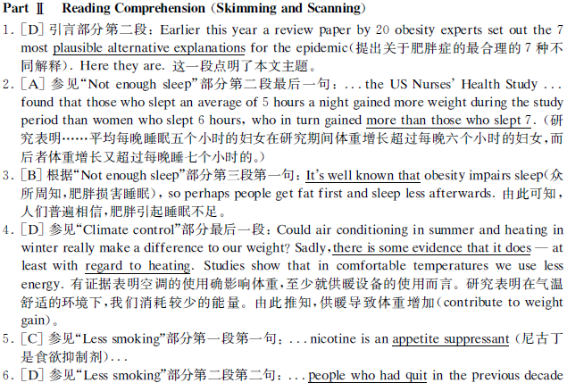
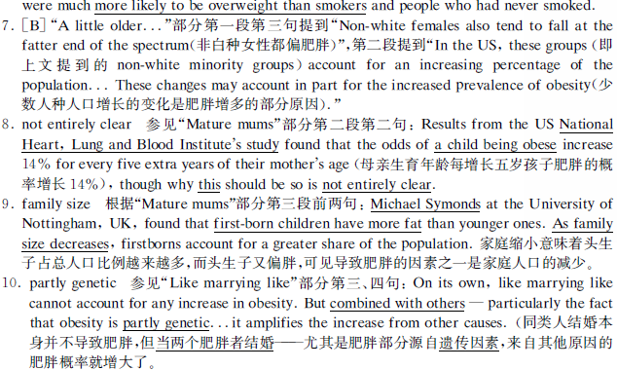

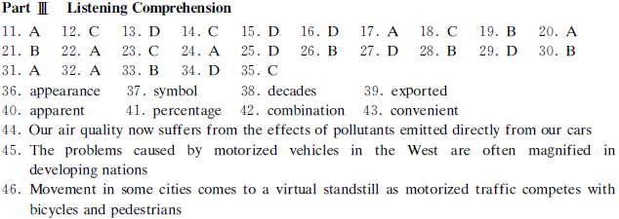
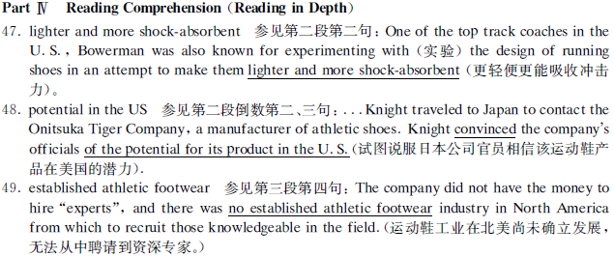
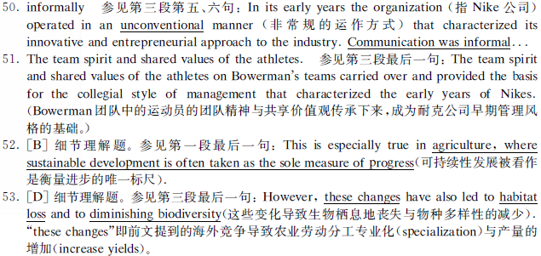
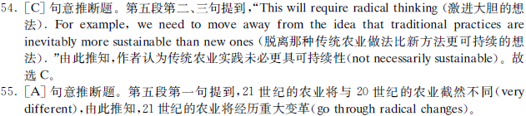

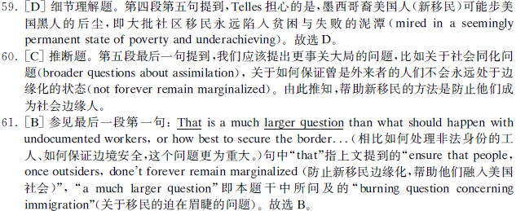




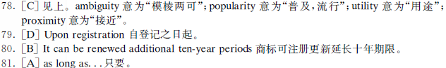
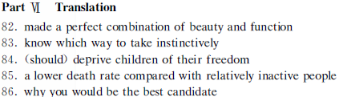

2007年6月英语六级真题听力原文
11. W: Jim, you are on the net again! We are going to get off. It s time for the talk show!
M: Just a minute dear! I m looking at a new jewelry site. I want to make sure I get the right gift for mom s birthday.
Q: What is the man doing right now?
12．W: I ve never seen you have such confidence before in the exam!
M: It s more than confidence! Right now I felt that if I got less than an A, it will be the fault of the exam itself.
Q: What does the man mean?
13．W: Just look at this newspaper! Nothing but murder, death and war! Do you still believe people are basically good?
M: Of course I do! But newspapers hardly ever report stories about peace and generosity. They are not news!
Q: What do we learn from the conversation?
14．M: Tom must be joking when he said he plans to sell his shop and go to medical school.
W: You are quite right! He s just kidding! He s also told me time and time again he wished to study for some profession instead of going into business.
Q: What will Tom probably do according to the conversation?
15．W: I hear your boss has a real good impression of you, and he is thinking about giving you two more days off each month.
M: I hope not. I d rather get more work hours I can get enough bucks to help out my two kids at college.
Q: What does the man truly want?
16．M: I heard you took a trip to Mexico last month. How did you like it?
W: Oh, I got sick and tired of the hotel and hotel food! So now I understand the thing: East, west, home s best!
Q: What does the woman mean?
17．W: I m worried about Anna. She s really been depressed lately. All she does is staying in her room all day.
M: That sounds serious! She d better see a psychiatrist at the counseling centre.
Q: What does the man suggest Anna do?
18．M: I could hardly recognize Sam after we got that new job! He s always in a suit and tie now.
W: Yeah. He was never liked that in college. Back then, he went around in old T-shirts and jeans.
Q: What does the speaker say about Sam?
Conversation 1
M: Hi, Anna! Welcome back! How’s your trip to the States?
W: Very busy. I had a lot of meetings, so, of course, I didn’t have much time to see New York.
M: What a pity! Actually, I have a trip there myself next week.
W: Do you? Then take my advice, do the well-being in the air program. It really works.
M: Oh, I read about that in a magazine. You say it works?
W: Yes, I did the program on the flight to the States, and when I arrived at New York, I didn’t have any problem, no jet lag at all. On the way back, I didn’t do it, and I felt terrible.
M: You’re joking!
W: Not at all, it really meant a lot of difference.
M: En. So what did you do?
W: Well, I didn’t drink an alcohol or coffee, and I didn’t eat any meat or rich food. I drink a lot of water, and fresh juice, and I ate the noodles on the well-being menu. They’re lighter. They have fish, vegetables, and noodles, for example, and I did some of the exercises of the program.
M: Exercises? On a plane?
W: Yes. I didn’t do many, of course, there isn’t much space on a plane.
M: How many passengers do the exercises?
W: Not many.
M: Then how much champagne did they drink?
W: A lot! It was more popular than mineral water.
M: So, basically, it’s a choice. Mineral water and exercises, or champagne and jet lag.
W: That’s right! It’s a difficult choice.
Questions 19 to 22 are based on the conversation you’ve just heard.
19. Why did the woman go to New York?
20. What does the woman say about the well-being in the air program?
21. What did the woman do to follow the well-being menu?
22. What did the woman say about other passengers?
Conversation Two:
W: Morning. Can I help you?
M: Well, I’m not rally sure. I’m just looking.
W: I see. Well, there’s plenty to look at it again this year. I’m sure you have to walk miles to see each stand.
M: That’s true.
W: Er…, would you like a coffee? Come and sit down for a minute, no obligation.
M: Well, that’s very kind of you, but…
W: Now, please. Is this the first year you’ve been to the fair, Mr….
M: Yes, Johnson, James Johnson.
W: My name’s Susan Carter. Are you looking for anything in particular, or are you interested in computers in general?
M: Well, actually, I have some specific jobs in mind. I owe a small company, we’ve grown quite dramatically over the past 12 months, and we really need some technological help to enable us to keep on top of everything.
W: What’s your line of business, Mr. Johnson?
M: We’re a training consultancy.
W: I see. And what do you mean “to keep on top”?
M: The first thing is correspondence. We have a lot of standard letters and forms. So I suppose we need some kind of word processor.
W: Right. Well, that’s no problem. But it may be possible for you to get a system that does a lot of other things in addition to word processing. What might suit you is the MR5000. That’s it over there! It’s IBM compatible.
M: What about the price?
W: Well, the MR5000 costs 1,050 pounds. Software comes free with the hardware.
M: Well, I’ll think about it. Thank you.
W: Here’s my card. Please feel free to contact me.
Questions 23 to 25 are based on the conversation you’ve just heard:
23. Where did the conversation take place?
24. What are the speakers talking about?
25. What is the man’s line of business?
Passage
P1
The new year always brings with the cultural tradition of new possibilities. We see it as a chance for renewal. We begin to dream of new possible selves. We design our ideal self or an image that is quite different from what we are now. For some of us, we roll at dreamy film in our heads just because it’s the beginning of a new year. But we aren’t serious about making changes. We just make some half-hearted resolution and it evaporates after a week or two. The experience makes us feel less successful and leads us to discount our ability to change in the future. It’ not the change is impossible but that it would lose(?) unless our resolutions are supported with plans for implementation. We have to make our intentions manageable by detailing the specific steps that will carry us to our goal. Say your goal is to lose weight by dieting and cutting off sweets. But one night you just have to have a cookie. And you know there’s a bag of your favorites in the cupboard. You want one, you eat two, you check the bag and find out you’ve just shot 132 calories. You say to yourself, “What the hell!” and polish off the whole bag. Then you begin to draw all kinds of unpleasant conclusions about yourself. To protect your sense of self, you begin to discount the goal. You may think – “Well, dieting wasn’t that important to me and I won’t make it anyhow.” So you abandon the goal and return to your bad habits.
26 What do people usually wish to do at the beginning of a new year?
27 How can people turn their new year’s resolutions into reality?
28 Why does the speaker mention the example of sweets and cookies?
P2
25 years ago, Ray Anderson, a single parent with a one-year-old son witnessed a terrible accident which took place when the driver of a truck ran a red light and collided with the car of Sandra D. The impact of the collision killed Sandra instantly. But her three-month-old daughter was left trapped in the burning car. While others looked on in horror, Andersen jumped out of his vehicle and crawled into the car through the shadowed rear window to try to free the infant. Seconds later, the car was enclosed in flames. But to everyone’s amazement, Andersen was able to pull the baby to safety. While the baby was all right, Andersen was seriously injured. Two days later he died. But his heroic act was published widely in the media. His son was soon adopted by relatives. The most remarkable part of the story unfolded only last week. Karen and her boyfriend Michael were looking through some old boxes when they came across some old newspaper clippings. “This is me when I was a new born baby. I was rescued from a burning car. But my mother died in the accident,” explained Karen. Although Michael knew Karen’s mother had died years earlier, he never fully understood the circumstances until he skimmed over the newspaper article. To Karen’s surprise, Michael was absorbed in the details of the accident. And he began to cry uncontrollably. Then he revealed that the man that pulled Karen from the flames was the father he never knew. The two embraced and shed many tears, recounting stories told to them about their parents.
29 What happened twenty-five years ago?
30 What does the speaker say about Michael’s father?
31 Why did Michael cry uncontrollably when he skimmed over the newspaper article?
P3
Americans suffer from an overdose of work. Regardless of who they are or what they do. Americans spend more time at work than that any time since World War II. In 1950, the US had fewer working hours than any other industrialized country. Today, it exceeds every country but Japan where industrialized employees load 2155 hours a year compared with 1951 in the US and 1603 in the former West Germany. Between 1969 and 1989, employed Americans add an average of 138 hours to their yearly work schedules. The workweek has remained above 40 hours. But people are working more weeks each year. Specifically pay time off holidays, vacations, sick leave shrink by 50% in the 1980s. As corporations have experienced stiff competitions and slow in growth of productivity, they have pressed employees to work longer. Cost-cutting lay-offs in the 1980s reduce the professional and managerial runs, leaving fewer people to get the job done. In lower paid occupations where wages have been reduced, workers have added hours in overtime or extra jobs to preserve their living standards. The government estimates that more than 7 million people hold a second job. For the first time, large numbers of people say they want to cut back on working hours even it means earning less money. But most employers are unwilling to let them do so. The government which has stepped back from its traditional role as a regulator of work time should take steps to make shorter hours possible.
Question 32-35 are based on the passage you’ve just heard
32. In which country do industrial employees work the longest hours?
33. How do employed Americans manage to work more hours?
34. Why do corporations press their employees to work longer hours according to the speaker?
35. What does the speaker say many Americans prefer to do?
Compound dictation
Nursing, as a typically female profession, must deal constantly with the false impression that nurses are there to wait on the physician. As nurses, we are licensed to provide nursing care only. We do not have any legal or moral obligation to any physician. We provide health teaching, assess physical as well as emotional problems, coordinate patient related services, and make all our nursing decision based upon what is best or suitable for the patient. If in any circumstance we feel that a physician’s order is inappropriate or unsafe, we have a legal responsibility to question that order, or refuse to carry it out. Nursing is not a nine-to-five job with every weekend off. All nurses are aware of that before they enter the profession. The emotional and physical stress, however, that occurs due to odd working hours is a prime reason for a large of the career dissatisfaction. It is sometimes required that we work overtime, and that we change shifts four or five times a month. That disturbs our personal lives, destruct our sleeping and eating habits, and isolates us from everything except job related friends and activities. The quality of nursing care is being affected dramatically by these situations. Most hospitals are now staffed by new graduates, as experienced nurses finally give up trying to change the system. Consumers of medically related services have evidently not been affected enough yet to demand changes in our medical system. But if trends continue as predicted, they will find that most critical hospital care will be provided by new, inexperienced, and sometimes inadequately trained nurses.

