B.Tech. BCSE497J - Project-I
COMPARATIVE ANALYSIS OF TRANSFER LEARNING MODELS WITH EXPLAINABLE AI FOR AUTOMATED NAIL DISEASE CLASSIFICATION
Submitted in partial fulfillment of the requirements for the degree of

Bachelor of Technology
in
Programme
23BCE2291 | SATYAM MITTAL
23BCE0616 | SHASHWAT SINGH
23BCE2284 | PROGYA PAROMITA BISWAS
by

Under the Supervision of
KAUSHIK HARIHARAN
Assistant Professor
School of Computer Science and Engineering (SCOPE)



October 2026
DECLARATION

I hereby declare that the project entitled COMPARATIVE ANALYSIS OF TRANSFER LEARNING MODELS WITH EXPLAINABLE AI FOR AUTOMATED NAIL DISEASE CLASSIFICATION submitted by me, for the award of the degree of Bachelor of Technology in Computer Science and Engineering to VIT is a record of bonafide work carried out by me under the supervision of Prof. Kaushik Hariharan G.
I further declare that the work reported in this project has not been submitted and will not be submitted, either in part or in full, for the award of any other degree or diploma in this institute or any other institute or university.

Place : Vellore
Date :
Signature of the Candidate

CERTIFICATE

This is to certify that the project entitled COMPARATIVE ANALYSIS OF TRANSFER LEARNING MODELS WITH EXPLAINABLE AI FOR AUTOMATED NAIL DISEASE CLASSIFICATION submitted by << Student Name (Reg. No) >>, School of Computer Science and Engineering, VIT, for the award of the degree of Bachelor of Technology in Computer Science and Engineering, is a record of bonafide work carried out by him / her under my supervision during Fall Semester 2024-2025, as per the VIT code of academic and research ethics.

The contents of this report have not been submitted and will not be submitted either in part or in full, for the award of any other degree or diploma in this institute or any other institute or university. The project fulfills the requirements and regulations of the University and in my opinion meets the necessary standards for submission.

Place : Vellore
Date :

Signature of the Guide

Examiner(s)
Dr. Boominathan P
B.Tec Computer Science and Engineering

ACKNOWLEDGEMENTS

I am deeply grateful to the management of Vellore Institute of Technology (VIT) for providing me with the opportunity and resources to undertake this project. Their commitment to fostering a conducive learning environment has been instrumental in my academic journey. The support and infrastructure provided by VIT have enabled me to explore and develop my ideas to their fullest potential.
My sincere thanks to Dr. Jaisankar N, the Dean of the School of Computer Science and Engineering (SCOPE), for his unwavering support and encouragement. His leadership and vision have greatly inspired me to strive for excellence. The Dean’s dedication to academic excellence and innovation has been a constant source of motivation for me. I appreciate his efforts in creating an environment that nurtures creativity and critical thinking.
I express my profound appreciation to Dr. Boominathan P the Head of the Computer Science and Engineering, for his/her insightful guidance and continuous support. His/her expertise and advice have been crucial in shaping the direction of my project. The Head of Department’s commitment to fostering a collaborative and supportive atmosphere has greatly enhanced my learning experience. His/her constructive feedback and encouragement have been invaluable in overcoming challenges and achieving my project goals.
I am immensely thankful to my project guide, Prof. Kaushik Hariharan G., for his/her dedicated mentorship and invaluable feedback. His/her patience, knowledge, and encouragement have been pivotal in the successful completion of this project. My supervisor’s willingness to share his/her expertise and provide thoughtful guidance has been instrumental in refining my ideas and methodologies. His/her support has not only contributed to the success of this project but has also enriched my overall academic experience.

Thank you all for your contributions and support.

Name of the Candidate
TABLE OF CONTENTS

Sl.No | Contents | Page No.
 | Abstract | 12
1. | INTRODUCTION | 13
 | 1.1 Background | 13
 | 1.2 Motivation | 13
 | 1.3 Scope of the Project | 13
2. | PROJECT DESCRIPTION AND GOALS | 14
 | 2.1 Literature Review | 14
 | 2.1.1 Transfer Learning for Medical Image Classification | 14
 | 2.1.2 Automated Nail-Image Analysis | 14
 | 2.2 Research Gap | 15
 | 2.3 Research Objectives | 15
 | 2.4 Problem Statement | 15
 | 2.5 Project Plan and Contributions | 15
3. | TECHNICAL SPECIFICATION | 17
 | 3.1 Requirements | 17
 | 3.1.1 Functional Requirements | 17
 | 3.1.2 Non-Functional Requirements | 17
 | 3.2 Feasibility Study | 18
 | 3.2.1 Technical Feasibility | 18
 | 3.2.2 Economic Feasibility | 18
 | 3.2.3 Social Feasibility | 18
 | 3.3 System Specification | 19
 | 3.3.1 Hardware Specification | 19
 | 3.3.2 Software Specification | 19
4. | DESIGN APPROACH AND DETAILS | 20
 | 4.1 System Architecture | 21
 | 4.2 Design | 21
 | 4.2.1 Data Flow Diagram | 21
 | 4.2.2 Use Case Diagram | 22
 | 4.2.3 Class Diagram | 22
 | 4.2.4 Sequence Diagram | 23
5. | METHODOLOGY AND TESTING | 24
 | 5.1 Methodology | 24
 | 5.1.1 Dataset Preparation | 24
 | 5.1.2 Data Partitioning and Leakage Control | 24
 | 5.1.3 Image Preprocessing and Augmentation | 25
 | 5.1.4 Model Selection and Transfer-Learning Strategies | 25
 | 5.1.5 Training and Hyperparameter Tuning | 25
 | 5.1.6 Explainability Analysis Protocol | 25
 | 5.2 Module Description | 26
 | 5.2.1 Dataset Management Module | 26
 | 5.2.2 Image Preprocessing Module | 27
 | 5.2.3 Data Partitioning Module | 27
 | 5.2.4 Model Training Module | 27
 | 5.2.5 Evaluation and Statistical Analysis Module | 27
 | 5.2.6 Explainability and Error Analysis Module | 27
 | 5.2.7 Experiment Logging Module | 27
 | 5.3 Testing | 27
 | 5.3.1 Dataset and Data-Split Testing | 27
 | 5.3.2 Model Configuration Testing | 28
 | 5.3.3 Performance Testing | 28
 | 5.3.4 Statistical Testing | 28
 | 5.3.5 Error and Bias Testing | 28
 | 5.3.6 Reproducibility and Environment Testing | 28
 | 5.4 Summary | 28
6. | PROJECT DEMONSTRATION | 29
 | 6.1 Overview | 29
 | 6.2 Demonstration Workflow | 29
 | 6.3 Demonstration Outputs | 29
 | 6.4 Demonstration Environment | 30
7. | RESULT AND DISCUSSION | 31
 | 7.1 Experimental Evaluation | 31
 | 7.2 Best Reported Configuration | 31
 | 7.3 Comparison of Fine-Tuning Strategies | 32
 | 7.4 Model Efficiency and Practical Trade-Offs | 33
 | 7.5 Hyperparameter and Fold-Level Findings | 33
 | 7.6 Error Analysis and Explainability | 33
 | 7.6.1 Class-Wise Performance | 34
 | 7.6.2 Confusion Matrix | 34
 | 7.6.3 Source-Wise Recall | 35
 | 7.6.4 Watermark-Related Error Analysis | 36
 | 7.6.5 Faithfulness and Padding Saliency | 36
 | 7.6.6 Example Explanations and Agreement Between Models | 37
 | 7.6.7 Watermark Analysis | 39
 | 7.6.8 Summary of Explainability Findings | 41
 | 7.7.1 Paired Accuracy Comparison | 41
 | 7.7.2 Model Size, Latency, and Training Time | 42
 | 7.7 Cost Analysis | 42
 | 7.8 Limitations | 42
8. | CONCLUSION | 44
9. | REFERENCES | 45
 | APPENDIX A – SAMPLE CODE | 47

List of Figures

Figure No. | Title | Page No.
4.1 | System architecture of the nail disease classification research pipeline | 21
4.2 | Data Flow Diagram showing dataset preparation, training, evaluation, and output artifacts | 22
4.3 | Use Case Diagram for the research workflow | 22
4.4 | Conceptual Class Diagram of the research pipeline modules | 23
4.5 | Sequence Diagram showing model training and evaluation | 23
7.2 | Macro-F1 on the pooled held-out folds 1–4 by model and transfer strategy | 32
7.4 | Fold-0 macro-F1 as a function of the backbone learning-rate multiplier for partial and full fine-tuning | 33
7.6 | Confusion matrix of the best configuration (DINOv2, full fine-tuning) on the pooled folds 1–4 | 35
7.6.5 | Faithfulness and padding saliency of the explanation maps | 37
7.6.6 | Example explanations for correctly classified and misclassified images | 39
7.6.7 | Explanations for watermarked psoriasis images | 41

List of Tables

Table No. Title Page No.
3.1 Hardware Specifications 19
3.2 Software Specifications 20
6.1 Environment Specifications 30
Results on pooled test folds 1–4 (807 images) 31
7.3 Comparison of Fine-Tuning Strategy 32
7.4 Model Efficiency and Practical Trade-Offs 33
Class-wise precision, recall and F1 34
Recall by class and image source 35
Recall on psoriasis by watermark status 36
Faithfulness and padding saliency of maps 37
7.6.6 Mean per-image Spearman correlation 38
Watermark occlusion test (21 images) 40
Saliency inside the watermark boxes 40
Paired accuracy comparison 41
Model size and computational cost 42
7.8 Cost Analysis 42

List of Abbreviations
AdamW Adaptive Moment Estimation with Decoupled Weight Decay
AI Artificial Intelligence
AMP Automatic Mixed Precision
CI Confidence Interval
CNN Convolutional Neural Network
CUDA Compute Unified Device Architecture
DINOv2 Name of the pretrained, self-supervised visual representation model
F1-score Harmonic mean of precision and recall
FP16 16-bit Floating-Point Precision
FP32 32-bit Floating-Point Precision
GPU Graphics Processing Unit
Grad-CAM Gradient-weighted Class Activation Mapping
JSON JavaScript Object Notation
Macro-F1 Macro-averaged F1-score
PNG Portable Network Graphics
RF Random Forest
RGB Red, Green, Blue
ResNet Residual Network
SD Standard Deviation
timm PyTorch Image Models
ViT Vision Transformer
VGG Visual Geometry Group
XAI Explainable Artificial Intelligence

Symbols and Notations

N Total number of images or evaluated samples.
C Number of disease classes.
I Index of an image or sample.
y Ground-truth class label for sample i.
TP True positives: positive cases correctly predicted as positive for a given class.
FP False positives: negative cases incorrectly predicted as positive for a given class.
FN False negatives: positive cases incorrectly predicted as negative for a given class.
TN True negatives: negative cases correctly predicted as negative for a given class.
P Precision: TP / (TP + FP), calculated for a class.
R Recall: TP / (TP + FN), calculated for a class.
F1 F1-score: harmonic mean of precision and recall.
Acc Accuracy: number of correct predictions divided by the total number of predictions.
BA Balanced accuracy: mean recall across classes.
α Significance level used for statistical hypothesis testing
p p-value associated with a statistical test.
95% CI 95% confidence interval for an estimated metric or difference.
η Learning rate

ABSTRACT

Colour, texture shape and surface changes can happen to nails if they are effected by disease. So having nail images as an input for a computer aided screening system could be useful. A lot of papers will test one pre trained model on one split of data and never mention what there accuracy could come from. We have tested six pre trained networks (ResNet-50, VGG16, DenseNet-121, ConvNeXt-Tiny, ViT-B/16 and DINOv2 ViT-B/14) with three different methods of transfer learning (Frozen, Partially fine tuned and Fully fine tuned). On a small imbalanced data set of 13 classes and 1,008 images. We created a grouped stratified split with 5 folds to make sure similar images are not in different folds. Each experiment was ran on fold 0 (1 default and 3 runs) using the same hyper parameter search space. Once the best experiment was found it was ran on the other 4 folds. Our results are made up of predictions from these folds (807 images) and 95% confidence intervals were calculated using group bootstrapping. We found that each network performed better when fine tuned compared to frozen (Accuracy increased by 11.6-18.5 points, Macro-F1 was between 0.59-0.68 when frozen and 0.73-0.86 when fine tuned). When using DINOv2, ConvNeXt-Tiny and ResNet-50 partial fine tuning gave us similar results to fully fine tuning. With VGG16 and DenseNet-121 we saw a big difference between the two. Our highest Macro-F1 score was 0.857 using DINOv2 and fully fine tuning. This model was not significantly different to 5 other models including ResNet-50 which is 3.6 times smaller. The backbones learning rate was found to be our biggest factor in our results and using fold 0 over estimated our results by around 5 Macro-F1 points. Errors were mostly classified as onycholysis and onychomycosis and psoriasis. We have used explainable AI techniques to see what the model is basing its predictions on. Grad-CAM was used for the CNN's and Attention Rollout was used for the transformers. We calculated grad-cam and attention rollout for the five best configurations and one frozen configuration. The CNN's and DINOv2 produced maps that were more faithful than random and did not show much saliency on the padding of the image. ViT-B/16 maps were less faithful and showed more saliency on the padding. By hiding the watermarks we saw a drop in predicted probability of 0.06–0.10 which was higher than hiding the same size area of a random region for all six configurations explained. These models should be used as a screening method and not used to diagnose patients.
Keywords— Nail Disease Classification, Transfer Learning, Fine Tuning Methods, Vision Transformers, DINOv2, Small Datasets, Explainable AI, Grad-CAM.

CHAPTER 1

1. INTRODUCTION
There are many changes to nails that can indicate disease of the nail and some other conditions. If you notice your nails becoming discolored or thick/thin, misshapen or change in texture you may want to look into why. There are many conditions that can cause these changes. Some people may not be able to see a dermatologist depending on their location and what facilities they have available to them. So maybe image based machine learning could help classify and give some information.

1.1 Background
Many deep learning models have been created to classify images. You can use transfer learning from models that have already been trained to help when you don't have enough labeled data to train on [1, 2]. When dealing with medical data you may run into issues with the dataset being imbalanced. Images may have bad lighting or be low quality. Data sets can also have images that are too similar to each other. If we sample our data this way our model may perform poorly on other images.

1.2 Motivation
When selecting a model to use there are many things to keep in mind. How much of the model you want to fine tune and what learning rate to use can impact your results. If we test our models with the same fine tuning settings we may only know what model performs best with those settings.

We also want to make sure our classifier isn't taking shortcuts to get the right answer. There could be backgrounds or edges of the image that allow our model to get high accuracy [3, 4]. Since our data came from many different websites there could be similarities between images that are from the same website. Maybe size of the image or if its watermarked.

1.3 Scope of the Project
We will be looking at different ways to transfer learn on our dataset of nails with disease. We used 6 different models that were pre trained. These included some older CNN's one newer CNN and two transformer models. One transformer was supervised and one was self supervised. Each model was frozen and fine tuned half way through and all the way. (18 different models) Each model was allowed the same amount of time to learn and hyper parameters were selected. We tested on different folds of our grouped 5 fold cross validation and bootstrapped on groups. We also did paired testing and looked at errors by class.

CHAPTER 2

2. PROJECT DESCRIPTION AND GOALS
This section will cover the background of this research, current methods and what this project hopes to accomplish. It will also describe the key contributions of this project and what we plan on doing to compare transfer learning models for automatic nail disease classification.

2.1 Literature Review
This section will cover current literature on transfer learning and automatic nail-image classification. We will use this to help understand why we chose these models and what to expect when classifying nail diseases.

2.1.1 Transfer Learning for Medical Image Classification
Transfer learning allows you to take weights that have been trained on a source dataset and apply them to your target dataset. Which usually is a smaller dataset. There are arguments that say the first layers of a model learn general features that most models share [1] and the last layers learn more task specific features [5]. If you freeze your base model you have less parameters to learn. You can then fine tune certain layers or the entire model to gain better performance on your target dataset. Depending on how you split your data and the size of your dataset this can vary.

When looking at larger studies it becomes harder to see. Kornblith et al found that there was a correlation between ImageNet score and transfer learning score when fine-tuning models [6]. Raghu et al found that using ImageNet pre trained weights didn't benefit them on a medical imaging dataset and that a smaller network could achieve similar results to a normal network [2]. Doerrich et al used various CNN and Vision Transformer models on the MedMNIST+ dataset. They found that training the model end to end gave them better results than just fine-tuning the classifier. They also found that convolutional models were comparable to transformer models [7]. The models we will be using in this paper are from VGG16 [8] to ResNet-50 [9], DenseNet-121 [10] and ConvNeXt-Tiny [11]. We will also be using Vision Transformer models such as ViT-B/16 trained with supervised learning [12, 13] and DINOV2 ViT-B/14 which is trained with self supervised learning on 142M images. Should be able to pick up on general features for any task without fine-tuning [14].

2.1.2 Automated Nail-Image Analysis
There have been previous works that have tried to classify images of nails for certain nail abnormalities. They have also looked at if there are any diseases associated with nail abnormalities. Since the classes are similar to one another it can be hard to take pictures of nails that are consistent. There are also not as many classes and some images can be labeled incorrectly. Deep learning has been able to achieve great accuracies when classifying skin lesions [15]. Many of these papers that have classified nails have used small data sets and transfer learning. Coşar Soğukkuyu and Ata used transfer learning with VGG16 and VGG19 to classify Beau's lines, melanonychia and nail clubbing. Getting accuracies of 94% and 93% on 723 images [16]. Shandilya Gupta et al developed a Capsule CNN hybrid to classify 6 classes of nail disease. With the publicly available nail disease dataset and data augmentation they were able to achieve an accuracy of 99.25% on their test set [17]. These papers differ in how many classes they are trying to classify and what dataset they are using. Some have different labels for their classes as well so we won't be able to directly compare our results to these papers based on accuracy. Our paper will build on these papers by using 6 models with transfer learning on 3 types of grouped splits.

2.2 Research Gap
As you can see there are many papers that have tried to classify nail disease. But each paper uses different datasets and classes making it hard to compare their results to one another. We will be comparing 6 models with 3 types of fine-tuning and see which performs best on our classes.

2.3 Research Objectives
We want to see what transfer learning method works best for our classes and what factors may play a role in our models performance.
1. Fine tune models with frozen, partial fine-tune and full fine-tune. Using 6 different pre trained models on the same data pipeline. Give each model the same amount of time to tune.
2. See how each model performs on our classes and find the uncertainty on our holdout folds that we didn't tune hyper parameters on.
3. Determine what hyper parameters play a role when using a small amount of data.
4. Analyze errors per class and if they are from a specific location.
5. Apply Grad-CAM and Attention Rollout to our models and see if they are focusing on the nail or artifacts. Test for faithfulness, padding and watermarks.
6. Explain how we split our data and our train setup. What pitfalls there are and how to reproduce our work.

2.4 Problem Statement
Due to the many nail diseases that share similarities in their images and various qualities of images as well as size and source of data sets it can be difficult to classify nails correctly. By comparing different pre-trained models and ways to fine tune them we can see how they all perform when given the same data set.

2.5 Project Plan and Contributions
We will be looking at different architectures and ways to fine tune them then evaluate on hold out data. We will look at mis classifications and any short cuts that may be taken by our data set.
Our contributions are as follows:
1. Compare architecture's and ways to fine tune. Fine tuning for the same amount of time on each configuration. Using a 6 × 3 grid search.
2. Use grouped-folds where the fold used to find best hyper parameters is not one of the folds we report on.
3. Evaluate our models on macro-F1, balanced accuracy and accuracy. Look at each class and source individually. Use grouped bootstrapping and paired significance tests.
4. Try to find what hyper parameters/classes/sources effect our models performance. See if we can tell if there is a watermark.
5. Use explainability on our best configurations to find if they are faithful. Padding saliency and model to model agreement. Test our model against watermarks.

CHAPTER 3
3. TECHNICAL SPECIFICATION
In this chapter we will discuss about the requirements, feasibility and specification of our project. We will be discussing about the functional and non functional requirements of our project. Also we will be discussing about the feasibility of our project and what hardware/software we have used to train our deep learning models.

3.1 Requirements
We need a good dataset and pre trained deep learning models. Preprocessing of images and a good train/test pipeline are also needed. There are functional and non functional requirements for our project.

3.1.1 Functional Requirements
Below are the functional requirements of our project.
1. Input Nail Image: Our system needs to take in an image of a nail.
2. Preprocess Image: Convert image to RGB. Pad image to be square. Resize image to input size of model. Normalize image.
3. Use 6 Different Models: We need to test 6 pre trained models. These are ResNet-50, VGG16, DenseNet-121, ConvNeXt-Tiny, ViT-B/16 and DINOv2 ViT-B/14.
4. Transfer Learning: Our system should be able to freeze features, partially fine tune and fully fine tune our model.
5. Classify Diseases: Our models should be able to classify the nail image into one of the 13 classes we have in our dataset.
6. Evaluate Models: Our system should calculate the accuracy, balanced accuracy and Macro-F1 of our models.
7. Analyze Errors: Our system should allow us to analyze errors made by our models. By class and by source of data.
8. Explainability: For our CNNs we will be using Grad-CAM and for our Transformers we will be using Attention Rollout. This will allow us to see why our models predict certain classes.

3.1.2 Non-Functional Requirements
These are the non functional requirements that we want our project to meet.
1. Performance: We want our system to perform well when classifying the diseases we have in our dataset.
2. Reliable: We want our models to be tested on data they have not seen before when tuning hyper parameters.
3. Reproducible: We want to save our train settings, epochs logs, predictions, probabilities and models for further analysis.
4. Similar Tuning Budget: We want all our models to go through the same data pipeline and similar amount of time spent tuning hyper parameters.
5. Scalable: Allow for more experiments with different models/hyper parameters.
6. Robust: Take into account imbalanced classes, quality of images, water marks etc.
7. Interpretable: Use explainability methods to see what parts of an image our models look at when making predictions.

3.2 Feasibility Study
We will be looking at if our project is feasible or not. We will be taking into consideration if our project is technically feasible, economically feasible and socially feasible.

3.2.1 Technical Feasibility
Our project is technically feasible. As we are using pre trained deep learning models and applying transfer learning to them. We have 1008 images in our dataset that cover 13 different classes. We will be testing 6 different models with frozen features, partial fine tuning and full fine tuning.
We are using Pytorch and the timm package to get our models. We will be training and testing our models on Kaggle Notebooks with a Tesla T4 GPU. We will be using grouped five fold cross validation, multiple metrics and explainability methods.
This project is only to be used as a research tool and can be used to help screen people with nail diseases. It should not be used as a replacement for a doctors diagnosis.

3.2.2 Economic Feasibility
Using public datasets, model weights and libraries that are freely available as well as cloud notebooks allows this project to be created with minimal cost on infrastructure. As the experiments shown were done using Kaggle Notebooks and a Tesla T4 GPU we would have spent around 9.5 GPU hours on training our model. This does not include time spent loading and evaluating data.
As these resources are freely available this project is economically feasible for use within an academic setting. No expensive computer system was needed. Cost will depend on what resources you have access to and if more are needed down the line.

3.2.3 Social Feasibility
This project looks at the possibility of classifying images of nails to detect abnormalities. This could open the door to more research on image detection of nail abnormalities.
Due to the images being pulled from online sources we cannot confirm that every image is correctly labelled. There may be biases within the dataset and some images may be mislabelled. This system should only be used for research purposes and is not to be used as a replacement for a medical professional.

3.3 System Specification
System specification outlines what hardware and software is needed to complete this project. Below are the specifications that were used during our study.

3.3.1 Hardware Specification
Kaggle Notebooks were used to run our experiments.

Table 3.1. Hardware Specifications
Component | Specification
Computing platform | Kaggle Notebooks
GPU | NVIDIA Tesla T4
Dataset size | 1,008 images
Number of classes | 13
Model input size | 224 × 224 pixels
Batch size | 32
Training precision | FP16 automatic mixed precision
Approximate training time | 9.5 GPU hours, excluding data loading and evaluation
Table 3.1 This section will describe the hardware and setup we used to train our deep learning models on Kaggle Notebooks.We were able to use GPU to help with our models being able to train and fine tune our 6 deep learning models. There was no mention of what CPU or how much system memory and hard drive space was used.

3.3.2 Software Specification
Python was used with various deep learning packages and image manipulation programs to train our models and test how well they performed

Table 3.2. Software Specifications

Software / Library | Version or Details
Development environment | Kaggle Notebooks
Programming language | Python 3.13
Deep learning framework | PyTorch 2.11.0
Model library | timm 1.0.29
Machine learning library | scikit-learn 1.6.1
GPU computing | CUDA 12.8
Model architectures | ResNet-50, VGG16, DenseNet-121, ConvNeXt-Tiny, ViT-B/16, DINOv2 ViT-B/14
Optimization algorithm | AdamW
Evaluation metrics | Accuracy, balanced accuracy, Macro-F1
Explainability methods | Grad-CAM and Attention Rollout
Table 3.2 presents the software tools, libraries, frameworks, model architectures, and evaluation methods used to implement and assess the proposed deep learning system. The software environment supports model loading, image preprocessing, transfer learning, hyperparameter tuning, evaluation, and explainability analysis. The recorded software versions provide a reference for reproducing the experimental setup.

CHAPTER 4
4. DESIGN APPROACH AND DETAILS
In this section we will describe our design for our research on classifying nails with diseases. As mentioned in our report we will first prepare our dataset. Then we will preprocess our images and perform grouped cross validation. Transfer learning will be used and evaluate our models. We will also look at our errors and explainability.
4.1 System Architecture
Our system has many experiments that will take place in a certain order. First we will gather images from four different websites. These images will be stored in a manifest file that will include image path, label, website they came from, group id and information about the image. Our images will be preprocessed and split into 5 stratified groups to avoid similar images being in the same fold. We will test six different pretrained models with frozen, partial and full fine tuning. Fold 0 will be used to select hyper parameters and folds 1-4 will be used to confirm our results. Once all of these steps are done we can analyze our results, errors and explainability. Figure 4.1 shows our system architecture for classifying nails with diseases. It starts with preparing our dataset and ends with evaluating our models, analyzing errors and looking at explainability.

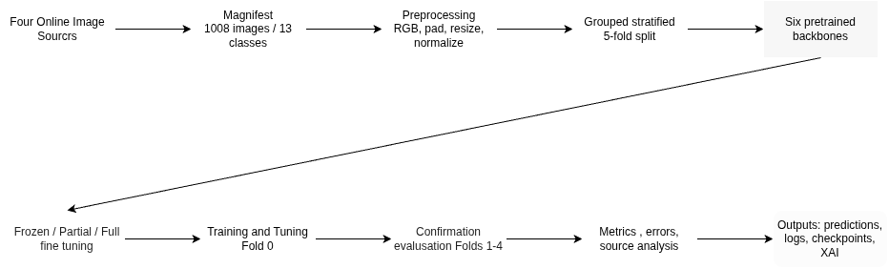
Figure 4.1. System architecture of the nail disease classification research pipeline.

4.2 Design
This design shows how our data will travel through our research. It also shows how the user will interact with our system and how our code will work together. It will show what order things will happen when training and evaluating our model. These diagrams are just concepts based on our research.
4.2.1 Data Flow Diagram
Data will start with images of nails from online. These images and their metadata will be put into a manifest. They will be preprocessed and split into grouped stratified folds. Our train component will try different models and fine tuning. Once a model is trained checkpoints, logs and predictions will be sent to our evaluate component. Our evaluate component will give us performance metrics, errors and explainability. Figure 4.2 shows our data flow diagram for our system. It starts with collecting images of nails and ends with giving us performance metrics, errors and explainability.

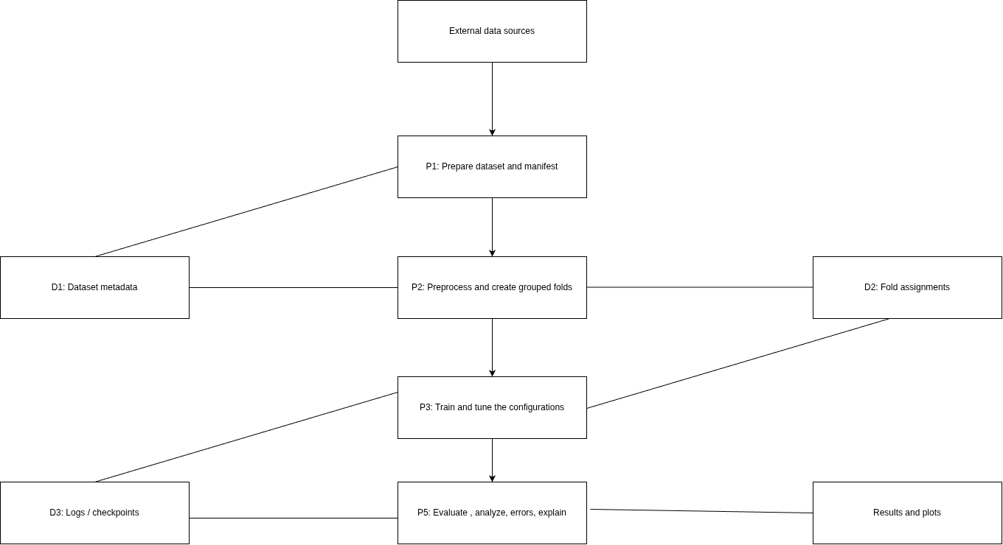
Figure 4.2. Data Flow Diagram showing dataset preparation, training, evaluation, and output artifacts.

4.2.2 Use Case Diagram
As shown in the diagram there is only one user. That user is the researcher. They will prepare their dataset, choose what models they want to use and what type of fine tuning they want to use. They will train their models and tune their hyper parameters. After that they can evaluate their models, look at their class and website wise errors. They can also generate explainability and save artifacts from their experiments. This use case diagram is just to show the flow of our research. It does not mean that we made an application for users to use.

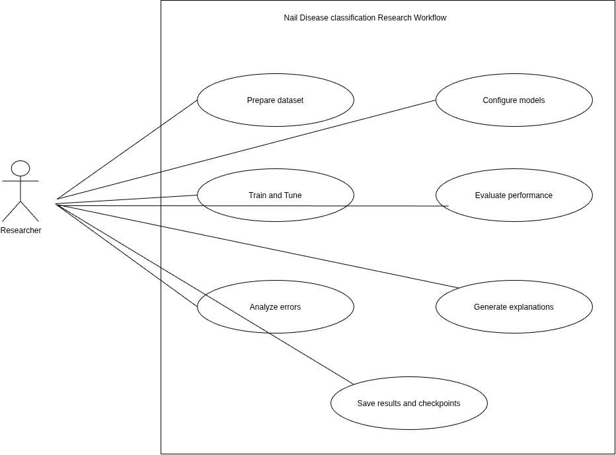

Figure 4.3. Use Case Diagram for the research workflow.

4.2.3 Class Diagram
There are several classes that each have different jobs they can perform. DatasetManager would be used to store the manifest and groups. The Preprocessor would apply transformations to images. FoldSplitter would generate grouped folds. ModelConfig would contain information about the model and strategies. ModelTrainer would train and tune models. Evaluator would compute metrics and uncertainty. Explainability would create visualizations. And ExperimentArtifacts would save checkpoints, logs and predictions. These classes are only used as a concept to show what we think our classes could look like and are not used in our code base. Figure 4.4 shows our conceptual class diagram of our pipeline and what each module will be responsible for.

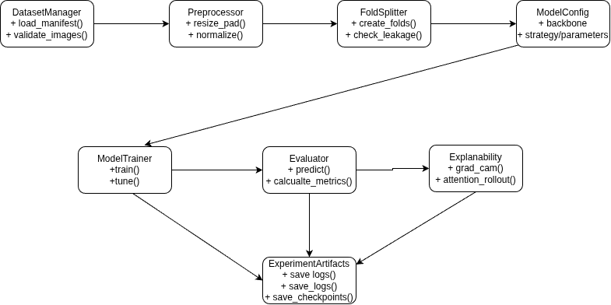
Figure 4.4. Conceptual Class Diagram of the research pipeline modules.

4.2.4 Sequence Diagram

This sequence diagram outlines what will happen when running an experiment. First the user will choose there dataset and config. Then our data pipeline will load the manifest, transform images and split them into grouped folds. Our trainer will instantiate the backbone and classifier of choice and train using the desired fine-tune strategy. It will then save any experiment artifacts. Our evaluator will take the predictions on the holdout set and calculate metrics and confidence intervals. It will also calculate errors per class and source and produce explainability outputs. Figure 4.5 shows our sequence diagram of our pipeline when training and evaluating our models
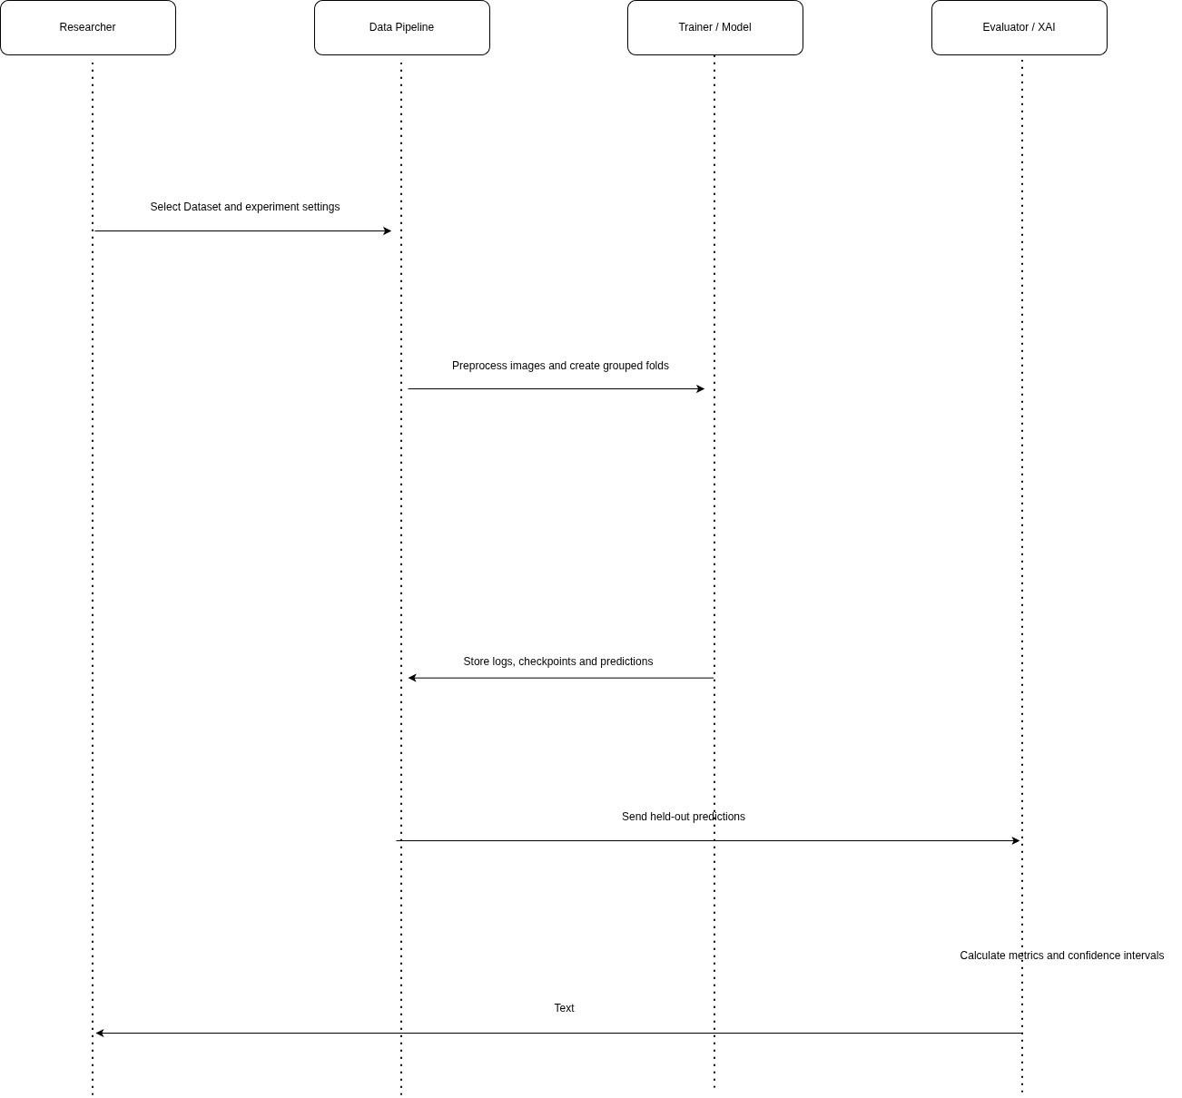

Figure 4.5. Sequence Diagram showing model training and evaluation.

CHAPTER 5
5. METHODOLOGY AND TESTING
This section will go over how I went about creating my models for automatically classifying nails with diseases. I will cover how I gathered the data and preprocessed it. As well as what models were used and how they were trained. I will also explain the key components of this research and how I went about testing them.
5.1 Methodology
I used a methodological approach where I compared multiple models against each other. There are 6 different models that I have tested with 3 types of transfer learning. Frozen features, partial fine tuning and full fine tuning. All models will use the same data pipeline and will be given a similar amount of time to tune hyperparameters.
5.1.1 Dataset Preparation
There are 1008 images of nails that belong to 13 classes. These images were taken from 4 different online datasets. They are labeled as BASE, archive6, archive5 and B1B2CD. I created a manifest file that lists the path of each image along with its class. I also listed what dataset it came from, what group it belongs to. What size the image was before being altered and if there was any confidence in the label. I also noted if the image had a watermark or was a wide shot.
If there were images that had conflicting labels they were removed. There are 2 classes that I did not include because there were only images from one source with augmented images. I was unable to find any other sources for these classes. Because the images were pulled from the internet there may be some noise in the labels and bias from the source.
5.1.2 Data Partitioning and Leakage Control
I split my images into 5 group folds. Images that were similar were put into groups using pixel hash, perceptual hash, embeddings or having the same stem from robflow. These images were then placed in a fold and would not appear in another fold. This will help prevent leakage from similar images.
Fold 0 was used for my first round of tuning. Once I had a configuration for each model and type of transfer learning I would train and test on folds 1-4. My confirmed results will come from these 4 folds.
5.1.3 Image Preprocessing and Augmentation
All images were converted to RGB and were padded to be a square using the normalization mean of the chosen model. While training images would be resized and cropped randomly. They would also be flipped on both axes and rotated -15 to 15 degrees. Some brightness, contrast and saturation would be applied to the image. The image was then converted to a tensor and normalized using the mean and std of the pretrained model.
All models were trained with a input size of 224x224 and a batch size of 32. When testing the images were just resized and normalized.
5.1.4 Model Selection and Transfer-Learning Strategies
The models used were ResNet-50, VGG16, DenseNet-121, ConvNext Tiny, ViT-B/16 and DinoV2 ViT-B/14. Each model had its last layer replaced with a classifier that had 13 outputs.
Each model was trained with 3 types of transfer learning. Frozen would only train the new classifier layer. Partial would train the classifier and some of the last layers/blocks. Full would train every layer in the model. This gave me 18 models to compare.
5.1.5 Training and Hyperparameter Tuning
I used AdamW as my optimizer and weighted cross entropy loss to account for unbalanced classes. I used a learning rate warmup and cosine decay. Label smoothing was used along with gradient clipping and fp16 auto cast. My models defaulted to 30 epochs for frozen models, 40 for partial and 50 for full fine tuning.
Each model and transfer learning type was given a default run and 3 tuning runs on fold 0. If the tuning run had a higher macro f1 score than the default it would be used. As long as it was 0.01 points higher than the default. Accuracy was used to break ties. These models were then tested on folds 1-4.
5.1.6 Explainability Analysis Protocol
Explanation maps were produced for the five configurations that were tied for highest Macro-F1 when using full or partial fine-tuning (DINOv2 fully fine-tuned, ResNet-50 fully and partially fine-tuned, ViT-B/16 fully fine-tuned and DenseNet-121 fully fine-tuned) and for the one frozen configuration (ViT-B/16) as a control. The remaining configuration tied for best performance (DINOv2 partially fine-tuned) was left unexplained. All images were explained using the checkpoint from the fold they were excluded from i.e. the model did not see that image during training. This resulted in all 1008 images being explained out-of-fold. We verified that we used the correct checkpoint by recalculating the predictions in FP32 and comparing to the saved FP16 predictions, they were equal for 99.9-100% of images in each configuration.
Grad-CAM [28] was calculated on the predicted class at the final conv layer for ResNet-50 (layer4, 7x7) and DenseNet-121 (last feature map before final batch norm, 7x7) and the patch embeddings going into the final attention layer for ViT-B/16 (14x14) and DINOv2 (16x16). Attention rollout [29] was also calculated for the transformer models by averaging the attention matrices over heads, adding the identity matrix, normalising rows and multiplying over all layers. The row corresponding to the class token was used as the explanation map. Maps were rescaled to be between 0 and 1 and resized to the 224x224 padded input image and mapped back to the original image using the deterministic padding.
Deletion and insertion [30] was used to measure faithfulness. Pixels were deleted from (or inserted into a blank image with the mean colour) in descending order of saliency over 21 steps and the area under the curve of the predicted class probability was calculated. Each explanation map was compared to a randomly generated smooth map of the same size and the difference is reported as a gain. Deletion gain is the difference between the AUC of the random map and the explanation map. Insertion gain is the difference between the AUC of the explanation map and the random map. A higher gain indicates that the explanation map is able to identify features that contribute to the prediction better than random. 95% confidence intervals were calculated using bootstrapping at the group level.
As images were padded to be square there is some information about the class in the aspect ratio of the image. The amount of saliency that fell on the padding was divided by the proportion of the image that was padding. If this number is greater than 1 it indicates that the explanation map is placing more importance on the padding. This was calculated for the 868 images that had padding. The correlation between explanation maps from different models and methods was calculated using the average spearman rank correlation per image. To ensure that the explanation maps were dependent on the knowledge that the network has gained we compared the Grad-CAM maps of each trained network to those of a randomly initialised network with the same architecture on 100 images from fold 0 [31].
There are 21 images that have a watermark or some form of text overlaid on them (14 DermNet logos, 4 Te Whatu Ora text, 2 iStock credit and 1 video player icon). All of these images were of BASE psoriasis. We used an AI assistant (Claude by Anthropic) to generate bounding boxes around the watermark/text from the image files and manually verified these on zoomed in images. Two tests were carried out. The first was to calculate the amount of saliency that fell within the box and divide by the proportion of the image that the box covered (mass ratio, 1 is uniform). We also used the pointing game to see if the most salient pixel was within the box. The second test was to replace the box with the mean colour of the image and calculate the decrease in predicted class probability. This was compared to the average decrease when 5 random boxes of the same size were placed within the image. A one sided wilcoxon signed rank test [32] was used to compare the difference for each configuration with Holm correction applied.
As there was no expert annotation of the nail area we were unable to quantify how much of the explanation map overlapped with the nail. These analyses are designed to detect bias towards certain artifacts and assess faithfulness.
5.2 Module Description
The following modules were created to complete each step of the research process.
5.2.1 Dataset Management Module
Used to store information about the image dataset. Includes file path, label, source, group id, image size and any other pertinent information about the image. Can also be used to validate image paths and check that the manifest matches the folds.
5.2.2 Image Preprocessing Module
Converts images to RGB, pads them to be square, resizes/crops to desired size, applies any augmentations for training, converts to tensor and normalises using the appropriate values for each model.
5.2.3 Data Partitioning Module
Splits the data into stratified groups of 5 folds. Ensures similar/duplicate images are in the same fold. Splits off the tuning fold from the remaining folds used for confirmatory analysis.
5.2.4 Model Training Module
Loads each of the 6 pretrained backbones and changes the classification head to predict our 13 classes. Fine tunes using either the frozen, partial or full method and trains the model using the set hyperparameters.
5.2.5 Evaluation and Statistical Analysis Module
Predictions will be made on the holdout folds. Accuracy, Balanced Accuracy and Macro-F1 will be calculated. Group level bootstrapping will be used to calculate 95% Confidence Intervals and paired statistics can be used to compare differences between configurations. Holm Correction will be applied where applicable to families of tests.
5.2.6 Explainability and Error Analysis Module
Errors will be analysed per class and data source. We will look at if any shortcut learning is taking place from image characteristics or watermark. Convolutional models will use Grad-CAM and Transformer models will use Attention Rollout to aid with visualising parts of the image.
5.2.7 Experiment Logging Module
Config files, epoch logs and predictions with probability scores and model weights will be saved. This will allow for further analysis and documenting of experiments.
5.3 Testing
Testing will be done to check our data pipeline and how well our models generalise. The following describes what was tested in the study. There are no traditional unit tests for an application described in this report.
5.3.1 Dataset and Data-Split Testing
Data processing scripts check if the folds align with the dataset manifest. All images have a valid path and no groups appear in more than one fold. This prevents similar images being in multiple folds.
5.3.2 Model Configuration Testing
Each of the 6 backbones were tested with 3 different methods of Transfer Learning. Giving us 18 configurations to test. Each configuration had the default setup and 3 trials when tuning. This allows for fair comparison between models and types of fine-tuning.
5.3.3 Performance Testing
Models were tested on folds 1-4 after being tuned on fold 0. Accuracy will give us how many correct predictions we made. Balanced Accuracy will average the recall of each class. Macro-F1 will weight each class equally when calculating F1 Score. Macro-F1 was chosen as the main metric due to the imbalanced classes in our dataset.
5.3.4 Statistical Testing
Group level bootstrapping was used to find 95% Confidence Intervals on our scores and differences between configurations. Paired predictions were compared using Mcnemar's Test and Holm Correction was applied where applicable. Since there can be correlation between images in a group and we only have 4 confirmation folds these statistics should be taken with caution.
5.3.5 Error and Bias Testing
Errors were analysed by class and source. If there are any characteristics about the images that could be used to classify them was investigated. A random forest was created to see if we could classify images using png size and aspect ratio/area. Source artifacts and watermarks were also considered as well as any mislabelled data.
5.3.6 Reproducibility and Environment Testing
Experiments were completed on Kaggle Notebooks using a Tesla T4 GPU. With Python 3.13, PyTorch 2.11.0, timm 1.0.29, CUDA 12.8 and scikit-learn 1.6.1. Training took around 9.5 GPU Hours without data loading and evaluation. Using cudnn auto tune means results may not be reproducible on a bit by bit level. When running ResNet-50 again it resulted in 2 less correct predictions out of 201 images.
5.4 Summary
Our methodology consists of Transfer Learning experiments with controlled data splitting, preprocessing and evaluation. We test our data to make sure it is split correctly and test our models to see how they perform. Looking at if our models are biased towards certain classes or sources. There are some caveats to this methodology due to the dataset being sourced online and having a small amount of images.

CHAPTER 6
6. PROJECT DEMONSTRATION
6.1 Overview
This project will show our method of using Deep-learning to classify Nail disease images. By using Transfer Learning and Explainable AI (XAI) we trained various models on the given data set. This was all done through Kaggle Notebooks. The project takes in images of nails and uses the same pre-processing technique on them. Then trains various models that have been pre-trained on different techniques. We then test these models on the remaining groups.
As this is a research based project it allows us to see how different models perform on our data set. And how we can use explainable AI to help us understand what areas of the image our models are using to make there predictions.
6.2 Demonstration Workflow
Inputting Data Set: Images were taken from 4 different websites and placed into the classes we had available.
Pre-Processing: All images were converted to RGB and added padding to create a square. They were then resized to 224 x 224 and normalised. The training images were augmented using the pre-set values.
Models: We used 6 different models ResNet-50, VGG16, DenseNet-121, ConvNeXt Tiny, ViT B/16 and DinoV2 ViT B/14.
Transfer Learning Techniques: Each model was used as a feature extractor with no fine-tuning, partially fine-tuned and fully fine-tuned. This gave us 18 models to train.
Training and Tuning: All models were trained using the same pipeline and amount of time tuning. Models were tuned on fold 0 and the results confirmed on folds 1-4.
Testing: Accuracy, Balanced Accuracy, Macro-F1 score, Confidence Intervals and testing for significance were calculated. Errors per class and source were also found.
Explainable AI: Grad-CAM was used to find which parts of the image our CNN models were using to make there prediction. For the Transformer models we used Attention Rollout.
6.3 Demonstration Outputs
The output of this project will be our trained models. Metrics of how well they performed, how the different transfer learning techniques affected our models. Errors per class and source and explainable AI images. This will allow us to further our research and find more accurate models and test if our models may be learning shortcuts.
When demonstrating this project we would take an image of a nail. Pre-process it using our previously mentioned steps. Then feed it into one of our trained models and show the output. We could then show the user what part of the image our model used to predict the class. Our report shows that we did this research but does not show that we created a front end for users.
6.4 Demonstration Environment

Table 6.1. Environment Specifications

Component | Reported setup
Execution platform | Kaggle Notebooks
GPU | NVIDIA Tesla T4
Deep-learning framework | PyTorch 2.11.0
Model library | timm 1.0.29
Evaluation library | scikit-learn 1.6.1
Python | 3.13
Approximate training time | 9.5 GPU hours, excluding data loading and evaluation

CHAPTER 7
7. RESULT AND DISCUSSION
7.1 Experimental Evaluation
There were 1008 images in total split across 13 classes. These images were grouped into 959 similarity/source groups and we used grouped stratified five-fold partitioning to prevent similar images from being in both train and eval splits. We used fold 0 for hyper parameter tuning and our reported confirmation evaluation used folds 1-4 which had 807 images.
We tested 6 models with 3 transfer learning methods resulting in 18 configurations. Each configuration was evaluated on accuracy, balanced accuracy and Macro-F1. We calculated group level bootstrap confidence intervals and did pairwise testing to compare the results.
7.2 Best Reported Configuration
Table 7.2 Results on test folds 1-4 combined (807 images). Macro-F1 shown with 95% confidence interval using group bootstrapping. Fold SD is standard deviation of each folds Macro-F1 (n=4). Models marked with † are not significantly lower than the best model (shown bolded in original table). Time to train is the mean time it took to run once on a T4 gpu.
When pooling the held out data we found that DINOv2 ViT-B/14 with fully fine tuned weights got the best Macro-F1 of 0.857. With DINOv2 partially fine tuned coming in second at 0.856. As you can see there are multiple models that have the dagger next to them which means they are not significantly lower than the best model. So we cannot say that our best model is better than all others. Another model that performed well was ResNet-50 with fully fine tuned weights with a Macro-F1 of 0.851. It also had less trainable parameters and file size.
Table 7.2. Results on pooled test folds 1-4 (807 images). Macro-F1 reported with a 95% group bootstrap CI, Fold SD is the std. deviation of fold wise macro-F1 (n = 4). Configurations marked with a † are not significantly different from the best (in bold). Time is average time it took to train one run on a T4 GPU.

Model | Strategy | Accuracy | Bal. acc. | Macro-F1 [95% CI] | Fold SD | Trainable (M) | Time (min)
DINOv2 ViT-B/14 | Frozen | 0.719 | 0.697 | 0.671 [0.629, 0.711] | 0.043 | 0.01 | 4.3
DINOv2 ViT-B/14 | Partial † | 0.880 | 0.855 | 0.856 [0.822, 0.885] | 0.017 | 28.4 | 4.3
DINOv2 ViT-B/14 | Full † | 0.881 | 0.846 | 0.857 [0.823, 0.886] | 0.037 | 85.7 | 9.4
ViT-B/16 | Frozen | 0.724 | 0.705 | 0.677 [0.636, 0.710] | 0.031 | 0.01 | 3.8
ViT-B/16 | Partial | 0.850 | 0.813 | 0.819 [0.781, 0.853] | 0.017 | 28.4 | 3.2
ViT-B/16 | Full † | 0.875 | 0.844 | 0.852 [0.815, 0.882] | 0.036 | 85.8 | 6.9
ResNet-50 | Frozen | 0.703 | 0.674 | 0.647 [0.607, 0.683] | 0.039 | 0.03 | 3.5
ResNet-50 | Partial † | 0.859 | 0.830 | 0.835 [0.799, 0.865] | 0.021 | 15.0 | 2.4
ResNet-50 | Full † | 0.871 | 0.839 | 0.851 [0.816, 0.879] | 0.006 | 23.5 | 3.3
DenseNet-121 | Frozen | 0.675 | 0.620 | 0.600 [0.558, 0.636] | 0.031 | 0.01 | 1.8
DenseNet-121 | Partial | 0.827 | 0.790 | 0.792 [0.754, 0.826] | 0.035 | 2.2 | 2.5
DenseNet-121 | Full † | 0.860 | 0.828 | 0.831 [0.793, 0.864] | 0.023 | 7.0 | 3.9
ConvNeXt-Tiny | Frozen | 0.722 | 0.674 | 0.663 [0.620, 0.697] | 0.034 | 0.01 | 3.7
ConvNeXt-Tiny | Partial | 0.843 | 0.807 | 0.814 [0.778, 0.848] | 0.017 | 15.5 | 2.7
ConvNeXt-Tiny | Full | 0.839 | 0.800 | 0.808 [0.771, 0.839] | 0.049 | 27.8 | 4.7
VGG16 | Frozen | 0.652 | 0.618 | 0.592 [0.550, 0.629] | 0.059 | 0.05 | 3.8
VGG16 | Partial | 0.783 | 0.743 | 0.734 [0.693, 0.770] | 0.025 | 7.1 | 2.7
VGG16 | Full | 0.830 | 0.787 | 0.793 [0.753, 0.825] | 0.046 | 134.3 | 6.4
Majority class | — | 0.149 | 0.077 | 0.020 | — | — | —
Metadata-only RF | — | 0.202 | 0.177 | 0.171 | — | — | —

DINOv2 ViT-B/14 with full fine-tuning achieved the highest reported Macro-F1 score of 0.857. This result indicates that adapting the pretrained representation to the nail-image task was more effective than using the backbone as a frozen feature extractor.

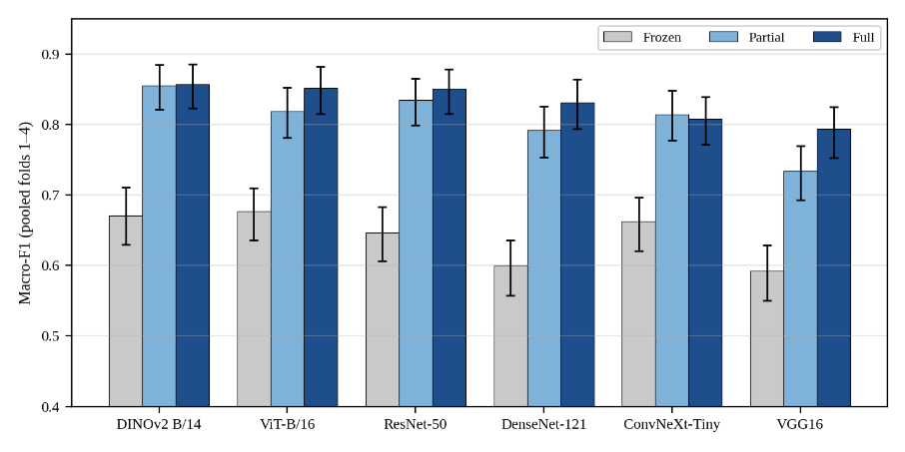
Figure 7.2. Macro-F1 on the pooled held-out folds 1–4 by model and transfer strategy. Error bars are 95% group-bootstrap intervals
7.3 Comparison of Fine-Tuning Strategies
Table 7.3. Comparison of Fine-Tuning Strategy
Strategy | Reported Macro-F1 range | Interpretation
Frozen feature extractor | 0.592–0.677 | Lowest overall range; the pretrained representations were not sufficiently adapted to the target classes.
Partial fine-tuning | 0.734–0.856 | Substantial improvement while updating only part of the backbone.
Full fine-tuning | 0.793–0.857 | Highest observed result, although not always statistically better than partial fine-tuning.
Based on the projects we were able to improve our accuracies by 11.6-18.5 percent when fine tuning. When using DINOv2 Convnext Tiny and Resnet 50 we saw similar results when partially fine tuning. So there isn't always a need to fine tune all parameters to get good results.
7.4 Model Efficiency and Practical Trade-Offs
Table 7.4. Model Efficiency and Practical Trade-Offs
Configuration | Parameters | Inference time per image | Checkpoint size
ResNet-50 — Full Fine-Tuning | 23.5 million | 6.3 ms | 94 MB
DINOv2 ViT-B/14 — Full Fine-Tuning | 85.7 million | 20.9 ms | 343 MB

DINOv2 showed the highest Macro-F1 out of all of our findings. However, it has more parameters, takes up more space in its checkpoint and will take longer to infer each image compared to ResNet-50. There was no significant difference between our best DINOv2 model and 5 other configurations one being ResNet-50. So although DINOv2 may have the highest number for one of our metrics it isn't necessarily the best option for your use case. Some models to look into would be ResNet-50 with partial or full fine tuning and DINOv2 with partial fine tuning.
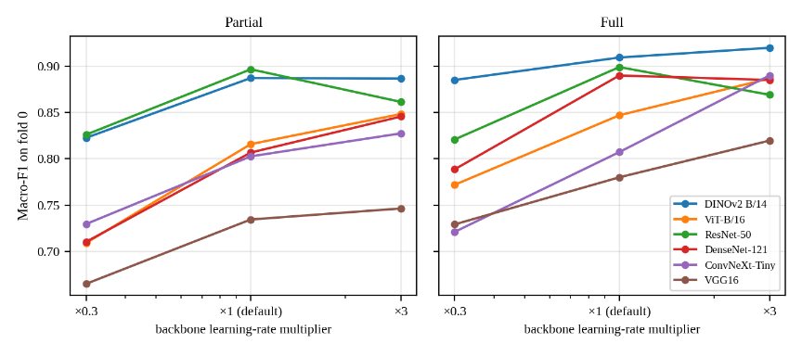
Figure 7.4. Fold-0 macro-F1 as a function of the backbone learning-rate multiplier for partial and full fine-tuning. A multiplier of 1 is the model-specific default.
7.5 Hyperparameter and Fold-Level Findings
Backbone learning rate was the most significant hyper parameter that was tuned. When increasing the backbone learning rate by 3 times it increased the performance on 8/12 of the partial and full fine-tune models we compared. Which shows that when choosing your model you should also take into account how you will be tuning it.
When averaging over the 18 chosen configurations fold 0 gave us an average of 0.797 Macro-F1. Folds 1-4 averaged 0.757, 0.783, 0.762 and 0.721 respectively. So fold 0 was an easier fold and gave us about 5 Macro-F1 points higher then what we could expect on validation. This backs up the idea of using grouped testing and reporting on folds you did not tune on.
7.6 Error Analysis and Explainability
As stated before many of the errors involved onycholysis and onychomycosis vs psoriasis. There were 145 errors between these two classes when looking at the 6 tied configurations. As we can see there are classes that look very similar and can cause our model to struggle.
When looking at the different sources we noticed that Psoriasis from BASE that had a visible watermark was predicted correctly more often then when the watermark was not visible. (0.98 vs 0.66) This could lead us to believe that our model learned this shortcut. However we cannot say that this is the reason for our models performance. We used Grad-CAM and Attention Rollout as explained in section 5.1.6 to see if our model was faithful and looked at padding saliency and watermarks (sections 7.6.5-7.6.8). These can help us understand our models decisions but do not guarantee that our model is thinking like a doctor.
7.6.1 Class-Wise Performance
Table 7.6.1. Class-wise precision, recall, and F1 for the best configuration; the last two columns compare recall across the tied six and frozen six configurations.
Class | n | Precision | Recall | F1 | Recall, tied six | Recall, frozen six
onycholysis | 41 | 0.81 | 0.61 | 0.69 | 0.63 | 0.45
half-and-half nails | 30 | 1 | 0.77 | 0.87 | 0.75 | 0.57
koilonychia | 31 | 0.79 | 0.74 | 0.77 | 0.77 | 0.61
Beau's lines | 34 | 0.93 | 0.74 | 0.82 | 0.79 | 0.67
eczema | 34 | 0.79 | 0.76 | 0.78 | 0.83 | 0.66
splinter haemorrhage | 50 | 0.94 | 0.88 | 0.91 | 0.83 | 0.6
alopecia areata | 32 | 0.76 | 0.88 | 0.81 | 0.85 | 0.71
onychomycosis | 120 | 0.9 | 0.87 | 0.88 | 0.86 | 0.71
psoriasis | 119 | 0.78 | 0.9 | 0.83 | 0.87 | 0.73
Darier's disease | 37 | 0.9 | 0.95 | 0.92 | 0.89 | 0.66
bluish nail | 41 | 0.91 | 0.98 | 0.94 | 0.92 | 0.7
clubbing | 120 | 0.99 | 0.95 | 0.97 | 0.95 | 0.74
healthy | 118 | 0.91 | 0.99 | 0.95 | 0.98 | 0.83

Onycholysis had the lowest listed F1 score (0.69) and recall (0.61), indicating an important area for improvement. Clubbing, healthy nails, and bluish nail achieved high F1 scores. Recall was generally higher for the fine-tuned configurations than for the frozen configurations.
7.6.2 Confusion Matrix
Figure 4. Confusion matrix of DINOv2 ViT-B/14 with full fine-tuning on pooled folds 1–4. Cell annotations show image counts; colour intensity represents the row-normalised share.
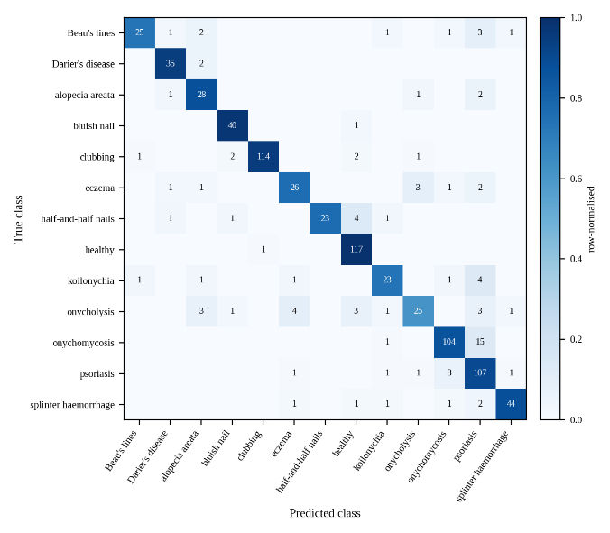
Figure 7.6. Confusion matrix of the best configuration (DINOv2, full fine-tuning) on the pooled folds 1–4; cell values are image counts, colour is the row-normalised share.

The confusion matrix shows strong diagonal counts for many classes, but notable confusion remains between onychomycosis and psoriasis. Onycholysis also has comparatively lower recall, consistent with the class-wise metrics. Figure 7.6 illustrates the confusion matrix of the best-performing configuration, DINOv2 with full fine-tuning, across pooled folds 1–4, highlighting correct classifications, misclassifications, and class-wise prediction patterns.
7.6.3 Source-Wise Recall
Table 7.6.3. Recall by class and image source for selected configurations pooled over folds 1–4.
Class | Source | n | Frozen | Partial | Full
healthy | BASE | 42 | 0.92 | 0.99 | 1.0
healthy | archive5 | 37 | 0.77 | 0.96 | 0.98
healthy | archive6 | 39 | 0.78 | 0.94 | 0.95
clubbing | BASE | 31 | 0.77 | 0.91 | 0.92
clubbing | archive5 | 89 | 0.73 | 0.93 | 0.96
psoriasis | BASE | 31 | 0.67 | 0.79 | 0.78
psoriasis | archive6 | 88 | 0.75 | 0.85 | 0.9
all classes | BASE | 434 | 0.67 | 0.8 | 0.81
all classes | external | 373 | 0.74 | 0.88 | 0.91
Table 7.6.3 shows the Recall across all classes; recall was lower for BASE images than for external-source images for each strategy shown. This suggests that source-specific image characteristics may affect performance and motivate testing on entirely unseen sources.

7.6.4 Watermark-Related Error Analysis

Table 7.6.4. Recall on psoriasis images with visible or possible watermarks and images not flagged for a watermark. Values average selected configurations across six models.
Psoriasis image subset | n images | Frozen | Partial | Full
BASE, visible watermark | 15 | 0.83 | 0.94 | 0.96
BASE, no watermark | 16 | 0.51 | 0.65 | 0.62
archive6, possible watermark | 14 | 0.77 | 0.87 | 0.95
archive6, not flagged | 74 | 0.74 | 0.85 | 0.89
On the BASE psoriasis images there was a higher recall when images contained a watermark compared to the subset without watermarks. While this may be due to the network learning a shortcut, we cannot conclude that the watermark caused this effect based on our observation. Further experiments where we remove or add watermarks would need to be conducted to see if this is the cause. We conduct our first occlusion experiment in section 7.6.7.
7.6.5 Faithfulness and Padding Saliency
In table 12 and figure 5 we show the faithfulness metrics of our maps across all 1,008 images. For the CNNs and DINOv2 we found that Grad-CAM was more faithful than a random map for both deletion and insertion. Deletion gains were 0.078 (ResNet-50 full), 0.029 (ResNet-50 partial), 0.075 (DenseNet-121) and 0.150 (DINOv2) while insertion gains were between 0.092 (DINOv2) and 0.258 (ResNet-50 full). All 95% confidence intervals did not include zero. The supervised ViT-B/16 showed less faithfulness with Grad-CAM having a deletion gain of approximately zero (-0.008; 95% CI [-0.018, 0.001]) and the attention-rollout method having a deletion gain of -0.061. This means that deleting the pixels marked by the rollout resulted in a higher probability of the predicted class than deleting random pixels. The ViT-B/16 also had positive insertion gains of 0.125 (Grad-CAM) and 0.052 (rollout) but were lower than the CNNs. Rollout for DINOv2 was also positive but lower than Grad-CAM (0.048 vs 0.150). The frozen ViT-B/16 had deletion gains close to zero (0.007 Grad-CAM and -0.017 rollout) and lower insertion gains (0.083 and 0.035) than the full fine tuned model.
Our maps for the CNNs and DINOv2 Grad-CAM had low saliency values on the padding. The padding saliency ratio was between 0.33-0.45 which means that around 6-8% of the saliency was on the padding which makes up 19% of the image. The ViT-B/16 maps had higher saliency on the padding with a ratio of 0.81 (full Grad-CAM) and 0.84 (frozen Grad-CAM) and over 1 for the attention rollout (1.23 full and 1.19 frozen). Meaning that the rollout assigned more saliency to the padding than the amount of space it takes up. DINOv2 rollout was in between at 0.67. Since the padding can tell us the aspect ratio of the image which can predict the class above chance. If our maps are assigning more saliency to the padding it could be an indicator that they are using this information. However this is only an indicator. Our insertion gains were lower for incorrectly classified images than correctly classified images for all three CNN configurations (i.e. 0.18 vs 0.26 for DenseNet-121). Our deletion gains were similar.
Table 7.6.5. Faithfulness and padding saliency of the explanation maps (1,008 images per row; padding ratio over the 868 images that have padding). Gains are differences from a random smooth map: deletion gain = AUC(random) − AUC(map), insertion gain = AUC(map) − AUC(random); positive values are better than random. Intervals are 95% group-bootstrap intervals.
Configuration | Method | Deletion gain [95% CI] | Insertion gain [95% CI] | Padding ratio
ResNet-50 (full) | Grad-CAM | +0.078 [+0.070, +0.086] | +0.258 [+0.246, +0.269] | 0.45
ResNet-50 (partial) | Grad-CAM | +0.029 [+0.023, +0.034] | +0.239 [+0.231, +0.248] | 0.45
DenseNet-121 (full) | Grad-CAM | +0.075 [+0.068, +0.082] | +0.249 [+0.239, +0.259] | 0.33
ViT-B/16 (full) | Grad-CAM | −0.008 [−0.018, +0.001] | +0.125 [+0.117, +0.132] | 0.81
ViT-B/16 (full) | Rollout | −0.061 [−0.068, −0.053] | +0.052 [+0.047, +0.058] | 1.23
ViT-B/16 (frozen) | Grad-CAM | +0.007 [−0.002, +0.015] | +0.083 [+0.075, +0.091] | 0.84
ViT-B/16 (frozen) | Rollout | −0.017 [−0.025, −0.008] | +0.035 [+0.027, +0.043] | 1.19
DINOv2 (full) | Grad-CAM | +0.150 [+0.142, +0.160] | +0.092 [+0.084, +0.101] | 0.34
DINOv2 (full) | Rollout | +0.048 [+0.039, +0.057] | +0.046 [+0.039, +0.054] | 0.67
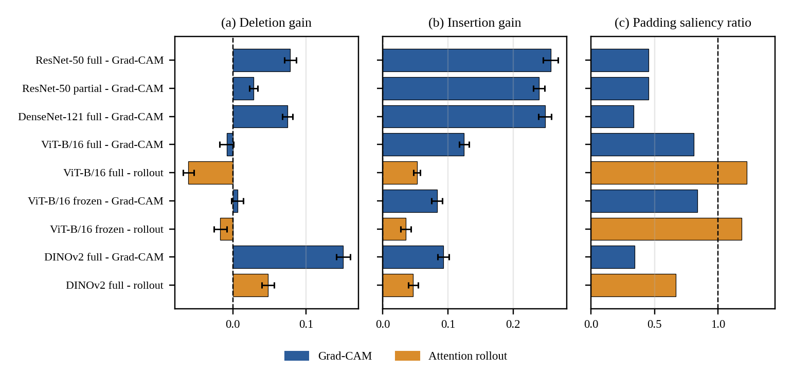
Figure 7.65. Faithfulness and padding saliency of the explanation maps. (a) Deletion gain and (b) insertion gain with 95% group-bootstrap intervals; positive values indicate maps better than a random map. (c) Padding saliency ratio; the dashed line at 1 marks uniform saliency.
7.6.6 Example Explanations and Agreement Between Models
Figure 6 displays explanations for some images that were selected by rule instead of visual inspection. These are three images that were all classified correctly by the four fully fine-tuned models from three randomly selected classes and three images that were all misclassified by the four models from three randomly selected classes (seed 0, there were 788 images that all four models got right and 51 they got wrong). For the correct classifications we can see that ResNet-50 and DenseNet-121 have a nice smooth area around the nail. DINOv2 Grad-CAM has a tighter and less uniform map while ViT-B/16 Grad-CAM and the rollouts have many hot spots and some along the edges and on the padding. When looking at the misclassifications we can see that the CNN maps still focus on the center of the nail. So these maps don't tell us why the image was misclassified.
The maps did not agree well between models and techniques (Table 13). The two CNN's had a decent agreement with each other (average spearman correlation per image of 0.72) but none of the other combinations of Grad-CAM maps had a correlation greater than 0.25 (0.13-0.25). ViT-B/16 rollout had a negative correlation with the CNN Grad-CAM maps (-0.26 and -0.28) and DINOv2 had a small positive correlation (0.15 and 0.16). Rollout also had a low correlation with its models Grad-CAM map (-0.06 ViT-B/16 and 0.07 DINOv2). So even when models have similar accuracies they are not focusing on the same areas. And depending on your technique you will get very different results.
When using randomization as a sanity check the CNN Grad-CAM maps had a correlation of 0.35 (ResNet-50 full), 0.35 (ResNet-50 partial) and 0.47 (DenseNet-121) with a randomly initialized model of the same architecture. The transformers only had a correlation of 0.10-0.13. This means that the CNN Grad-CAM maps still look somewhat like maps that are not learned from the data. Maybe because they are only 7x7 pixels. So we should be careful when interpreting the finer details of these maps.
Table 7.6.6. Mean per-image Spearman correlation between saliency maps of different models and methods (all 1,008 images; configurations with full fine-tuning). R50 = ResNet-50, D121 = DenseNet-121, V16 = ViT-B/16, DV2 = DINOv2 (Grad-CAM unless marked rollout). The last column is the correlation of the Grad-CAM map with the map of a randomly initialized network of the same architecture (100 images of fold 0).
Map | R50 | D121 | V16 | DV2 | V16 roll. | DV2 roll. | vs random network
ResNet-50 Grad-CAM | 1.00 | 0.72 | 0.13 | 0.21 | −0.26 | 0.15 | 0.35
DenseNet-121 Grad-CAM | 0.72 | 1.00 | 0.15 | 0.25 | −0.28 | 0.16 | 0.47
ViT-B/16 Grad-CAM | 0.13 | 0.15 | 1.00 | 0.13 | −0.06 | 0.00 | 0.11
DINOv2 Grad-CAM | 0.21 | 0.25 | 0.13 | 1.00 | −0.10 | 0.07 | 0.13
ViT-B/16 rollout | −0.26 | −0.28 | −0.06 | −0.10 | 1.00 | 0.26 | –
DINOv2 rollout | 0.15 | 0.16 | 0.00 | 0.07 | 0.26 | 1.00 | –
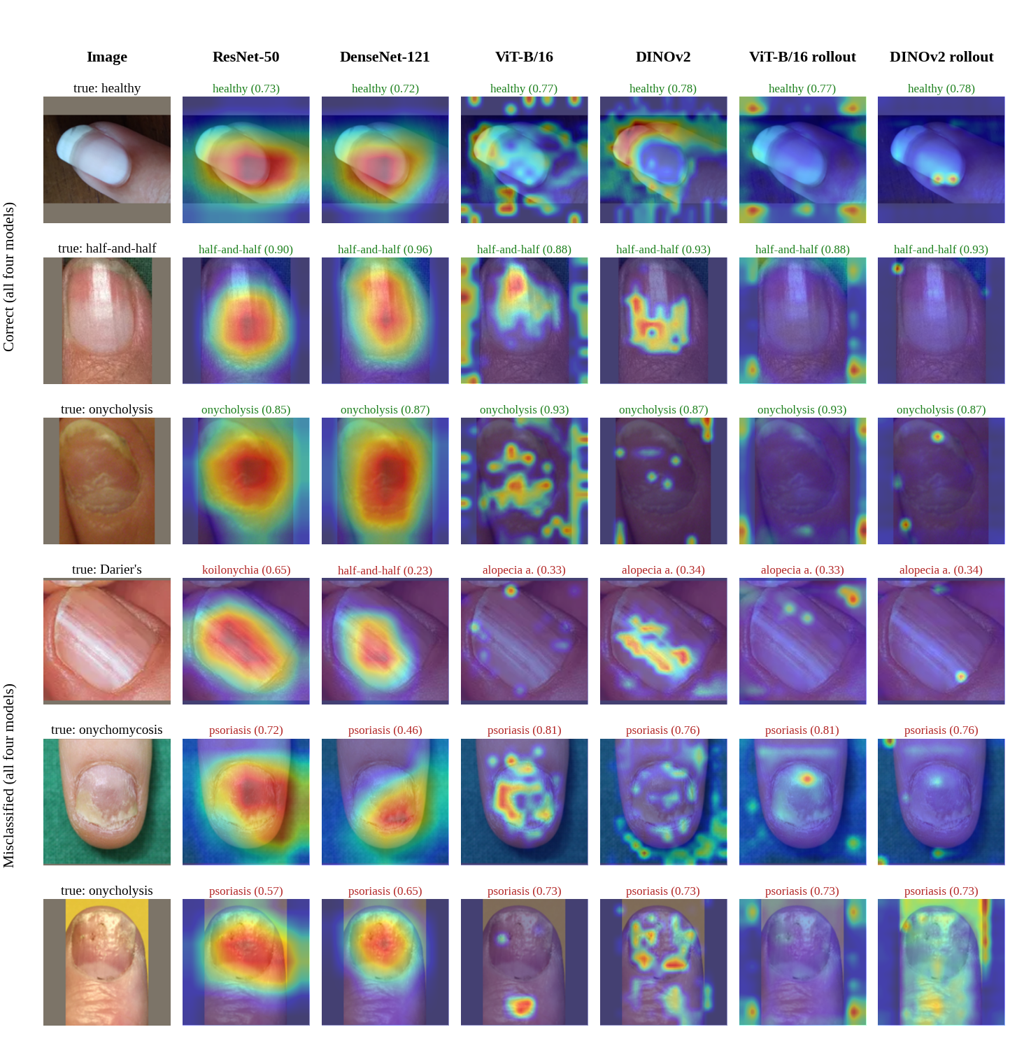
Figure 7.6.6. Explanations for images selected by a fixed rule: three correctly classified (top) and three misclassified (bottom) by all four fully fine-tuned models. Titles give the predicted class and its probability (green = correct, red = wrong). The first column shows the padded image that the models received.
7.6.7 Watermark Analysis
On average there was a decrease in predicted-class probability of 0.064 to 0.097 when the watermark was concealed. This was higher than the decrease seen with random boxes of similar sizes which ranged from 0.006 to 0.045 (Table 14). In 14-20 out of 21 images the effect of the watermark was greater than that of the random box. The difference between the two ranged from 0.048 to 0.087 probability points (one sided Holm adjusted p value 0.0001-0.025 all less than 0.05). The 95% CI for ResNet-50 partially fine tuned contained zero (-0.002 to 0.095). There was a change in predicted class in 0-3 of the 21 images. When looking at each watermark type and averaging across the six configurations. Te Whatu Ora text had the largest effect (decrease of 0.165 compared to 0.010 for random boxes 4 images). Followed by iStock credit (0.090 compared to 0.045 2 images) and DermNet logo (0.065 compared to 0.015 14 images). No effect was seen with the one video player watermark.

Table 7.6.7. Watermark occlusion test on the 21 watermarked psoriasis images. Drop = decrease in the predicted-class probability when the box is replaced by the mean color; random box = mean over five boxes of identical size inside the image content. Holm p = one-sided Wilcoxon signed-rank test, corrected over six configurations.
Configuration | Drop, watermark hidden | Drop, random box | Difference [95% CI] | Images where watermark larger | Holm p | Predictions changed
ResNet-50 (full) | 0.094 | 0.022 | 0.072 [+0.011, +0.142] | 18 / 21 | 0.009 | 2
ResNet-50 (partial) | 0.093 | 0.045 | 0.048 [−0.002, +0.095] | 14 / 21 | 0.025 | 0
DenseNet-121 (full) | 0.084 | 0.023 | 0.060 [+0.018, +0.107] | 16 / 21 | 0.019 | 3
ViT-B/16 (full) | 0.064 | 0.009 | 0.056 [+0.006, +0.114] | 17 / 21 | 0.012 | 0
ViT-B/16 (frozen) | 0.097 | 0.009 | 0.087 [+0.025, +0.152] | 17 / 21 | 0.011 | 3
DINOv2 (full) | 0.066 | 0.006 | 0.060 [+0.028, +0.104] | 20 / 21 | <0.001 | 1
Grad-CAM had 1.3-2.3x more saliency within the box than what would be expected from the area (mass ratio; Table 15) with all 95% intervals not including 1 except for the frozen ViT-B/16 (0.79-1.87). 10%-33% of images using Grad-CAM had their highest saliency pixel within the box compared to 4.5% if random. This did not happen at all for ViT-B/16 attention rollout (0/21) and happened 19% of the time for DINOv2 rollout. When the model correctly classified a watermarked image the mass ratio was higher then when it did not (ie. ViT-B/16 full 2.53 vs 0.97) but there were only 0-8 misclassified watermarked images for each configuration.
Table 7.6.8. Saliency inside the watermark boxes (21 images; boxes cover on average 4.5% of the image). Mass ratio = share of saliency inside the box divided by the box's share of the area (1 = uniform); pointing-game hit = most salient location lies inside the box.
Configuration | Method | Mass ratio [95% CI] | Pointing-game hit | Hit expected by chance
ResNet-50 (full) | Grad-CAM | 1.42 [1.21, 1.60] | 24% | 4.5%
ResNet-50 (partial) | Grad-CAM | 1.40 [1.22, 1.55] | 19% | 4.5%
DenseNet-121 (full) | Grad-CAM | 1.70 [1.38, 2.00] | 24% | 4.5%
ViT-B/16 (full) | Grad-CAM | 2.31 [1.27, 3.67] | 19% | 4.5%
ViT-B/16 (full) | Rollout | 1.17 [1.01, 1.42] | 0% | 4.5%
ViT-B/16 (frozen) | Grad-CAM | 1.29 [0.79, 1.87] | 10% | 4.5%
ViT-B/16 (frozen) | Rollout | 1.22 [1.04, 1.47] | 0% | 4.5%
DINOv2 (full) | Grad-CAM | 2.13 [1.42, 2.98] | 33% | 4.5%
DINOv2 (full) | Rollout | 2.02 [1.72, 2.40] | 19% | 4.5%
All of this indicates that our models do utilize the watermark to some degree. Occluding the watermark causes a decrease in confidence more so than occluding the same amount of pixels from another area. We also see Grad-CAM highlight the watermark frequently. However this only accounts for about 6-10 points of probability and will not change the classes that are predicted. So we cannot conclude that our model is utilizing the watermark to increase our recall on watermarked BASE psoriasis images (0.98 vs 0.66 table 11). There could be other factors that play into our models higher recall on watermarked images such as what they were photographed with. Another factor to consider is mean color occlusion. This technique can cause a decrease in the probability of a class being predicted. Using a random box helps alleviate this issue but does not completely rule it out. Our watermarks are usually located on a darker background which could play a role in this. We only had 21 images to test this on. Boxes were generated by an AI and manually verified.
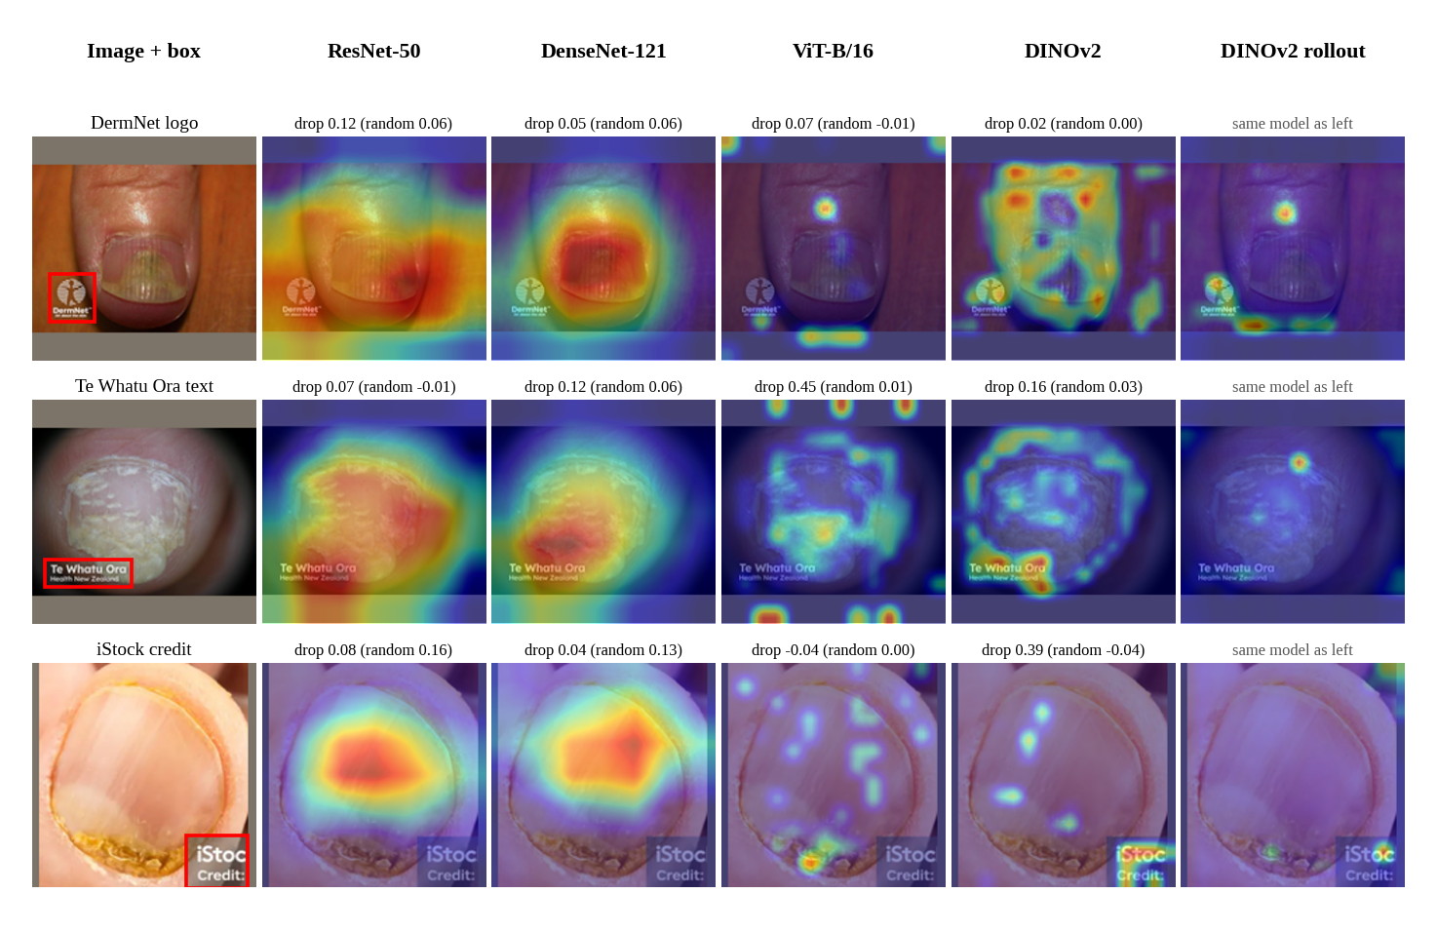
Figure 7.6.7. Explanations for watermarked psoriasis images, one randomly chosen for each watermark type (DermNet logo, Te Whatu Ora text, iStock credit). Red boxes mark the watermarks. Titles give the drop in predicted-class probability when the watermark is hidden (in brackets: mean drop for random boxes of the same size).
7.6.8 Summary of Explainability Findings
We found 4 things. Grad-CAM for our CNNs and DINOv2 were more faithful than random maps and didn't put much saliency on the padding. The supervised ViT-B/16 was less faithful and liked the padding more. Models with comparable accuracy focused on different areas and rollout did not agree with Grad-CAM. So there isn't one heat map that can explain a model's decision. All 6 explained methods used some watermarking but not to a high degree that would affect many predictions. We didn't measure how much the saliency overlapped with the nail so we can't say if any of these models are thinking like they should be.
7.7.1 Paired Accuracy Comparison
Table 7.7.1. Paired accuracy comparison against the best configuration. Confidence intervals are in percentage points; Holm p-values adjust for multiple comparisons.
Model | Δ accuracy (points) | 95% CI | Discordant pairs | McNemar p | Holm p
DINOv2 ViT-B/14 | +0.1 | [−2.1, +2.3] | 40 / 39 | 1.000 | 1.000
ViT-B/16 | +2.5 | [+0.5, +4.4] | 45 / 25 | 0.022 | 0.090
ResNet-50 | +1.2 | [−1.1, +3.6] | 48 / 38 | 0.332 | 0.996
DenseNet-121 | +3.3 | [+1.0, +5.8] | 61 / 34 | 0.007 | 0.037
ConvNeXt-Tiny | −0.4 | [−2.5, +1.7] | 37 / 40 | 0.820 | 1.000
VGG16 | +4.7 | [+2.6, +7.1] | 59 / 21 | <0.001 | <0.001
Following holm correction there was a significant difference in paired accuracies between DenseNet-121 and VGG16 (holm p=0.037 and &lt;0.001). All other comparisons were not significant at the 0.05 level with holm correction. Keep in mind these paired accuracies should be taken separately from the macro-f1 comparisons.
7.7.2 Model Size, Latency, and Training Time
Table 7.7.2. Model size and computational cost. Latency is median forward-pass time for one image in FP32 on a T4 GPU; training time is for one run with the selected configuration.
Model | Parameters (M) | Checkpoint (MB) | Latency (ms) | Frozen (min) | Partial (min) | Full (min)
DINOv2 ViT-B/14 | 85.7 | 343 | 20.9 | 4.3 | 4.3 | 9.4
ViT-B/16 | 85.8 | 343 | 15.7 | 3.8 | 3.2 | 6.9
ResNet-50 | 23.5 | 94 | 6.3 | 3.5 | 2.4 | 3.3
DenseNet-121 | 7.0 | 28 | 15.7 | 1.8 | 2.5 | 3.9
ConvNeXt-Tiny | 27.8 | 111 | 5.8 | 3.7 | 2.7 | 4.7
VGG16 | 134.3 | 537 | 14.7 | 3.8 | 2.7 | 6.4
While DINOv2 produced the highest Macro-F1 score it was not the lightest or quickest model. A good middle ground would be using ResNet-50. It has a median latency of 6.3 ms, its checkpoint size is 94 MB and can be fully fine tuned in 3.3 minutes. The lowest latency was from the ConvNeXt-Tiny at 5.8 ms. DenseNet-121 had the least amount of parameters and therefore the smallest checkpoint size.
7.8 Cost Analysis
There is no information given about how much money was spent on this project. No bill or cost analysis can be found from our results. So we cannot give a definitive price for our project. Table 5 shows the time it took to train each model on average using a Tesla T4. Our project took around 9.5 GPU hours to complete. Not including loading data and testing models.
Table 7.8. Cost Analysis
Cost factor | Available information
Compute | Approximately 9.5 GPU hours on a Tesla T4; monetary charge not reported.
Software | Python, PyTorch, timm, and scikit-learn were used; separate licence costs were not reported.
Storage | Model checkpoint sizes included 94 MB for ResNet-50 full fine-tuning and 343 MB for DINOv2 full fine-tuning.
Inference | Reported per-image times were 6.3 ms for ResNet-50 full fine-tuning and 20.9 ms for DINOv2 full fine-tuning.
Human/expert annotation | No monetary cost or expert annotation budget was specified in the available report.
In terms of efficiency ResNet-50 takes up less memory and has lower inference times when compared to DINOv2 for the results shown. It also performs similarly to the best result with statistical significance. To calculate how much this model would cost you would need to know what device you want to run it on, how many images you expect to run through it, if its being hosted on your own server or externally and how much storage space you need. You may also want to consider costs of labelling data and validating it in a clinical setting.
7.8 Limitations
The data set is small and taken from various websites. Therefore there could be some bias towards certain sources.
Acral lentiginous melanoma and onychogryphosis have been left out of the study as they only have one source which has been augmented.
As only one seed was used we can't tell the difference between variance from seed and variance between folds.
It can't be assumed that our model will perform well on unseen images or data sets that are separated by patients or in a clinical environment.
Our explainability techniques give us an idea of where the model is looking but not why it may be looking there.
We did not have any expert annotations of where the nail is located so we couldn't measure how much the saliency map overlapped with the nail.
Only 5 out of the 6 best performing configurations have been explained along with one frozen model. We did not explain DINOv2 with partial fine tuning, ConvNeXt-Tiny or VGG16.
The watermark was applied using the mean colour of the image and only 21 images were tested. The box locations were found using an AI assistant and verified by eye. Our CNN's grad cam maps had a correlation of 0.35-0.47 with a randomly initialised network so more care should be taken when looking at finer details.

CHAPTER 8
8. CONCLUSION
We have looked at various transfer-learning models with Explainable AI to classify images of nails with diseases. We tested 6 different pre-trained models, ResNet-50, VGG16, DenseNet-121, ConvNeXt-Tiny, ViT-B/16 and DINOv2 ViT-B/14. These models were either feature extracted from, partially fine-tuned or fully fine-tuned. This gave us a total of 18 different model configurations that we then trained and compared using the same methodology. We used grouped five folds to try and avoid leakage from similar images and images from the same source.
Our best performing model was DINOv2 ViT-B/14 when fully fine-tuned. It achieved an accuracy of 0.881, a balanced accuracy of 0.846 and a Macro-F1 of 0.857. With a 95% confidence interval of 0.823-0.886 for the Macro-F1. There were 5 other model configurations that performed similarly to this. So we cannot say that one model is better than the others. ResNet-50 is a good option if you want a smaller and quicker model. And using partial fine-tuning may be beneficial.
From our experiments we found that fine-tuning was beneficial. That the learning rate of the base model had a big impact. And that using a tuning fold can give you a false sense of your models performance. When looking at errors per class and per source we found that there are certain classes that are hard to distinguish from each other. We also believe that there is a correlation between watermarks and model performance. Grad-CAM and Attention Rollout were used to help understand why our models made certain predictions. But these methods alone cannot be used to validate a models predictions.
We were able to find 3 things when explaining our models. Our CNN's and DINOv2 produced Grad-CAM maps that were more faithful than random maps. They also did not focus much on the padding around the image. Where as ViT-B/16 was not as faithful and focused more on the padding. Models that performed similarly highlighted different areas of interest. So we cannot rely on one heat map to explain a models decision. All of our explained models used watermarks to some degree. If we hid the watermark our model probability dropped by 0.06-0.10. Which was higher than if we hid a random patch of the same size. But it did not change the predicted class most of the time. And does not explain all of the difference in recall for psoriasis images with and without watermarks. We did not look at if the area of interest overlapped with the nail.
Limitations to this project include the size and sources of our dataset. We removed 2 classes that only had one source. Only used one seed and did not validate our models clinically. In the future we would like to increase our dataset. Have the images labelled by experts. Test on images from new sources and patients. Label where the nail is in each image and see if our area of interest overlaps with it. Explain our remaining models. Look deeper into the watermark effect. Perhaps by filling in the watermark or adding watermarks to images that don't have them. Train our models with multiple seeds. And look at uncertainty and ways to fine-tune our models with fewer parameters.
Overall we have shown that there are many ways to classify images of nails with diseases. Using transfer learning and explainable AI. Our models should be used for research purposes and maybe as a screening tool. But should not replace a medical professional or be used as a medical device.

CHAPTER 9
9. REFERENCES
- Yosinski, J., Clune, J., Bengio, Y. and Lipson, H., 2014. How transferable are features in deep neural networks? Advances in Neural Information Processing Systems, 27, pp. 3320–3328.
- Raghu, M., Zhang, C., Kleinberg, J. and Bengio, S., 2019. Transfusion: Understanding transfer learning for medical imaging. Advances in Neural Information Processing Systems, 32.
- Geirhos, R. et al., 2020. Shortcut learning in deep neural networks. Nature Machine Intelligence, 2, pp. 665–673.
- DeGrave, A.J., Janizek, J.D. and Lee, S.-I., 2021. AI for radiographic COVID-19 detection selects shortcuts over signal. Nature Machine Intelligence, 3, pp. 610–619.
- Zeiler, M.D. and Fergus, R., 2014. Visualizing and understanding convolutional networks. European Conference on Computer Vision (ECCV), pp. 818–833.
- Kornblith, S., Shlens, J. and Le, Q.V., 2019. Do better ImageNet models transfer better? Proceedings of the IEEE/CVF Conference on Computer Vision and Pattern Recognition (CVPR), pp. 2661–2671.
- Doerrich, S., Di Salvo, F., Brockmann, J. and Ledig, C., 2025. Rethinking model prototyping through the MedMNIST+ dataset collection. Scientific Reports, 15, 7669.
- Simonyan, K. and Zisserman, A., 2015. Very deep convolutional networks for large-scale image recognition. Proceedings of the International Conference on Learning Representations (ICLR).
- He, K., Zhang, X., Ren, S. and Sun, J., 2016. Deep residual learning for image recognition. Proceedings of the IEEE Conference on Computer Vision and Pattern Recognition (CVPR), pp. 770–778.
- Huang, G., Liu, Z., van der Maaten, L. and Weinberger, K.Q., 2017. Densely connected convolutional networks. Proceedings of the IEEE Conference on Computer Vision and Pattern Recognition (CVPR), pp. 2261–2269.
- Liu, Z., Mao, H., Wu, C.-Y., Feichtenhofer, C., Darrell, T. and Xie, S., 2022. A ConvNet for the 2020s. Proceedings of the IEEE/CVF Conference on Computer Vision and Pattern Recognition (CVPR), pp. 11976–11986.
- Dosovitskiy, A. et al., 2021. An image is worth 16x16 words: Transformers for image recognition at scale. Proceedings of the International Conference on Learning Representations (ICLR).
- Steiner, A., Kolesnikov, A., Zhai, X., Wightman, R., Uszkoreit, J. and Beyer, L., 2022. How to train your ViT? Data, augmentation, and regularization in vision transformers. Transactions on Machine Learning Research (TMLR).
- Oquab, M. et al., 2024. DINOv2: Learning robust visual features without supervision. Transactions on Machine Learning Research (TMLR).
- Esteva, A. et al., 2017. Dermatologist-level classification of skin cancer with deep neural networks. Nature, 542(7639), pp. 115–118.
- Coşar Soğukkuyu, D.Y. and Ata, O., 2023. Classification of melanonychia, Beau’s lines, and nail clubbing based on nail images and transfer learning techniques. PeerJ Computer Science, 9, e1533.
- Shandilya, G., Gupta, S. et al., 2024. Autonomous detection of nail disorders using a hybrid capsule CNN: A novel deep learning approach for early diagnosis. BMC Medical Informatics and Decision Making, 24, 414.
- Wightman, R., 2019. PyTorch Image Models (timm). GitHub repository.
- Loshchilov, I. and Hutter, F., 2019. Decoupled weight decay regularization. Proceedings of the International Conference on Learning Representations (ICLR).
- Loshchilov, I. and Hutter, F., 2017. SGDR: Stochastic gradient descent with warm restarts. Proceedings of the International Conference on Learning Representations (ICLR).
- Szegedy, C., Vanhoucke, V., Ioffe, S., Shlens, J. and Wojna, Z., 2016. Rethinking the Inception architecture for computer vision. Proceedings of the IEEE Conference on Computer Vision and Pattern Recognition (CVPR), pp. 2818–2826.
- Micikevicius, P. et al., 2018. Mixed precision training. Proceedings of the International Conference on Learning Representations (ICLR).
- Efron, B. and Tibshirani, R.J., 1993. An Introduction to the Bootstrap. New York, NY, USA: Chapman & Hall.
- McNemar, Q., 1947. Note on the sampling error of the difference between correlated proportions or percentages. Psychometrika, 12(2), pp. 153–157.
- Holm, S., 1979. A simple sequentially rejective multiple test procedure. Scandinavian Journal of Statistics, 6(2), pp. 65–70.
- Paszke, A. et al., 2019. PyTorch: An imperative style, high-performance deep learning library. Advances in Neural Information Processing Systems, 32.
- Kumar, A., Raghunathan, A., Jones, R., Ma, T. and Liang, P., 2022. Fine-tuning can distort pretrained features and underperform out-of-distribution. Proceedings of the International Conference on Learning Representations (ICLR).
- Selvaraju, R.R. et al., 2017. Grad-CAM: Visual explanations from deep networks via gradient-based localization. Proceedings of the IEEE International Conference on Computer Vision (ICCV), pp. 618–626.
- Abnar, S. and Zuidema, W., 2020. Quantifying attention flow in transformers. Proceedings of the 58th Annual Meeting of the Association for Computational Linguistics (ACL), pp. 4190–4197.
- Petsiuk, V., Das, A. and Saenko, K., 2018. RISE: Randomized input sampling for explanation of black-box models. Proceedings of the British Machine Vision Conference (BMVC).
- Adebayo, J., Gilmer, J., Muelly, M., Goodfellow, I. and Hardt, M., 2018. Sanity checks for saliency maps. Advances in Neural Information Processing Systems, 31.
- Wilcoxon, F., 1945. Individual comparisons by ranking methods. Biometrics Bulletin, 1(6), pp. 80–83.

APPENDIX A – Sample Code
Below you can find snippets of code used throughout this project. Listing A.1-A.5 and A.7-A.9 are from our train/tune/explain scripts. These have just been adjusted to fit on one page and some comments were trimmed down. Listing A.6 contains the code used to calculate the confidence intervals and significance tests. This has been expanded for readability and verified to give the correct results (i.e. Macro-F1 of 0.857 with a 95% CI of [0.823, 0.886] when using DINOv2 fully fine tuned). Any import statements and other functions have been left out.
A.1 Transfer Strategies: Frozen, Partial and Full Fine-Tuning
Which parameters are trainable under each strategy, and how frozen BatchNorm layers are kept in evaluation mode.
def apply_strategy(model, model_key, strategy):
"""Set requires_grad according to the strategy. Returns the head parameter names."""
head = head_param_names(model)
prefixes = MODEL_REGISTRY[model_key]["partial_prefixes"]
for n, p in model.named_parameters():
if strategy == "full":
p.requires_grad = True
elif strategy == "partial":
p.requires_grad = n in head or any(n.startswith(pr) for pr in prefixes)
elif strategy == "frozen":
p.requires_grad = n in head
else:
raise ValueError(strategy)
return head

def set_train_mode(model, strategy):
"""model.train(), but BatchNorm layers whose weights are frozen stay in eval mode,
so their ImageNet running statistics are not overwritten by our tiny batches."""
model.train()
if strategy != "full":
for m in model.modules():
if isinstance(m, nn.modules.batchnorm._BatchNorm):
own = list(m.parameters(recurse=False))
if own and not any(p.requires_grad for p in own):
m.eval()

A.2 Optimizer Parameter Groups, Learning-Rate Schedule and Class Weights
Separate learning rates for the new head and the unfrozen backbone, warm-up with cosine decay, and inverse-frequency class weights.
def make_param_groups(model, head_names, lr_backbone, lr_head, weight_decay):
"""Head and backbone get separate LRs; no weight decay on biases and norm weights."""
buckets = {}
for n, p in model.named_parameters():
if not p.requires_grad:
continue
is_head = n in head_names
no_decay = p.ndim <= 1 or n.endswith(".bias")
buckets.setdefault((is_head, no_decay), []).append(p)
groups = []
for (is_head, no_decay), params in buckets.items():
groups.append(
{
"params": params,
"lr": lr_head if is_head else lr_backbone,
"weight_decay": 0.0 if no_decay else weight_decay,
"group_name": ("head" if is_head else "backbone")
+ ("_nodecay" if no_decay else ""),
}
)
return groups

def warmup_cosine(optimizer, total_steps, warmup_steps, min_ratio=0.01):
def factor(step):
if step < warmup_steps:
return (step + 1) / max(1, warmup_steps)
progress = min(1.0, (step - warmup_steps) / max(1, total_steps - warmup_steps))
return min_ratio + (1 - min_ratio) * 0.5 * (1 + math.cos(math.pi * progress))

return torch.optim.lr_scheduler.LambdaLR(optimizer, factor)

def class_weights(labels, num_classes):
counts = np.bincount(labels, minlength=num_classes).astype(float)
w = 1.0 / np.maximum(counts, 1)
return w / w.mean()

A.3 Training Loop with Mixed Precision and Gradient Clipping
One epoch of training: FP16 autocast, weighted cross-entropy with label smoothing, gradient clipping and a per-step learning-rate schedule.
for epoch in range(1, cfg["epochs"] + 1):
t0 = time.time()
set_train_mode(model, args.strategy)
tot_loss, tot_correct, tot_n = 0.0, 0, 0
for x, y in train_loader:
x = x.to(device, non_blocking=True).to(memory_format=torch.channels_last)
y = y.to(device, non_blocking=True)
with torch.autocast(
device_type=device.type, dtype=torch.float16, enabled=use_amp
):
logits = model(x)
loss = criterion(logits.float(), y)
optimizer.zero_grad(set_to_none=True)
scaler.scale(loss).backward()
if cfg["grad_clip"] > 0:
scaler.unscale_(optimizer)
torch.nn.utils.clip_grad_norm_(trainable, cfg["grad_clip"])
scaler.step(optimizer)
scaler.update()
scheduler.step()
tot_loss += loss.item() * len(y)
tot_correct += (logits.argmax(1) == y).sum().item()
tot_n += len(y)

A.4 Integrity Checks of the Grouped Folds
Checks run before any training: the fold file agrees with the manifest, no group crosses a fold, and every image file exists.
# ---- integrity checks -------------------------------------------------
if len(m) != 1008:
print(f"WARNING: expected 1008 images, manifest has {len(m)}")
if set(m["id"]) != set(f["id"]) or m["id"].duplicated().any():
fail("manifest.csv and folds.csv do not contain the same unique ids")
j = m.merge(f, on="id", suffixes=("", "_folds"), validate="one_to_one")
for col in ["fold", "path", "class", "source_dataset", "group_id"]:
if col + "_folds" in j and not (j[col] == j[col + "_folds"]).all():
bad = j.loc[j[col] != j[col + "_folds"], ["id", col, col + "_folds"]]
fail(f"'{col}' differs between manifest and folds.csv:\n{bad.head()}")
print("OK folds.csv agrees with the manifest (fold, path, class, source, group)")

spans = m.groupby("group_id")["fold"].nunique()
if (spans > 1).any():
fail(f"{(spans > 1).sum()} groups span more than one fold")
print(f"OK no group spans folds ({m['group_id'].nunique()} groups)")

missing = [p for p in m["path"] if not os.path.exists(os.path.join(data_dir, p))]
if missing:
fail(f"{len(missing)} image files missing, e.g. {missing[:3]}")
print("OK all image files exist")

A.5 Tuning Trials and Winner Selection Rule
The three trials per strategy and the rule that replaces the default only when a trial improves Macro-F1 by at least 0.01.
def trials_for(model, strategy):
"""[(tag, extra train.py args)] -> the default plus exactly 3 trials."""
b = base_lrs(model)
t = [("default", [])]
if strategy == "frozen":
# frozen heads are under-trained: higher LR, longer training, lighter augmentation
t += [
("h_x3", ["--lr_head", g(b["head"] * 3)]),
("h_x3_e60", ["--lr_head", g(b["head"] * 3), "--epochs", "60"]),
(
"h_x3_e60_lightaug",
["--lr_head", g(b["head"] * 3), "--epochs", "60"] + LIGHT_AUG,
),
]
else:
# partial/full overfit early: LR down/up and a stronger regularization recipe
lr = b[strategy]
t += [
("lr_x0.3", ["--lr_backbone", g(lr * 0.3)]),
("lr_x3", ["--lr_backbone", g(lr * 3)]),
("reg", REG),
]
return t

def select_tag(df, model, strategy):
"""Winner = best fold-0 macro-F1; the default stays unless beaten by MIN_GAIN."""
d = df[(df.model == model) & (df.strategy == strategy) & (df.fold == 0)]
d = d[~d.tag.str.startswith(NOT_CANDIDATES)]
if d.empty:
return None
best = d.sort_values(["macro_f1", "acc"], ascending=False).iloc[0]
base = d[d.tag == "default"]
if len(base) and best.macro_f1 - base.iloc[0].macro_f1 < MIN_GAIN:
return "default"
return best.tag

A.6 Group-Level Bootstrap Interval and Exact McNemar Test
Statistics used for the pooled held-out folds: confidence intervals that resample whole groups, and the paired test on per-image correctness.
import numpy as np
from scipy.stats import binomtest
from sklearn.metrics import f1_score

def group_bootstrap_ci(y_true, y_pred, groups, metric, n_boot=1000, seed=0):
"""95% interval of metric(y_true, y_pred), resampling whole groups, not images."""
rng = np.random.default_rng(seed)
groups = np.asarray(groups)
unique = np.unique(groups)
members = {g: np.flatnonzero(groups == g) for g in unique}
stats = []
for _ in range(n_boot):
drawn = rng.choice(unique, size=len(unique), replace=True)
idx = np.concatenate([members[g] for g in drawn])
stats.append(metric(y_true[idx], y_pred[idx]))
return np.percentile(stats, [2.5, 97.5])

def mcnemar_exact(correct_a, correct_b):
"""Exact McNemar test on per-image correctness of two models (same images)."""
only_a = int(np.sum(correct_a & ~correct_b))
only_b = int(np.sum(~correct_a & correct_b))
n = only_a + only_b
p = 1.0 if n == 0 else binomtest(only_a, n, 0.5).pvalue
return only_a, only_b, p

def macro_f1(y, p):
return f1_score(y, p, average="macro", labels=list(range(13)), zero_division=0)

A.7 Grad-CAM and Attention Rollout
Grad-CAM for the predicted class at the last convolutional stage (or the last-block patch tokens of the transformers) and attention rollout for ViT-B/16 and DINOv2.
def norm01(c):
c = c - c.amin(dim=(1, 2), keepdim=True)
return c / c.amax(dim=(1, 2), keepdim=True).clamp_min(1e-8)

class Explainer:
def __init__(self, model, model_key):
self.model, self.key = model, model_key
self.vit = model_key in VIT_MODELS
self.layer = TARGET_LAYER[model_key](model)
if self.vit:
self.grid = tuple(model.patch_embed.grid_size)
self.n_prefix = model.num_prefix_tokens

def gradcam(self, x):
"""Grad-CAM for the predicted class: cams (B,gh,gw) in [0,1], logits, pred."""
store = {}

def fwd(_m, _i, out):
store["a"] = out
out.register_hook(lambda g: store.__setitem__("g", g))

hd = self.layer.register_forward_hook(fwd)
try:
with torch.enable_grad():
self.model.zero_grad(set_to_none=True)
logits = self.model(x)
pred = logits.argmax(1)
logits.gather(1, pred[:, None]).sum().backward()
finally:
hd.remove()
a, g = store["a"].detach(), store["g"].detach()
if self.vit: # tokens -> (B,C,gh,gw), drop prefix tokens
gh, gw = self.grid
a = (
a[:, self.n_prefix :, :]
.reshape(a.shape[0], gh, gw, -1)
.permute(0, 3, 1, 2)
)
g = (
g[:, self.n_prefix :, :]
.reshape(g.shape[0], gh, gw, -1)
.permute(0, 3, 1, 2)
)
w = g.mean(dim=(2, 3), keepdim=True)
cam = F.relu((w * a).sum(1))
return norm01(cam), logits.detach(), pred

@torch.no_grad()
def rollout(self, x):
"""Attention rollout: head mean + identity, row-normalize, multiply over layers."""
assert self.vit
attn, hooks, fused = [], [], []
for blk in self.model.blocks:
fused.append(blk.attn.fused_attn)
blk.attn.fused_attn = False
hooks.append(
blk.attn.attn_drop.register_forward_hook(
lambda _m, _i, out: attn.append(out)
)
)
try:
self.model(x)
finally:
for h in hooks:
h.remove()
for blk, f in zip(self.model.blocks, fused):
blk.attn.fused_attn = f
assert len(attn) == len(self.model.blocks)
B, _, N, _ = attn[0].shape
eye = torch.eye(N, device=x.device)[None]
res = eye.expand(B, N, N).clone()
for a in attn:
a = a.mean(1) + eye
a = a / a.sum(-1, keepdim=True)
res = a @ res
gh, gw = self.grid
m = res[:, 0, self.n_prefix :].reshape(B, gh, gw)
return norm01(m)

A.8 Deletion and Insertion Faithfulness and Padding Saliency
Area under the predicted-class probability curve when pixels are removed from, or added to, a mean-color image in order of saliency, and the share of saliency on padding.
@torch.no_grad()
def deletion_insertion(model, x, sal224, target, steps=21, amp=False):
"""x: normalized (3,H,W) image; returns (deletion AUC, insertion AUC) of p(target)."""
H, W = sal224.shape
n = H * W
order = torch.argsort(sal224.flatten(), descending=True, stable=True)
rank = torch.empty(n, dtype=torch.long, device=x.device)
rank[order] = torch.arange(n, device=x.device)
frac = torch.linspace(0, 1, steps, device=x.device)
k = torch.round(frac * n).long()
removed = (
(rank[None, :] < k[:, None]).reshape(steps, 1, H, W).to(x.dtype)
) # top-k most salient pixels
xs = torch.cat(
[x[None] * (1 - removed), x[None] * removed], 0
) # deletion, insertion (baseline = mean color = 0)
ps = []
for c0 in range(0, len(xs), 21): # chunked forward: bounded memory
with torch.autocast(
device_type=x.device.type, dtype=torch.float16, enabled=amp
):
ps.append(F.softmax(model(xs[c0 : c0 + 21]).float(), 1)[:, target])
p = torch.cat(ps)
f = frac.cpu().numpy()
trap = getattr(np, "trapezoid", None) or np.trapz
return float(trap(p[:steps].cpu().numpy(), f)), float(
trap(p[steps:].cpu().numpy(), f)
)

def pad_metrics(sal224, pad_mask):
pad_mask = pad_mask.to(sal224.dtype)
area = float(pad_mask.mean())
mass = float((sal224 * pad_mask).sum() / sal224.sum().clamp_min(1e-8))
return area, mass, (mass / area if area > 0 else float("nan"))

A.9 Watermark Occlusion Test
The annotated watermark box is replaced by the mean color and compared with same-size random boxes placed inside the image content.
@torch.no_grad()
def occlude(
model, x, tgt, true_idx, iid, w, h, boxes, geom, fold, gen, device, n_ctrl=5
):
"""Fill each watermark box with the mean color; compare with same-size random boxes."""
ox, oy, kk = geom
x224_boxes = []
for x1, y1, x2, y2 in boxes:
a, b = int(round((x1 + ox) * kk)), int(round((y1 + oy) * kk))
c, d = int(round((x2 + ox) * kk)), int(round((y2 + oy) * kk))
x224_boxes.append((max(a, 0), max(b, 0), min(c, SIZE), min(d, SIZE)))

cx0, cx1 = int(round(ox * kk)), int(round((ox + w) * kk))
cy0, cy1 = int(round(oy * kk)), int(round((oy + h) * kk))

def prob(xx):
p = F.softmax(model(xx[None]).float(), 1)[0]
return float(p[tgt]), float(p[true_idx]), int(p.argmax())

p0 = prob(x)
xo = x.clone()
for a, b, c, d in x224_boxes:
xo[:, b:d, a:c] = 0
p1 = prob(xo)
drops = []
for _ in range(n_ctrl): # control: same-size boxes placed inside the image content
xc = x.clone()
for a, b, c, d in x224_boxes:
bw, bh = c - a, d - b
x0 = cx0 + int(
torch.randint(0, max(1, (cx1 - cx0) - bw), (1,), generator=gen)
)
y0 = cy0 + int(
torch.randint(0, max(1, (cy1 - cy0) - bh), (1,), generator=gen)
)
xc[:, y0 : y0 + bh, x0 : x0 + bw] = 0
drops.append(p0[0] - prob(xc)[0])
area = sum((c - a) * (d - b) for a, b, c, d in x224_boxes) / SIZE**2
return [
dict(
image_id=iid,
fold=fold,
box_area_frac=area,
p_pred_before=p0[0],
p_pred_after=p1[0],
drop_wm=p0[0] - p1[0],
drop_random_boxes_mean=float(np.mean(drops)),
p_true_before=p0[1],
p_true_after=p1[1],
pred_before=p0[2],
pred_after=p1[2],
pred_changed=int(p0[2] != p1[2]),
)
]

