How to add page names on web.config: 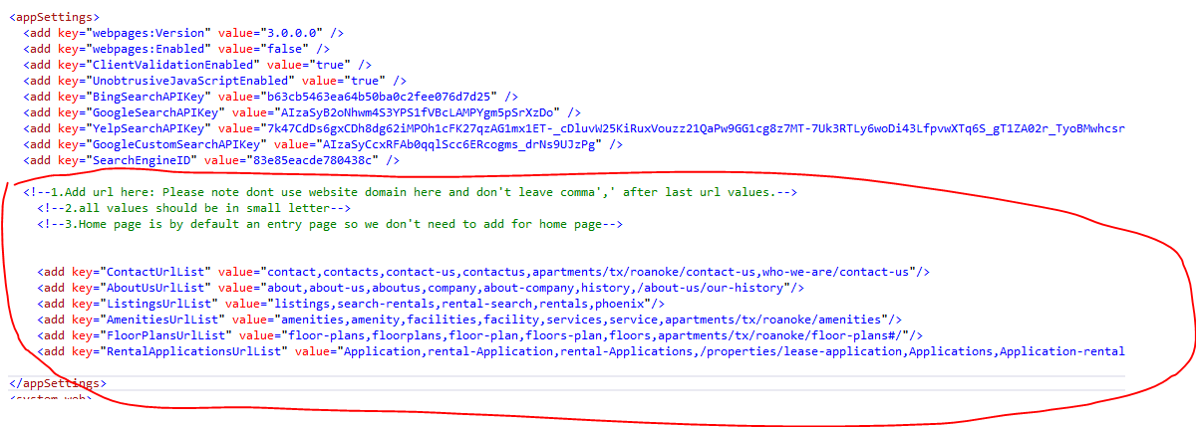
Step-1: Go to web.config file and under <appSettings> there are list of keys of each page names.
Step-2: Add page names inside value section separated by comma.
Step-3: Then save the file, that’s it.
Please note:
- Do not add full domain URL for example: creditrentreality.com/contacts it’s not a valid format instead just add contacts on value section separated by comma of respective key area.
- All values should be in small case/letter.
- Try not to leave comma after last value.
Thank You.

