BOOKWORM
Online City Library

Software Requirements Specification
Livrarea 2

Team bookworm
ICSS – 2026
Date: 22/04/2026

ALEXANDRU-GABRIEL CĂLIN
ALEXANDRU-RAFAEL HODOR
ANTONIO-FLORIAN ZLAT
MARIAN-DANIEL DUMITRESCU

1. Introduction
This document constitutes the Software Requirements Specification (SRS) for the bookworm system - the Online City Library. It defines user requirements, the context model, a complete use-case model, and a requirements traceability matrix.

1.1 Scope
Many cities maintain physical libraries that are costly to operate and require residents to visit in person during limited opening hours. bookworm is a software application that implements a fully online city library, allowing any resident with a verified stable address to borrow and read books at any time without visiting a physical location.
The key distinguishing features of bookworm are:
- Books exist only in electronic form stored in a central database - no physical stock is maintained.
- The application is available 24 hours a day, 7 days a week.
- Content protection mechanisms prevent downloading or copying of books; all reading takes place inside the application.
- A rental model limits the number of simultaneous readers per title, with an automated waiting queue.
- The interface is fully responsive and usable on any smartphone.
The following aspects are explicitly out of scope:
- Procurement and licensing negotiations with publishers.
- Physical library operations or hybrid lending.
- Payment processing (the service is free for registered city residents).

1.2 Definitions, Acronyms, and Abbreviations
The following terms are used throughout this document:

Term / Abbreviation | Definition
SRS | Software Requirements Specification - this document.
UC | Use Case
FR | Functional Requirement
NFR | Non-Functional Requirement
DRM | Digital Rights Management - technology used to protect copyrighted digital content.
GDPR | General Data Protection Regulation - EU regulation on personal data processing.
Borrowing | The act of a user obtaining temporary read access to a book title.
Waiting Queue | An ordered list of users waiting for access to a title whose simultaneous reader limit has been reached.
City Resident | A person with a registered stable address within the city, eligible to use the library.
Library Manager | The administrator appointed by the city hall to manage the library catalogue and borrowing policies.

1.3 Overview
This document is organised as follows:
- Section 2 - User Requirements: lists all functional requirements (grouped by priority) and non-functional requirements.
- Section 3 - Context Model: presents the goal statement, the context diagram, and descriptions of all system externals.
- Section 4 - Use-Case Model: lists all actors and use cases, provides the use-case diagram, and details each use case with a form and a UML sequence diagram.
- Section 5 - Requirements Traceability: provides a matrix linking functional requirements to use cases.

2. User Requirements
User requirements describe what the system must do from the perspective of its stakeholders. Functional requirements are grouped by priority. Non-functional requirements follow.

2.1 Functional Requirements

2.1.1 High Priority

FR1 – User Registration
The system shall allow any city resident with a verified stable address to create an account by providing personal details (name, address, email, password).

FR2 – Address Verification
During registration the system shall verify that the applicant has a stable address within the city before activating the account.

FR3 – Account Activation
The system shall activate a user account only after successful address verification. Until activation the user cannot access library services.

FR4 – User Authentication
The system shall allow registered users to log in using their credentials (email and password). Authentication is an internal system concern and not an external actor.

FR5 – Session Management
The system shall maintain authenticated user sessions and allow users to log out explicitly.

FR6 – Password Recovery
The system shall provide a mechanism for users to reset a forgotten password via their registered email address.

FR7 – Book Search
The system shall provide a search function allowing users to find books by title, author, genre, or keyword.

FR8 – Availability Check
Before a user borrows a book the system shall check whether the simultaneous reader limit for that title has been reached.

FR9 – Borrow Book
If a title is available the system shall grant the user read access and record the borrowing with a due-return date.

FR10 – Waiting Queue
If a title is not available the system shall offer the user the option to join a waiting queue. When access becomes available the next user in the queue shall be notified automatically.

FR11 – Return Book
The system shall allow a user to explicitly return a borrowed title before or on the due date, making it available to the next user in the queue.

FR12 – Automatic Return
The system shall automatically revoke read access when the borrowing period expires.

FR13 – Secure In-App Reading
The system shall display book content exclusively through the built-in reader. Downloading, printing, and copying of content shall be technically prevented.

FR14 – DRM Enforcement
The system shall enforce content protection so that book files cannot be extracted from the application.

FR15 – Book Ratings
The system shall allow authenticated users to assign a numeric rating to a book they have borrowed.

FR16 – Comments and Recommendations
The system shall allow users to write comments on books and recommend titles to other users.

FR17 – Library Catalogue Management
The Library Manager shall be able to add, edit, and remove book records (metadata and electronic files) and organise them into categories.

FR18 – New Arrivals and News Section
The system shall maintain a section highlighting newly added titles and library news, manageable by the Library Manager.

FR19 – Borrowing Policy Management
The Library Manager shall be able to configure the maximum simultaneous readers per title and the maximum borrowing duration.

FR20 – Browsing History
The system shall record and display each user's browsing and borrowing history, accessible only to that user.

FR21 – Information Section
The system shall provide a publicly accessible section containing Terms and Conditions, Frequently Asked Questions, and Help content.

2.1.2 Medium Priority
None identified at this stage.

2.1.3 Low Priority
None identified at this stage.

2.2 Non-Functional Requirements

2.2.1 Availability Requirements
NFR1 – The system shall be available 24 hours a day, 7 days a week, 365 days a year, with a maximum planned downtime of 4 hours per month for maintenance.

2.2.2 Security Requirements
NFR2 – All communication between the client and the server shall be encrypted using industry-standard transport security protocols.
NFR3 – User passwords shall be stored using a one-way hashing algorithm with salt; plain-text passwords shall never be stored.
NFR4 – The system shall enforce DRM so that book content cannot be downloaded, printed, or copied outside the application.
NFR5 – User personal data (name, address, browsing history) shall be stored and processed in compliance with GDPR.
NFR6 – Each session shall be protected by token-based authentication; session tokens shall expire after a configurable period of inactivity.

2.2.3 Usability Requirements
NFR7 – The user interface shall be responsive and fully functional on any smartphone, tablet, or desktop browser without requiring a native application installation.
NFR8 – The registration process shall be completed in no more than five steps.
NFR9 – The search results page shall be returned within 3 seconds under normal load conditions.

2.2.4 Performance Requirements
NFR10 – The system shall support a minimum of 500 concurrent users without degradation of response times beyond the thresholds specified in NFR9.
NFR11 – The waiting queue mechanism shall update user positions and send notifications within 60 seconds of a title becoming available.

2.2.5 Operational Requirements
NFR12 – The system shall be scalable so that capacity can be increased without architectural redesign.
NFR13 – The system shall maintain audit logs of all borrowing, returning, and administrative actions for a minimum of two years.

3. Context Model

3.1 Goal Statement
The goal of the bookworm system is to provide city residents with unrestricted, cost-effective, around-the-clock access to a digital library, increasing the number of active readers while minimising operational costs for the city administration.

3.2 Context Diagram
The context diagram below shows the bookworm system and all external entities that interact with it.

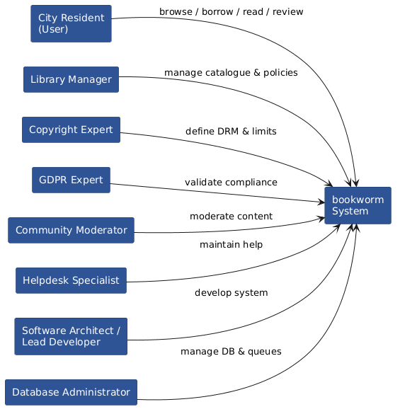

3.3 System Externals
The following table describes all entities that interact with the bookworm system from the outside.

External Entity | Description
City Resident (User) | A person with a registered stable address in the city. The primary beneficiary of the system. Interacts through registration, authentication, borrowing, reading, and reviewing.
Library Manager | Appointed by the city hall. Defines borrowing policies, manages the book catalogue and categories, and publishes news and new arrivals.
Copyright Expert | Defines the legal constraints on simultaneous reading limits and content protection requirements to prevent copyright infringement.
GDPR Expert | Validates that personal data (browsing history, address, etc.) is stored and processed in compliance with applicable data protection law.
Community Moderator | Oversees user-generated content: ratings, comments, and recommendations. May be a library employee or an automated system with human oversight.
Helpdesk Specialist | Manages the FAQ, Help, and Terms & Conditions sections. Assists residents unfamiliar with the technology.
Software Architect / Lead Dev | Designs and maintains the application architecture, ensures smartphone scalability, and implements core technical subsystems.
Database Administrator | Manages electronic book storage, browsing history records, and the queue logic for simultaneous borrowing limits.

4. Use-Case Model

4.1 Actor List

Actor Name | Actor Role
User | A registered and authenticated city resident. Primary actor for all reading, borrowing, and community interactions.
Library Manager | Administrative actor responsible for catalogue management, policy configuration, and content publishing. Cannot initiate user-facing use cases.

4.2 Use-Case List

Use-Case Name | Short Description
UC1 – Register | Allows a city resident to create a library account after address verification.
UC2 – Login | Allows a registered user to authenticate and start a session.
UC3 – Search Books | Allows a user to search and browse the library catalogue.
UC4 – Borrow Book | Allows a user to borrow an available title or join the waiting queue if unavailable.
UC5 – Return Book | Allows a user to explicitly return a borrowed title.
UC6 – Read Book | Allows a user to read a currently borrowed title through the secure in-app reader.
UC7 – Rate and Review Book | Allows a user to rate a book, write a comment, or recommend it to other users.
UC8 – Manage Library | Allows the Library Manager to add, edit, or remove books and manage catalogue categories and borrowing policies.
UC9 – View Browsing History | Allows a user to view their personal history of viewed and borrowed titles.
UC10 – View News and New Arrivals | Allows any user to view the news section and recently added titles.

4.3 Use-Case Diagram
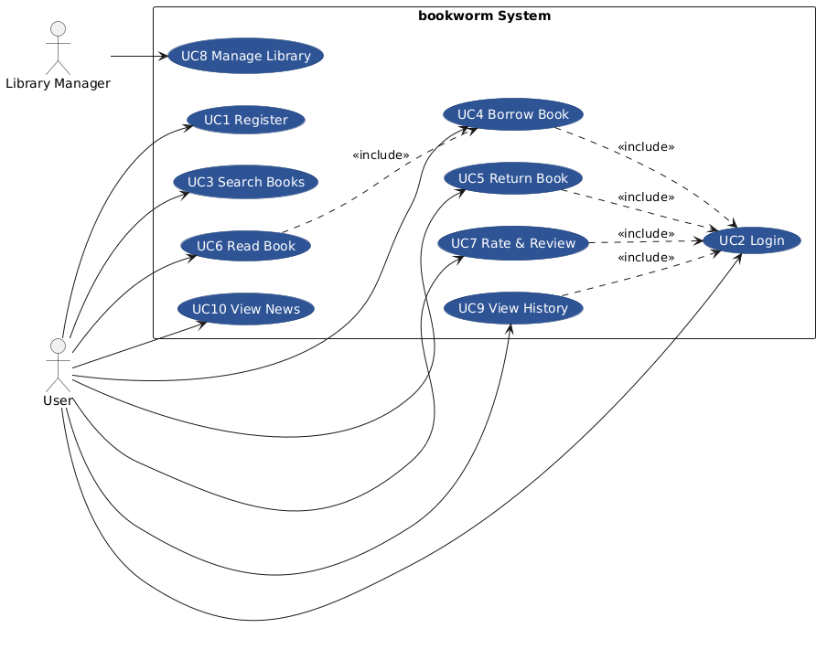

4.4 Use Cases

4.4.1 Use Case 1 – Register
Use Case Name | Register
XRef | FR1, FR2, FR3
Description | Allows a city resident to create a bookworm account. The system collects personal details and verifies the applicant has a stable city address before activating the account.
Priority | 1
Actors | User (primary)
Precondition | The applicant is not yet registered and has access to the application.
Basic Path | 1. The user navigates to the registration page.  2. The user fills in their name, address, email, and password.  3. The system validates the format of all fields.  4. The system verifies the address is within the city.  5. The system creates the account and sends an activation email.  6. The user confirms the email.  7. The account is activated and the user may log in.
Alternative Paths | 4.1 Address cannot be verified - the system displays an error; the account is not created.  6.1 The user does not confirm the email within 48 hours - the pending account is deleted.
Exception Paths | 3.1 Required fields are missing or invalid - the system highlights the erroneous fields and prompts correction.
Postcondition | A verified, active user account exists in the system.
Related Use-Cases | UC2 Login
Used Use-Cases | -
Extended Use-Cases | -

UC1 Register sequence diagram:
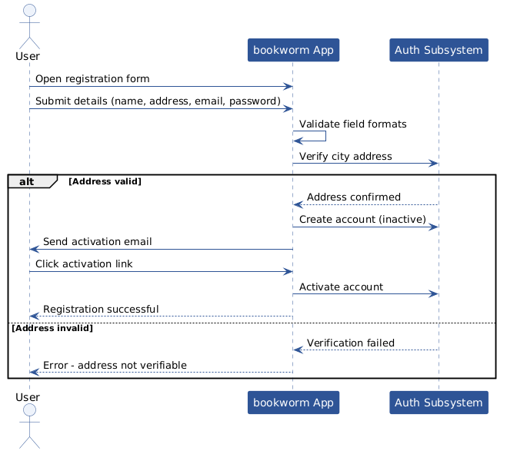

4.4.2 Use Case 2 – Login
Use Case Name | Login
XRef | FR4, FR5, FR6
Description | Allows a registered user to authenticate with their credentials and establish a session. Included by most other use cases as a precondition enforced at the application level.
Priority | 1
Actors | User (primary)
Precondition | The user has a registered, activated account.
Basic Path | 1. The user navigates to the login page.  2. The user enters email and password.  3. The system validates the credentials.  4. The system creates a session token.  5. The user is redirected to the home page.
Alternative Paths | 3.1 Credentials are incorrect - the system displays an error. After 5 consecutive failures the account is temporarily locked.  3.2 User selects 'Forgot password' - the system initiates the password recovery flow (FR6).
Exception Paths | -
Postcondition | An active authenticated session exists for the user.
Related Use-Cases | UC1 Register, UC3–UC9
Used Use-Cases | -
Extended Use-Cases | -

UC2 Login sequence diagram:
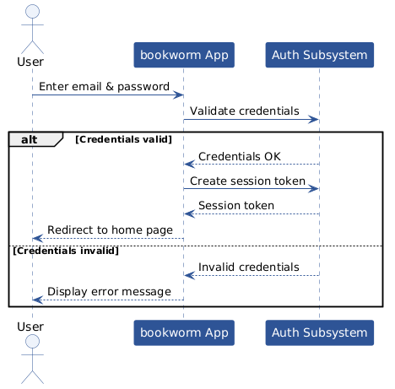

4.4.3 Use Case 3 – Search Books
Use Case Name | Search Books
XRef | FR7
Description | Allows an authenticated user to search the library catalogue by title, author, genre, or keyword and view book details including current availability.
Priority | 1
Actors | User (primary)
Precondition | The user is authenticated (UC2 completed).
Basic Path | 1. The user enters a search query in the search bar.  2. The system queries the catalogue and returns matching results.  3. The user browses the results list.  4. The user selects a title to view its detail page (description, author, genre, rating, availability status).
Alternative Paths | 2.1 No results found - the system displays a 'no results' message and suggests alternative queries.
Exception Paths | -
Postcondition | The user has viewed search results and optionally a book detail page. Browsing history is updated (FR20).
Related Use-Cases | UC4 Borrow Book
Used Use-Cases | UC2 Login
Extended Use-Cases | -

UC3 Search Books sequence diagram:
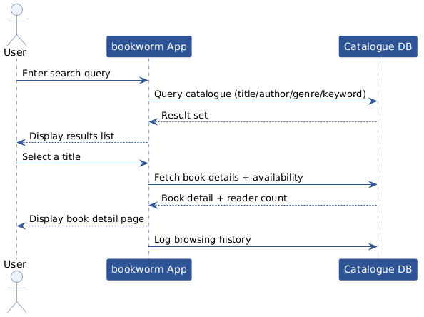

4.4.4 Use Case 4 – Borrow Book
Use Case Name | Borrow Book
XRef | FR8, FR9, FR10, FR11
Description | Allows an authenticated user to borrow an available title, obtaining read access for a configured period. If the simultaneous reader limit is reached the user may join the waiting queue.
Priority | 1
Actors | User (primary)
Precondition | The user is authenticated. The user has selected a book (UC3).
Basic Path | 1. The user selects 'Borrow' on the book detail page.  2. The system checks the simultaneous reader count against the configured limit.  3. The title is available - the system creates a borrowing record with a due-return date.  4. The system grants the user read access.  5. The user is notified of the borrowing and due date.
Alternative Paths | 2.1 The simultaneous reader limit has been reached - the system offers the user the option to join the waiting queue.  2.1.1 The user accepts - the system adds the user to the queue and displays their position.  2.1.2 The user declines - no action is taken.
Exception Paths | -
Postcondition | The user has an active borrowing record, or is registered in the waiting queue.
Related Use-Cases | UC5 Return Book, UC6 Read Book
Used Use-Cases | UC2 Login
Extended Use-Cases | -

UC4 Borrow Book sequence diagram:
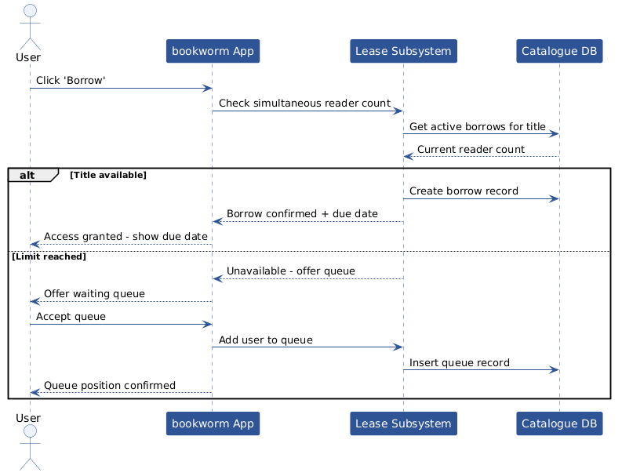

4.4.5 Use Case 5 – Return Book
Use Case Name | Return Book
XRef | FR8, FR12
Description | Allows a user to explicitly return a borrowed title before or on the due date. The system revokes read access and notifies the next user in the waiting queue if one exists.
Priority | 1
Actors | User (primary)
Precondition | The user has an active borrowing record for the title.
Basic Path | 1. The user navigates to 'My Books' and selects 'Return'.  2. The system confirms the return action with the user.  3. The system revokes read access.  4. The borrowing record is closed.  5. If a waiting queue exists for this title, the system notifies the next user in the queue.
Alternative Paths | 2.1 The user cancels the return confirmation - no action is taken.
Exception Paths | -
Postcondition | The borrowing record is closed. The title is available to the next user.
Related Use-Cases | UC4 Borrow Book
Used Use-Cases | UC2 Login
Extended Use-Cases | -

UC5 Return Book sequence diagram:
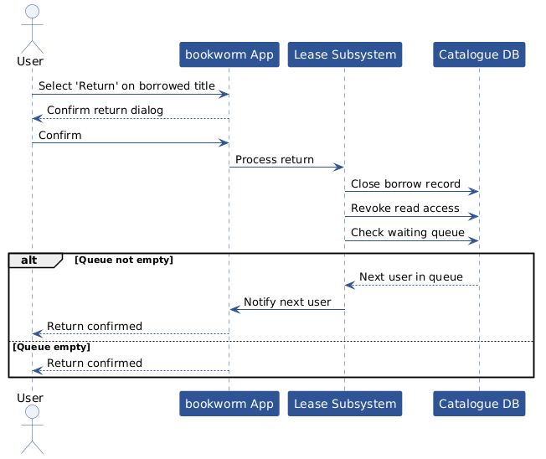

4.4.6 Use Case 6 – Read Book
Use Case Name | Read Book
XRef | FR13, FR14
Description | Allows a user with an active borrow to read the book content through the secure in-app reader. Content protection mechanisms prevent downloading, printing, or copying.
Priority | 1
Actors | User (primary)
Precondition | The user has an active, non-expired borrowing record for the title (UC4 completed).
Basic Path | 1. The user navigates to 'My Books' and selects 'Read'.  2. The system verifies the borrowing is still active.  3. The secure in-app reader opens and renders the book content.  4. The user reads the book. Progress is saved automatically.  5. The user closes the reader.
Alternative Paths | 2.1 The borrowing has expired - the system displays an expiry message and redirects to the borrow page.
Exception Paths | -
Postcondition | Reading progress is saved. The borrowing record remains active.
Related Use-Cases | UC4 Borrow Book, UC5 Return Book
Used Use-Cases | UC2 Login, UC4 Borrow Book
Extended Use-Cases | -

UC6 Read Book sequence diagram:
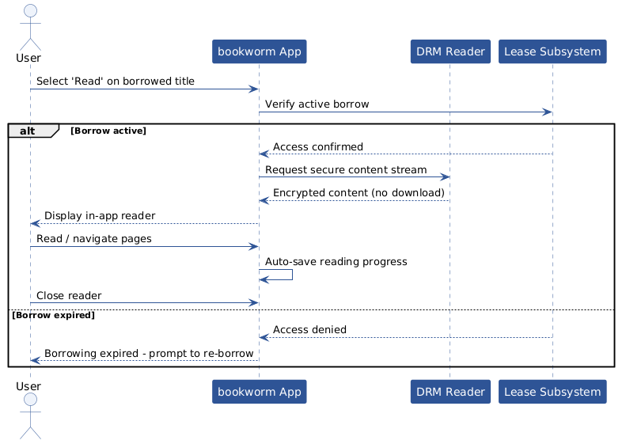

4.4.7 Use Case 7 – Rate and Review Book
Use Case Name | Rate and Review Book
XRef | FR15, FR16
Description | Allows an authenticated user who has borrowed a title to assign a rating, write a comment, and/or recommend the title to another user.
Priority | 2
Actors | User (primary)
Precondition | The user is authenticated and has borrowed the title at least once.
Basic Path | 1. The user navigates to the book detail page.  2. The user submits a numeric rating (1–5 stars).  3. The user optionally writes a comment.  4. The system saves the rating and comment.  5. The user optionally selects another user and sends a recommendation.
Alternative Paths | 3.1 The user submits only a rating without a comment - this is accepted.
Exception Paths | -
Postcondition | The rating and comment are visible on the book detail page. The target user receives the recommendation notification.
Related Use-Cases | UC3 Search Books
Used Use-Cases | UC2 Login
Extended Use-Cases | -

UC7 Rate and Review Book sequence diagram:
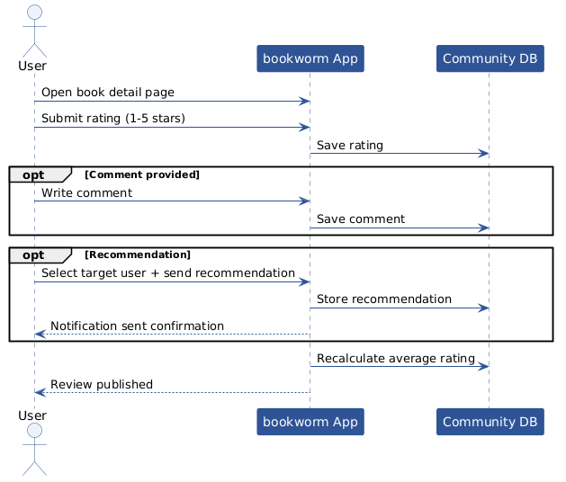

4.4.8 Use Case 8 – Manage Library
Use Case Name | Manage Library
XRef | FR17, FR18, FR19
Description | Allows the Library Manager to add, edit, and remove book records, manage catalogue categories, publish news and new arrivals, and configure borrowing policies (simultaneous reader limits and borrowing duration).
Priority | 1
Actors | Library Manager (primary)
Precondition | The Library Manager is authenticated with administrative privileges.
Basic Path | 1. The Library Manager accesses the administration panel.  2. To add a book: the manager fills in metadata (title, author, genre, description) and uploads the electronic file; the system saves the record and makes it available in the catalogue.  3. To edit a book: the manager modifies metadata; the system updates the record.  4. To remove a book: the manager confirms deletion; the system removes the record and revokes all active borrows.  5. To manage categories: the manager creates, renames, or deletes categories and assigns books.  6. To configure policies: the manager sets simultaneous reader limits and borrowing duration per title or globally.  7. To publish news: the manager writes and publishes a news item or marks a title as a new arrival.
Alternative Paths | 4.1 The book has active borrows - the system warns the manager before confirming deletion.
Exception Paths | -
Postcondition | The catalogue, policies, or news section is updated.
Related Use-Cases | -
Used Use-Cases | UC2 Login
Extended Use-Cases | -

UC8 Manage Library sequence diagram:
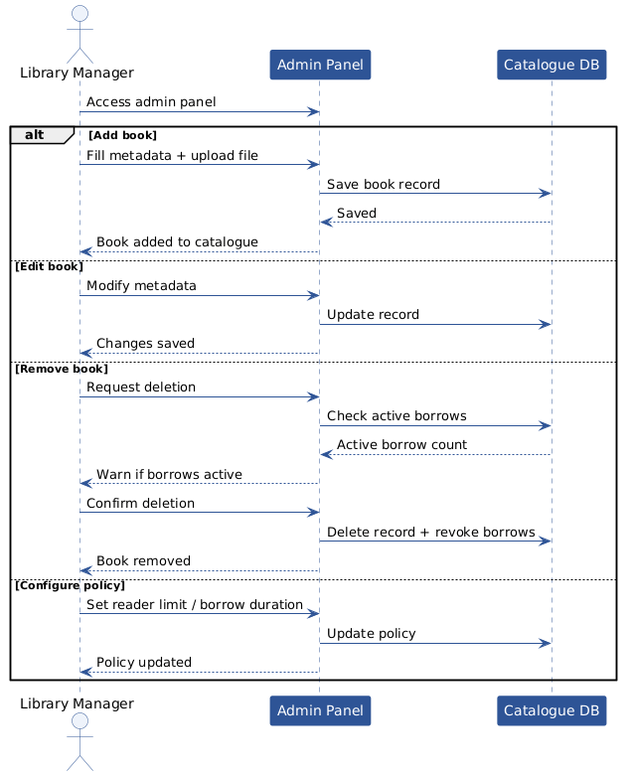

4.4.9 Use Case 9 – View Browsing History
Use Case Name | View Browsing History
XRef | FR20
Description | Allows an authenticated user to view their personal history of viewed book pages and borrowed titles, in reverse chronological order.
Priority | 2
Actors | User (primary)
Precondition | The user is authenticated.
Basic Path | 1. The user navigates to 'My History'.  2. The system retrieves the user's browsing and borrowing history.  3. The system displays the history in reverse chronological order.  4. The user may select a title from the history to view its detail page.
Alternative Paths | 2.1 History is empty - the system displays a 'no activity yet' message.
Exception Paths | -
Postcondition | The user has reviewed their history. No data is modified.
Related Use-Cases | UC3 Search Books
Used Use-Cases | UC2 Login
Extended Use-Cases | -

UC9 View Browsing History sequence diagram:
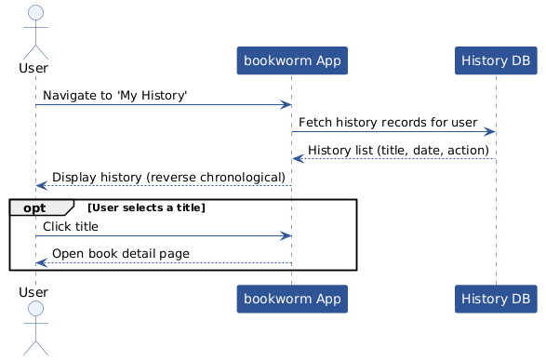

4.4.10 Use Case 10 – View News and New Arrivals
Use Case Name | View News and New Arrivals
XRef | FR21
Description | Allows any authenticated user to browse the news section and view recently added titles. Content is published by the Library Manager.
Priority | 3
Actors | User (primary)
Precondition | The user is authenticated.
Basic Path | 1. The user navigates to the News or New Arrivals section.  2. The system retrieves published news items and recently added titles.  3. The system displays the content in reverse chronological order.  4. The user may select a news item or a new title to view details.
Alternative Paths | 2.1 No content published yet - the system displays a placeholder message.
Exception Paths | -
Postcondition | The user has viewed the section. No data is modified.
Related Use-Cases | UC3 Search Books, UC8 Manage Library
Used Use-Cases | UC2 Login
Extended Use-Cases | -

UC10 View News and New Arrivals sequence diagram:

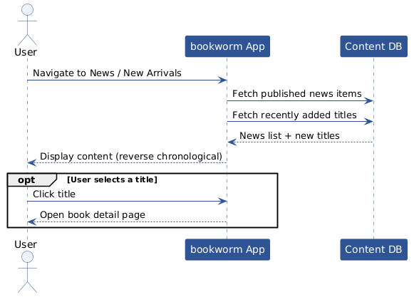

5. Requirements Traceability
The matrix below maps each use case (UC1–UC10) to the functional requirements (FR1–FR21) it addresses. An 'X' indicates that the use case implements or directly depends on the corresponding requirement.

UC \ FR | 1 | 2 | 3 | 4 | 5 | 6 | 7 | 8 | 9 | 10 | 11 | 12 | 13 | 14 | 15 | 16 | 17 | 18 | 19 | 20 | 21
UC1 | X | X | X
UC2 |  |  |  | X | X | X
UC3 |  |  |  |  |  |  | X
UC4 |  |  |  |  |  |  |  | X | X | X | X
UC5 |  |  |  |  |  |  |  | X |  |  |  | X
UC6 |  |  |  |  |  |  |  |  |  |  |  |  | X | X
UC7 |  |  |  |  |  |  |  |  |  |  |  |  |  |  | X | X
UC8 |  |  |  |  |  |  |  |  |  |  |  |  |  |  |  |  | X | X | X
UC9 |  |  |  |  |  |  |  |  |  |  |  |  |  |  |  |  |  |  |  | X
UC10 |  |  |  |  |  |  |  |  |  |  |  |  |  |  |  |  |  |  |  |  | X

End of Document

