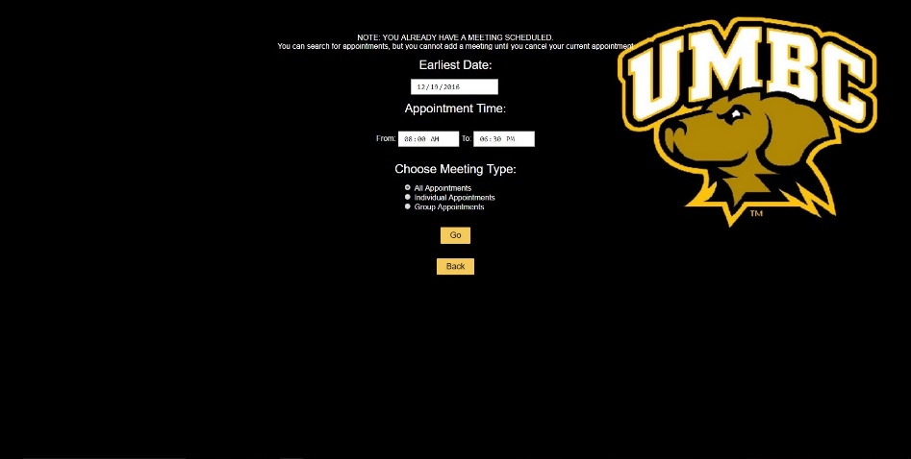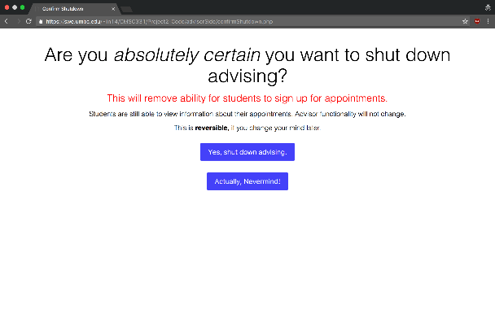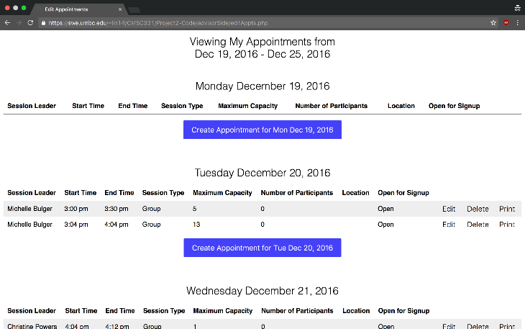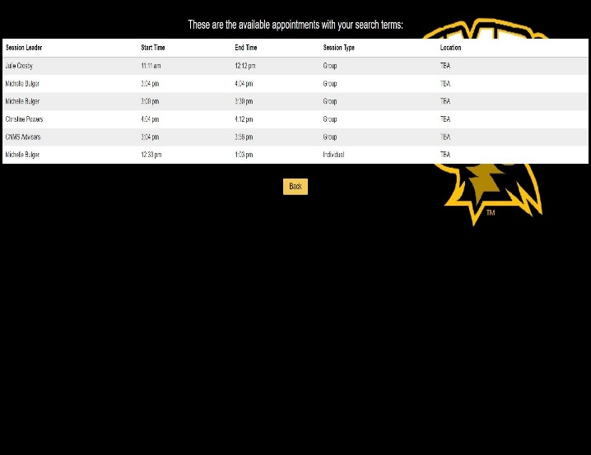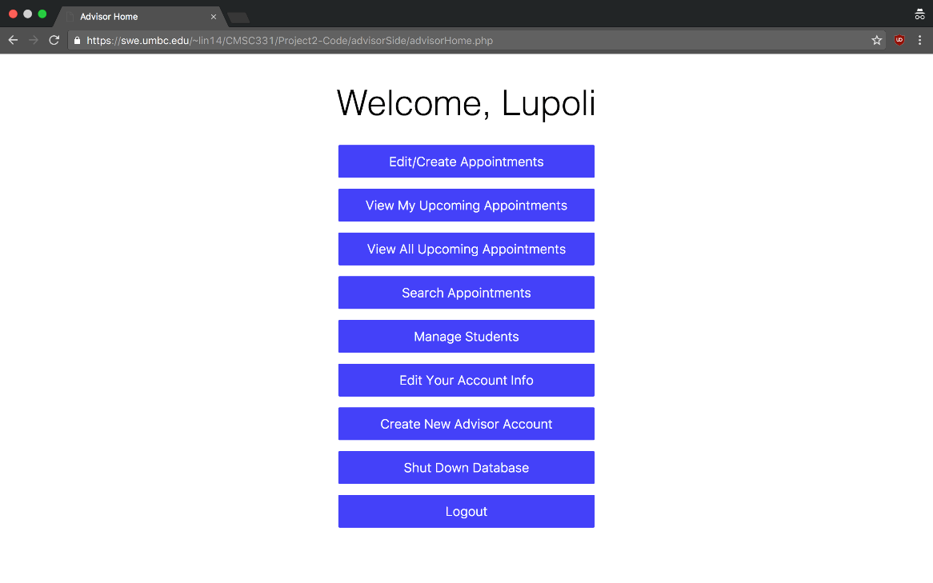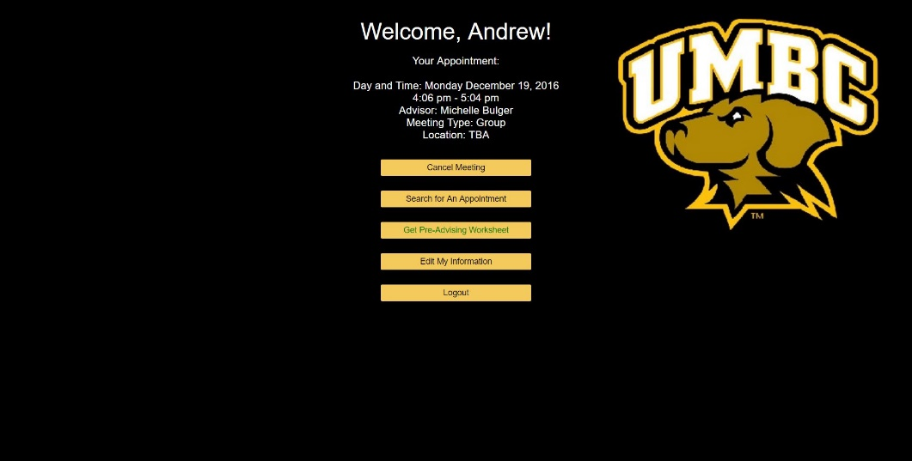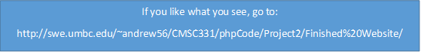

If you like what you see, go to:

http://swe.umbc.edu/~andrew56/CMSC331/phpCode/Project2/Finished%20Website/

View Your Appointment on Your Homepage!

Forgot Your Password? No Problem! Password Reset is Enabled.

Quick, Easy, Meeting Searches

**As a Student…**

Edit, Add, and Delete meetings with Ease

Open and Close Meeting Scheduling to Students with Ease!

**As an Advisor…**

A

And much, much, more!

[Insert Student Home Here]

[Insert Advisor Home Here]

**CNMS Advising Website**