FPT UNIVERSITY
Course: PRN222 – .NET Programming
PROJECT REPORT
SUSHI RESTAURANT MANAGEMENT SYSTEM
(Sushi Restaurant Management System)
Team: Group 3 – Class SE19B
Members:
(1) Nguyễn Xuân Đăng Khoa
(2) Phạm Ngô Bích Trâm
(3) Nguyễn Hoàng Ngọc Châu
(4) Đào Thị Thanh Hương
Report date: 20/07/2026

TABLE OF CONTENTS

TABLE OF CONTENTS 2
1. OVERVIEW 3
1.1. Background & Objectives 3
1.2. Scope 3
2. TECHNOLOGIES USED 3
3. SYSTEM ARCHITECTURE 4
3.1. Layered Architecture 4
3.2. Key Services 4
4. USER STORY 4
5. USE CASE 6
6. ERD 6
7. BUSINESS RULE 7
8. DATABASE DESIGN 8
8.1. Table list 8
8.2. Status types (Enum) 9
9. MAIN FEATURES 9
9.1. Authentication & Authorization 9
9.2. Booking 10
9.3. Menu & Ordering (Menu – Cart – Order) 10
9.4. Administration (Admin) 10
9.5. Background Service & Notifications 10
10. PERMISSION TABLE 11

1. OVERVIEW

1.1. Background & Objectives
This project builds a web-based sushi restaurant management system serving two core operations: advance table Booking and food Ordering. The system aims to digitize the service workflow: guests book tables and order food conveniently, while the restaurant manages tables, menu, orders and staff centrally through an administration interface.
Main objectives:
- Allow guests to book tables by date/time/area and view available-table status in real time.
- Allow food ordering through a visual menu, a dynamic cart, item customization and order submission.
- Provide an administration site (Admin/Staff) to manage the menu, orders, bookings, staff, customers and revenue statistics.
- Apply a layered architecture, EF Core and ASP.NET Core techniques (Razor Pages, DI, Session, Hosted Service).

1.2. Scope
The system focuses on the in-restaurant service flow: table booking, food ordering (pre-order and at-table ordering), and operational administration. Online payment, payment-gateway integration and a mobile app are out of scope for the current version.

2. TECHNOLOGIES USED
Category | Technology / Library | Role
Platform | .NET 8, ASP.NET Core Razor Pages | Web framework, Page-Model pattern
ORM / Database | Entity Framework Core + MySQL | Object–relational mapping, MySQL queries
Password security | BCrypt.Net | Hash & verify staff passwords
Session & authorization | ASP.NET Core Session | Store login state, role, cart
Background service | IHostedService (BackgroundService) | Auto-updates table status every 5 minutes
External integration | HttpClient → Zalo API | Send booking notifications (demo via console)
User interface | Bootstrap 5, Font Awesome 6, CSS/JS | Responsive UI, icons, dynamic cart

3. SYSTEM ARCHITECTURE

3.1. Layered Architecture
The solution is split into 5 independent projects by responsibility, reducing coupling and easing maintenance:
Layer (Project) | Components | Responsibility
BusinessObjects | 8 Models + 5 Enums | Define entities & business status types
DataAccessObjects | RestaurantSystemDbContext, Requests (DTO) | EF Core configuration, table mapping, input/result DTOs
Repositories | 8 Interfaces + 8 Implementations | Data access (CRUD) via DbContext
Services | 10 Interfaces + 11 Implementations | Business logic, orchestrating Repositories
Web (Razor Pages) | Pages, wwwroot, Program.cs | UI, routing, DI, pipeline configuration

Request processing flow: Razor Page (PageModel) → Service (business logic) → Repository (data access) → DbContext → MySQL, then results flow back for display. All dependencies are registered via Dependency Injection in Program.cs.

3.2. Key Services
- IBookingService: create bookings, get available tables, change status, order history by table.
- ITableAvailabilityService: count available/booked tables, statistics per 30-minute time slot.
- IMenuItemService / IMenuCategoryService: CRUD for dishes & categories.
- IOrderService / IOrderItemService: create & update orders, get orders by booking.
- ICustomerService / IStaffService: CRUD for customers & staff, adjust loyalty points.
- INotificationService: send confirmation / status change / booking reminders.

4. USER STORY
4.1. Booking & Ordering Features (Customer / Serving staff at the terminal)
- US-01 (View available tables): As a customer/staff member, I want to view the number and status of available tables in real time (date, time, Normal/VIP/Bar area) so that I can choose a suitable time to visit the restaurant.
- US-02 (Book a table): As a customer/staff member, I want to make a booking by entering the date, time, number of guests, desired area and notes, so that the system issues a Booking ID and reserves a spot for me in advance.
- US-03 (View the visual menu): As a customer, I want to view the dish list as a grid with vivid images, prices and descriptions grouped by category (Sushi, Sashimi...) so that I can choose dishes easily.
- US-04 (Dynamic cart): As a customer, I want to add dishes to the cart via a quick button without reloading the page (AJAX), and see the number of items in the cart increase in real time.
- US-05 (Quick cart editing): As a customer, I want to open a floating cart to quickly view the list and total amount, with a quick delete (×) button to adjust my selection fast.
- US-06 (Confirm Order - Checkout): As a customer, I want to open the cart detail page to increase/decrease dish quantities and press "Submit order" so that the system creates an Order linked to my booking (Pre-order) or my table number.
4.2. Operations & Service Features (Staff)
- US-07 (System login): As a serving staff member, I want to log in with my personal phone number and password to access the operations interface and help customers book tables/order food.
- US-08 (Update booking status): As a staff member, I want to change a booking's status from PENDING to COMPLETED when the customer has actually arrived and taken the table.
- US-09 (Process food orders): As a staff member, I want to track new orders (PENDING) and update their status to PREPARING and COMPLETED to coordinate with the kitchen and serve customers.
4.3. Administration Features (Admin)
- US-10 (Statistics Dashboard): As an Admin, I want to view charts/statistics on the number of bookings, available tables and total revenue over a custom time range to evaluate business performance.
- US-11 (Menu Management - CRUD): As an Admin, I want to add new dishes, edit information (name, price, image), filter by category, paginate the list and stop selling (soft delete) dishes that are no longer served.
- US-12 (Staff & Customer Management): As an Admin, I want to manage the staff list (add/edit/delete) and view the member-customer list along with their membership tier (Silver, Gold, Diamond) and loyalty points.

5. USE CASE
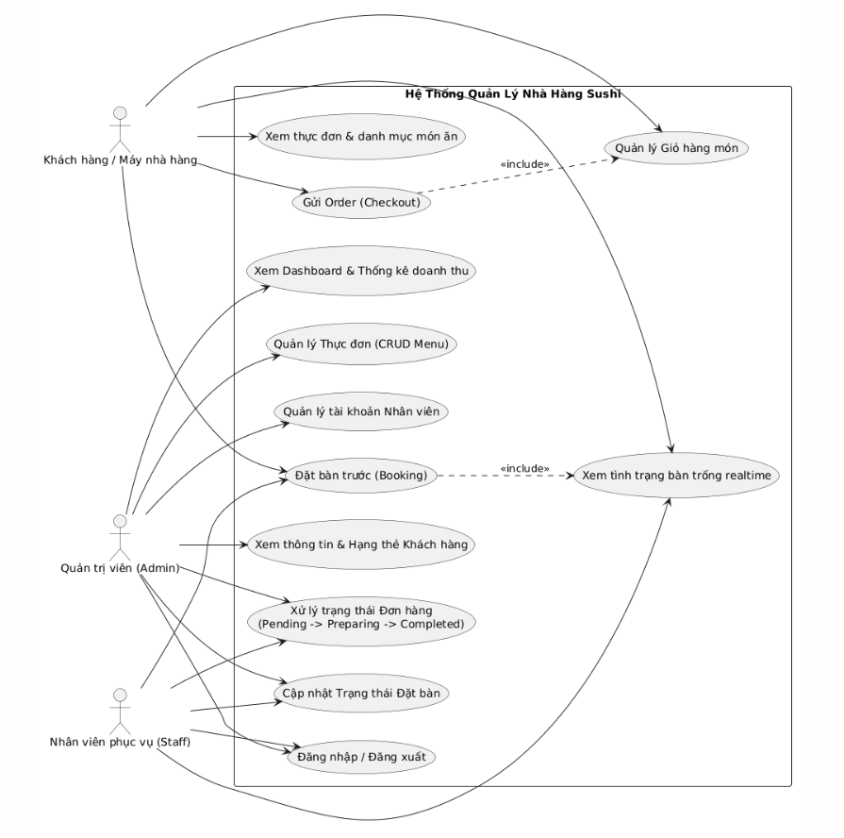

6. ERD
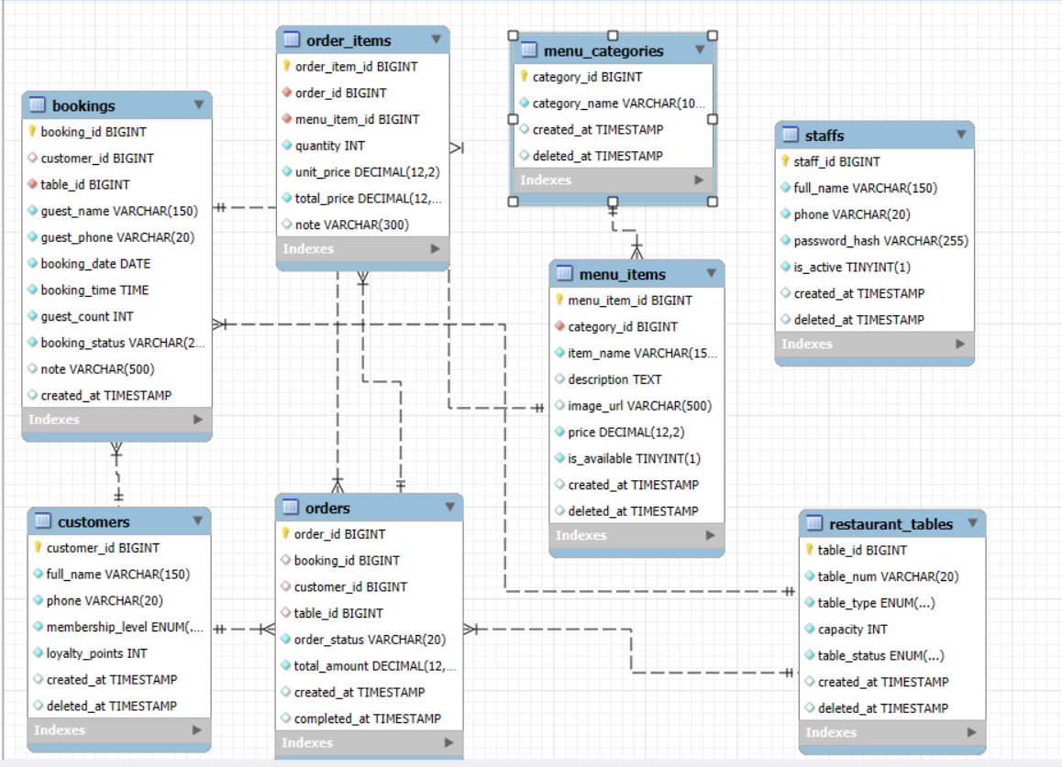

7. BUSINESS RULE
7.1. Table Management and Booking Rules (Booking & Table Rules)
- Table status integrity: The table status (TableStatus) must stay tightly synchronized with the service process:
  - AVAILABLE (Empty table): No booking or seated guest at the time of check.
  - BOOKED: Assigned to a Booking with PENDING status in a specific time slot.
  - OCCUPIED (Guests present): The guest has arrived and taken the table (Booking moved to COMPLETED) or a walk-in guest is dining at the table.
- Statistics time slots: The system divides and reports table usage density and occupancy rate in fixed blocks of every 30 minutes on the Availability page.
- Automatic table release (Hosted Service background job): The system has a background service that periodically runs every 5 minutes to check:
  - If a Booking passes its scheduled time and the guest does not arrive, the booking status is automatically moved to COMPLETED (or Cancelled depending on advanced operational configuration) to release the table status back to AVAILABLE.
  - The system automatically sends a reminder message/log 30 minutes before the guest's scheduled booking time.
7.2. Menu and Ordering Rules (Menu & Order Rules)
- Dish display constraint: Only dishes with is_available = true are shown on the customer-facing grid menu for ordering. Soft-deleted dishes (with a value in the deleted_at field) are hidden from all public interfaces.
- Two Order processing flows:
  - Pre-order flow: The order is created before the guest arrives and must be linked to a valid booking code (booking_id not null).
  - At-table ordering flow: The order is created on the spot and must be linked to a specific physical table (table_id not null).
- Order status lifecycle: An order must strictly follow the status progression: PENDING (Awaiting acceptance) $→$ PREPARING (Being prepared in the kitchen) $→$ COMPLETED (Served / Paid). An order may move to CANCELLED if an issue occurs on the customer or kitchen side.
7.3. Security and Authorization Rules (Security & Authorization Rules)
- Account security: All staff passwords, when stored in the database, must be securely hashed using the library BCrypt.Net. Passwords must not be stored in plain text.
- Interface-layer access control:
  - The Admin account (high-level system administrator) is defined statically in the appsettings.json file.
  - All pages in the administration module (Dashboard, Staff, Customer, Order management) must inherit from AdminPageModel to check permissions via the processed Session. If the Session does not carry the Admin role, the system immediately blocks access.
  - Vulnerability remediation note: The MenuManager page currently does not inherit AdminPageModel; the business rule requires the next version to integrate it to keep security consistent.

8. DATABASE DESIGN

8.1. Table list
Table | Meaning | Key fields
customers | Customers / members | customer_id, full_name, phone, membership_level, loyalty_points
restaurant_tables | Restaurant tables | table_id, table_num, table_type, capacity, table_status
bookings | Table bookings | booking_id, customer_id, table_id, booking_date, booking_time, guest_count, booking_status
menu_categories | Dish categories | category_id, category_name
menu_items | Dishes | menu_item_id, category_id, item_name, price, image_url, is_available
orders | Food orders | order_id, booking_id, customer_id, table_id, order_status, total_amount
order_items | Order details | order_item_id, order_id, menu_item_id, quantity, unit_price, note
staffs | Staff | staff_id, full_name, phone, password_hash, is_active

8.2. Status types (Enum)
Enum | Values
BookingStatus | PENDING, COMPLETED, CANCELLED
OrderStatus | PENDING, PREPARING, COMPLETED, CANCELLED
TableStatus | AVAILABLE, BOOKED, OCCUPIED
TableType | NORMAL, VIP, BAR
MembershipLevel | NONE, SILVER, GOLD, DIAMOND

Main relationships: bookings & orders reference customers/restaurant_tables; order_items link orders to menu_items; menu_items belong to menu_categories. Several tables use deleted_at for soft deletion.

9. MAIN FEATURES

9.1. Authentication & Authorization
- Log in with phone number + password (BCrypt hash); Register, Forgot & Reset password.
- The Admin account is hard-coded in appsettings.json; staff are stored in the staffs table.
- authorization via Session (StaffRole = Admin/Staff); the AdminPageModel class blocks access to admin pages if the user is not an Admin.

9.2. Booking
- The guest chooses date, time, number of guests, area (Normal/VIP/Bar) and notes.
- The system shows the number of available tables at that time; confirming the booking → generates a Booking ID and a success page.
- The Availability page reports total tables, booked tables, available tables and occupancy rate per 30-minute time slot.

9.3. Menu & Ordering (Menu – Cart – Order)
- Grid menu displaying images (12 dishes with real photos), price and description; supports a fallback image when missing.
- Floating cart: a fixed cart button at the bottom-right, a badge counting items that increases; add dishes via AJAX without reloading the page.
- View & edit cart: open a panel listing dishes and the total; a × button to remove a dish; a Checkout button leading to the Cart page.
- The Cart page allows increasing/decreasing quantity, removing dishes, viewing the provisional total; submitting the order → creates an Order with PENDING status.
- Supports two flows: pre-ordering (pre-order linked to a Booking) and at-table ordering (linked to a Table).

9.4. Administration (Admin)
- Dashboard: statistics on bookings, available tables, revenue by date range (with filters).
- Menu Management (full CRUD): Add dish / Edit (name, category, price, status) / Stop selling (soft delete) / View list with search, category filter, pagination; add category groups.
- Order Management: filter/search orders, update status PENDING → PREPARING → COMPLETED / CANCELLED.
- Staff & Customer Management: add/edit/delete, search, pagination; view membership tier & customer points.

9.5. Background Service & Notifications
- TableStatusUpdateHostedService runs every 5 minutes: automatically moves overdue bookings to COMPLETED and sends reminders 30 minutes in advance.
- NotificationService sends booking notifications via Zalo (the current version demos with console logs; the real API can be enabled via configuration).

10. PERMISSION TABLE
Function | Admin | Staff | Guest
Log in / Log out | ✓ | ✓ | —
Book table, Order food, View cart | ✓ | ✓ | ✓ (operated via the restaurant terminal)
Dashboard & Revenue statistics | ✓ | ✗ | ✗
Menu Management (CRUD) | ✓ | ✗ | ✗
Order / Booking Management (status change) | ✓ | Partial | ✗
Staff / Customer Management | ✓ | ✗ | ✗

7. REPORT ASSIGNMENT (4 MEMBERS)
Development and presentation work is divided equally among the 4 members by module. Replace [Name] with the actual group members' names.
Member | Development responsibility | Presentation part in the report
M1 – [Name] (Leader) | Overall architecture, project configuration (Program.cs, DI); Authentication & Authorization module (Login/Register/Forgot/Reset, Admin, AdminPageModel) | Sections 1, 2, 3, 5.1, 6
M2 – [Name] | Booking module: Create, Availability, time-slot statistics; Background service auto-updating table status; Zalo notifications | Sections 5.2, 5.5
M3 – [Name] | Menu & Ordering module: Menu + images, floating cart + × button, Cart, Checkout → Order, order history | Section 5.3
M4 – [Name] | Database & data-layer design; Administration module: Dashboard, Menu management (CRUD), Orders, Staff, Customers | Sections 4, 5.4

Suggested demo time per person: 2–3 minutes, presenting the module you are responsible for following the script in Section 8.

8. DEMO SCRIPT
Preparation: run MySQL with sample data (customers, tables, menu, staffs...), start the application, and keep a Console window open to watch the background service/Zalo logs. Total duration ~10–12 minutes.

Part A – Customer / Serving staff role (M1 opens, M2 & M3 demo)
- Log in with a staff account (e.g. 0988000003 / 123456) → enter the operations screen. (M1)
- Book a table: choose date, time, number of guests, area → view available tables in real time → Confirm → receive a Booking ID + success page (Zalo log shown in the Console). (M2)
- View table status on the Availability page: total tables, booked, available by time slot. (M2)
- Order food: go to Menu → 12 dishes display the correct images → add a few dishes (cart badge increases, no reload). (M3)
- Edit cart: open the floating cart → remove one dish with the × button → total updates immediately → press Checkout → Cart page → Submit order → receive an Order code. (M3)

Part B – Admin role (M4 demo, M1 assists)
- Admin login (account configured in appsettings.json) → enter the Dashboard.
- Dashboard: view bookings, available tables, revenue; filter by date range.
- Menu Management: Add a new dish → Edit price/status → Stop selling; filter by category, search, pagination.
- Booking Management: change status PENDING → COMPLETED when the guest arrives.
- Order Management: the order just created in Part A → change status PENDING → PREPARING → COMPLETED.
- Staff / Customer Management: demonstrate add/edit/delete, view membership tier & points.

Part C – Background service
- Background service: describe (or wait for) the process that runs every 5 minutes to auto-update table status & send reminders — watch the log in the Console. (M2)

9. LIMITATIONS & FUTURE WORK
Some items from the original description are not yet complete and are the next steps for development:
- Dedicated customer accounts: currently Register/Login operate on the staff table; a password must be added for customers so members can log in themselves.
- Loyalty members: no automatic point accrual yet (10,000 VND = 1 point) and no tier-based discount yet (Silver/Gold/Diamond).
- Voucher / Discount code: no data table or cart-side code-application UI yet; the Cart has no discount line yet.
- Dish customization: currently a free-text note field, not yet a structured suggestion popup (e.g. Wasabi: Yes/No).
- Kitchen: no 'Print kitchen ticket' button yet; the Home page has no two quick-access Booking/Order buttons yet.
- Security: the MenuManager page does not inherit AdminPageModel yet, so it does not enforce access as strictly as other admin pages (needs to be added).
- Zalo notifications are only at Console-demo level; the AccessToken must be configured to run the real API.

— HẾT —

