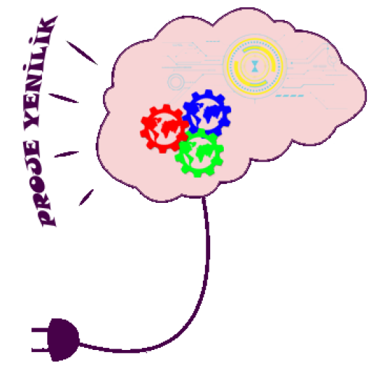

PROJECT NEWNESS

Tracker & IOT Stack

13.09.2021

|  |  |  |  |
| --- | --- | --- | --- |
|  | **Name Surname** | **Title** | **Date** |
| **Prepared** |  |  |  |
| **Reviewer** |  |  |  |
| **Approver** |  |  |  |

|  |  |  |  |
| --- | --- | --- | --- |
| **No** | **Descripiton** | **Change Owner** | **Date** |
| 1 |  |  |  |
| 2 |  |  |  |
| 3 |  |  |  |
| 4 |  |  |  |
| 5 |  |  |  |
| 6 |  |  |  |
| 7 |  |  |  |
| 8 |  |  |  |

**Contents**

Abbreviations and Definitions 4

Reference Documents 4

1. Purpose 4

2. Scope 4

# Abbreviations and Definitions

|  |  |
| --- | --- |
| **Keyword** | **Description** |
|  |  |
|  |  |
|  |  |
|  |  |
|  |  |
|  |  |
|  |  |

# Reference Documents

|  |  |  |
| --- | --- | --- |
| **Document No** | **Revision Number / Date** | **Document Name** |
|  |  |  |
|  |  |  |
|  |  |  |
|  |  |  |
|  |  |  |
|  |  |  |
|  |  |  |
|  |  |  |

# Purpose

...

# Scope

...