**BookMyAirway**



**Service at your hands-Serving the World**

**Project Team Members:**

1.Ashok K. (Team Leader)  
2.Chandrahaas S.  
3.Niharika T.  
4.Anjali k.  
5.Bhavana B.

Table of Contents

1.0 Document Purpose 3

1.1 Objectives 3

2.0 Module for User Login 3-4

2.3 Module for Project Usage Types 4

3.0 Design and Implementation Constraints 4

4.0 Define module & Functionality: 5

5.0 Technical 5

6.0 Process Model……………………………………...6-9

7.0 Conclusion to the Project…………………………..9

**1.0 Document Purpose**  
 This software helps passengers to look up flights between two points which can be domestic or international. The passengers can find and book tickets for flights through this software. Developed in java, it is fairly easy to use software having a user-friendly interface.

This project includes modules such as

1. Admin module
2. Client module

**1.1 Objectives:**

The users can access flight information and book tickets as per their convenience. The main objective is to reduce the mistakes which creep up in manual systems. It provides good level of security so it takes care of the user’s safety concerns as well. Passengers can access the whole list of all the flights available on different routes with their timings and fare both for economy and business classes. One can compare the best deals for them and book a flight accordingly. When the passengers enter all the details the software helps them to find all available flights and also information if there are seats available on that particular flight. The manual work is thus reduced and the chances of errors are reduced to minimum.

**Existing System:**

There is a higher risk of errors in manual work and in case of an error it gets tedious to rectify it manually. The passengers have to depend on the airline authority to get their tickets booked or cancelled and this might introduce unforeseen problems due to wrong interpretation while communicating.

**Proposed System:**

Airline reservation system allows passengers to find flights as per their convenience and book them at their own interest. This reduces the dependence on airlines to get the ticket booked. This software provides passengers with all the required information about flights along with the fares for economic and business class. Both domestic and international flights database can be accessed and the passenger is then able to book the tickets as they want. This mainly reduces manual errors.

# 2.0 Module for User Login

**2.1 Admin module**

This module handles the Insertion, Updation , Deletion of the User records where only the Admin has the authority to access these Details(Terms & conditions apply).

* Admin ID
* Admin Password

**2.2 Client module**

This module contains User Registration and User Login page which retrieves and Stores the User record. The User can come to know some basic information about the Flight details and Airports with Timings etc through this module.

This module contains sub-modules which are mentioned below:

* User Name
* User Password

# 2.3 Module for Project Usage Types

* Domestic Flight Module:- This modules provides information about all the available domestic flights along with their fares for both economy and business class.
* Domestic Flight Booking Module:- This module provides facility to book a domestic flight between a pair of cities. It takes as input the source and destination cities, date of journey and number of passengers and provides information about seat availability.
* International Flight Module:- This module provides information about all the international flights available and their respective fares for economy as well as business class.
* International Flight Booking Module:- This module provides facility to book an international flight. It takes as input the source and destination cities, date of journey and number of passengers and provides information about seat availability.

# 3.0 Design and Implementation Constraints

**3.1 Database:** The system shall use the Oracle SQL Database, which is open source and free.  
 **3.2 Operating System:** The Development environment shall be Windows10  
 **3.3 Web-Based:** The system shall be a Web-based application.

**4.0 Define module & Functionality**

The system functions can be described as follows:

**Registration:** User needs to be registered in this Application before using it . For registering , the user enters all his personal details including First name, Last name, Mail Id, Date of Birth and user needs to make his/her own password etc.. After Registration ,User can login and enjoy the benefits of the Application through his/her Mail Id and with his/her own Password.

**Login:** When Email Id and password is matched it allows the user to dashboard or else it denies the user to Enter into Application.

**5.0 Technical:**

**Software Requirements**

* JVM

**Hardware Requirements**

* Hard Disk – 2 GB.
* RAM required – 1 GB (minimum)
* Processor – Dual Core or Above.

**Front End:**

1. **HTML**
2. **CSS**
3. **JavaScript**

**Back End:**

1. **Servlets**
2. **Java Server Pages(JSP)**
3. **JDBC**
4. **Hibernate Basics**

**Database:**

**Oracle Data Base(Language Used is Oracle SQL)**

**5.0 Process Model**

**Login Page: (For Both User and Admin)**

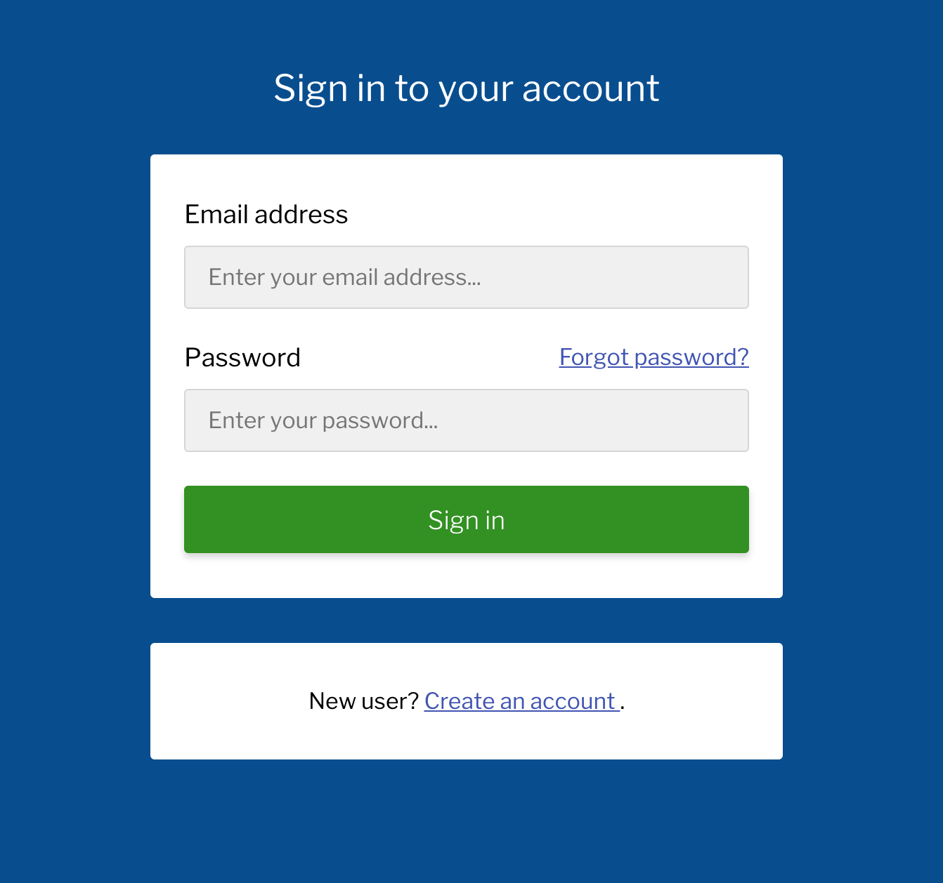

**Home Page:**

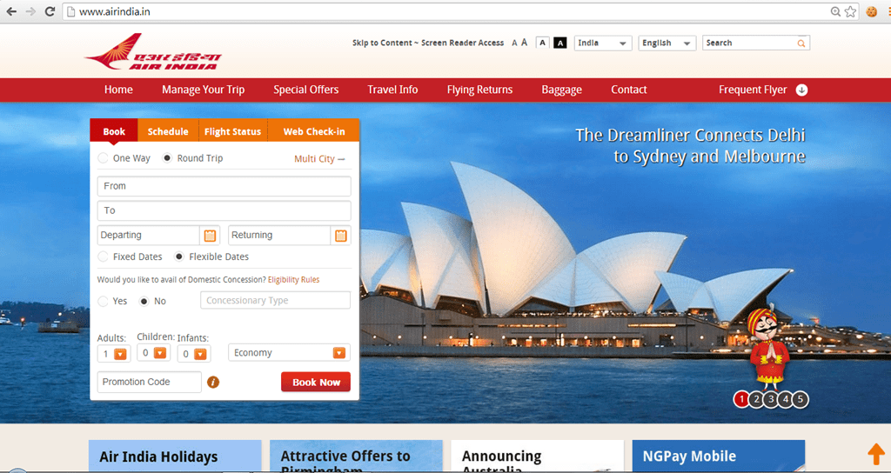

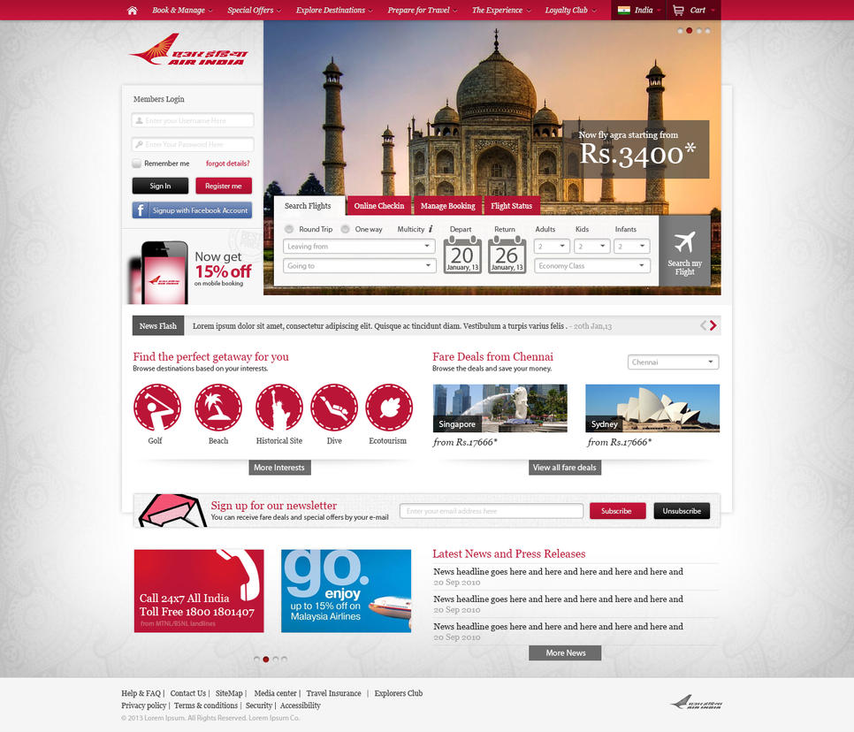

**Booking Site:**

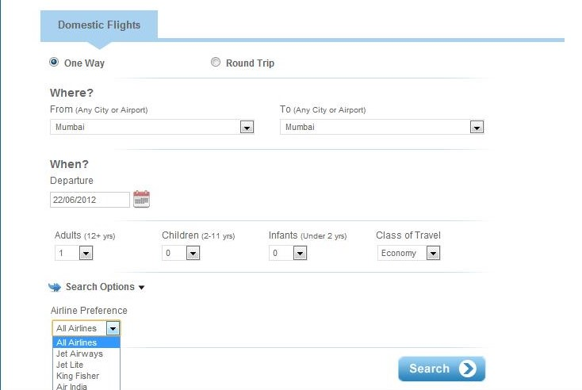

**Booking Receipt/Details**

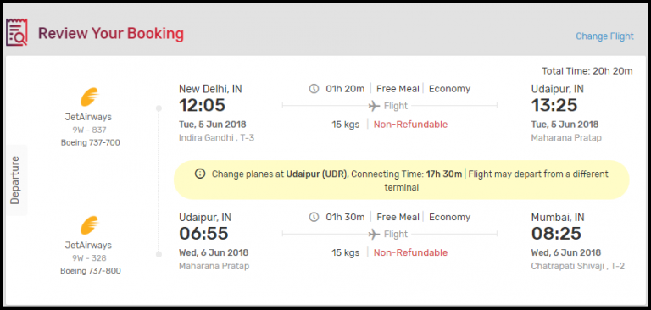

**6.0 Conclusion**

* Airline reservation system allows passengers to find flights as per their convenience and book them at their own interest.
* This reduces the dependence on airlines to get the ticket booked.
* This software provides passengers with all the required information about flights along with the fares for economic and business class.
* Both domestic and international flights database can be accessed and the passenger is then able to book the tickets as they want.
* This mainly reduces manual errors.