

A Project Report

On

“FINANCIAL CAUSALITY DETECTION”

Batch Details

Sl. No. | Roll Number | Student Name
1 | VINUSHA GURANAVAR RUDRAPPA | 20211CEI0129
2 | MANCHIKANTI ASHRITA | 20211CEI0154
3 | POORNIMA C BALAGONDAR | 20211CEI0135
4 | ABHISHEK K S | 20211CEI0131

School of Computer Science,
Presidency University, Bengaluru.

Under the guidance of,
Dr. JOE ARUN RAJA
School of Computer Science,
Presidency University, Bengaluru

CONTENTS

- Introduction

- Literature Review

- Objectives

Methodology

- Timeline for Execution of Project

- Expected Outcomes

- Conclusion

- References

1. INTRODUCTION
Financial causality detection plays a significant role in analyzing financial disclosures and reports. By understanding cause-effect relationships within financial texts, businesses, regulators, and investors can make informed decisions. This task involves both extractive and generative approaches to Question Answering (QA) for detecting causal effects in financial data.
Extractive QA focuses on finding exact answers from the text, while generative QA can generate creative and abstract answers by forming deeper inferences from the data. By implementing Natural Language Processing (NLP) techniques with models like RoBERTa and GPT-2, we can automate the process of detecting causal relationships in both English and Spanish datasets.The task involves preprocessing text using language models like SpaCy for tokenization, RoBERTa for extractive QA, and GPT-2 for generative QA.

2. LITERATURE REVIEW
“Deep Learning. MIT Press.”
- Author: Goodfellow, I., Bengio, Y., & Courville, A.
- Algorithm Used:
- Deep Neural Networks (DNNs): The book covers a wide range of deep learning architectures such as Convolutional Neural Networks (CNNs), Recurrent Neural Networks (RNNs), and generative models like Generative Adversarial Networks (GANs).
- Drawbacks:
- Computationally Expensive: Training deep networks requires a lot of computational power and memory.
- Overfitting: Deep networks can easily overfit, especially when trained on small datasets.

“Attention is All You Need.”
- Author: Vaswani, A. Shazeer, N., Parmar, N., et al.
- Algorithm Used:
- Transformer Architecture: Introduces the transformer model based purely on attention mechanisms, eliminating the need for recurrent layers. The core concept is the self-attention mechanism, which enables the model to focus on different parts of the input sequence dynamically.
- Drawbacks:
- Scalability: Transformers have quadratic complexity with respect to sequence length due to the self-attention mechanism, making them computationally expensive for long sequences.
- Memory Consumption: The self-attention mechanism consumes large amounts of memory, especially for long input sequences.

“BERT: Pre-training of Deep Bidirectional Transformers for Language Understanding.”
- Author : Devlin, J., Chang, M. W., Lee, K., & Toutanova, K.
- Algorithm Used:
- BERT (Bidirectional Encoder Representations from Transformers): A pre-trained language model using bidirectional transformers that capture context from both directions of a sentence.
- Drawbacks:
- Computational Cost: Fine-tuning BERT on specific tasks requires a lot of computational resources, including GPUs or TPUs.
- Inference Speed: BERT models are slow during inference due to their deep layers and the bidirectional nature of their architecture.

-ADVANTAGES AND LIMITATIONS:

1. Manual Analysis
Advantages:
- Allows domain experts to apply contextual understanding.
- Adaptable to nuanced scenarios where automated systems fail.
Limitations:
- Time-consuming and inefficient for large datasets.
- Prone to human error, leading to inconsistencies.

2. Rule-Based Systems
Advantages:
- Simple to implement for well-defined rules.
- Provides deterministic outputs.
Limitations:
- Inflexible to complex relationships and varied syntax.
- Poor performance in multilingual scenarios, e.g., Spanish financial texts.

3. Monolingual Focus
Advantages:
- Focused models for English texts can achieve higher precision.
- Lower computational complexity compared to multilingual systems.
Limitations:
- Excludes non-English datasets, missing critical market insights.
- Limited applicability in regions where languages like Spanish dominate.

4. Deep Neural Networks (DNNs)
Advantages:
- Handles complex feature extraction and relationships.
- Scalable for various financial datasets.
Limitations:
- High computational cost for training and inference.
- Susceptible to overfitting on small datasets​.

5. Transformer Models
Advantages:
- Efficient handling of sequence data via self-attention.
- Eliminates reliance on recurrent layers.
Limitations:
- Quadratic computational complexity with sequence length.
- Significant memory requirements, especially for long documents​.
- 6. BERT (Bidirectional Encoder Representations from Transformers)
Advantages:
- Captures bidirectional context effectively.
- Pre-trained for a wide range of NLP tasks.
Limitations:
- Computationally intensive fine-tuning process.
- Slower inference speeds due to deep architecture​.

7. GPT Models (e.g., GPT-2)
Advantages:
- Generates creative and abstract answers.
- Effective in inferential and generative QA tasks.
Limitations:
- May produce responses with factual inaccuracies.
- Requires significant computational resources for training​.

8. Language Models like SpaCy
Advantages:
- Efficient tokenization and preprocessing.
- Supports multiple languages, enhancing preprocessing capabilities.
Limitations:
- Limited to preprocessing tasks, not causal inference.
- Requires integration with advanced models for causal detection.

9. Domain-Specific Datasets
Advantages:
- Tailored datasets improve model accuracy in financial contexts.
- Allows fine-tuning of pre-trained models for specific tasks.
Limitations:
- Limited availability of high-quality bilingual datasets.
- Requires significant effort in data cleaning and alignment.

10. Hybrid QA Approaches
Advantages:
- Combines strengths of extractive (precise) and generative (inference) QA.
- Provides comprehensive causal insights.
Limitations:
- Increased system complexity due to hybrid architecture.
- Requires fine-tuning and balancing between extractive and generative components.

3. OBJECTIVES
- Develop a hybrid QA system that detects causal relationships from financial disclosures using extractive and generative models.
- Ensure the system works for both English and Spanish languages.
- Automate the analysis of financial disclosures to reduce manual effort and improve accuracy.
- Provide both verbatim extractive answers and creative generative answers for complex causal relationships.
- Improve scalability by enabling the system to analyze large datasets efficiently.

-EXPERIMENTAL DETAILS

Hardware:
- CPU: 2.4 GHz (Quad-Core or higher)
- Memory: Minimum 16GB RAM
- Disk: Minimum 256GB SSD
- GPU (Optional for faster inference): NVIDIA GPU with CUDA support

Software:
- Python 3.x
- Django 3.x
- PyTorch for deep learning
- SpaCy for text preprocessing
Hugging Face’s transformers library for QA Models.

4. METHODOLOGY
Text Preprocessing:
- Use SpaCy to tokenize and clean the input text.
- Preprocess input context based on language selection (English or Spanish).
Extractive QA:
- Use RoBERTa (deepset/roberta-base-squad2) for extractive question-answering to find exact matches from the context.
Generative QA:
- Use GPT-2 to generate creative answers for questions that require abstract inferences.
Hybrid Approach:
- Combine the extractive and generative answers to provide a complete understanding of the causal relationship.

-DESIGN PROCEDURE
User Interface:
- Users input financial documents and ask questions via a web interface.
- Choose language (English/Spanish).
Preprocessing Module:
- Preprocesses text using SpaCy for tokenization and language-specific cleaning.
QA System:
- Extractive QA: Uses RoBERTa to extract exact answers from the text.
- Generative QA: Uses GPT-2 to generate creative answers.

5. TIMELINE OF THE PROJECT/ PROJECT EXECUTION PLAN
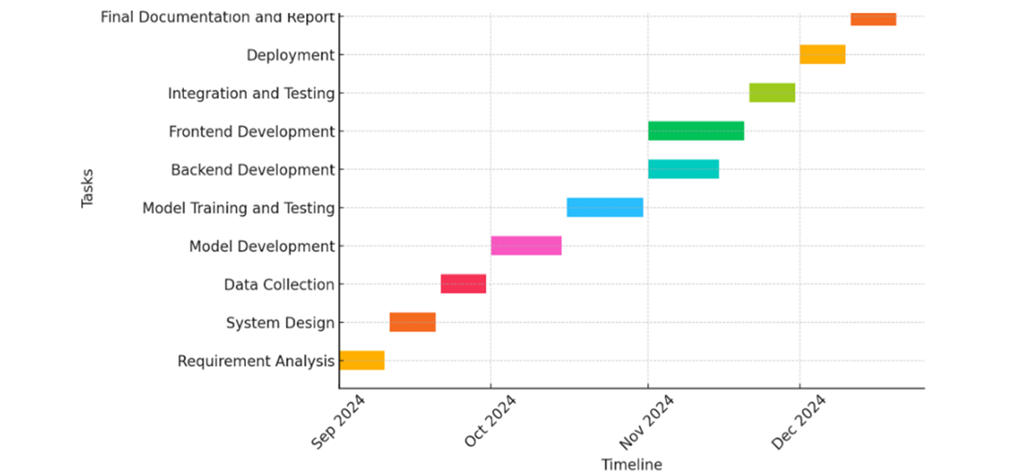

Fig 5.1- Timeline of project
6. OUTCOMES
- Improved Efficiency: The system will automate financial causality detection, reducing manual effort.
- Multilingual Support: Support for both English and Spanish will expand the system’s applicability in diverse markets.
- Accurate Causal Detection: The hybrid approach will provide both accurate extractive answers and insightful generative answers.
- Scalability: The system will be capable of analyzing large financial datasets efficiently, making it suitable for enterprise-level application.

7.CONCLUSION
The proposed financial causality detection system offers an innovative hybrid QA approach that combines extractive and generative models to uncover cause-effect relationships in financial disclosures. By leveraging state-of-the-art NLP techniques like RoBERTa and GPT-2, the system provides both exact and creative insights into financial data, making it a valuable tool for businesses, regulators, and financial analysts. The solution’s multilingual capability further enhances its usability across different regions and languages, making it a comprehensive solution for financial analysis.

8.REFERENCES
- Goodfellow, I., Bengio, Y., & Courville, A. (2016). Deep Learning. MIT Press.
- Vaswani, A., Shazeer, N., Parmar, N., et al. (2017). Attention is All You Need. Advances in Neural Information Processing Systems, 30, 5998-6008.
- Devlin, J., Chang, M. W., Lee, K., & Toutanova, K. (2019). BERT: Pre-training of Deep Bidirectional Transformers for Language Understanding. NAACL-HLT.
- Radford, A., Wu, J., Child, R., Luan, D., Amodei, D., & Sutskever, I. (2019). Language Models are Unsupervised Multitask Learners. OpenAI Blog.
- Rajpurkar, P., Jia, R., Liang, P. (2018). Know What You Don't Know: Unanswerable Questions for SQuAD. Proceedings of the 56th Annual Meeting of the Association for Computational Linguistics.

